**SOFTWARE REQUIREMENT SPECIFICATION**

**(SRS)**

**PROJECT: AM-EX INSURANCE BROKERS ERP**

**AUTHOR: HARI PRIYA, BUSINESS ANALYST**

**DATE: March 15, 2024**

**DOCUMENT VERSION: V1.0.8**

**TABLE OF CONTENTS**

1. Introduction
   1. .0 Purpose
   2. .0 Scope
   3. .0 Functional Requirements
   4. .0 Intended Audience
   5. .0 Module Division
   6. .0 System Set Up
2. Insurance Module

2.1.0 Dashboard

2.2.0 CRM

2.2.1 Corporate Customers

2.2.2 Retail Customers

2.2.3 Enquiries

2.2.4 Customer Leads

2.2.5 RFQs

2.2.6 Approvals

2.2.7 QC Approvals

2.2.8 Placement

2.2.9 Offers

2.3.0 Placement Slip

2.3.1 Policies

2.3.2 Claims

2.3.3 Endorsement

2.3.4 Renewal

2.3.5 Organogram

2.4.0 Users

2.5.0 Insurance Settings

2.5.1 Master Categories

2.5.2 Categories

2.5.3 Products

2.5.4 Insurance Companies

2.5.5 TPA

2.5.6 Coverages & Clauses

2.5.7 Industries

2.5.8 Insurancezone Categories

2.5.9 Insurance Zones

2.6.0 Event Log

2.7.0 Master Settings

2.7.1 Branches

2.7.2 Departments

2.7.3 IP-Blacklist

2.7.4 State

2.7.5 Districts

2.7.6 Stages-Leads

2.7.7 Dynamic Configuration

2.7.8 Holiday Settings

2.7.9 Newsletter

2.8.0 Questionnaire

2.8.1 CMS

2.8.2 Surveyors

2.8.3 Banks

2.9.0 Forms Management

3.0.0 HRMS

3.1.0 Dashboard

3.2.0 Designation

3.3.0 Recruitment

3.3.1 Vacancies

3.3.2 Candidates

3.3.3 Selection Funnel

3.3.4 Candidate Performance

3.3.5 Settings

3.4.0 Employees

3.5.0 Leave

3.5.1 My Leave

3.5.2 Leave Type

3.5.3 Leave Requests

3.5.4 Leave Balance

3.5.5 Leave Overview

3.6.0 Attendance

3.6.1 Attendance View

3.6.2 Attendance Upload

3.6.3 Mark Self Attendance

3.6.4 Approve Attendance

3.7.0 Salary

3.7.1 Salary Components

3.7.2 Load Payscale

3.7.3 Fix Payscale

3.7.4 Pay Runs

3.8.0 Asset Management

3.8.1 Asset

3.8.2 Manage Asset

3.8.3 Asset Allocate

3.9.0 Employee Finance

3.9.1 Advance Payment

3.9.2 Reimbursement

3.9.3 Loans

3.9.4 Employee Insurance

3.10.0 Reports

3.10.1 Candidate

3.10.1.1 Candidate Report

3.10.1.2 Education Report

3.10.2Employee

3.10.2.1 Employee Report

3.10.2.2 Education Report

3.11.0 Event Logs

3.12.0 Master Settings

3.12.1 Agency

3.12.2 Extra Working Days

3.12.3 Week Offs

3.12.4 Payment Category

3.12.5 Pay Schedule

4.0.0 Accounts

4.1.0 Project Overview

4.2.0 Project Scope

4.3.0 Project Architecture

4.4.0 Project Audience

4.5.0 Project Features

4.6.0 Accounts Management

4.6.1 Account Heads (Accounts)

4.7.0 Posting Transactions

4.7.1 Entry Type

4.7.2 Date

4.7.3 Transaction Number

4.7.4Compund Entry

4.8.0 Tax Settings

4.8.1 Tax Slab

4.8.2 Tax Accounts

4.9.0 Tax Period Settings

5.0.0 Generate Invoice

5.1.0 Incentive Entry

5.2.0 Credit Note

5.3.0 Cost Centre

5.4.0 Reports

5.5.0 Year End Process

5.6.0 Conclusion

1. **Introduction**
   1. **Purpose**

The goal of the initiative is to create an ERP (Enterprise Resource Planning) system tailored for Am-Ex Insurance Brokers. This software solution consolidates different business operations and functions within the insurance company into a cohesive platform. By integrating various processes, the ERP enhances efficiency, facilitates better decision-making, and provides real-time access to crucial data. The ERP Model encompasses four primary modules:

* System Admin
* Insurance Admin
* HRM
* Accounts

The main services provided in Insurance Admin Module include the CRM (Customer Relationship Management) which comprises of RFQ Creation, Policy, Claims, Endorsement & Renewal. Also, the Insurance Settings associated with the RFQ Creation like Master Categories, Categories, Products, etc.

In System Admin Module, it handles the Master Data Settings like Branches, Departments, Stages-Leads, Surveyors, Questionnaire, etc.

In HRM, it comprises of Recruitment, handling of Leaves, Attendance, Salary, Employee Details, Payrolls, Asset Management, Employee Finance, etc.

In Accounts, it manages Sales, Invoice Creation, Transactions, Assets, Expenses and maintains Reports for Trial Balance, Cash Flow, Balance Sheet, etc.

* 1. **SCOPE**

The entire ERP model relies on the 4 modules – System Admin, Insurance Admin, HRM & Accounts. All the four modules are interconnected with each other.

* + - * + In Insurance Admin Module, mostly works as a CRM tool where the key features like RFQ, Policies, Claims, Endorsements & Renewal processes in Insurance are captured. The detailed work will be explained in the coming modules.
        + In System Admin Module, it only handles the Master Data Settings.
        + In HRM Module, covers the Recruitment process, Candidate registration, Employees, Leave, Salary, Payrolls, etc.
        + In the Accounts Module, covers the Invoice, Transactions, Pay-outs, TDS, Year End Process, etc. AMS focuses on implementing Accounts management processes such as Account Heads, Transactions, Pay Outs, Assets, Expenses etc. Here we follow double entry system for accounting. AMS also provides basic financial statements like P&L, Trial Balance, Balance Sheet etc. User can generate an invoice and make pay-outs against the created invoice; user will be able to list the invoice based on the status like fully paid and partially paid.
  1. **FUNCTIONAL REQUIREMENTS**

Some of the key functional requirements of the Insurance ERP are:

* User Registration and Authentication: Only users with registered credentials can log in to the system. It ensures secure authentication mechanisms, such as username and password. Credentials can be created for specific roles depending on the login.
* Policy Management: Allow users to request quotes for different insurance policies. Enable users to purchase, renew, or modify insurance policies. Calculate premiums based on policy type, coverage, and other factors. Manage policy terms, conditions, and coverage details.
* Claims Processing: Enable users to file insurance claims. Track the status of claims processing. Provide communication channels for users to interact with claims agents.
* Policy Document Generation: Generate and provide policy documents to users upon purchase or renewal. Ensure the accuracy of policy information in the documents.
* Customer Communication: Send automated notifications for policy renewals, upcoming payments, and important updates.
* Placement Slip: Generation of Placement Slip which will be used in the Policy.
* Notifications and Alerts: Notify users about policy changes, claims status updates, and other important events.
* Human Resource Management (HRM)
* Employee Recruitment, On boarding etc
* Accounts Management System
  1. **INTENDED AUDIENCE**

The audience for this project will be:

* Insurance Brokers
* Insurance Companies
* Admin
* HR Department
* Accounts Department
* Employees
* Sales Department
* Operations Team
  1. **MODULE DIVISION**

The entire ERP is divided into 4 modules – System Admin, Insurance Admin, HRM & Accounts

The switching will depend upon the type of the logged in user.

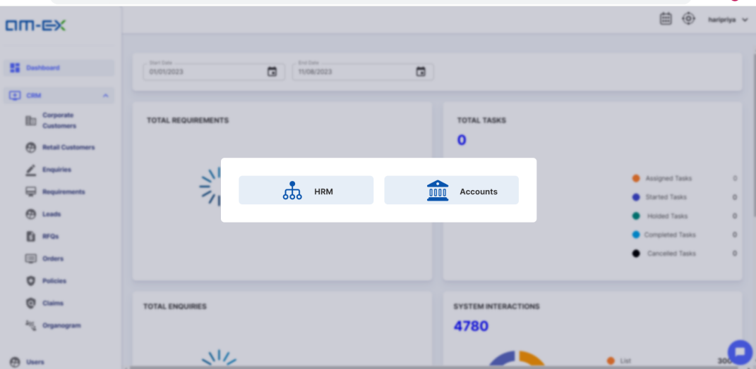

* To see the module divisions, click on “View Menus”. 
* When we select the View Menus option, only 2 modules will be visible at a time & the other module will be the one where the user logged in.
* In the screenshot attached above, one can see HRM & Accounts. In the Insurance Module, the user has logged in.

With respect to the division of modules as mentioned during the meeting, the screens are designed as shown below:

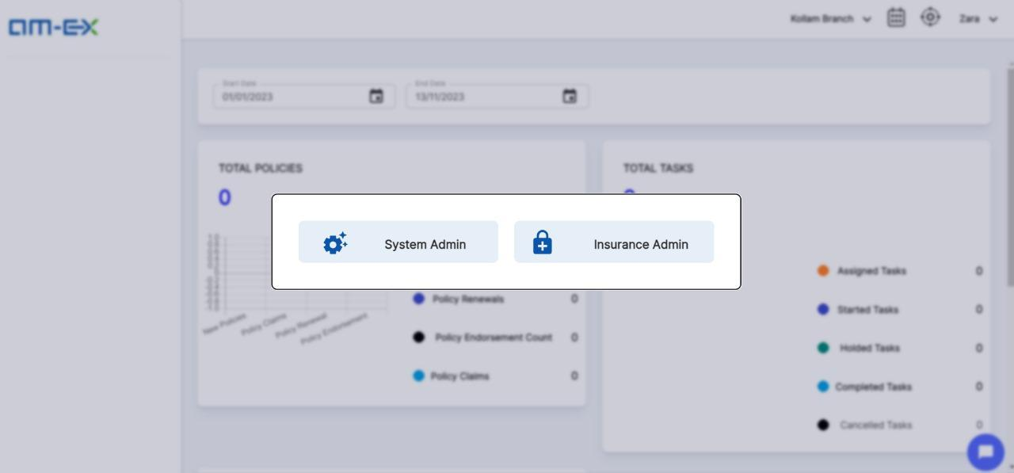

When admin logs in, the above pop up appears. This pop up of switching the System Admin & Insurance Admin only comes if the logged in user is an **Admin**.

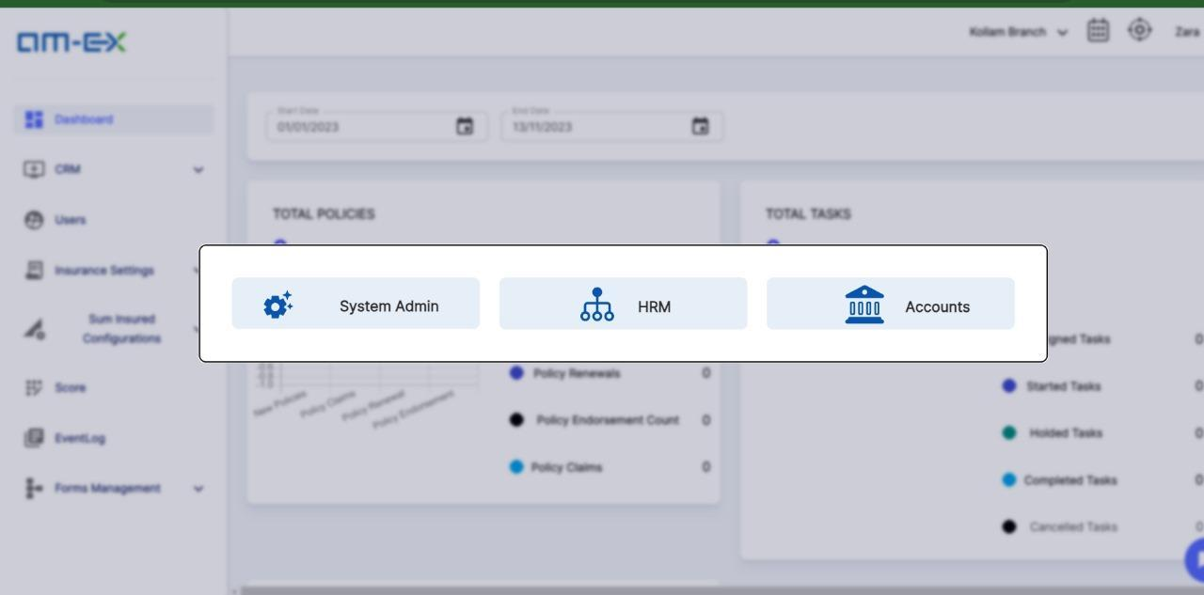

Once switched, we can also change the admin window by switching the above options.

If the logged user is admin, an extra option for switching will appear, which will be the System Admin.

If it is not an admin, then the visible modules are Insurance Admin, HRM & Accounts.

If System Admin is selected, then it appears as shown below:

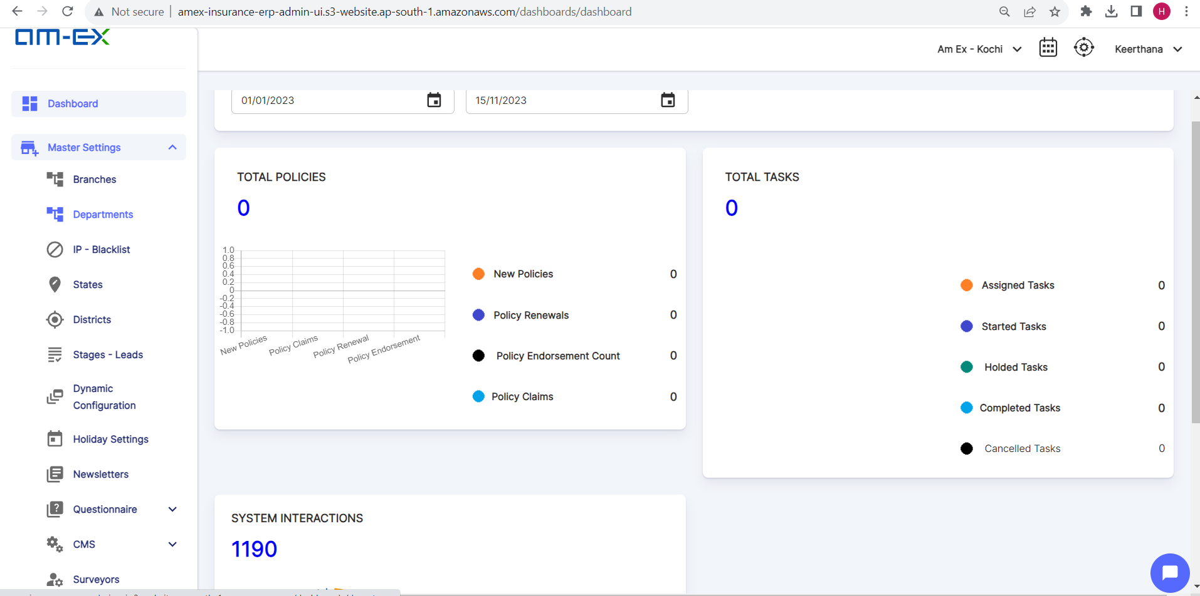

Only the Master data related activities will only be visible under System Admin

* 1. **SYSTEM SET UP**

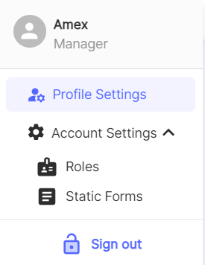

* Profile Settings
* Account Settings
  + Roles
  + Static Forms

**Profile Settings:**

Under Profile Settings, one can handle the User settings like Personal Details & Passwords.

There are two tabs under Profile Settings:

* + - Profile
    - Password

Under Profile>>It helps to manage information related to the user's personal details**.**

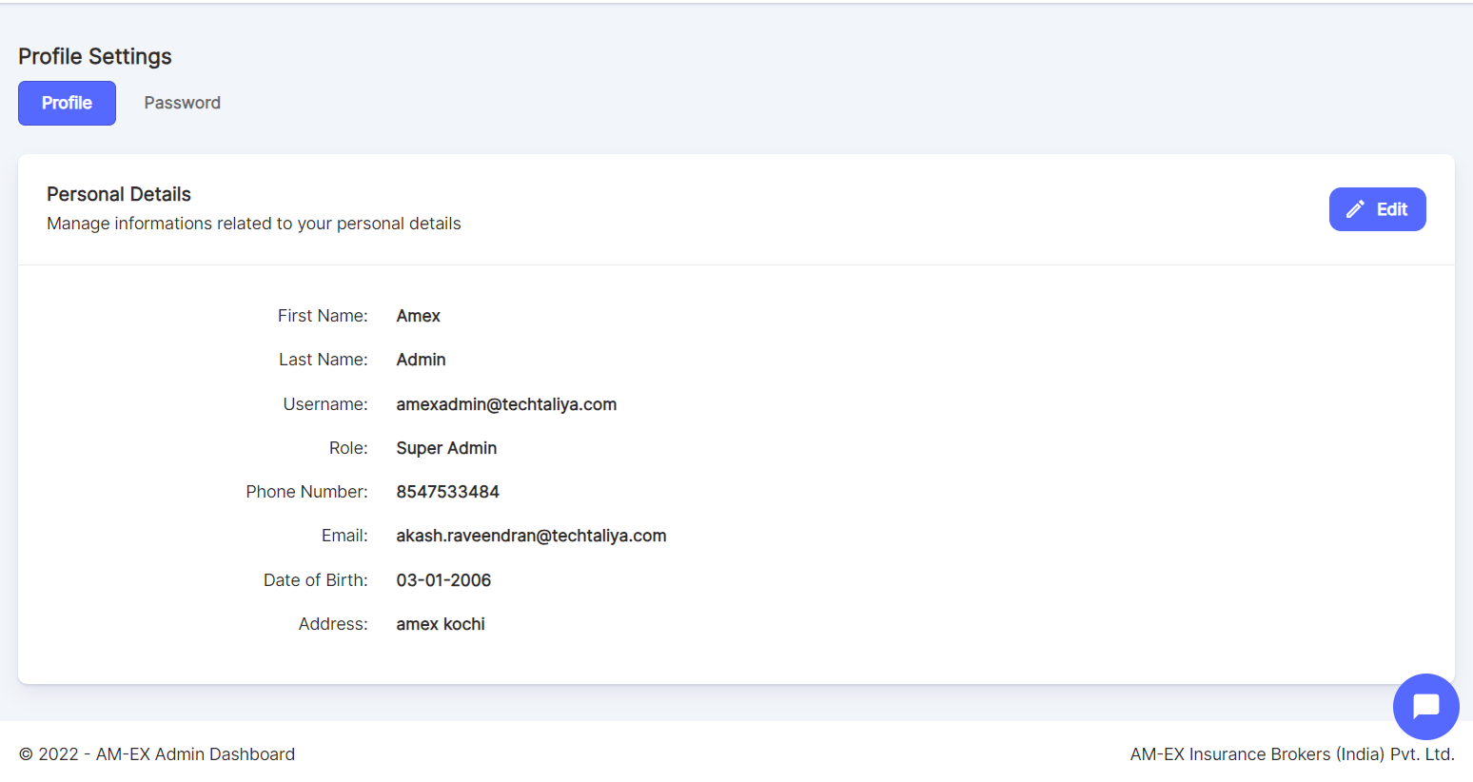

As per the client suggestion, referral link is removed from profile settings.

**Edit Profile**

Once the user clicks on Edit, the profile details can be updated & saved.

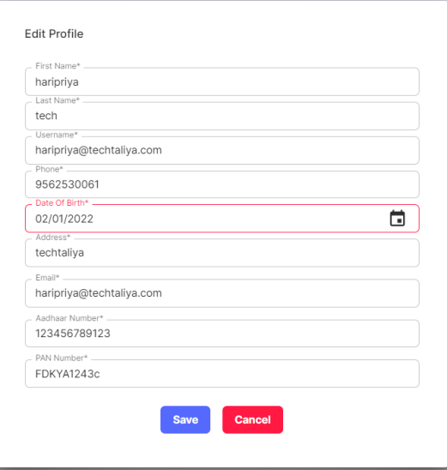

Users can change the password in the Password tab.

* Click on Change Password.
* A Pop-up window will come to enter the Old Password & New Password.

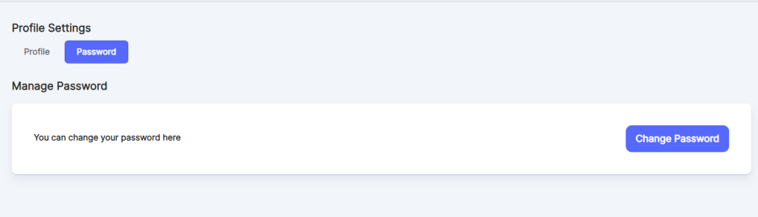

Once Change Password is selected, the below pop-up appears:

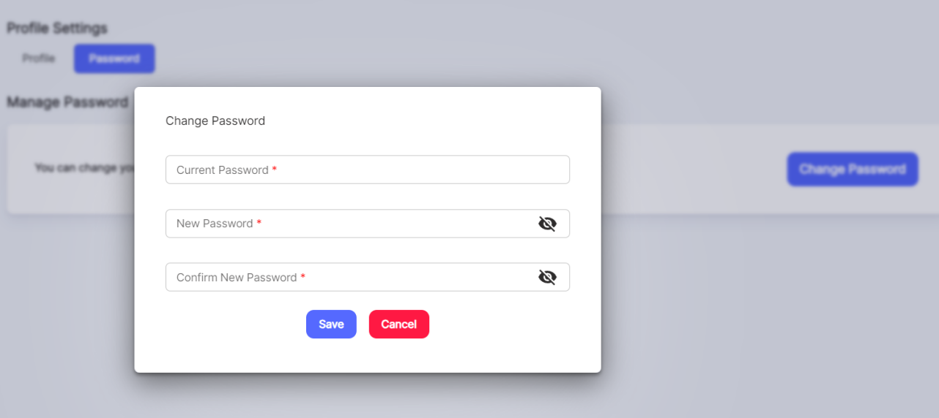

**Account Settings:**

Under Account Settings, there are 2 categories:

* Roles
* Static Forms

Account Settings only will be visible for Admin & Super Admin.

**Roles:**

Under Roles, one can manage the Role Permissions. Against a role, these permissions can be mapped using the Role Permissions.

Client Query: When a user is created - it should be possible to give access to particular screens/reports only and not to an entire module (meaning user should not be able to view other options/menus in the same module other than the ones that are given access

When a user logs in, user should see only the options allowed for that user

Response: This will be handled using Role Privileges

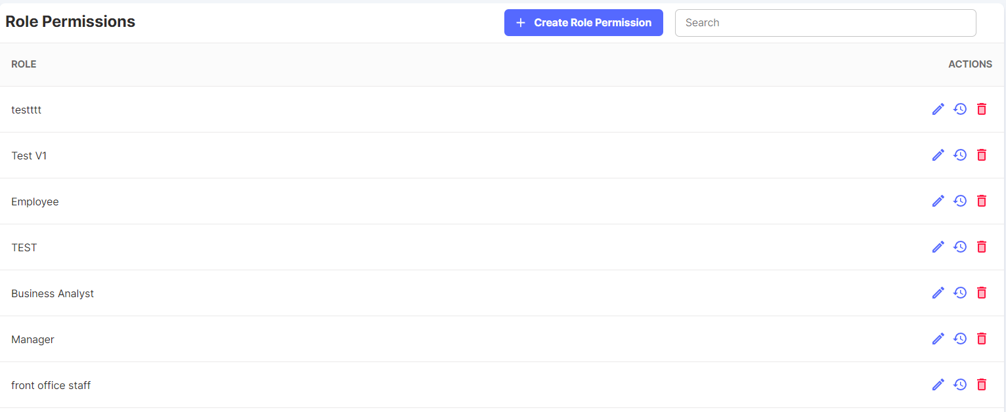

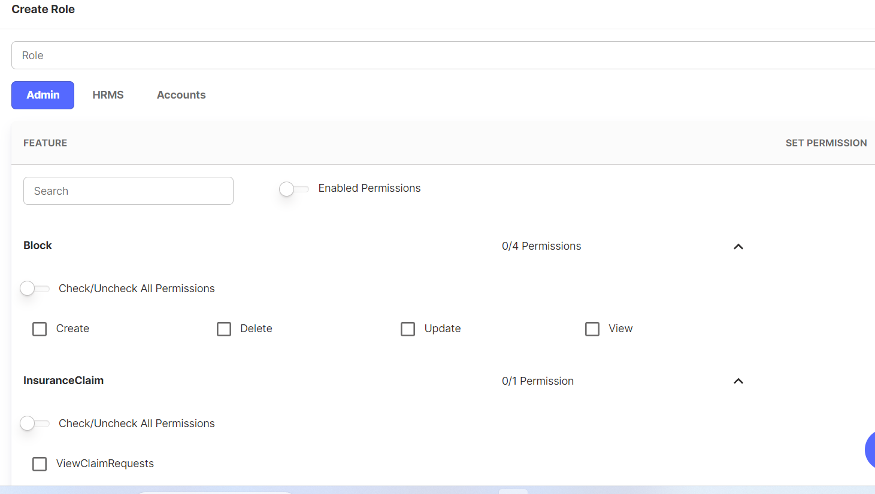

1. Click on Create Role Permission. Then a form appears as shown above to enter the role & to select the Module.
2. Also, the Features & the permissions against each feature are also displayed. By selecting the checkboxes, one can select the permissions needed for each role.
3. After selecting the permissions, click on the Save button in the form.

It also has Edit, View History, Delete and Search Feature as well.

In the case of Deletion, one cannot easily delete if the particular role is active in the application or being used anywhere in the app.

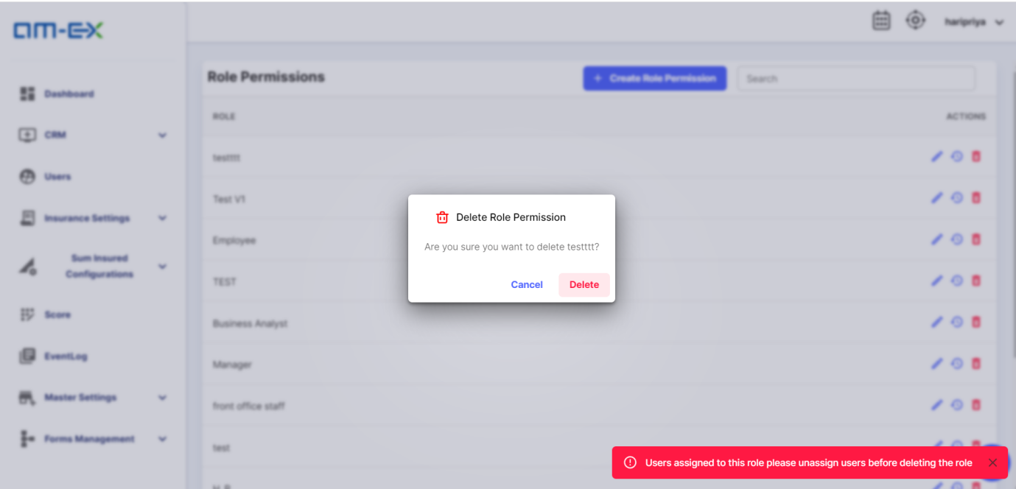

This is how Search Feature works.

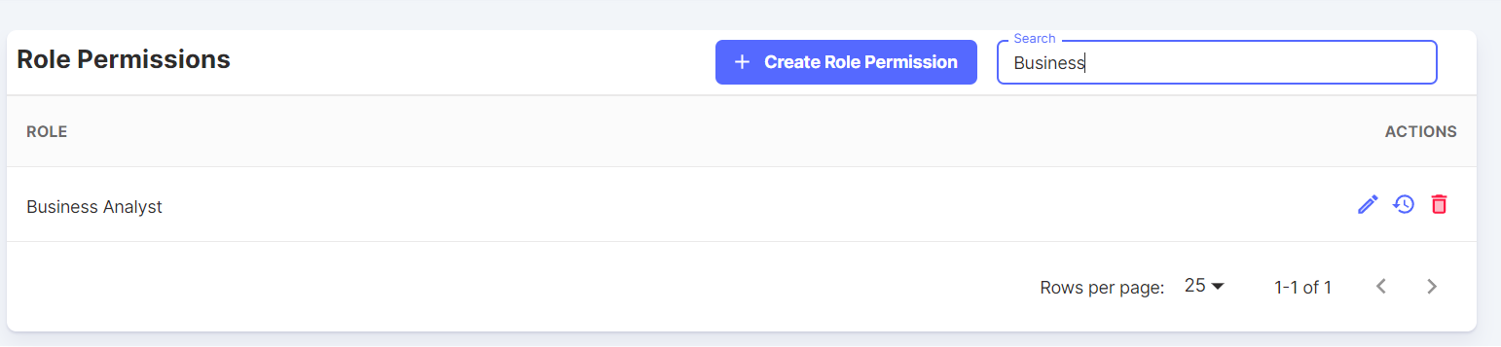

**Static Forms:**

There will be different forms used by the Insurance Companies. Based on the Type of Policy like Health, Vehicle, etc. the forms might also differ!

Once Insurance is created, the forms are called from this module.

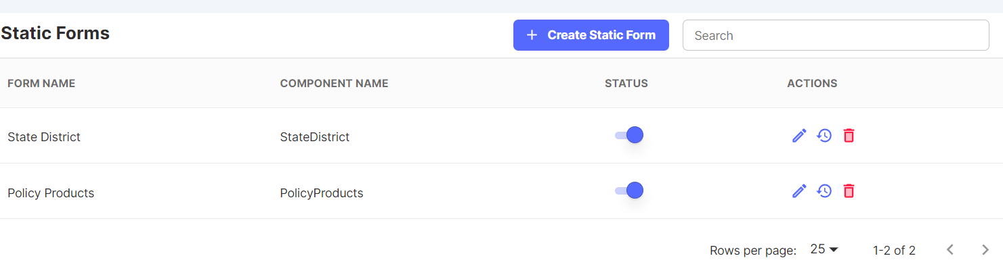

Click on Create Static Form. A form page appears to enter the Form Name & Component Name.

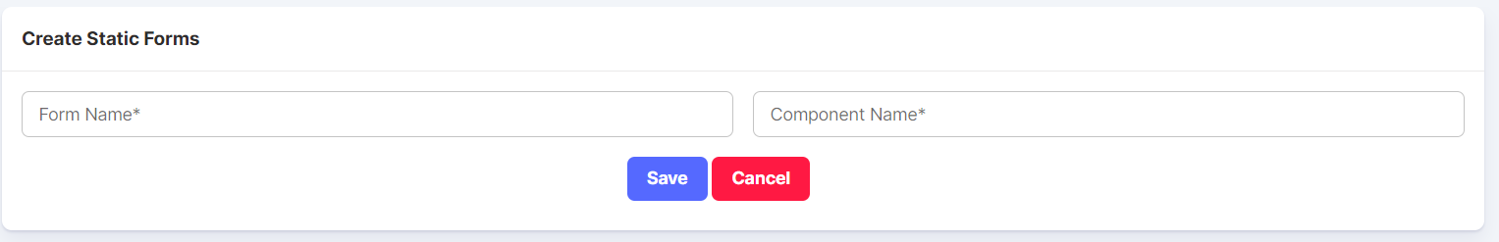

Similar to the Feature & Permission Actions, it also has Edit, View History & Delete Feature as well. There is a Search Feature as well.

Also, we can disable a Static Form if it is not needed for the time being instead of deleting the entire form.

Note: Currently the use of Static Forms is not identified in the application as per the client discussions. This is yet to be discussed. This module will be kept as such for the current release and if needed, changes can be brought only in subsequent phases after understanding the client requirements in detail.

1. **INSURANCE ADMIN**

**Login Screen**

This will be the login image of the application. Users with registered credentials can log in to the platform.

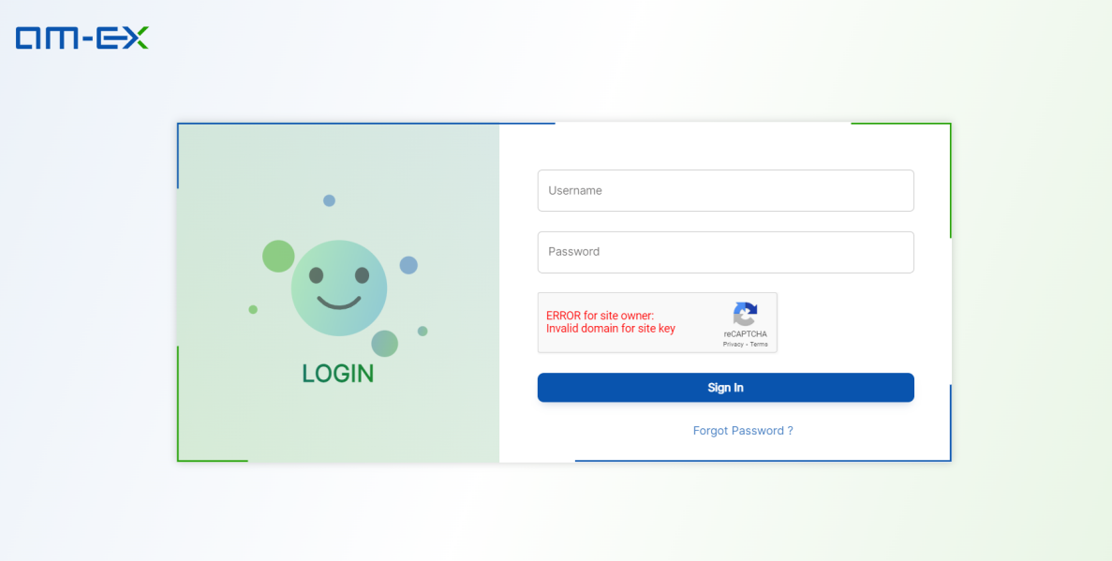

Once the user logs in, they will be able to see the Dashboard as the default landing page of the platform. 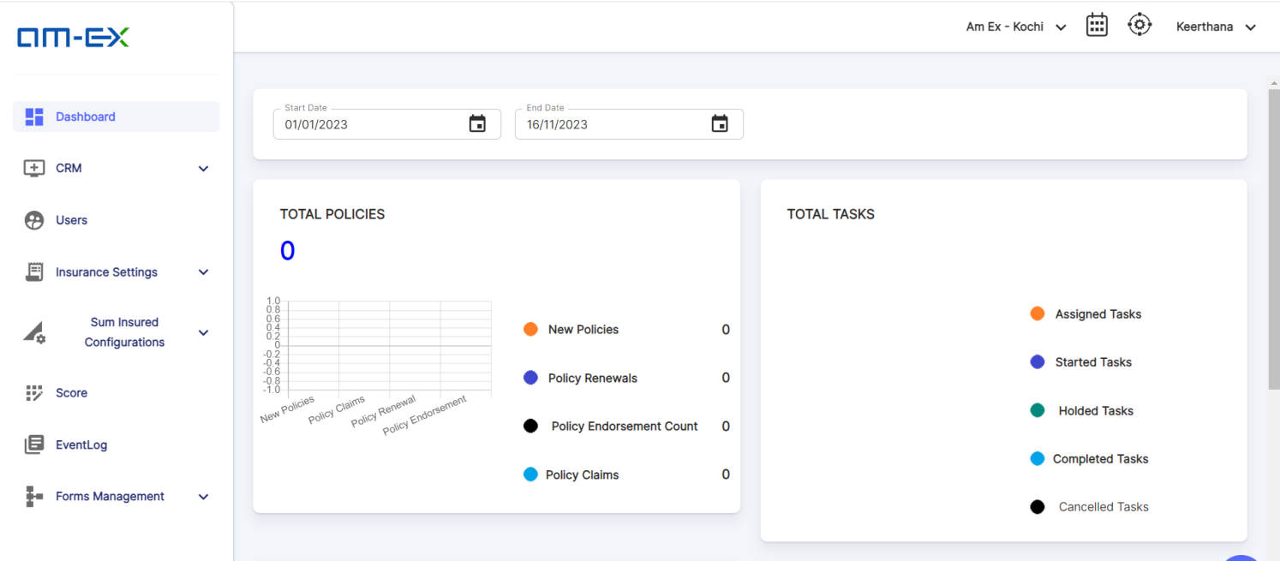

If it is an Admin login, then the below pop up appears:

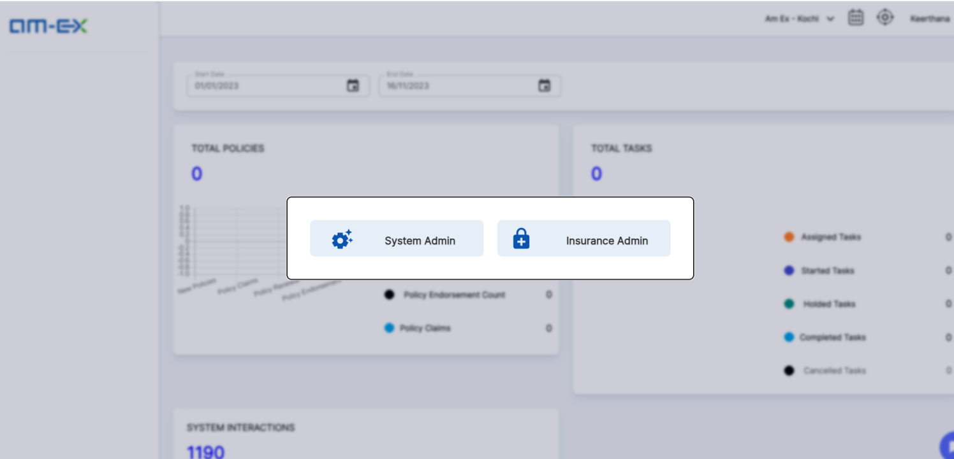

In the Insurance Admin Module, it captures the following modules:

* Dashboard (Requirements yet to be shared by client)
* CRM
  + Corporate Customers
  + Retail Customers
  + Enquiries
  + Customer Leads
  + RFQs
  + QC Approval
  + Placements
  + Offers
  + Placement Slip
  + Policies (We only received the requirements till Policy. Rest of the Modules like Claims, Endorsement & Renewal will be incorporated only after client discussions. In the current SRS, for Insurance Module, the screens are designed only upto Policy Creation. From Policy QC Approvals, it will be captured after client confirmation)
  + Policy - QC Approvals
  + Claims
  + Endorsement
  + Renewal
  + Organogram
* Users
* Insurance Settings
* Master Categories
* Categories (As per client suggestion, Categories is Risk Name)
* Products (As per client suggestion, Policy Type is Product)
* Insurance Companies
* TPA
* Coverages & Clauses
* Industries
* Insurance Zone Categories
* Insurance Zones
* Sum Insured Configurations (just created as a sample reference for Premium Calculations based on the master data sheet shared by client)

(Premium Calculations is now considered in Offer Screens.)

* Occupancies
* Machine Types
* Voyages
* Vehicle Types
* Product Rates
* Occupations
* Event Log
* Forms Management
* Master Input Fields

If System Admin is selected then the following modules appears:

* Dashboard (Requirements yet to be shared by client)
* Master Settings
* Branches
* Departments
* IP-Blacklists
* States
* Districts
* Stages-Leads
* Dynamic Configurations
* Holiday Settings
* Newsletters
* Questionnaire
  + Questions
  + Questionnaire
  + Assessments
  + Assessments Summary
* CMS
  + Category
  + Sub Category
  + Article
* Surveyors

**2.1.0 Dashboard** (Requirements yet to be shared by client)

* A dashboard is a visual representation of data and information that is designed to provide a concise and easily understandable overview of key performance indicators (KPIs), metrics, trends, and other relevant information.
* The purpose of a dashboard is to help users quickly and effectively monitor, analyze, and make informed decisions based on the data presented.
* Here, there are 2 dashboards:
  1. Total Requirements: It gives a pictorial representation of how many New Policies, Policy Endorsements, Policy Renewals & Claims are there

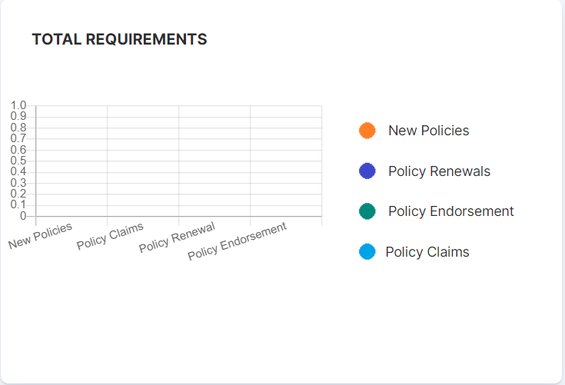

* 1. Total Enquiries: It is a pie-chart representation of the Total Enquiries count along with the individual counts of the Completed, Pending & Cancelled Enquiries

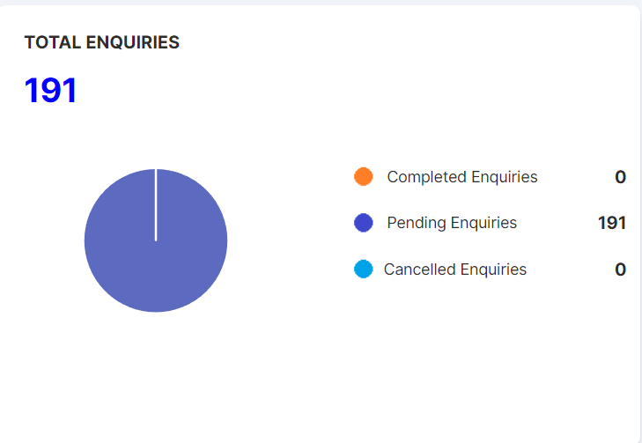

**2.2.0 CRM**

* CRM stands for "Customer Relationship Management."
* It refers to a set of strategies, processes, and technologies that companies use to manage their interactions and relationships with existing and potential customers.
* The primary goal of CRM is to improve customer satisfaction, enhance customer loyalty, and ultimately drive business growth.
* In this application, there are several categories handled by CRM which will be explained in the below modules.
  + 1. **Corporate Customers**
* There are two types of Customers. They are Corporate Customers & Retail Customers.
* This refers to a business entity that is a customer of a particular organization, such as a bank, supplier, or service provider.
* Corporate customers are typically larger entities, like companies or organizations, as opposed to individual retail customers.

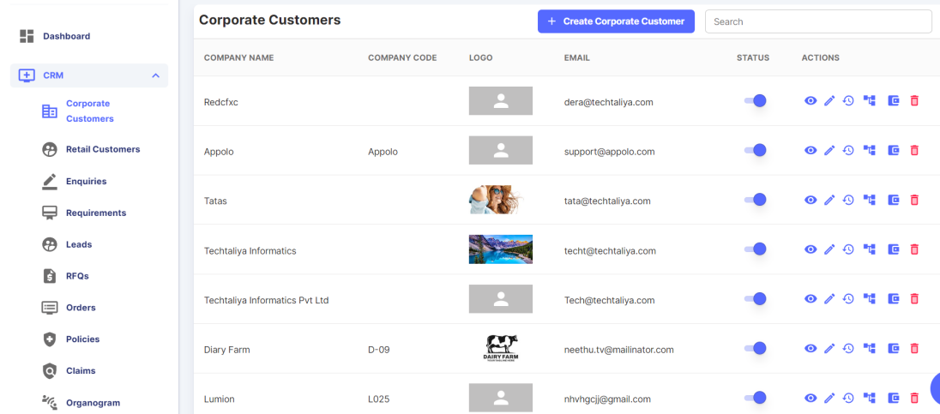

Click on Create Corporate Customer. Then a form appears to enter the details.

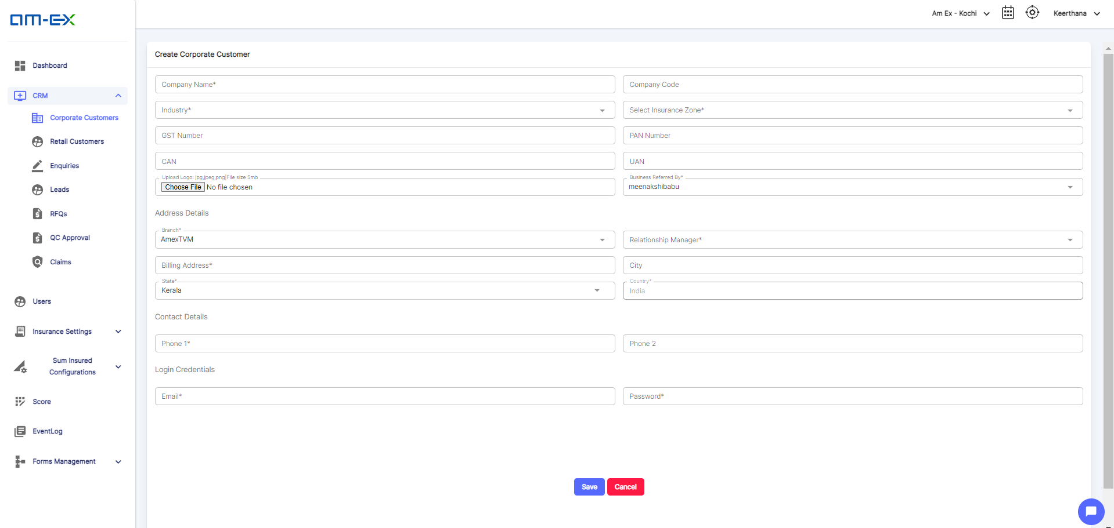

The field Business Referred By is added as per the suggestion. It is a drop-down field and will show the list of all users irrespective of Branch

Relationship Manager field is visible only at the time of Branch Selection.

The Actions that can be performed are:

* + Edit Corporate Customer
  + View More
  + View History
  + Follow Up
  + Corporate Customer Branches
  + Wallet (Will be considered in next release as full requirements are not shared. - an option for Wallet to be added in Placement Slip under Payment Type)
  + Delete

**Edit Corporate Customer:**

Click on the Edit Button. The form will open up to Update the customer details.

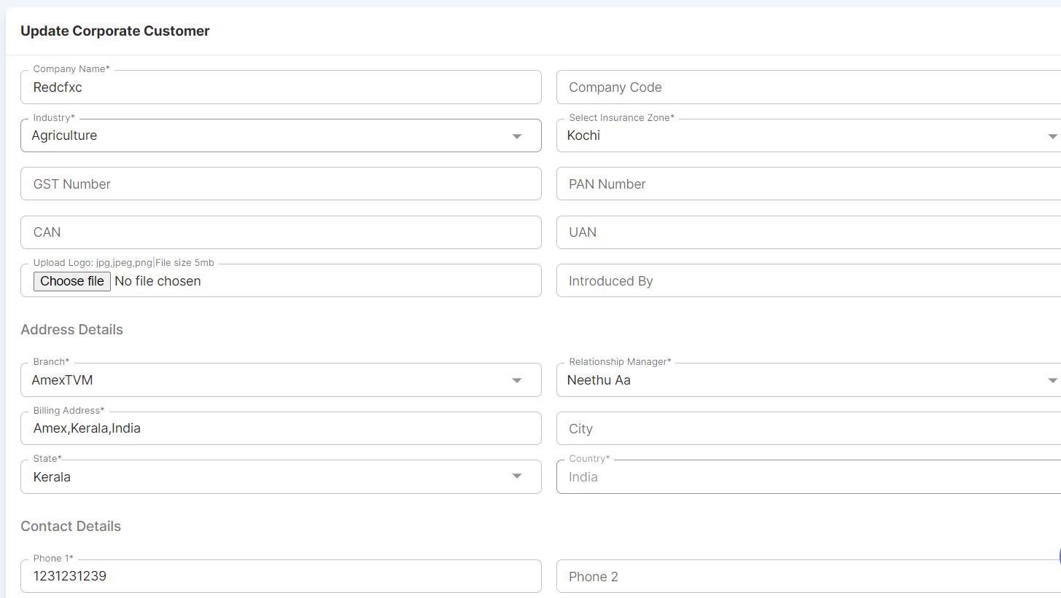

**View More:**

It is similar to a Preview feature.

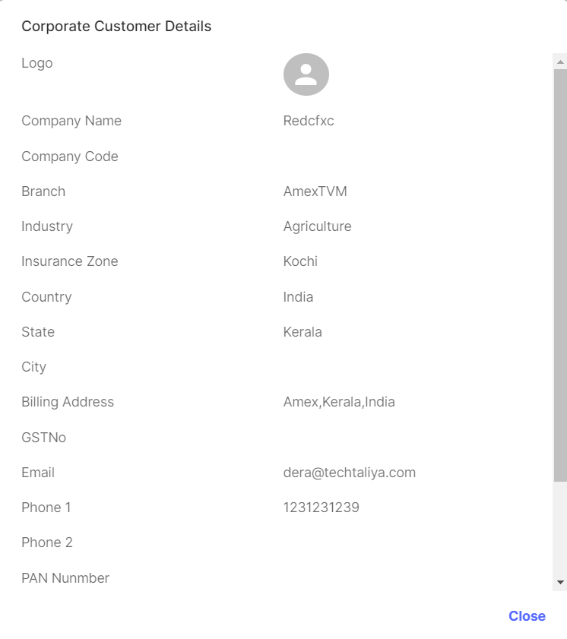

**Event Log:**

* It gives a history of all the actions happened within the Corporate Customer Module against a record.

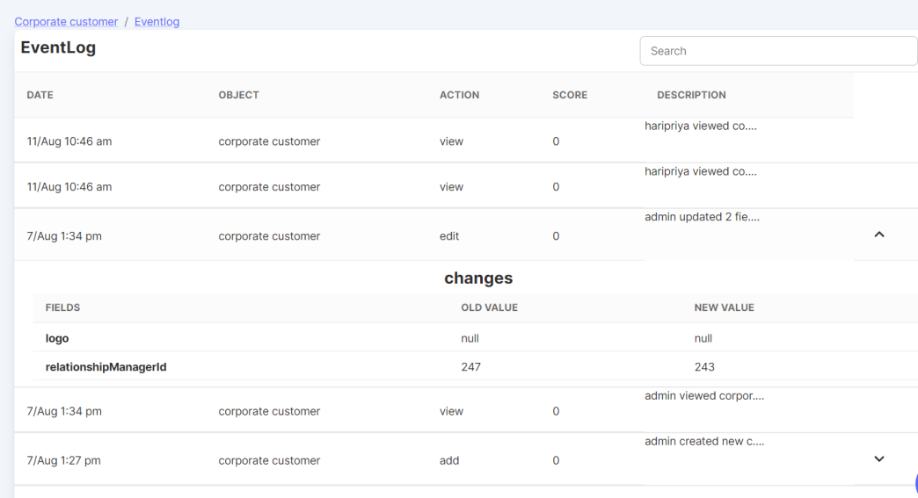

**Follow Up:**

* There is a follow-up module for Corporate Customers. The mode of follow up can be like Phone Call, Email etc.
* It shows if any follow ups are already assigned with a provision to Upload Attachments & if any notes as well.

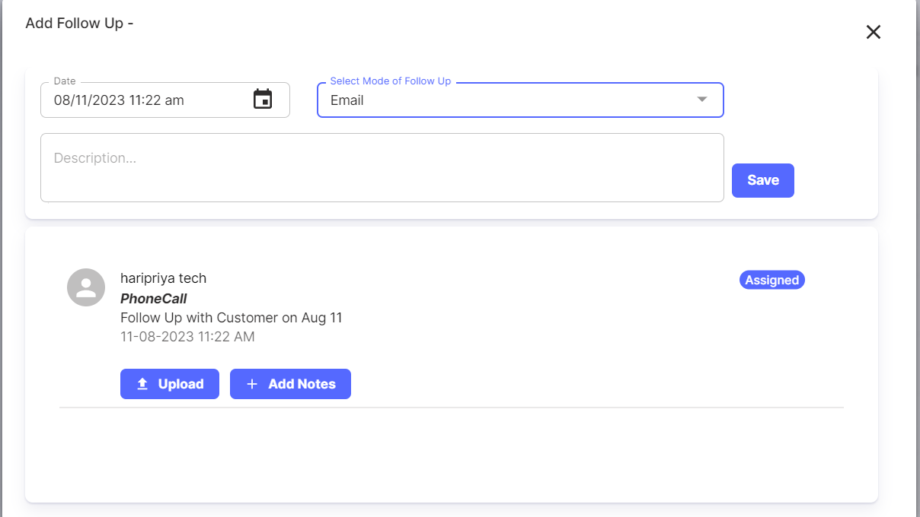

**Corporate Customer Branches:**

* Corporate customer branch will be automatically created against a corporate customer.
* If needed, one can create multiple branches using this feature**.**

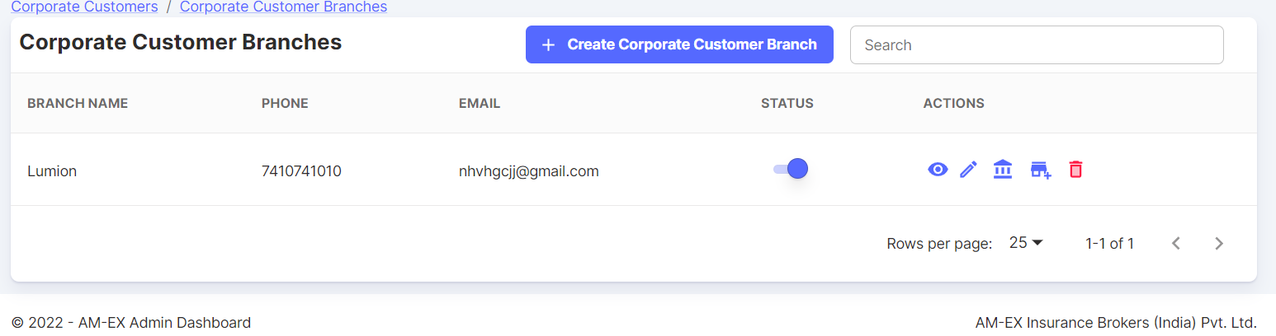

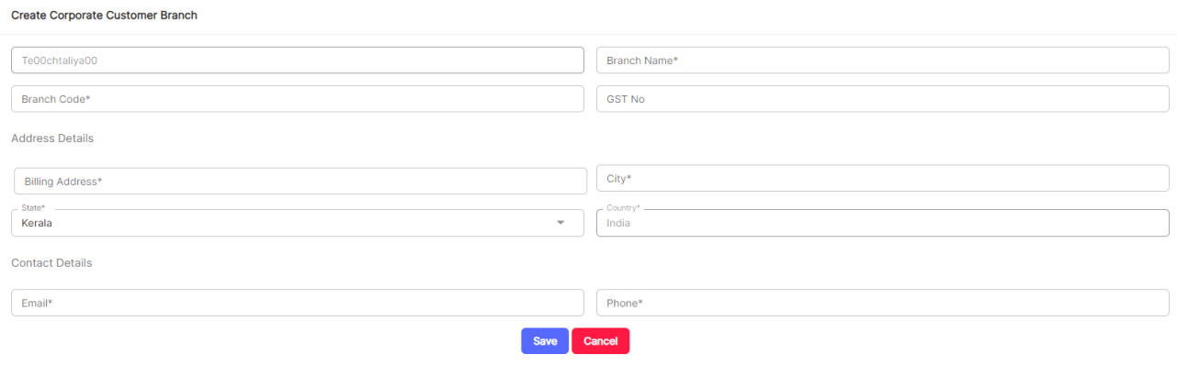

The possible Actions in Corporate Customer Branches are:

* View More
* Edit Branch
* Add Premises
* Delete

**Add Premises:**

* Premises refer to the building or land occupied or owned by an insured to know whether
* it's rented or leased.
* The "premise" is the physical space or building where the branch operates.
* It includes the facilities, infrastructure, and resources necessary to serve customers, conduct business operations, and offer services/products.

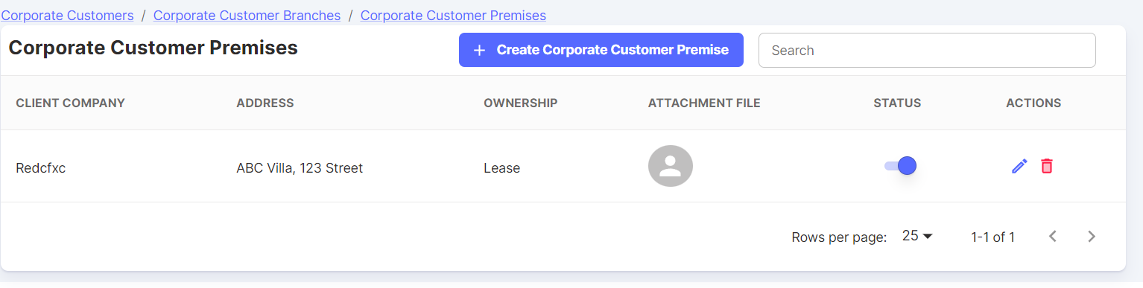

Click on Create Corporate Customer Premise. Then, a form appears against the respective corporate customer branch & need to select the ownership (like Own, Lease, Rent) and other details associated with it.

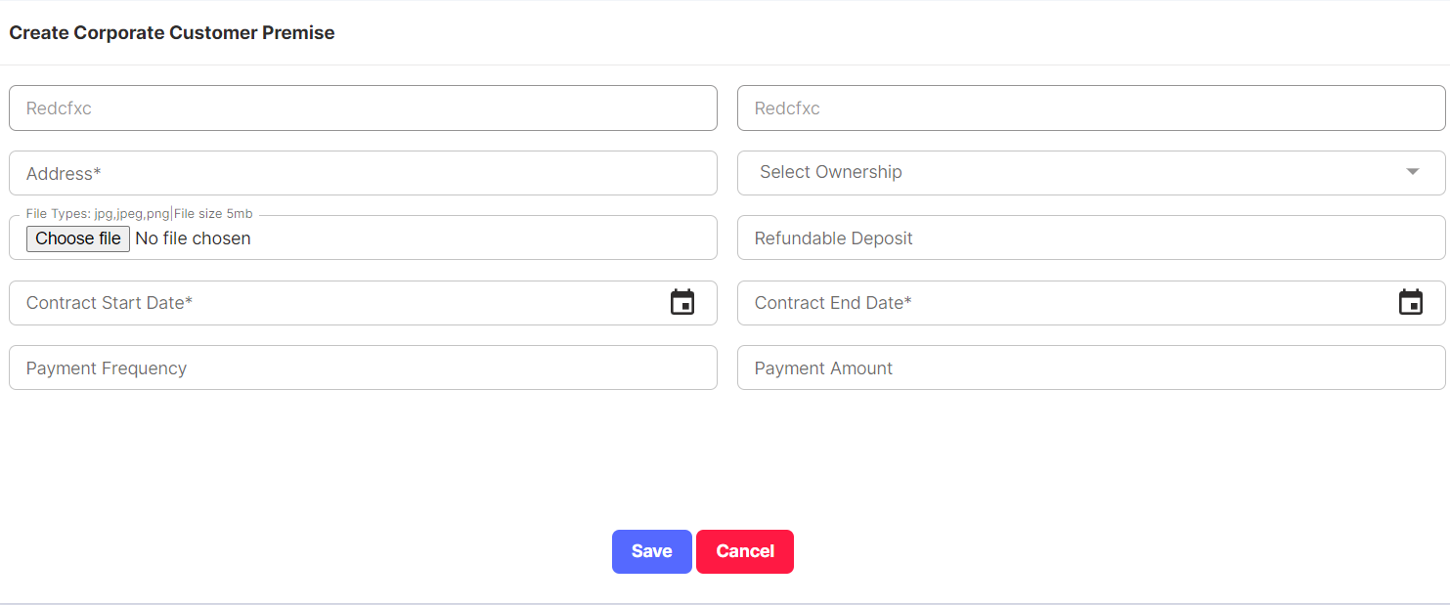

**Wallet:**

* A "wallet" typically refers to a digital or physical tool that enables a business or corporate entity to manage its finances, transactions, and financial instruments conveniently.
* A Wallet is for parking funds received as lumpsum payment towards many policies and will be utilised as and when required
* The term "wallet" in this context is often used interchangeably with "corporate account" or "business account."
* Wallet has Edit & Delete Actions. There is a Search feature as well.

Click on Create Wallet.

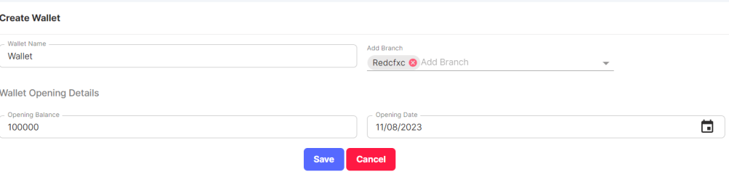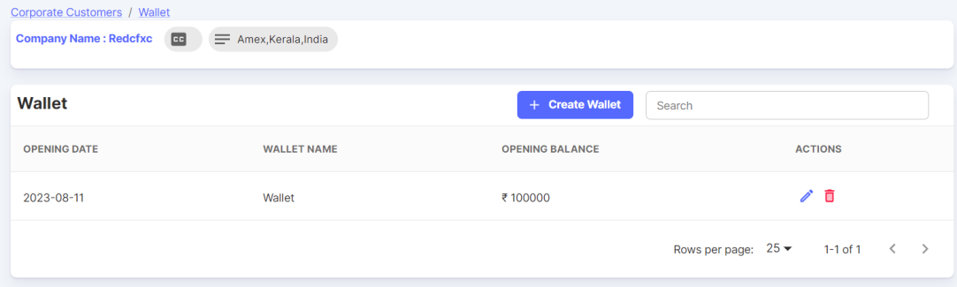

* In the recent discussion, client suggested that wallet to be considered as a Payment Type in the Placement Slip screen.
* In the Create Wallet Screen, instead of Branch, add Insurance Company selection. (These changes will be brought in next phase release only as these are new changes suggested.)
  + 1. **Retail Customers**
* A retail customer, often referred to as an individual customer or consumer, is a person seeking insurance coverage for personal needs, such as health, auto, home, life, or travel insurance.
* Retail customers typically purchase insurance to protect themselves, their families, and their personal property.
* The insurance products for retail customers are usually more standardized and straightforward compared to the customized policies designed for corporate customers

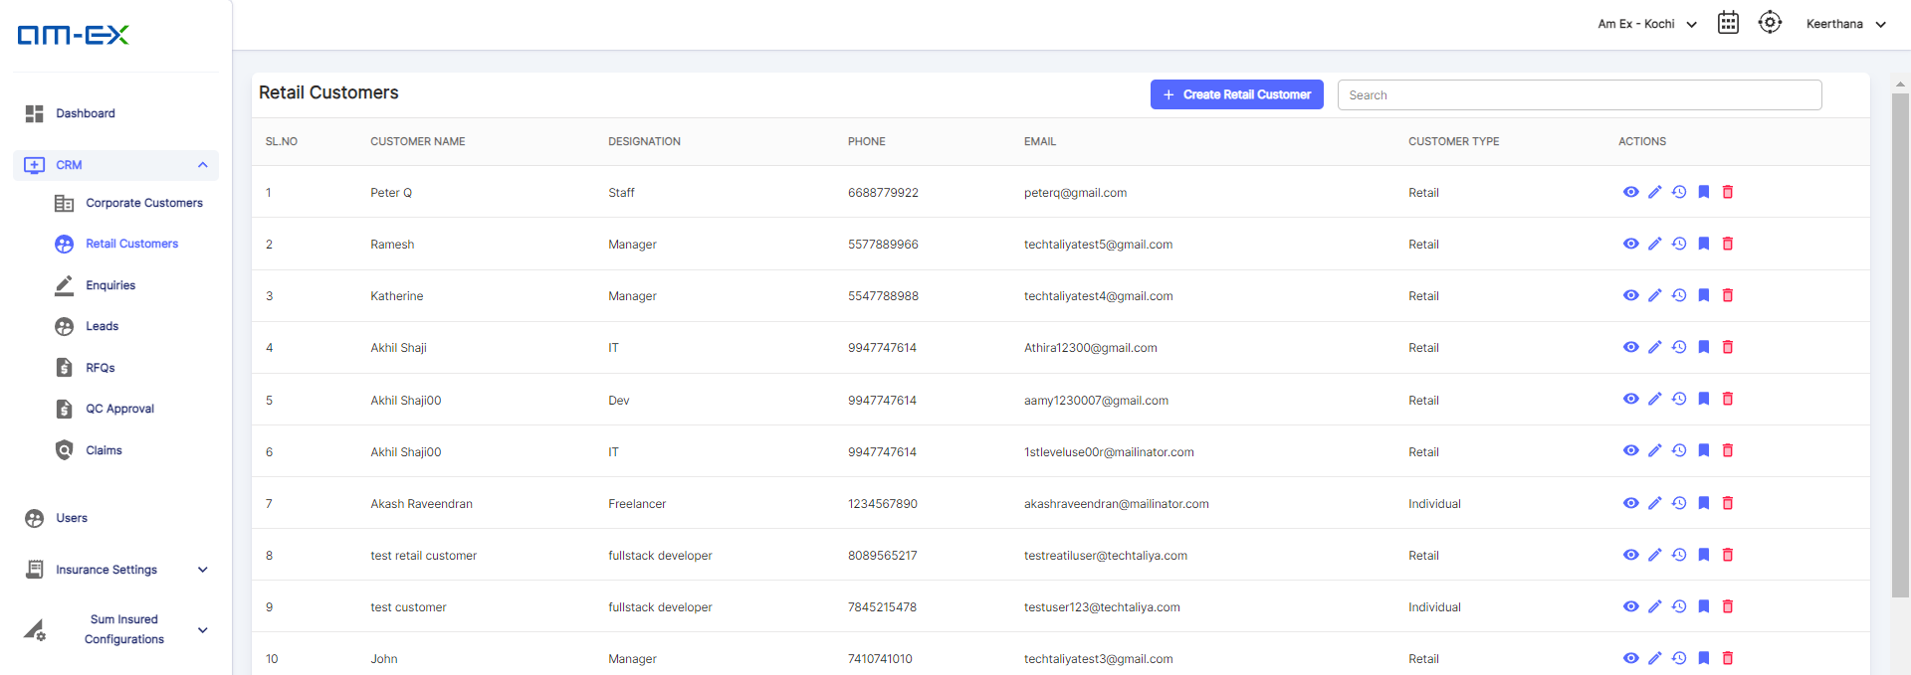

Click on Create Retail Customer. A page appears to enter the customer details & save it. Here also, similar like Corporate customer, Business Referred by is added.

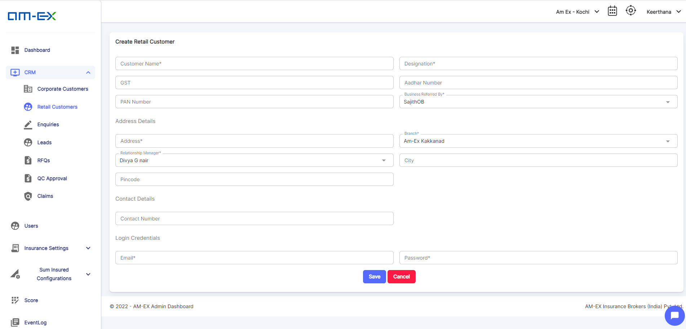

The possible Actions in Retail Customer are:

More Info

Edit Retail Customer

View History

Follow Up

Delete

**More Info (Preview)**

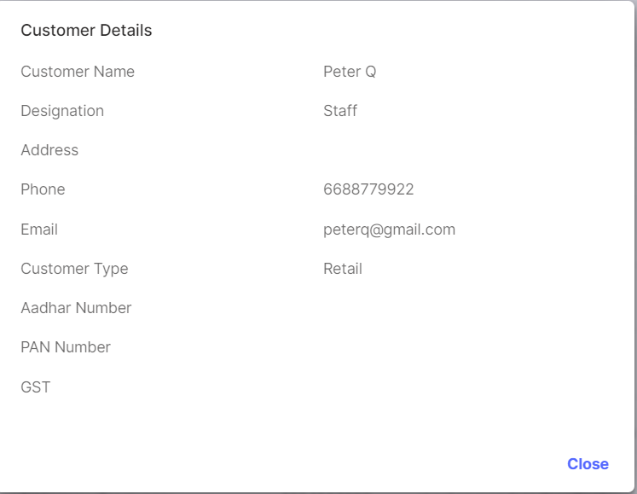

**Edit Retail Customer**

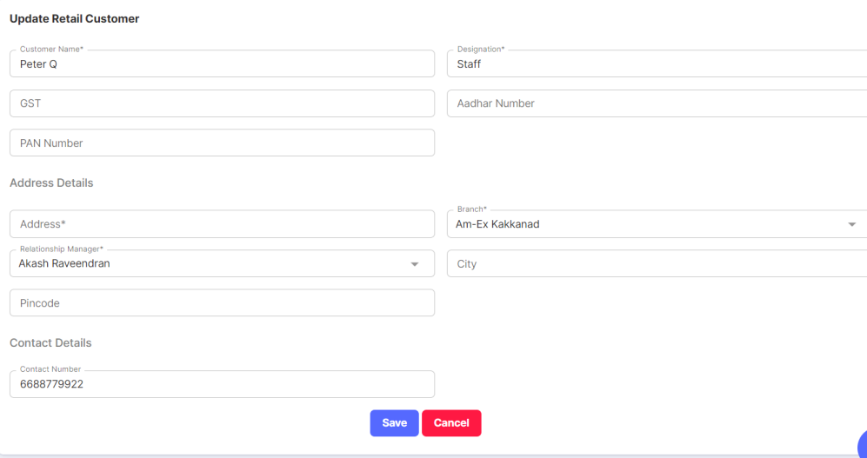

**View History:**

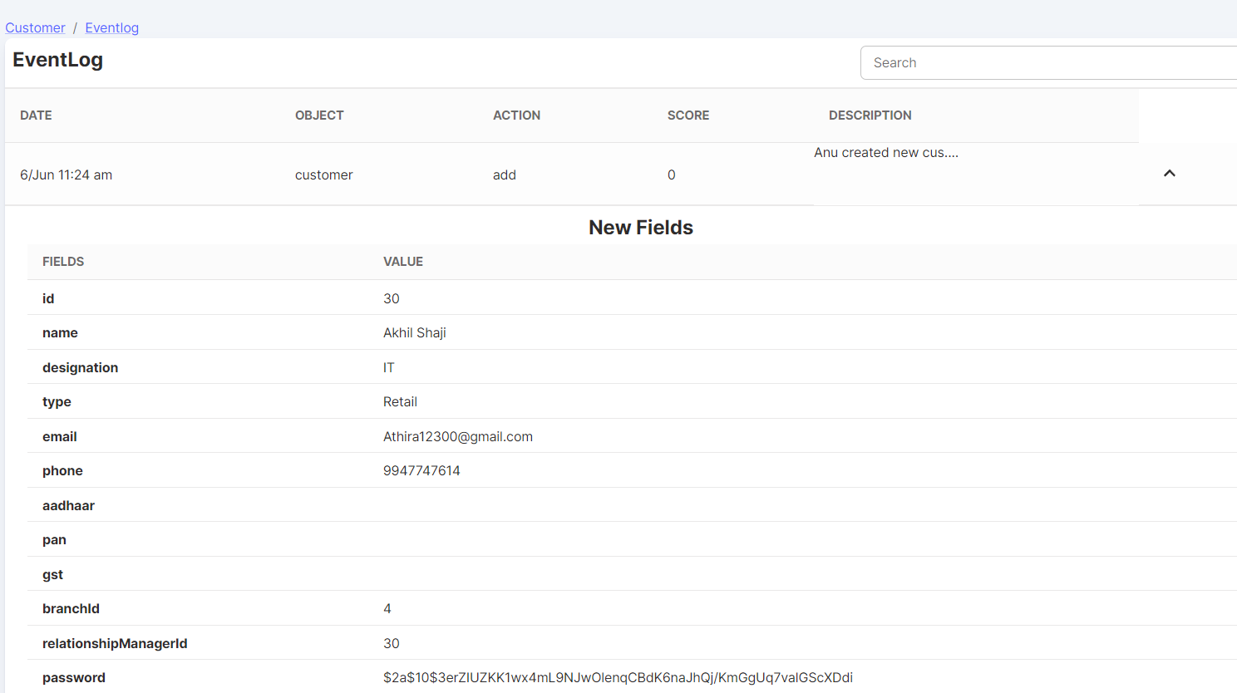

**Follow Up:**

In the follow-up module, Mode of Follow Up can be like Phone Call, Customer Visit, Email etc.

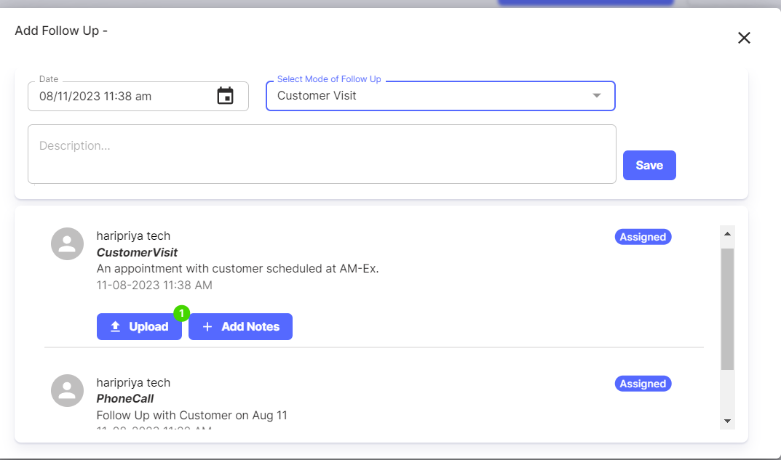

In the screenshot, against upload a number indicates that an attachment is there for that follow up.

* + 1. **Enquiries**

Enquiries can be created against a customer – be it a Corporate or Retail Customer.

Also, it gives track of the source of Enquiry & the customer type as well along with the respective details.

The purpose of an enquiry module in insurance is to manage enquiries from various stakeholders, streamline communication, enhance customer service, and improve overall operational efficiency within the insurance company.

RFQ can be created against an Enquiry also.

Against each enquiry, there is an option to create RFQ, Add Notes, and View History.

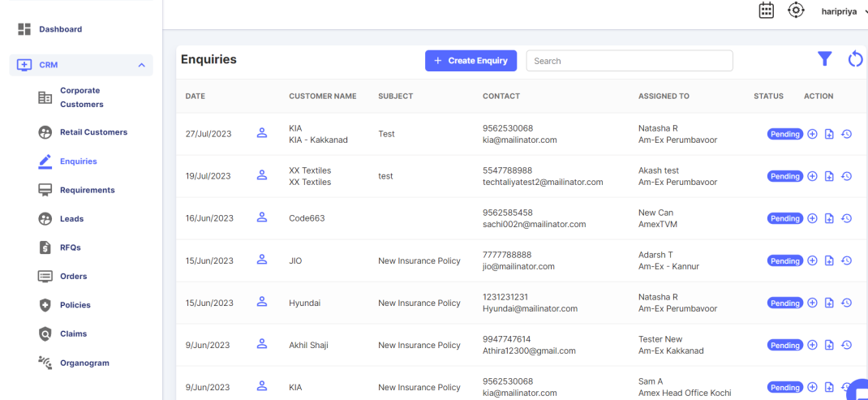

Click on Create Enquiry. Then a form appears to enter the Enquiry Details.

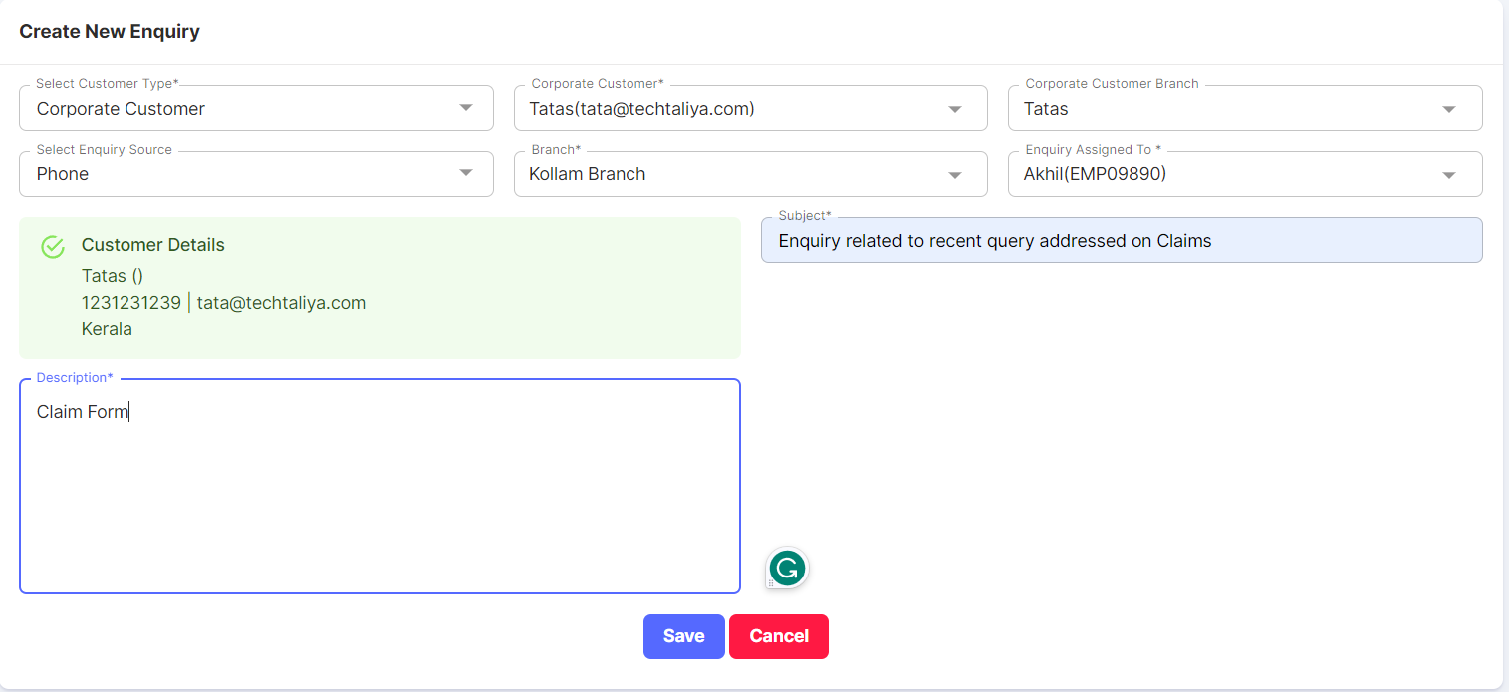

**Create RFQ:**

* RFQ can be created directly from the RFQ screen or by using enquiries also.
* Against enquiry, there is an Action to Create RFQ.
* Click on Create RFQ.
* Then, a pop-up appears as shown below.
* RFQ will be created by the Relationship Manager or anyone from the Operations Team.

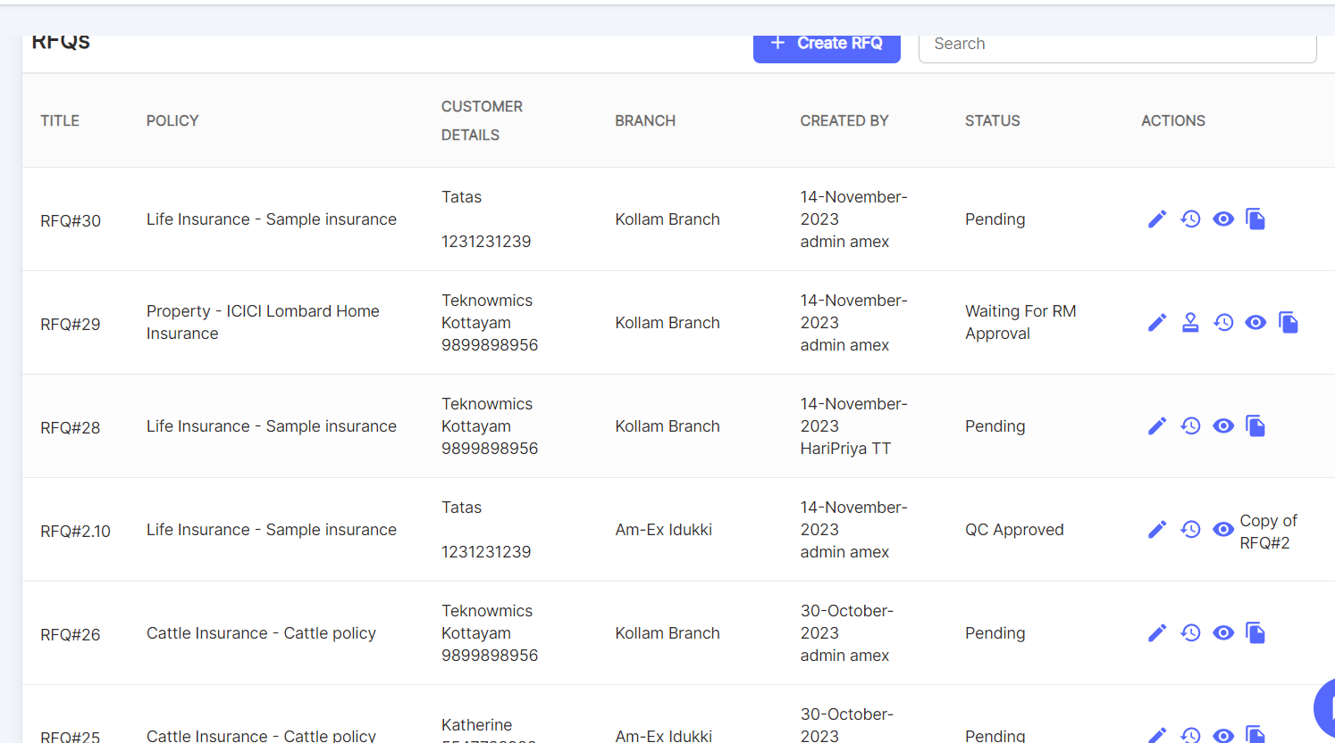

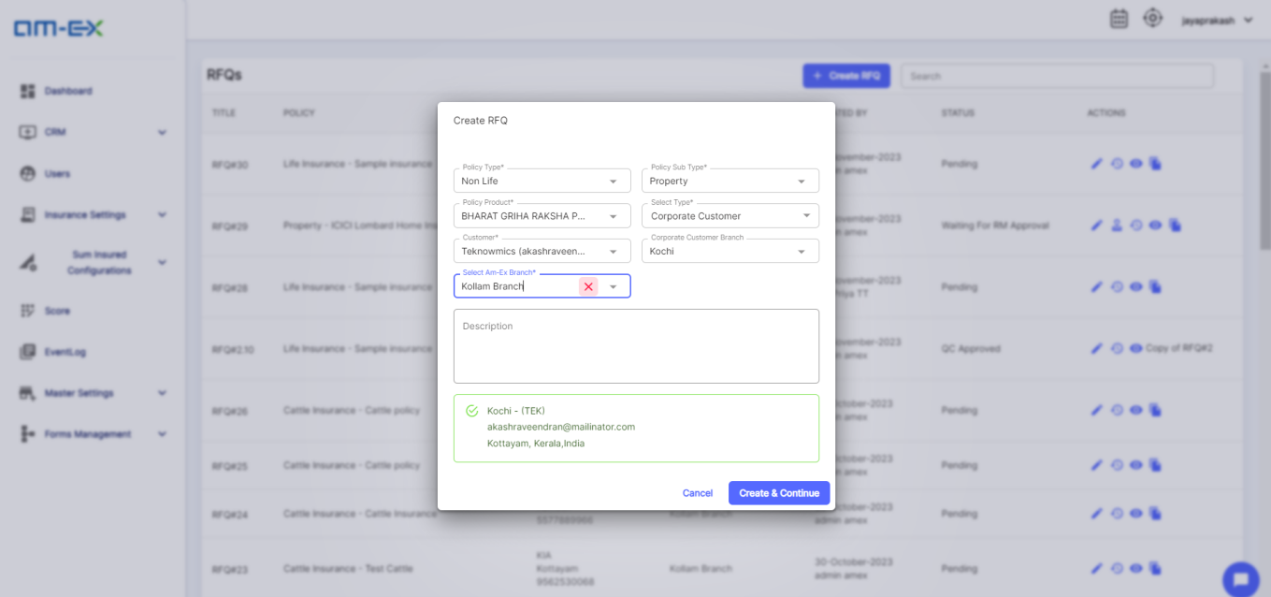

Once, create & continue is selected, it will direct to the RFQ Page. if RFQ is created via Enquiry then the Enquiry ID will also be added in the RFQ.

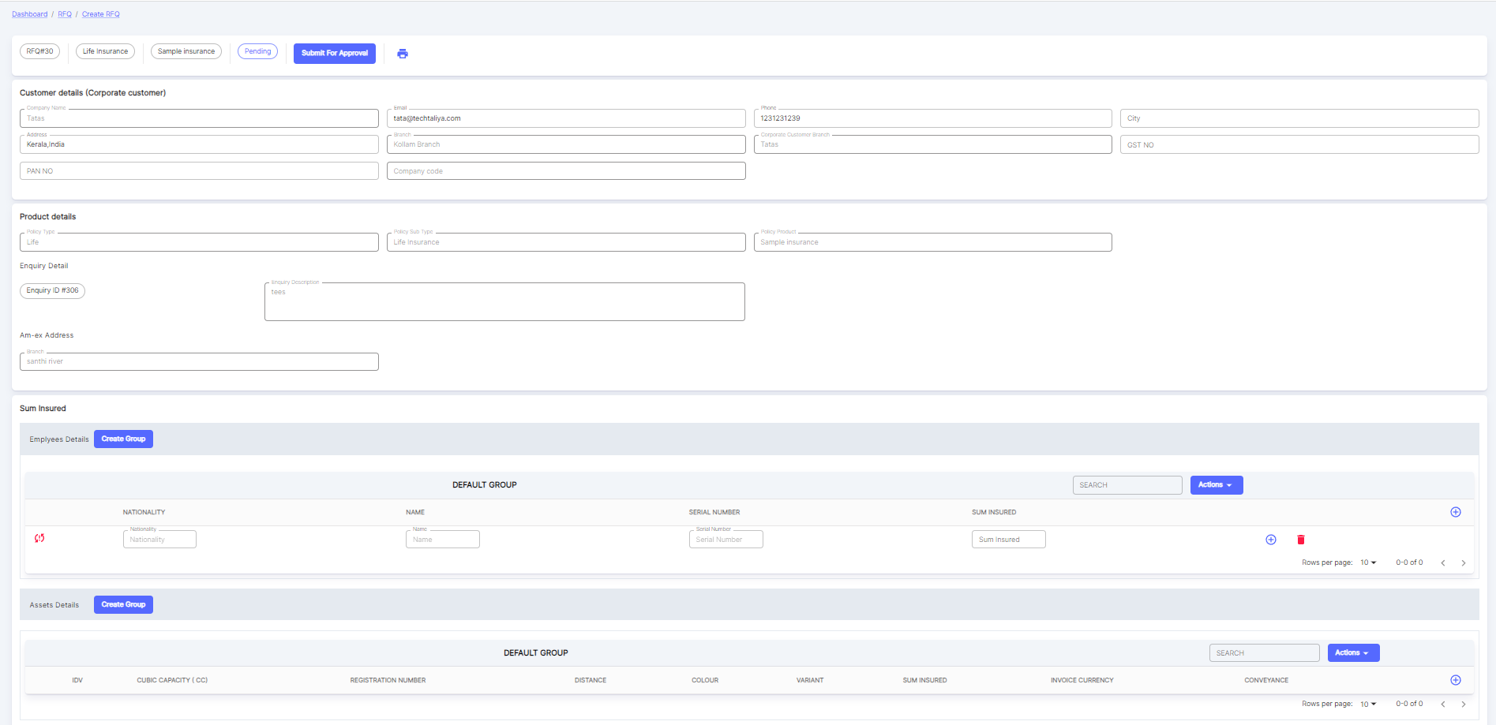

**Add Notes:**

Notes regarding the inquiry can be captured, and there is also an upload option available in case there are any attachments.

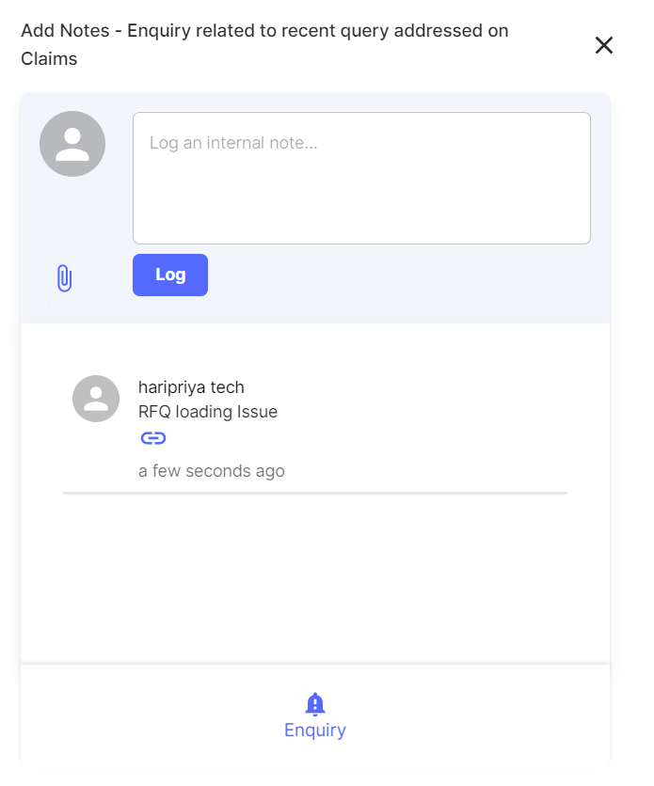

**Event Log:**

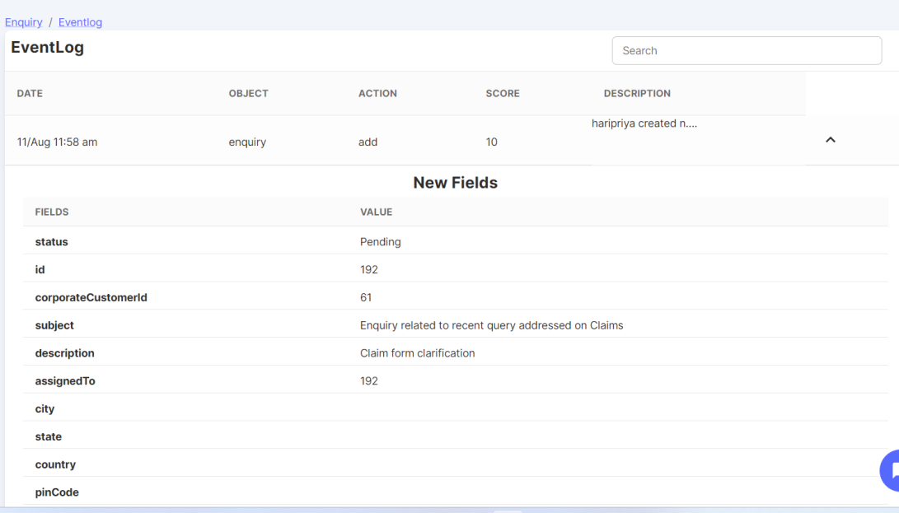

There is a Filter option in common for the Enquiry Module. Click on the Filter Icon. Then below pop-up appears:

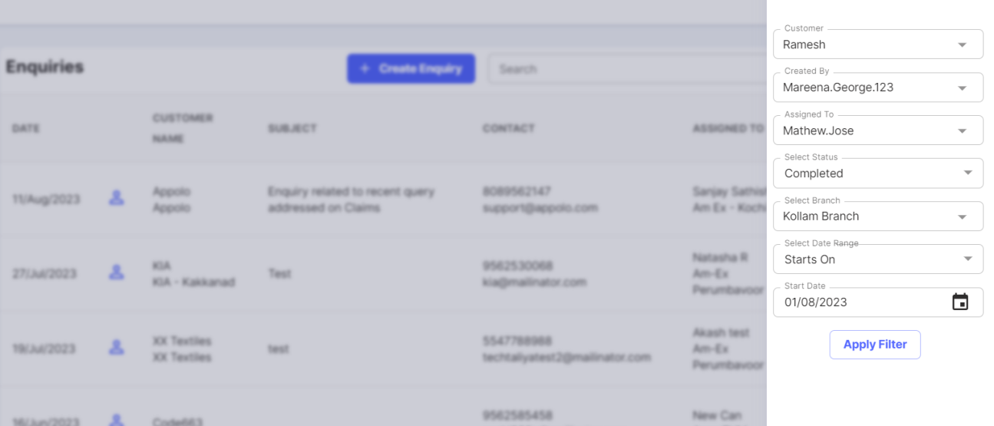

* + 1. **Leads**

(To be discussed in detail pertaining to the query mentioned in the clarification sheet -

When data is uploaded from 3rd party, how are we going to store, what format to be used for storing? We need to know the fields. For Phase-1 will proceed with the current Leads module built in the ERP system as per the client discussion.

If any changes are needed in future, client to give the requirements in a document with clearly defined inputs.)

* A "lead" refers to a potential customer or prospect who has expressed interest in purchasing insurance products or services.
* Leads play a crucial role in the insurance business as they are the starting point for generating new business and expanding the customer base.
* Click on Create Customer Lead.

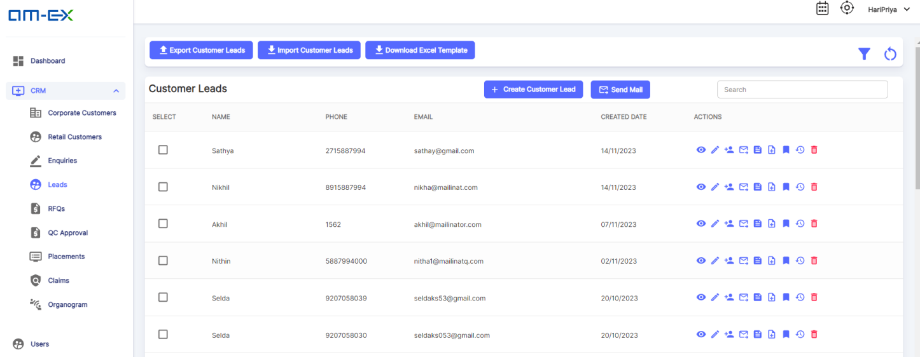

Then a page appears similar like this to create customer lead details against a branch.

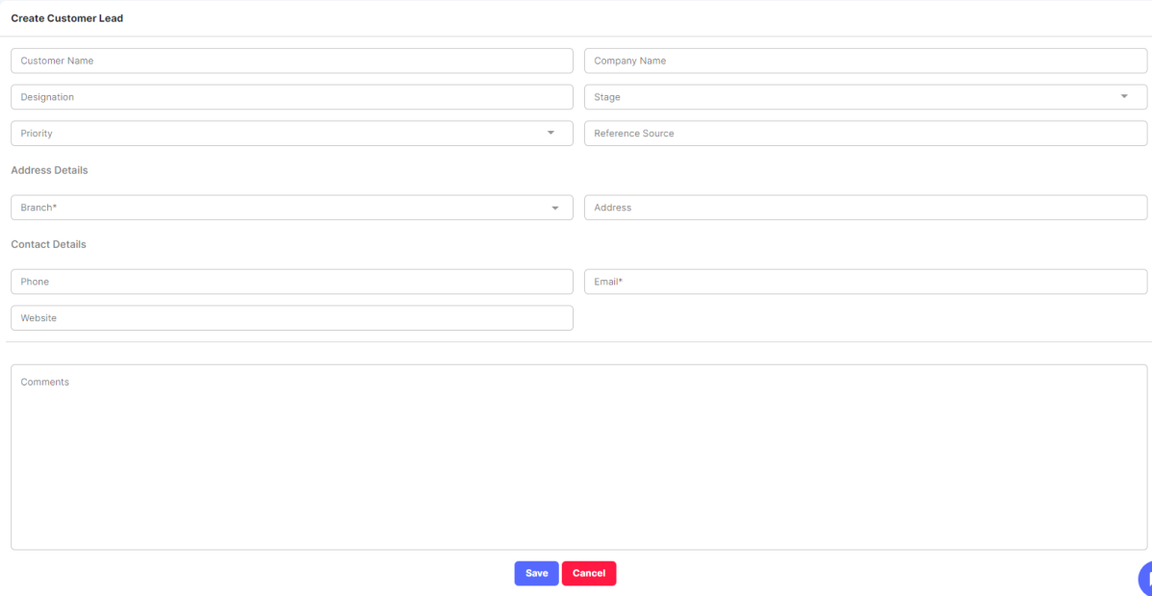

There is an option to Import & Export Customer Leads.

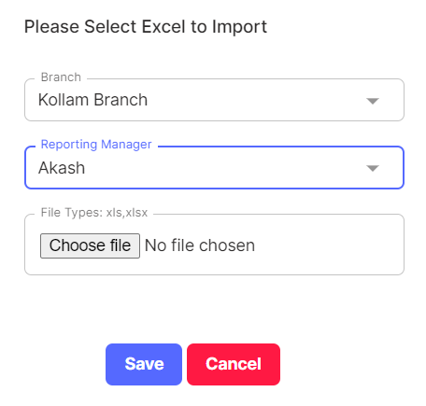 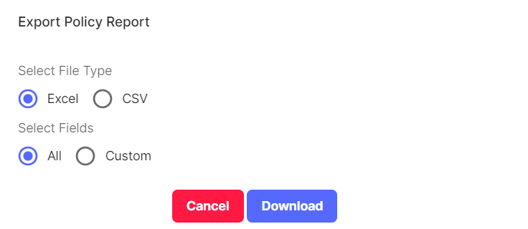

Once Uploaded, leads are distributed against a branch.

Note that already uploaded leads should not get mixed with the list as it will create duplicates

In Export, once File Type & field selection is done, click Download. An Excel file will get downloaded & below picture is the format.

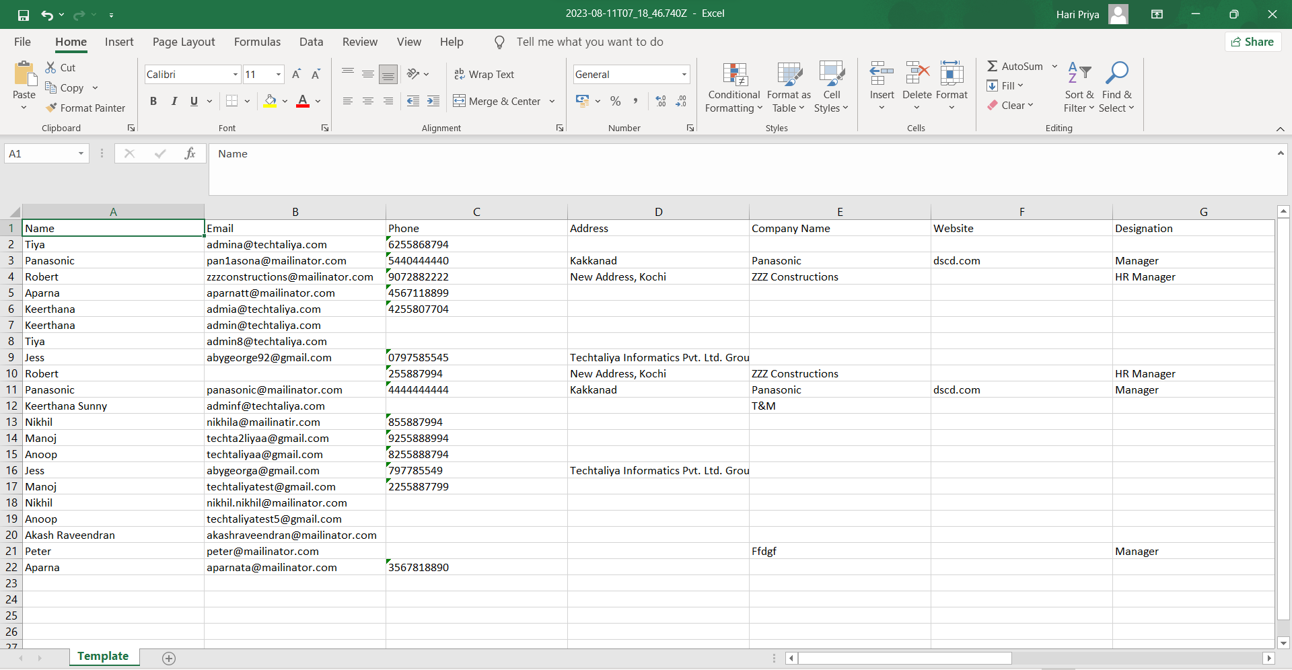

**Download Excel Template:**

To upload data, a user needs to adhere to a specific format, which can be obtained by selecting the download option on the page. Once the download is initiated, the corresponding template will be downloaded.

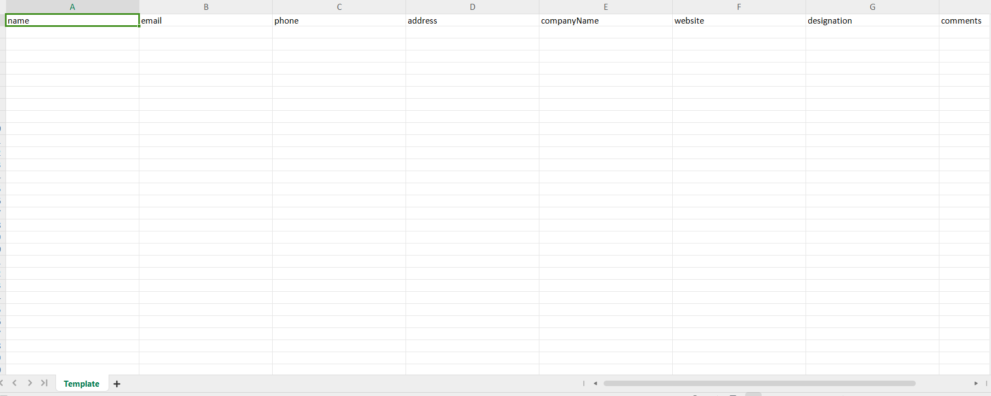

Also, there is an option to Send Email to multiple Customers directly at a time. At least 1 customer should be selected from the list to send Email directly.

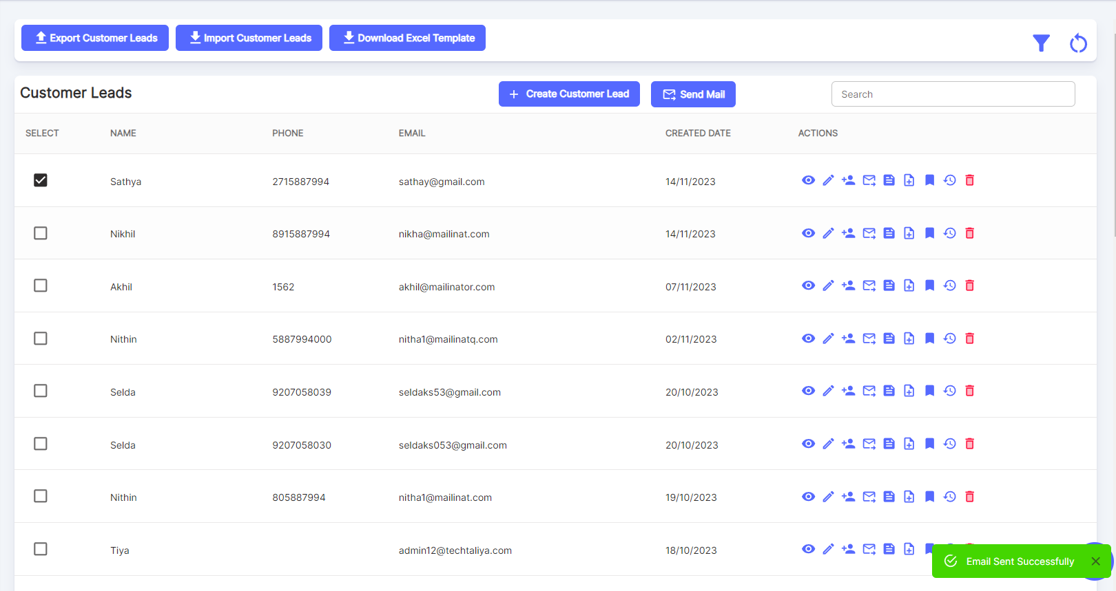

The actions in Customer Leads are:

* View More
* Edit Customer Lead
* Add to Customers
* Send Email
* Subscribe Newsletter
* Add Notes
* Follow Up
* View History
* Delete

**View More:**

It is similar like a Preview to see the details entered.

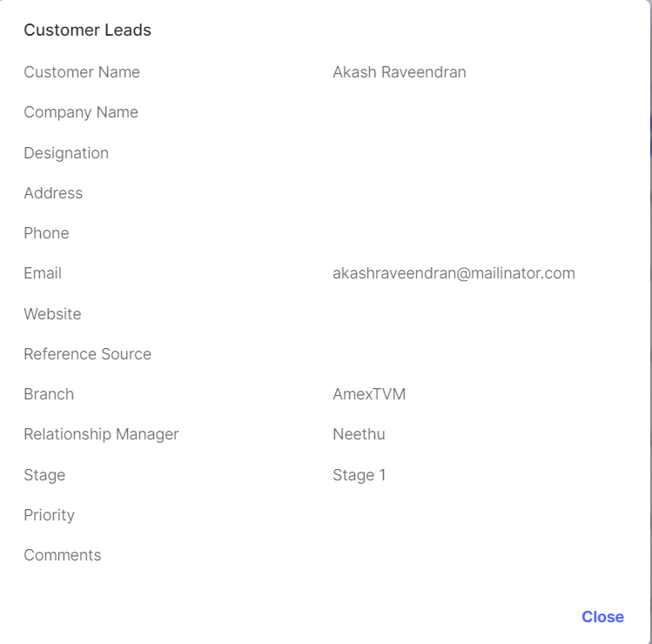

**Edit Customer Lead:**

Click on Edit & it will show a page to Update the Customer Lead Details.

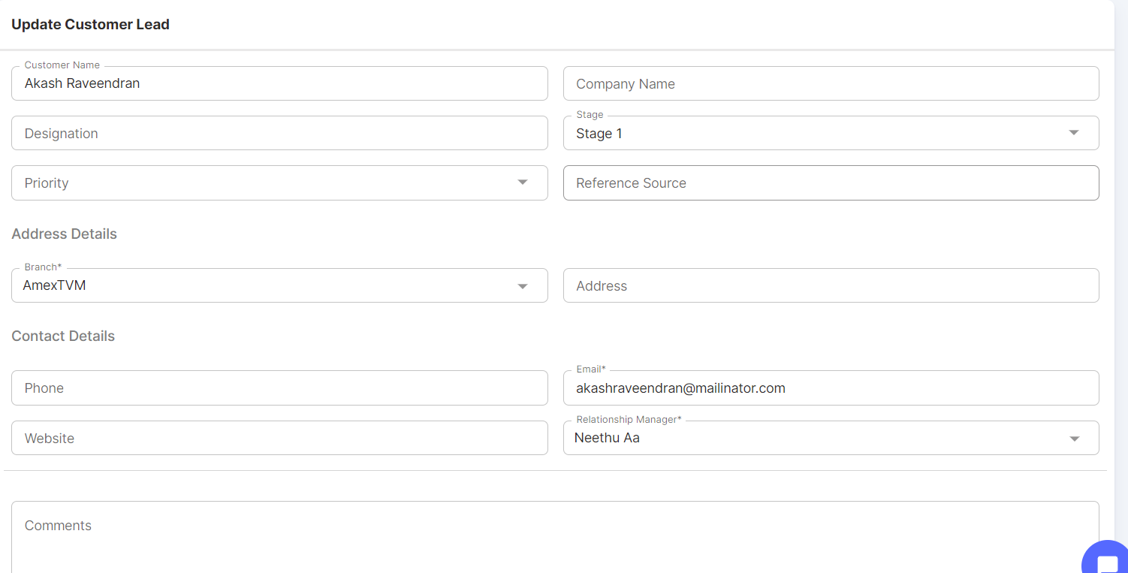

**Add to Customers:**

If we need to add any of the Customer Leads to a Corporate or Retail Customer, then click on Add to Customers. By switching the tab, one can add the Customer Lead under Corporate Customer or Retail Customer.

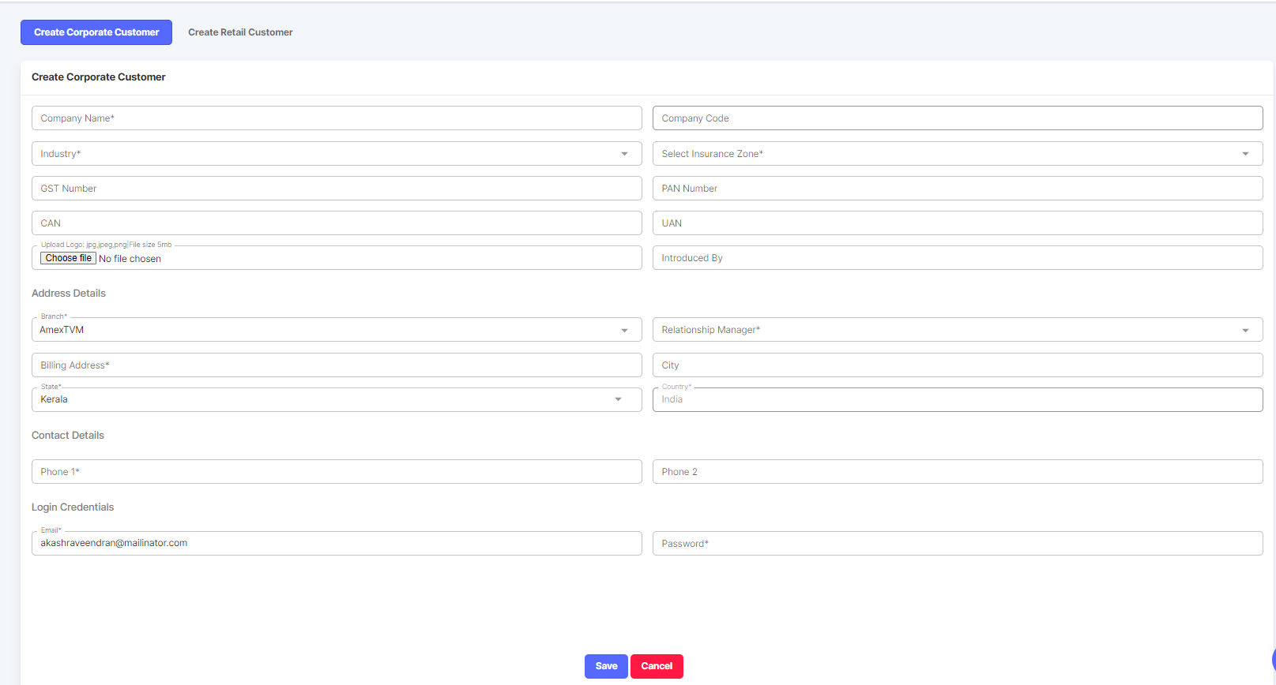

Once Saved, details will be added to corporate customer since Create Corporate Customer tab is selected. 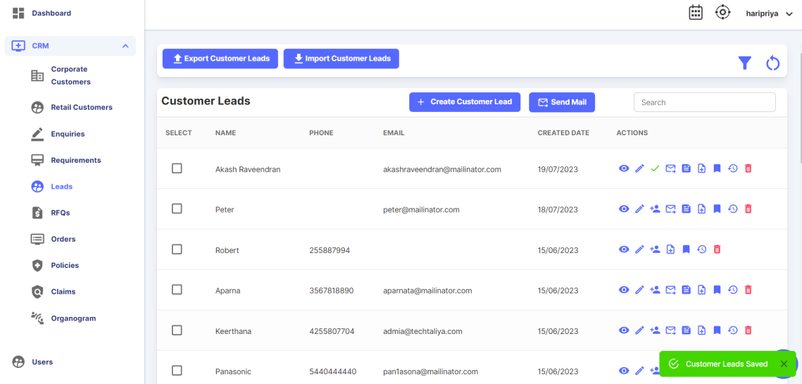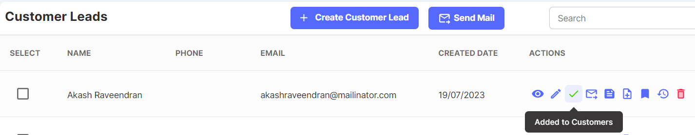

**Send Email:**

There is a provision to send Email against a Lead.

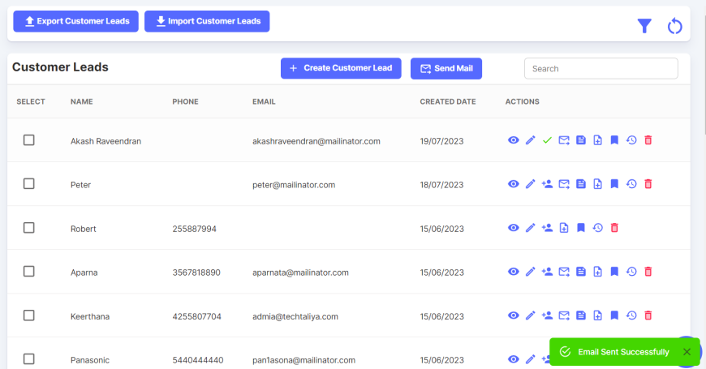

**Subscribe Newsletter:**

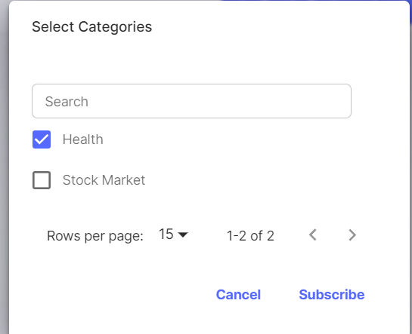

If we need to receive any updates as a newsletter for any of the categories, then select the respective categories & click on Subscribe.

**Add Notes:**

Notes can be captured regarding the enquiry. Upload option also there if in case any attachments are there.

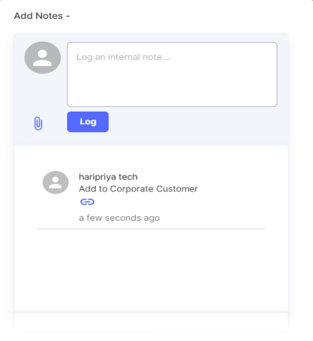

**Follow Up:**

Follow Up can be done using different modes of follow up like Phone, Email, Meeting etc.

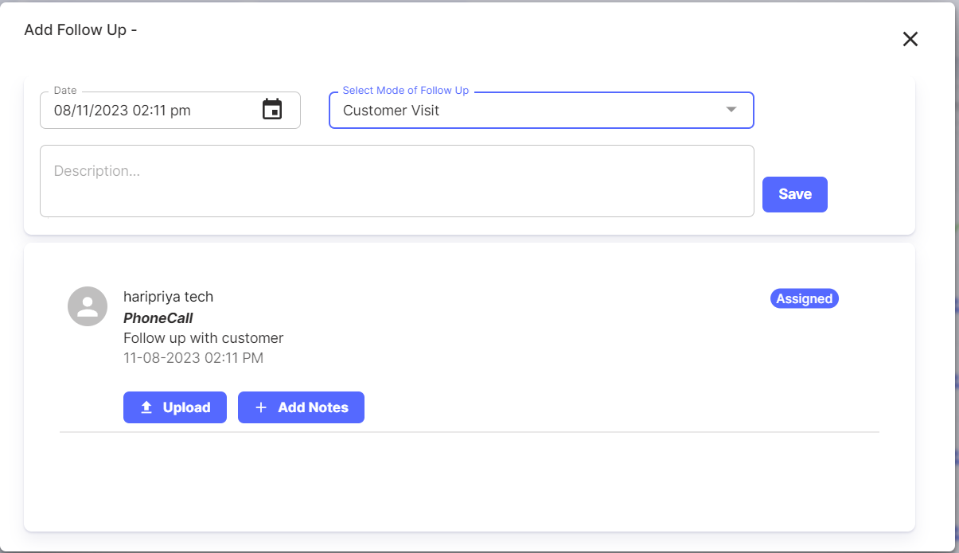

**Event Log:**

In the Event Log, it helps to understand what all new fields are added and also the old values as well.

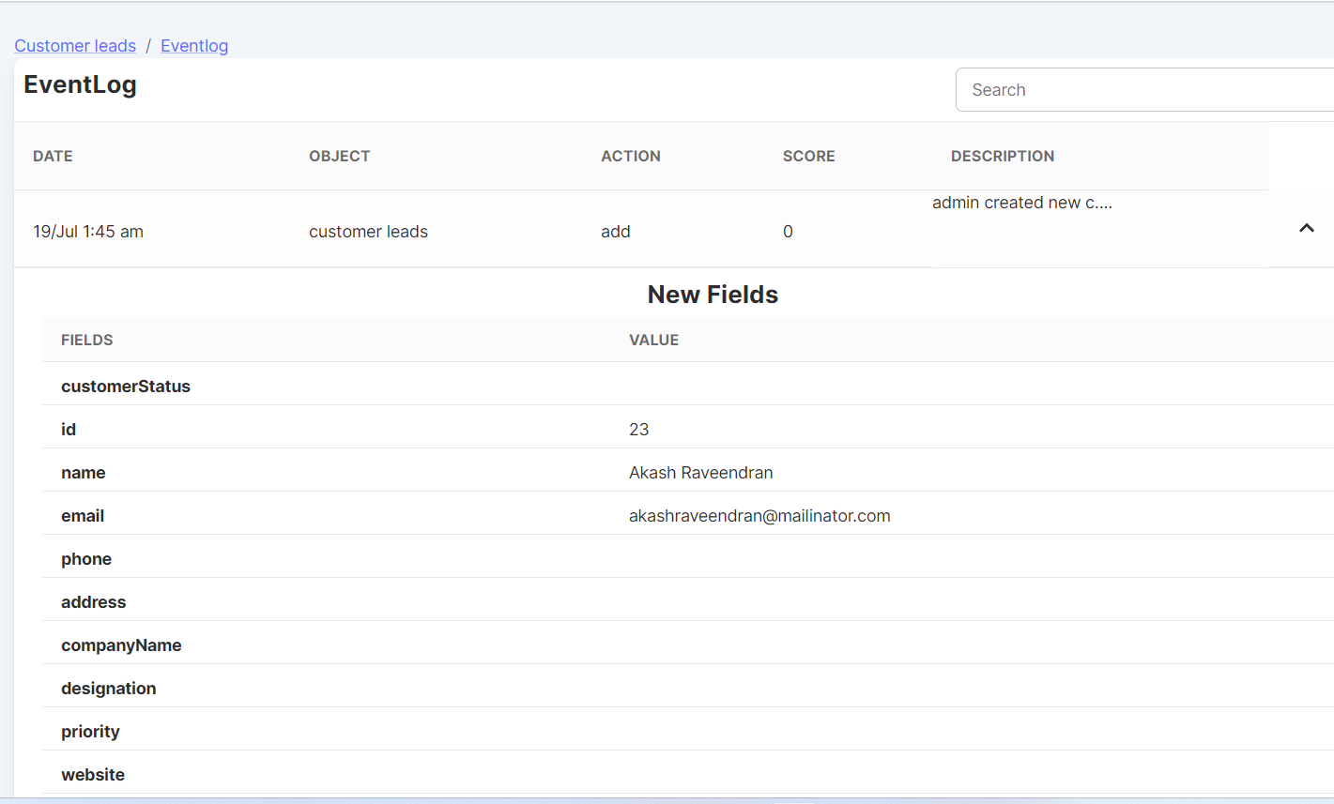

**Delete:**

There is an option to delete the created Customer Lead if they are not needed in this application.

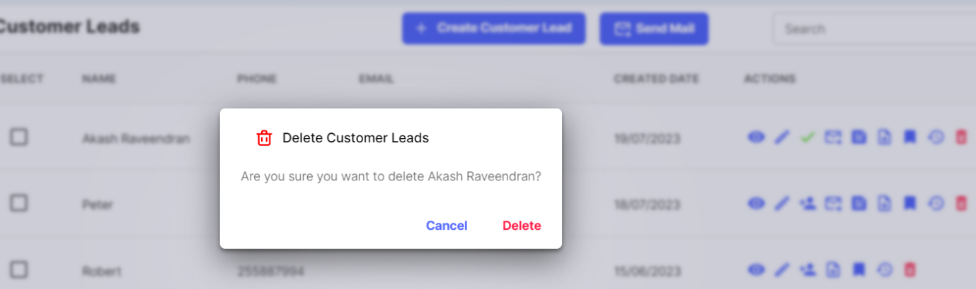

* + 1. **RFQs**
* RFQ stands for "Request for Quote."
* An RFQ is a formal document that an organization, individual, or entity sends to insurance providers to request price quotes and proposals for insurance coverage.
* This process is common in commercial insurance, where businesses seek insurance policies to cover various aspects of their operations, such as property, liability, workers' compensation, and more.
* The RFQ outlines the specific insurance needs and requirements of the requester, including the type of coverage, coverage limits, deductibles, and any other relevant details.
* Insurance companies then respond to the RFQ with their proposed insurance policies, including premium costs, terms and conditions, and any additional information that the requester may need to make an informed decision.
* The RFQ process allows insurance buyers to compare offers from multiple insurance providers, ensuring that they can choose the policy that best meets their needs while considering factors such as coverage, cost, and service.
* It's an essential step in the insurance procurement process, especially for businesses looking to secure comprehensive and cost-effective insurance coverage.
* As earlier said in Enquiries, the RFQs created via Enquiries will also appear in the RFQ List.
* The person who has permission to create RFQ can also create an RFQ request directly using the RFQ Module.
* RFQ will be created by the Relationship Manager or from the Operations Team.
* An RFQ will be marked as Completed only after sharing the quote to Insurance Companies. 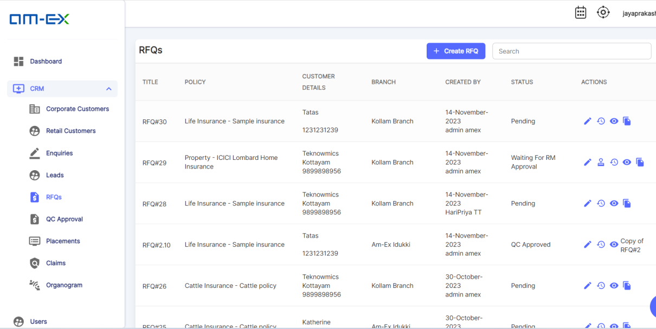

The Actions possible under RFQ are: Go to RFQ (Edit), RFQ Event Log, Share View (Preview) & Copy RFQ

Click on Create RFQ. As mentioned during the meeting, Non-Life is now set as default under Policy Type. Currently the terminologies like Policy Type & policy Sub Type are not going to change in the UI as it might affect the rest of the functionalities. Will consider after current release.

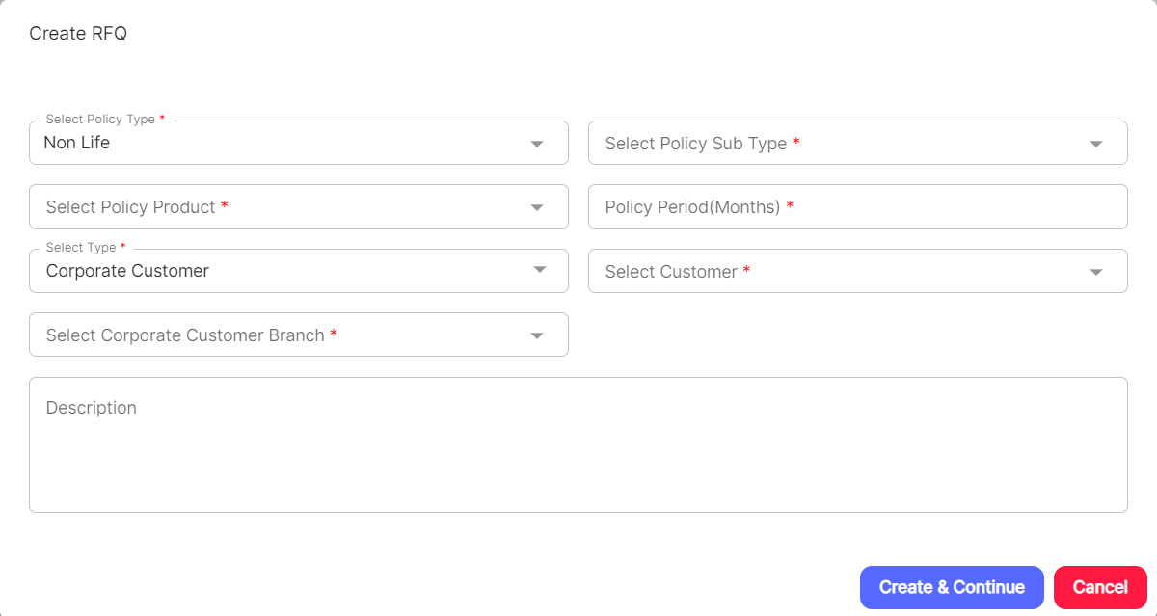



Click on Create & Continue. It will take you to the RFQ Details Page.

In the RFQ Page, there will be different sections like:

* Customer Details
* Product Details
* Enquiry Details
* Am-Ex Address
* Sum Insured
* Dynamic Data
* Clauses & Coverages
* Attachments
* Claim Details etc.

All these are divided into different sections in the RFQ template. Please find the below screenshot for

reference.

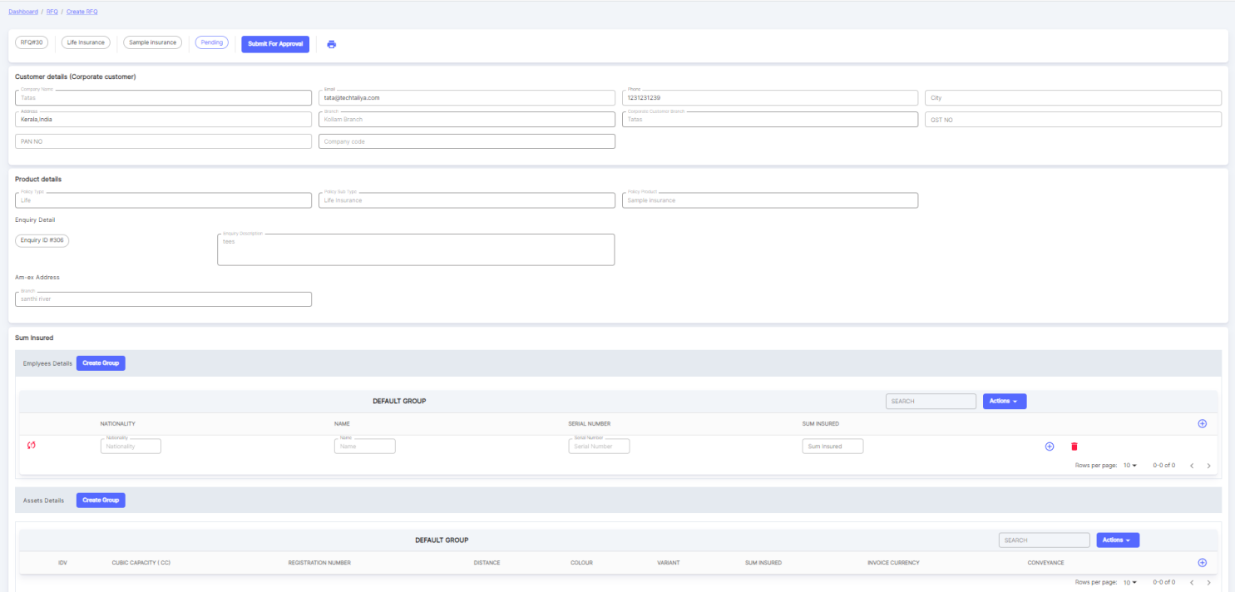



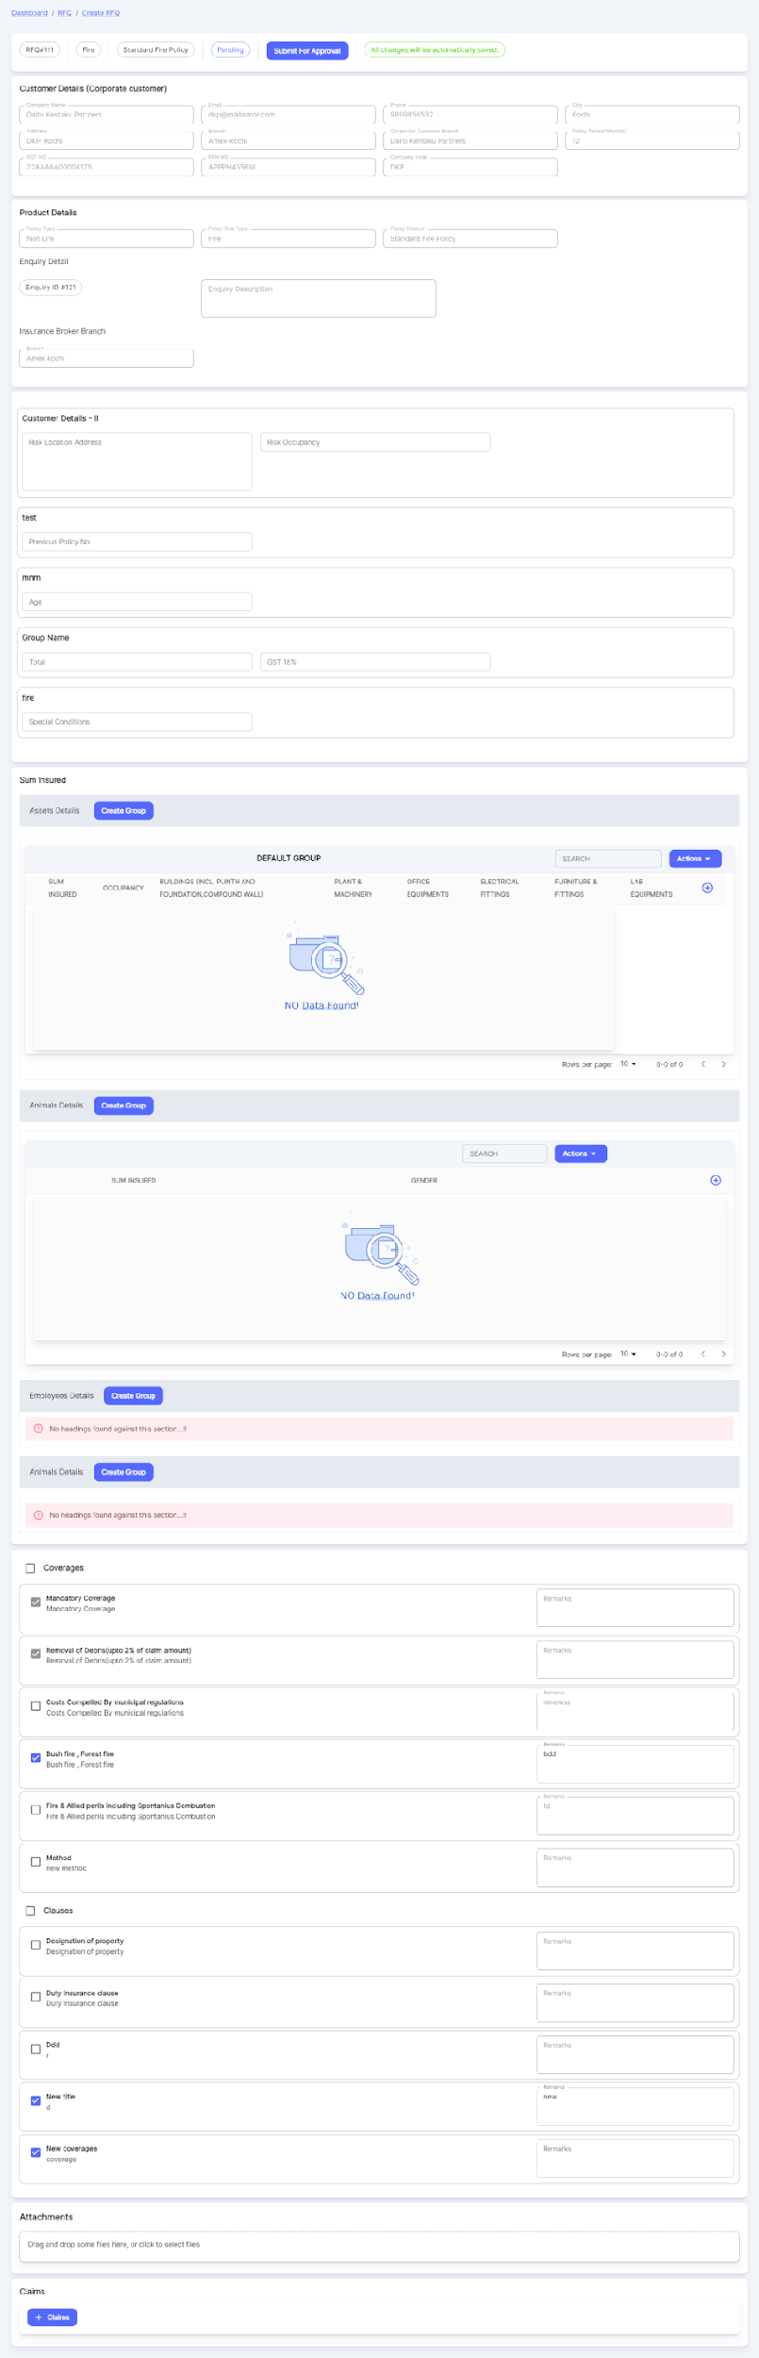

While creating Lists like Asset Lists or Employee Lists, there will be some grouping factors like Location, Occupancy, etc.

There will be a provision to create a Group in the RFQ section under Sum Insured. When create group is selected, a pop-up window appears to select the grouping factors. There will be a default group already. Default group will be considered if no grouping is done.

If there is a group already present with some data & the user is trying to create a new group, if the criteria satisfy the new records, then existing data can be modified & moved to the new group.

Editing is not possible. Only deletion happens if needed. Once a group is deleted, all data inside the group will be deleted. Users can delete & create a new group if necessary.

No Duplicate criteria are allowed while creating a group. At the time of group creation, the same conditions should not repeat again.

An RFQ is created against a Product. Under Insurance Settings>>Products, click on Create Product Template  under Actions.

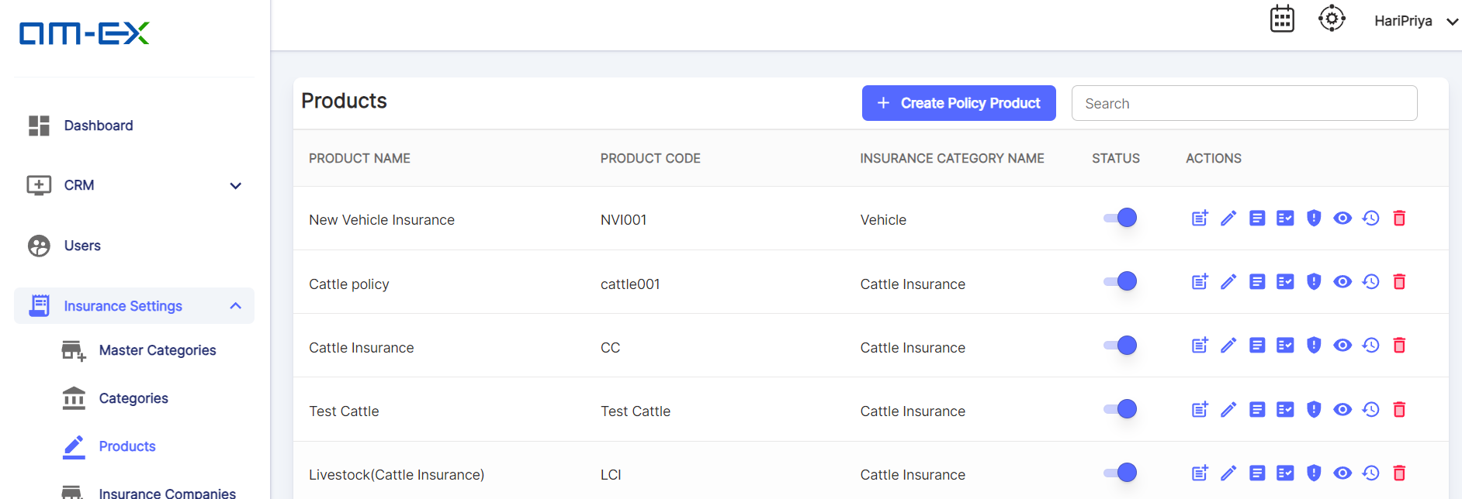

Click on Create Product Template & a page appears. Under Sum Insured Section, you can Add New Sections.

Once Section is Added & Saved, Select Table Headers.

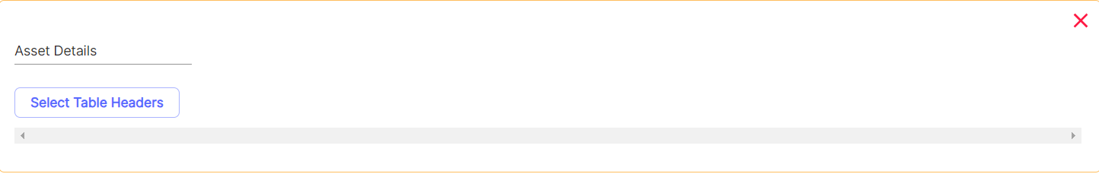

When Select Table Headers is selected, the below pop-up appears to select the required fields to appear as Table Headers.

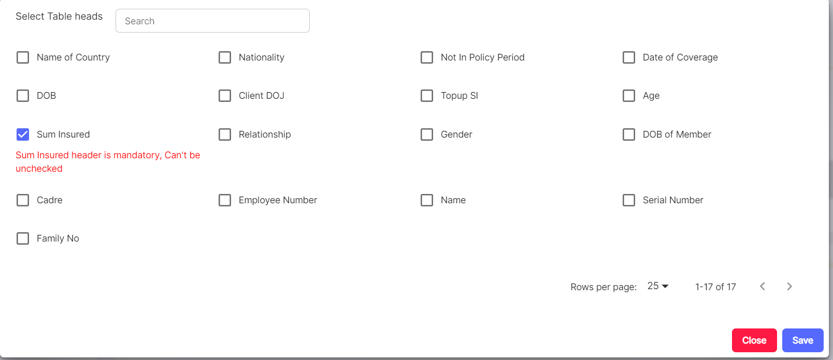

Sum Insured Header will be mandatory & users can select required fields which need to be appeared in the header.

Once selected, click on Save & the selected Headers will appear as Table Headers under the section.

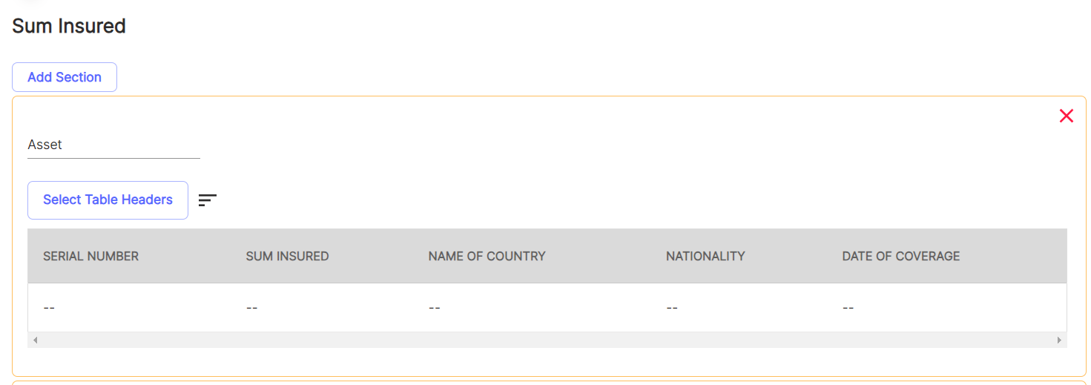

Table Heads can be sorted depending on our requirement. Click on the button next to Select Table Headers. Then a pop-up appears as shown below.

Simply, drag & replace the Table heads.

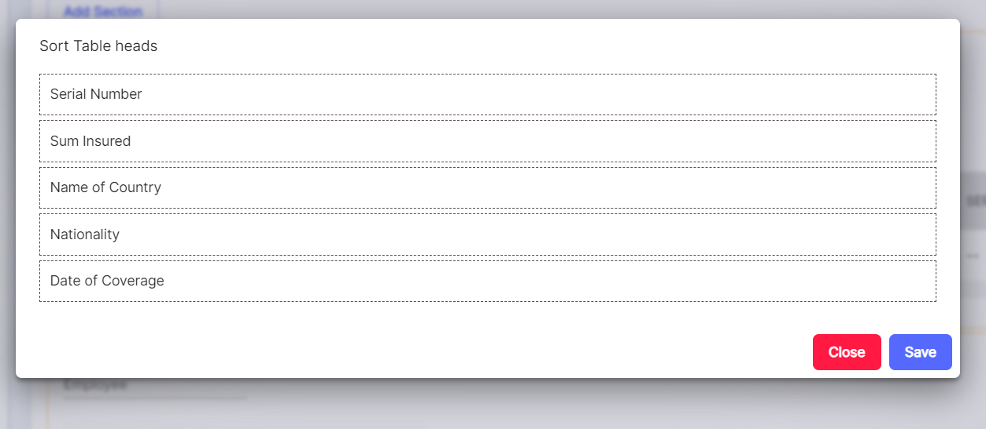

Now, go to CRM>>RFQ. Click on Create RFQ. Then a Pop up appears to enter the details to create RFQ.

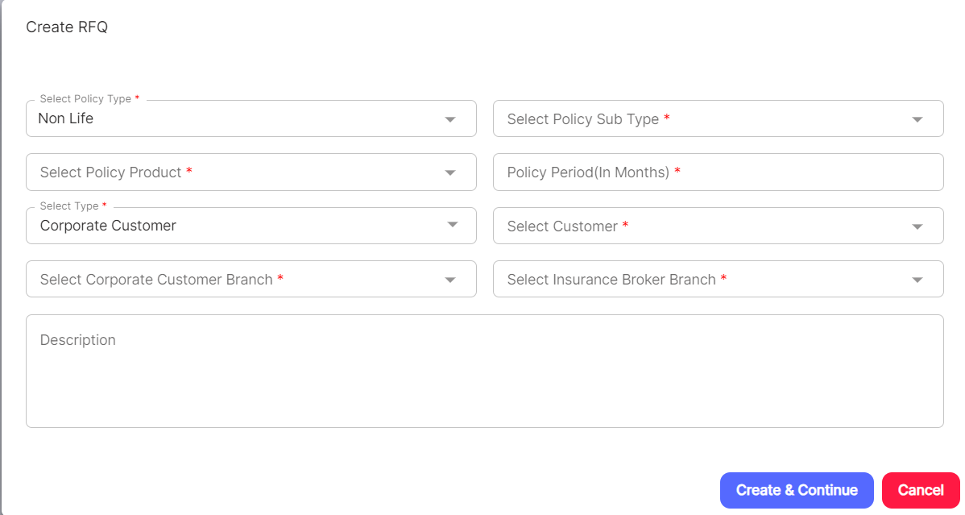

Once the details are filled, click on Create & Continue. It will take you to the RFQ Page.

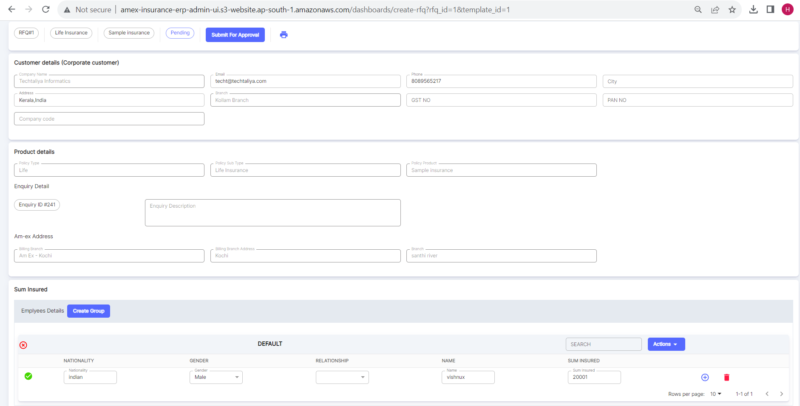

Since it was said that the Billing Branch (under Product Details) needs to be removed from the Insurance Admin Module, it is removed. Please find the new screenshot for reference.

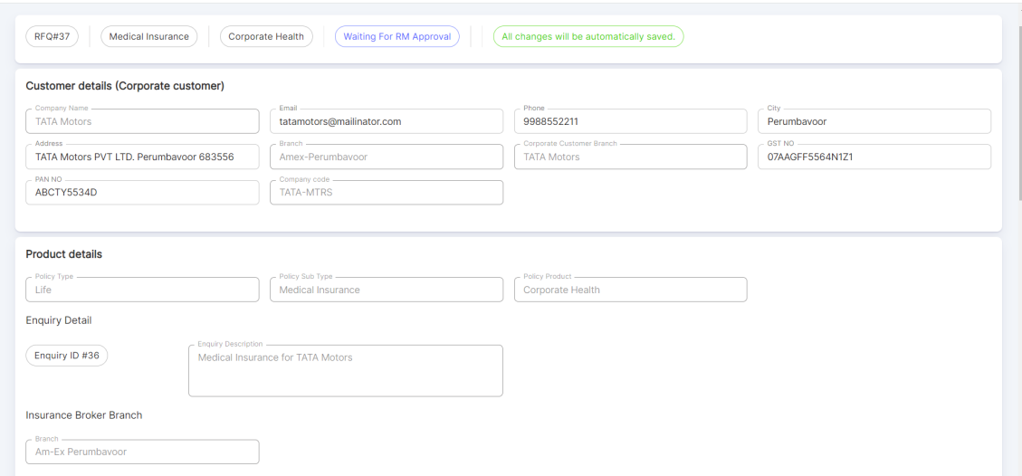

Under Sum Insured, based on the Product selected, the respective details will be loaded! If a new group needs to be created, then click on Create Group.

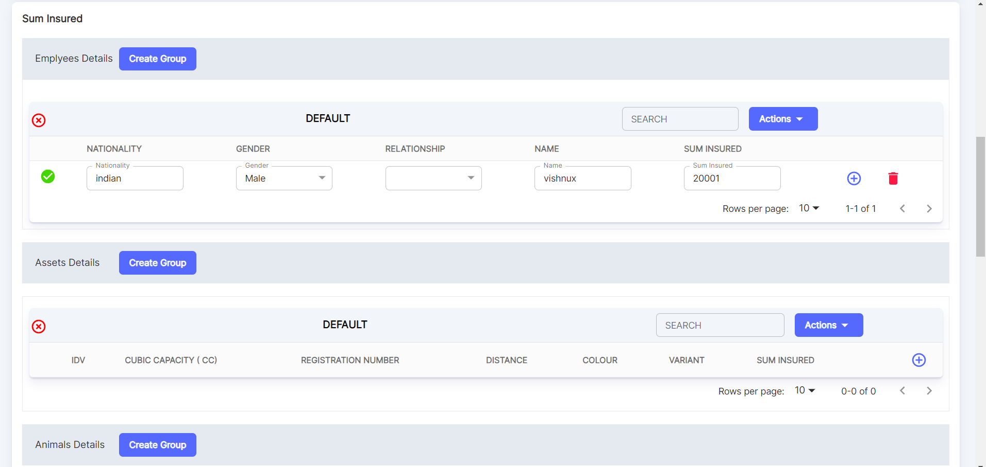

Once Create Group is selected, the below pop-up appears!

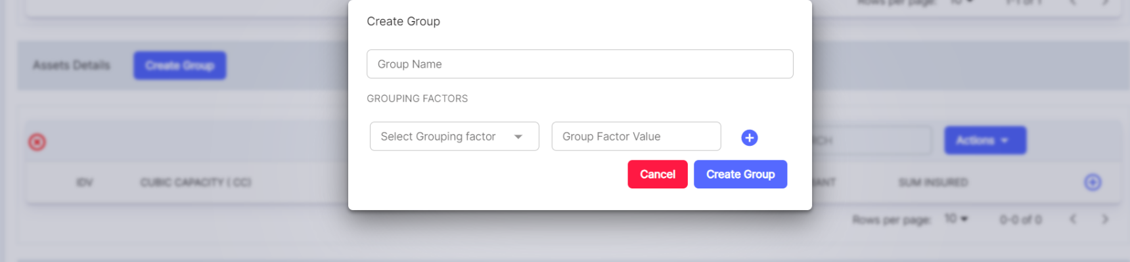

When Select Grouping factor is selected, it will show a list based on the table headers we added in the Product under Sum Insured. Only the selected

Headers will appear in the list under RFQ>>Sum Insured.

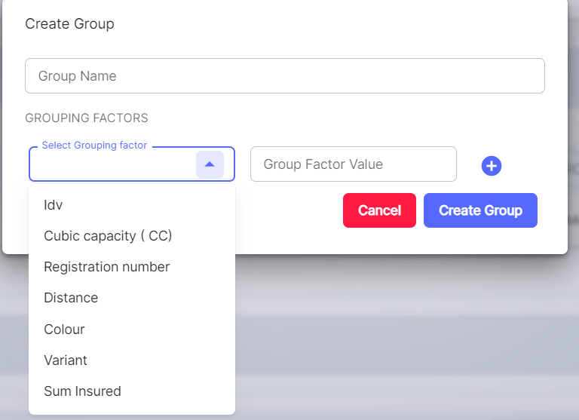

Once a Group is created, it can also be deleted as well by clicking on the cross icon 

**Preview:**

When Preview is selected, RFQ details are made visible as more concise in a Report like format.

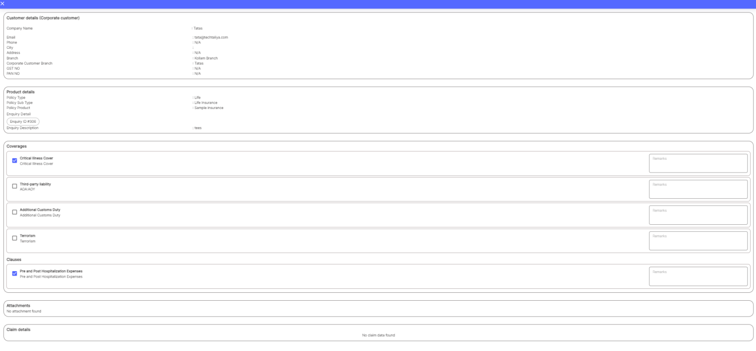

Print Feature is also available in RFQ Preview & QC Approvals Preview. Save As PDF feature is there.

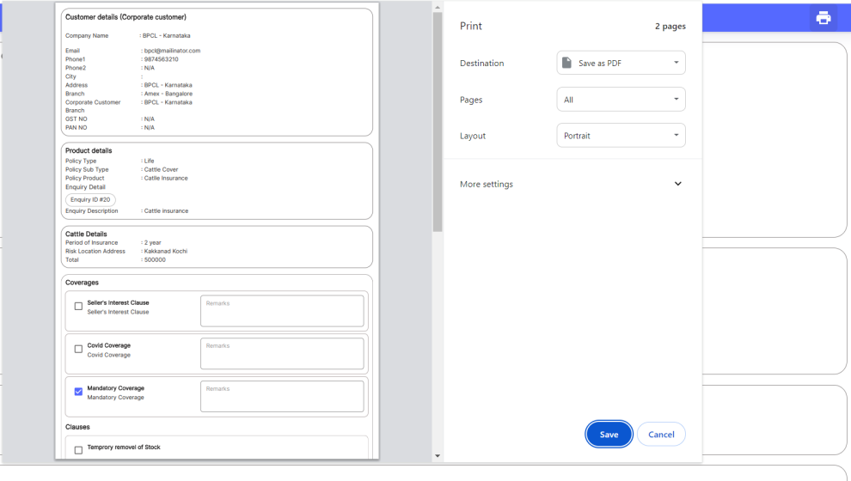

In the clarification sheet shared by the client, it is mentioned that there is an option to upload previous policy copies/endorsements (optional).

In the RFQ screen, we already added a provision to upload Supporting Docs as Attachments as shown above. User can upload, multiple documents

Necessary for the RFQ creation.

**RFQ Copy:**

When the user needs to create a copy from an existing RFQ, click on the Action - Copy RFQ. The below pop-up appears:

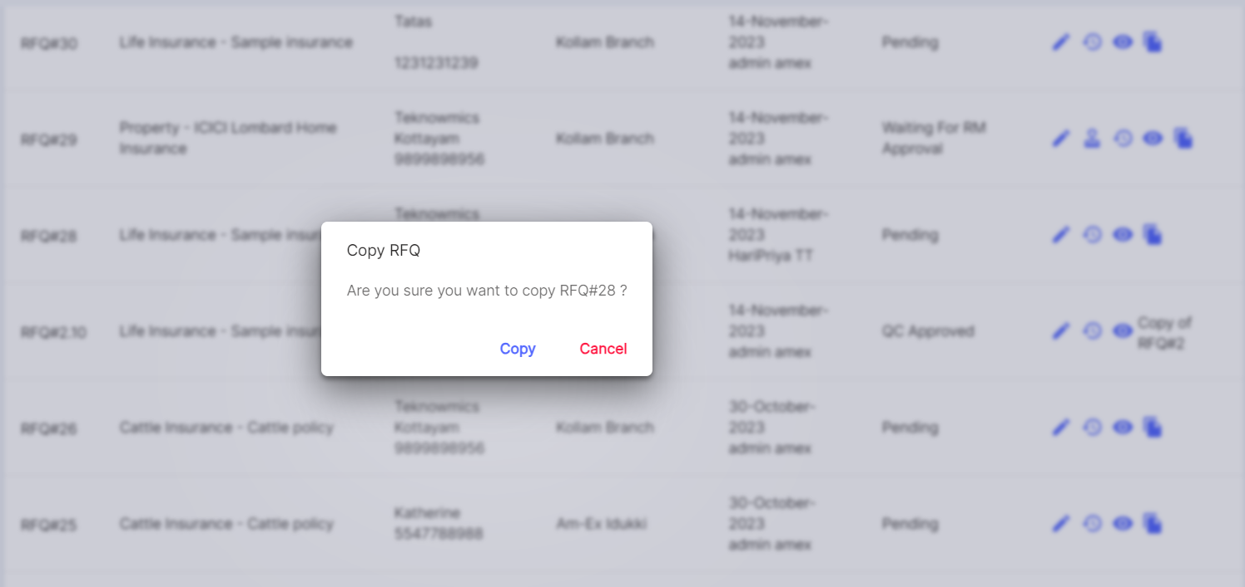

RFQ Copy will be enabled only once RFQ is in completed status (after sharing to Insurance companies). This provision is given so that the user does not want to type all the details of the RFQ again and they can reuse it if a new RFQ with the same details needs to be raised.

Click Copy. A copy of the RFQ is created as shown below:

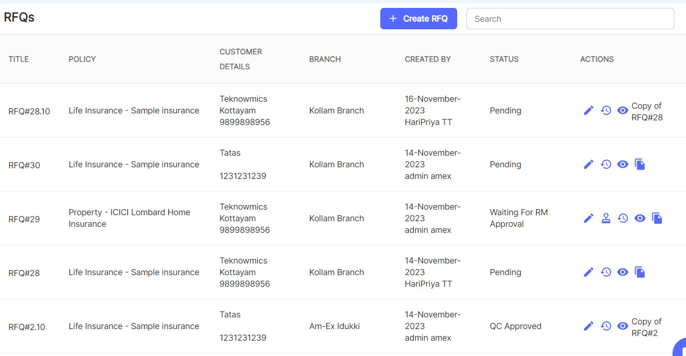

If more than 1 copy is created from the same RFQ then, it looks like as shown below:

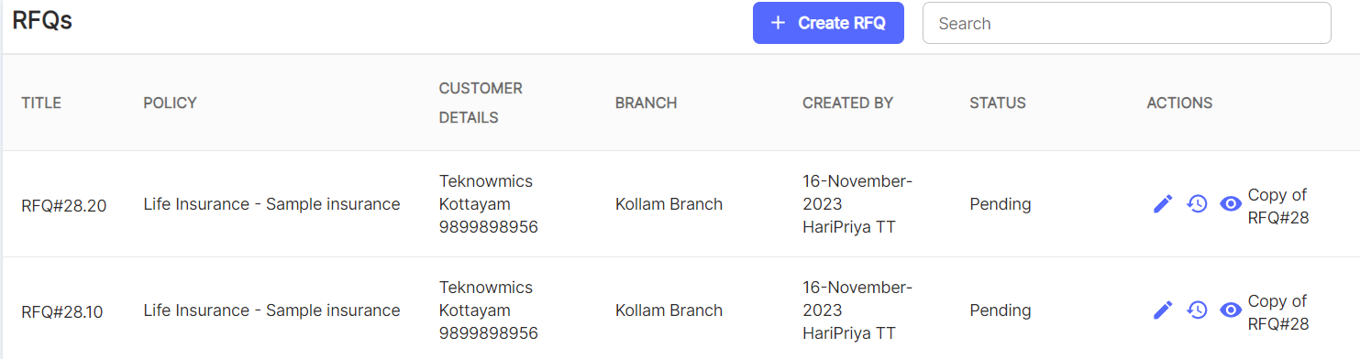

Once all RFQ-related details are captured, click on Submit for Approval. It will go to the Approval stage.

The below screens are just shown for reference to depict what all form fields will come for a RFQ

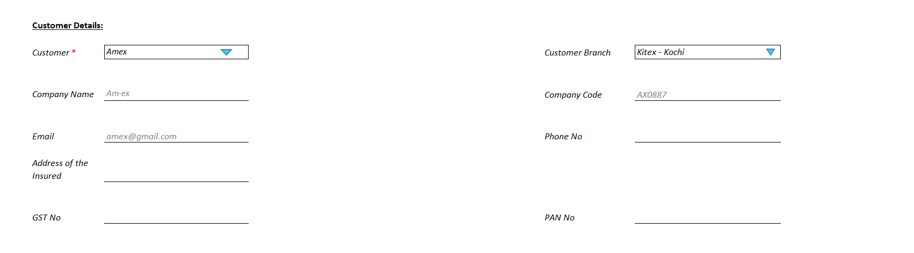 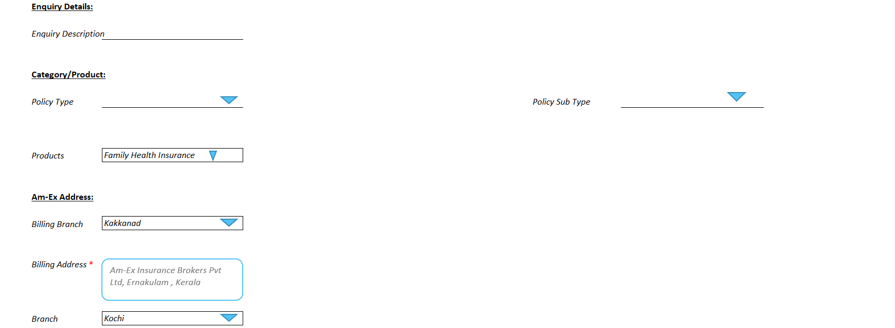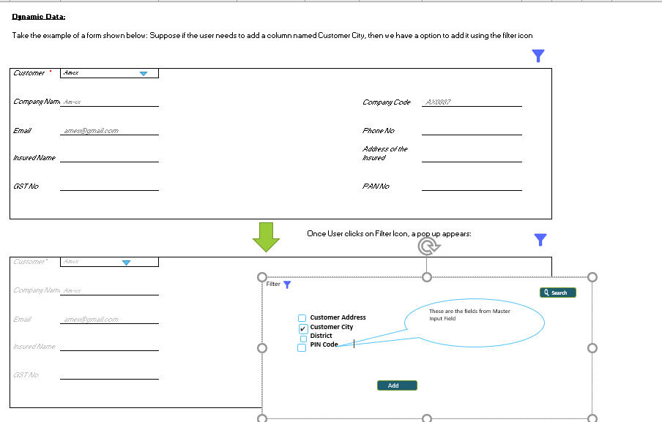 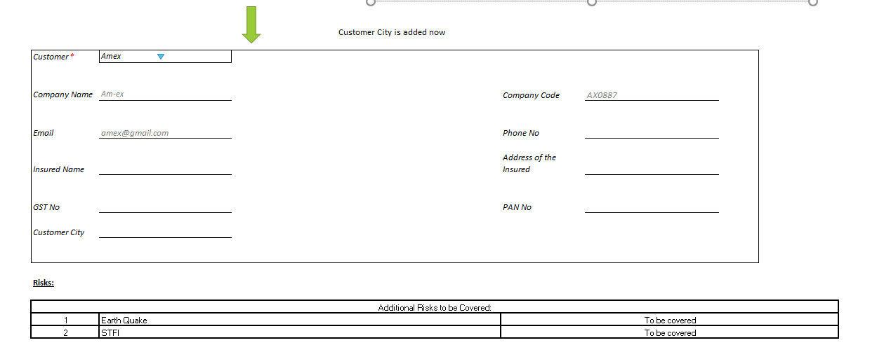

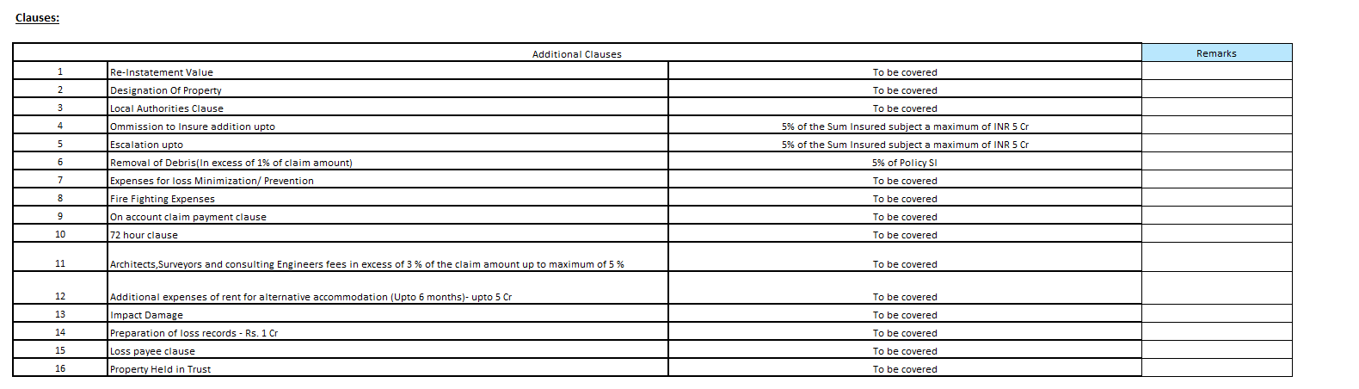

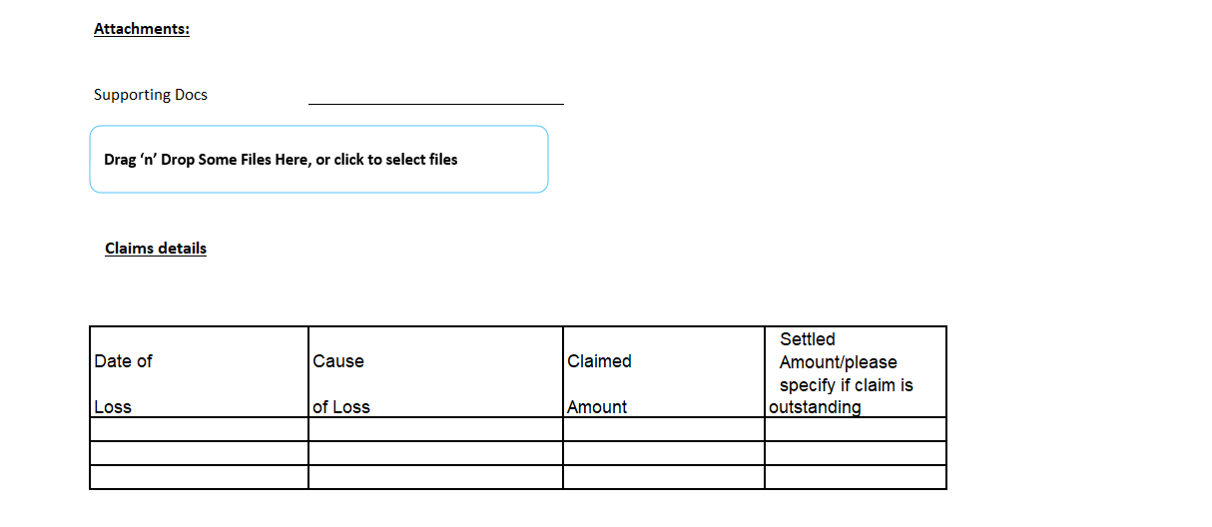

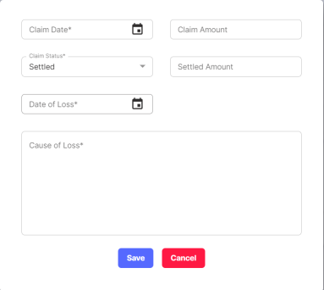

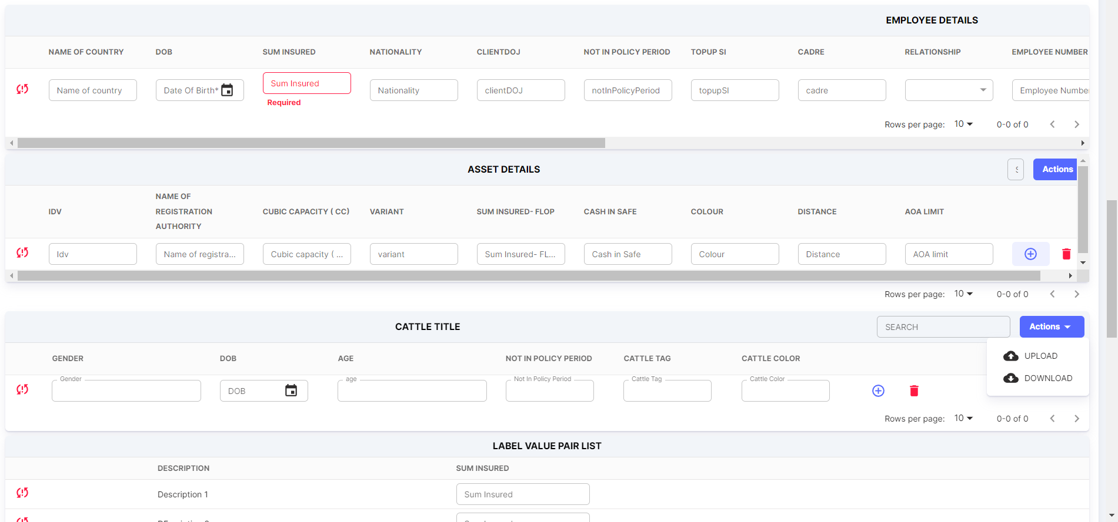

Sum Insured Type can be:

* Asset List
* Employee List
* Cattle List
* Label Value Pair
  + 1. **Approvals**
* Once RFQ details are filled in, click on Submit for Approval. The status will be changed to Waiting for RM Approval. Now, the RFQ needs to go through the two-level approval process.
* Relationship Manager (RM) Approval
* QC Approval

If the Relationship Manager is unable to approve or if he is on leave, then the Reporting Manager can approve. The Reporting Manager has visibility as well.

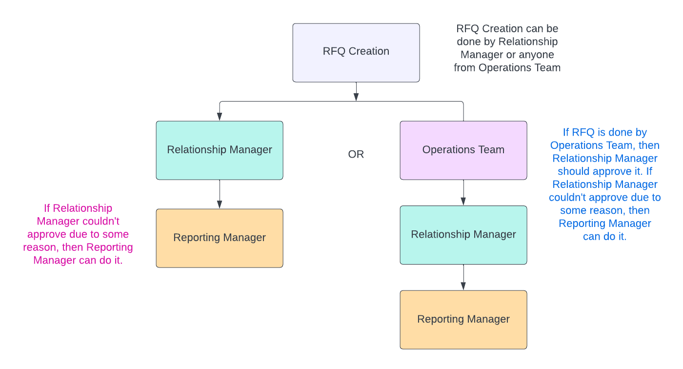

**Approval Flow of Relationship Manager/Operations Team:**

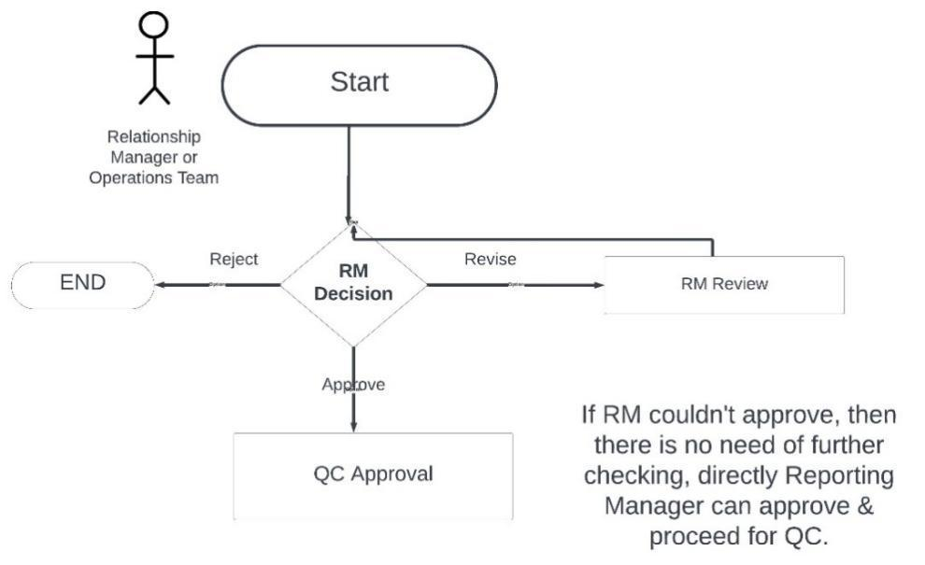

Note: The person who created RFQ along with the respective dependents of the created person can only see the RFQ details.

* There are 3 decisions: Approved, Revised & Rejected

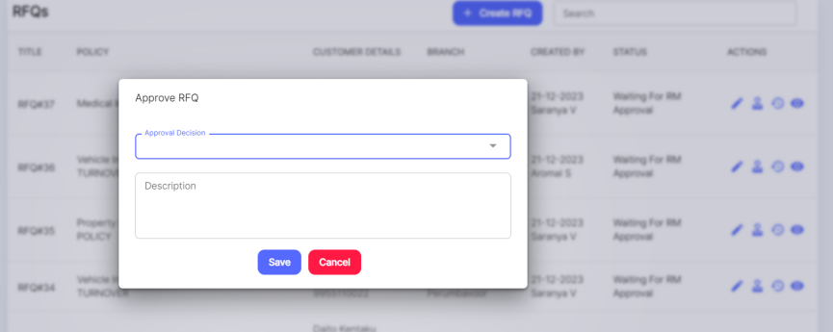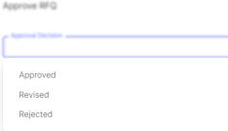

If it’s Approved, then description need not be mandatory. For the other 2 options, Description is mandatory.

Before Approval RM can do Edit by clicking on Go to RFQ. The ownership of Edit will be for the one who does this task. Give a notification to the user who created RFQ that changes are done in the RFQ! Also, approval notification is needed in separate.

* + 1. **QC Approvals:**
  + Once Approved, it will go for QC Approval. QC Approvals are needed in Policies, Claims & RFQ. Similar to Relationship Manager, they also can Approve, Revise & Reject.
  + In QC Approval, there will be a checklist so that they can check whatever details are being verified during the approval process. The checklist is configured against Product.

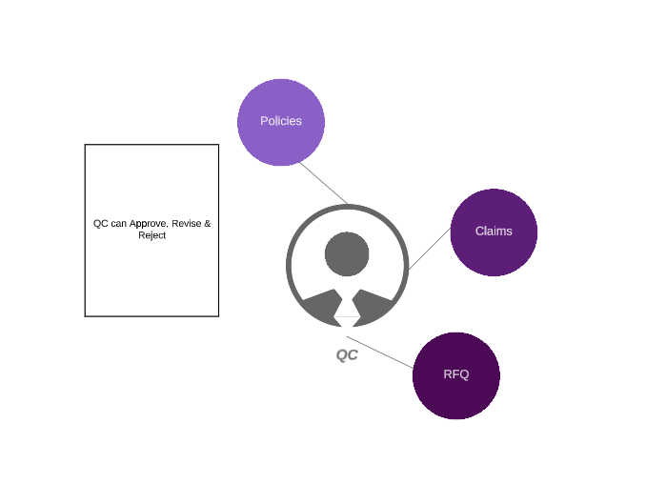



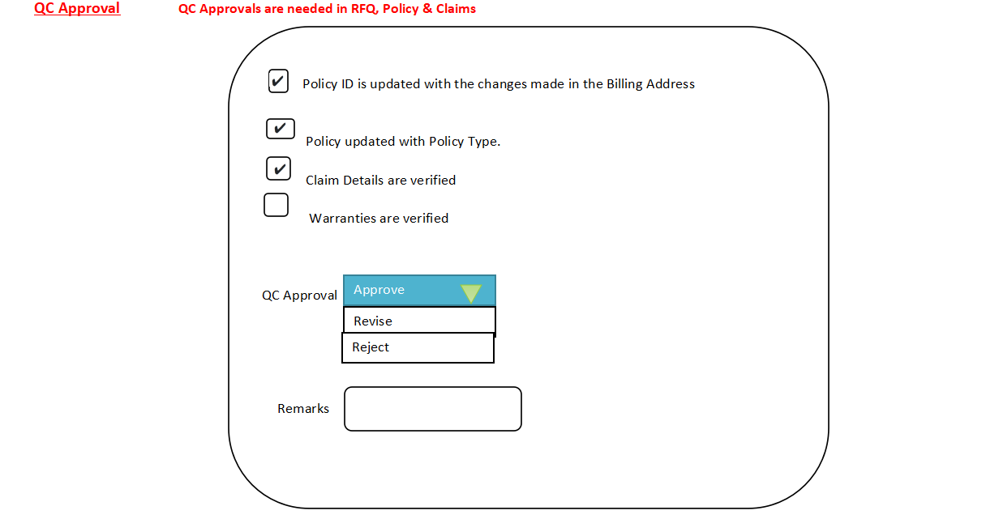

(In current UI)

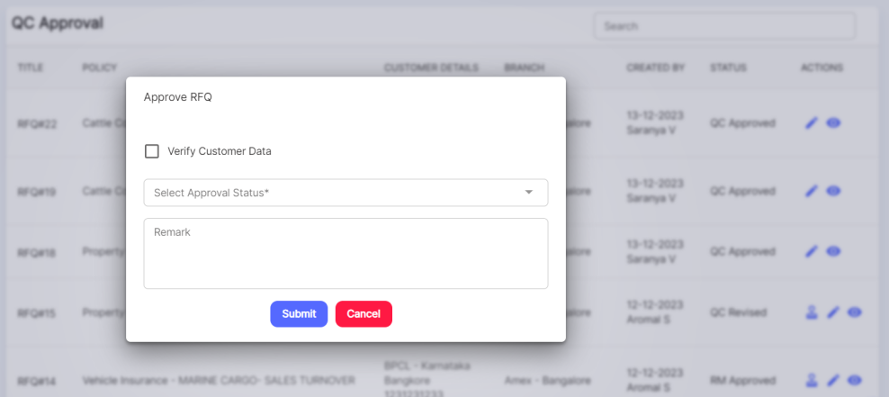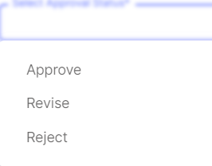

If it’s Approved, then description need not be mandatory. For the other 2 options, Description is mandatory.

Similar to RM, QC can also edit before Approval. **RM can also be given the QC Permission**.

Screenshot from existing RFQ:

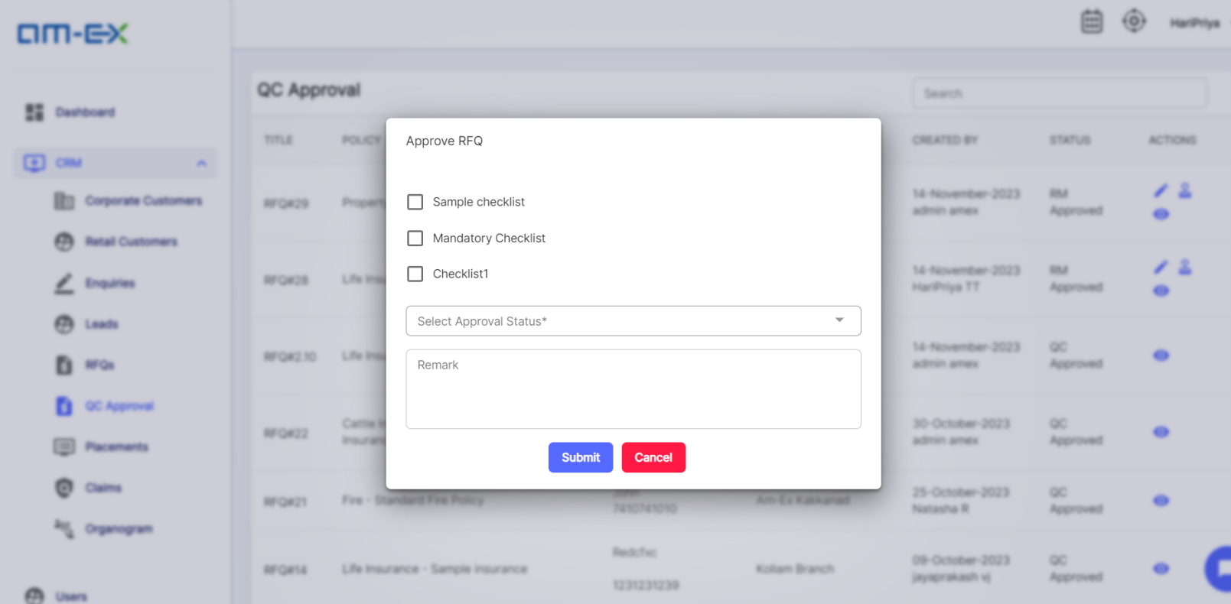

Different RFQ Statuses are: (statuses to be confirmed by client)

* Pending
* RFQ Created
* Awaiting RM Approval
* Awaiting QC Approval
* RM Approved
* RM Revised
* RM Reject
* QC Approved
* QC Revision
* QC Reject
* Placement Slip Generated
* Shared to Company
* Shared to Customer
* Completed
* Rejected



* + 1. **Placement:**

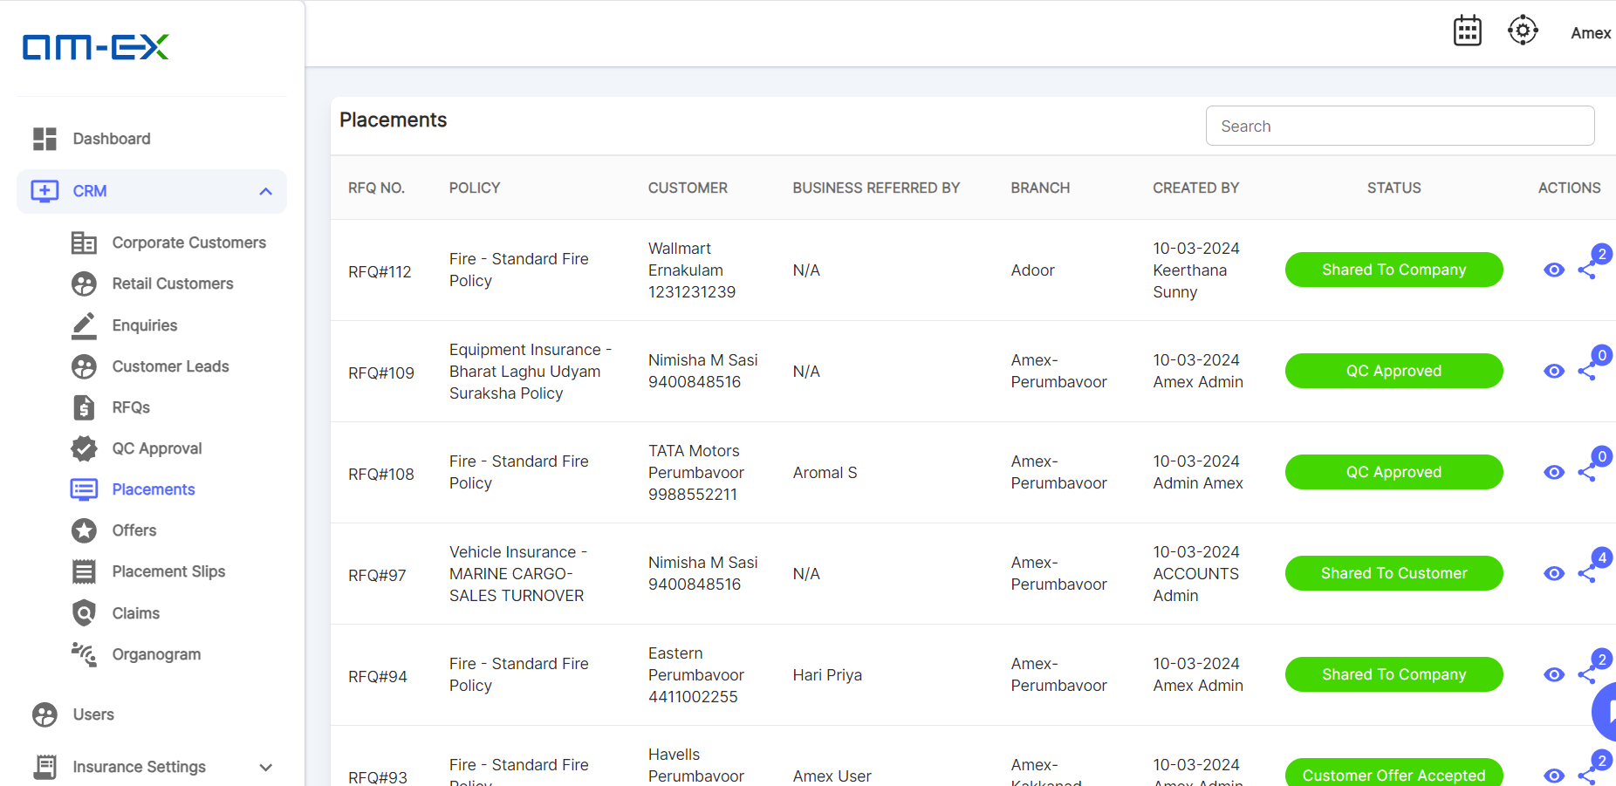

* After QC Approval, then it will go to the Placement Team for review. No editing is allowed at this stage after QC Approval. Placement team will review the details & then the entire RFQ will be shared to multiple Insurance Companies. A single RFQ can be shared to multiple Insurance Companies.
* When Share button is selected, the below screen appears:

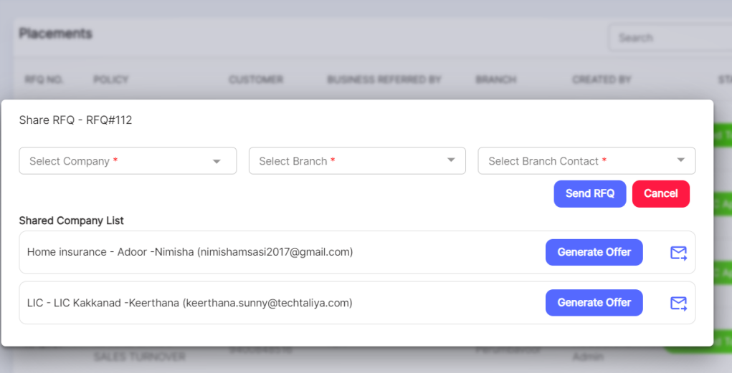

At the time of Send RFQ, Branch Contact selection should be multiple. So email will go to multiple contacts of the same Insurance Company - This will be considered in the next phase only.

After QC approval, no more editing is allowed.

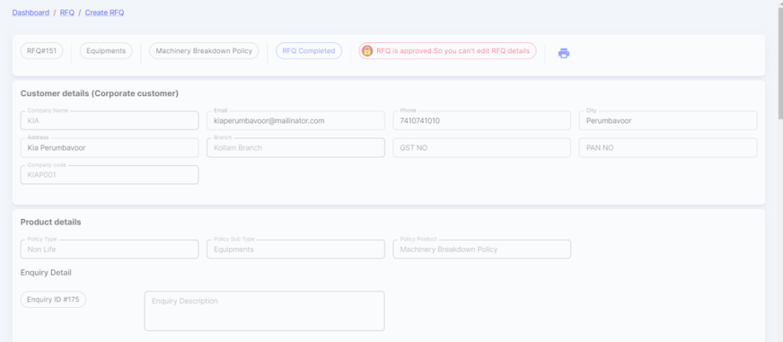

* + 1. **Offers:**
* Insurance Companies will review the RFQs shared and based on that back & forth communications will happen offline.
* Multiple Offers will be shared by the Insurance Companies based on the RFQs shared.
* A Comparison view is also provided for the customers to select the best offer
* Offer can be done from Amex end or admin also. In future, Insurance company can do through an email

Link.





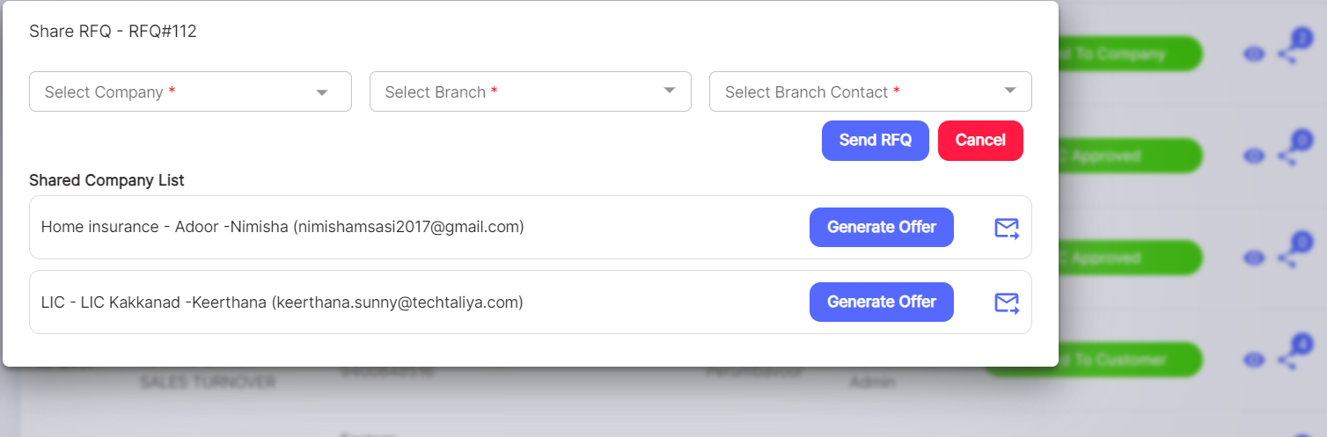

Once Generate Offer is selected against the shared company, below screen appears:

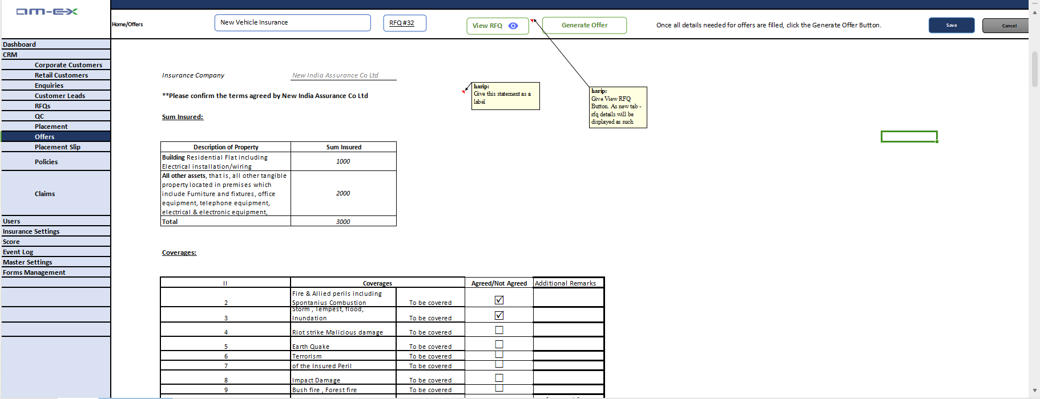

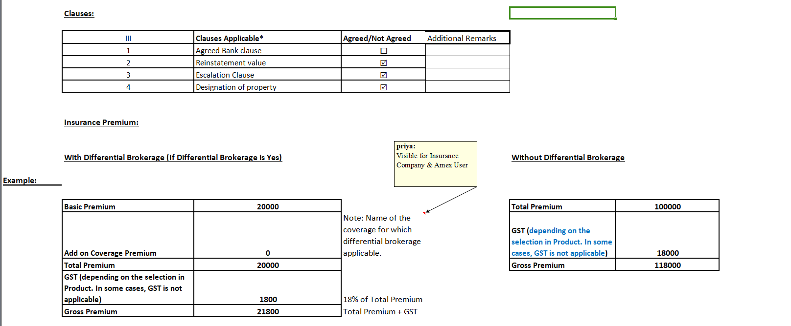

**Current UI Offers (in the application)**

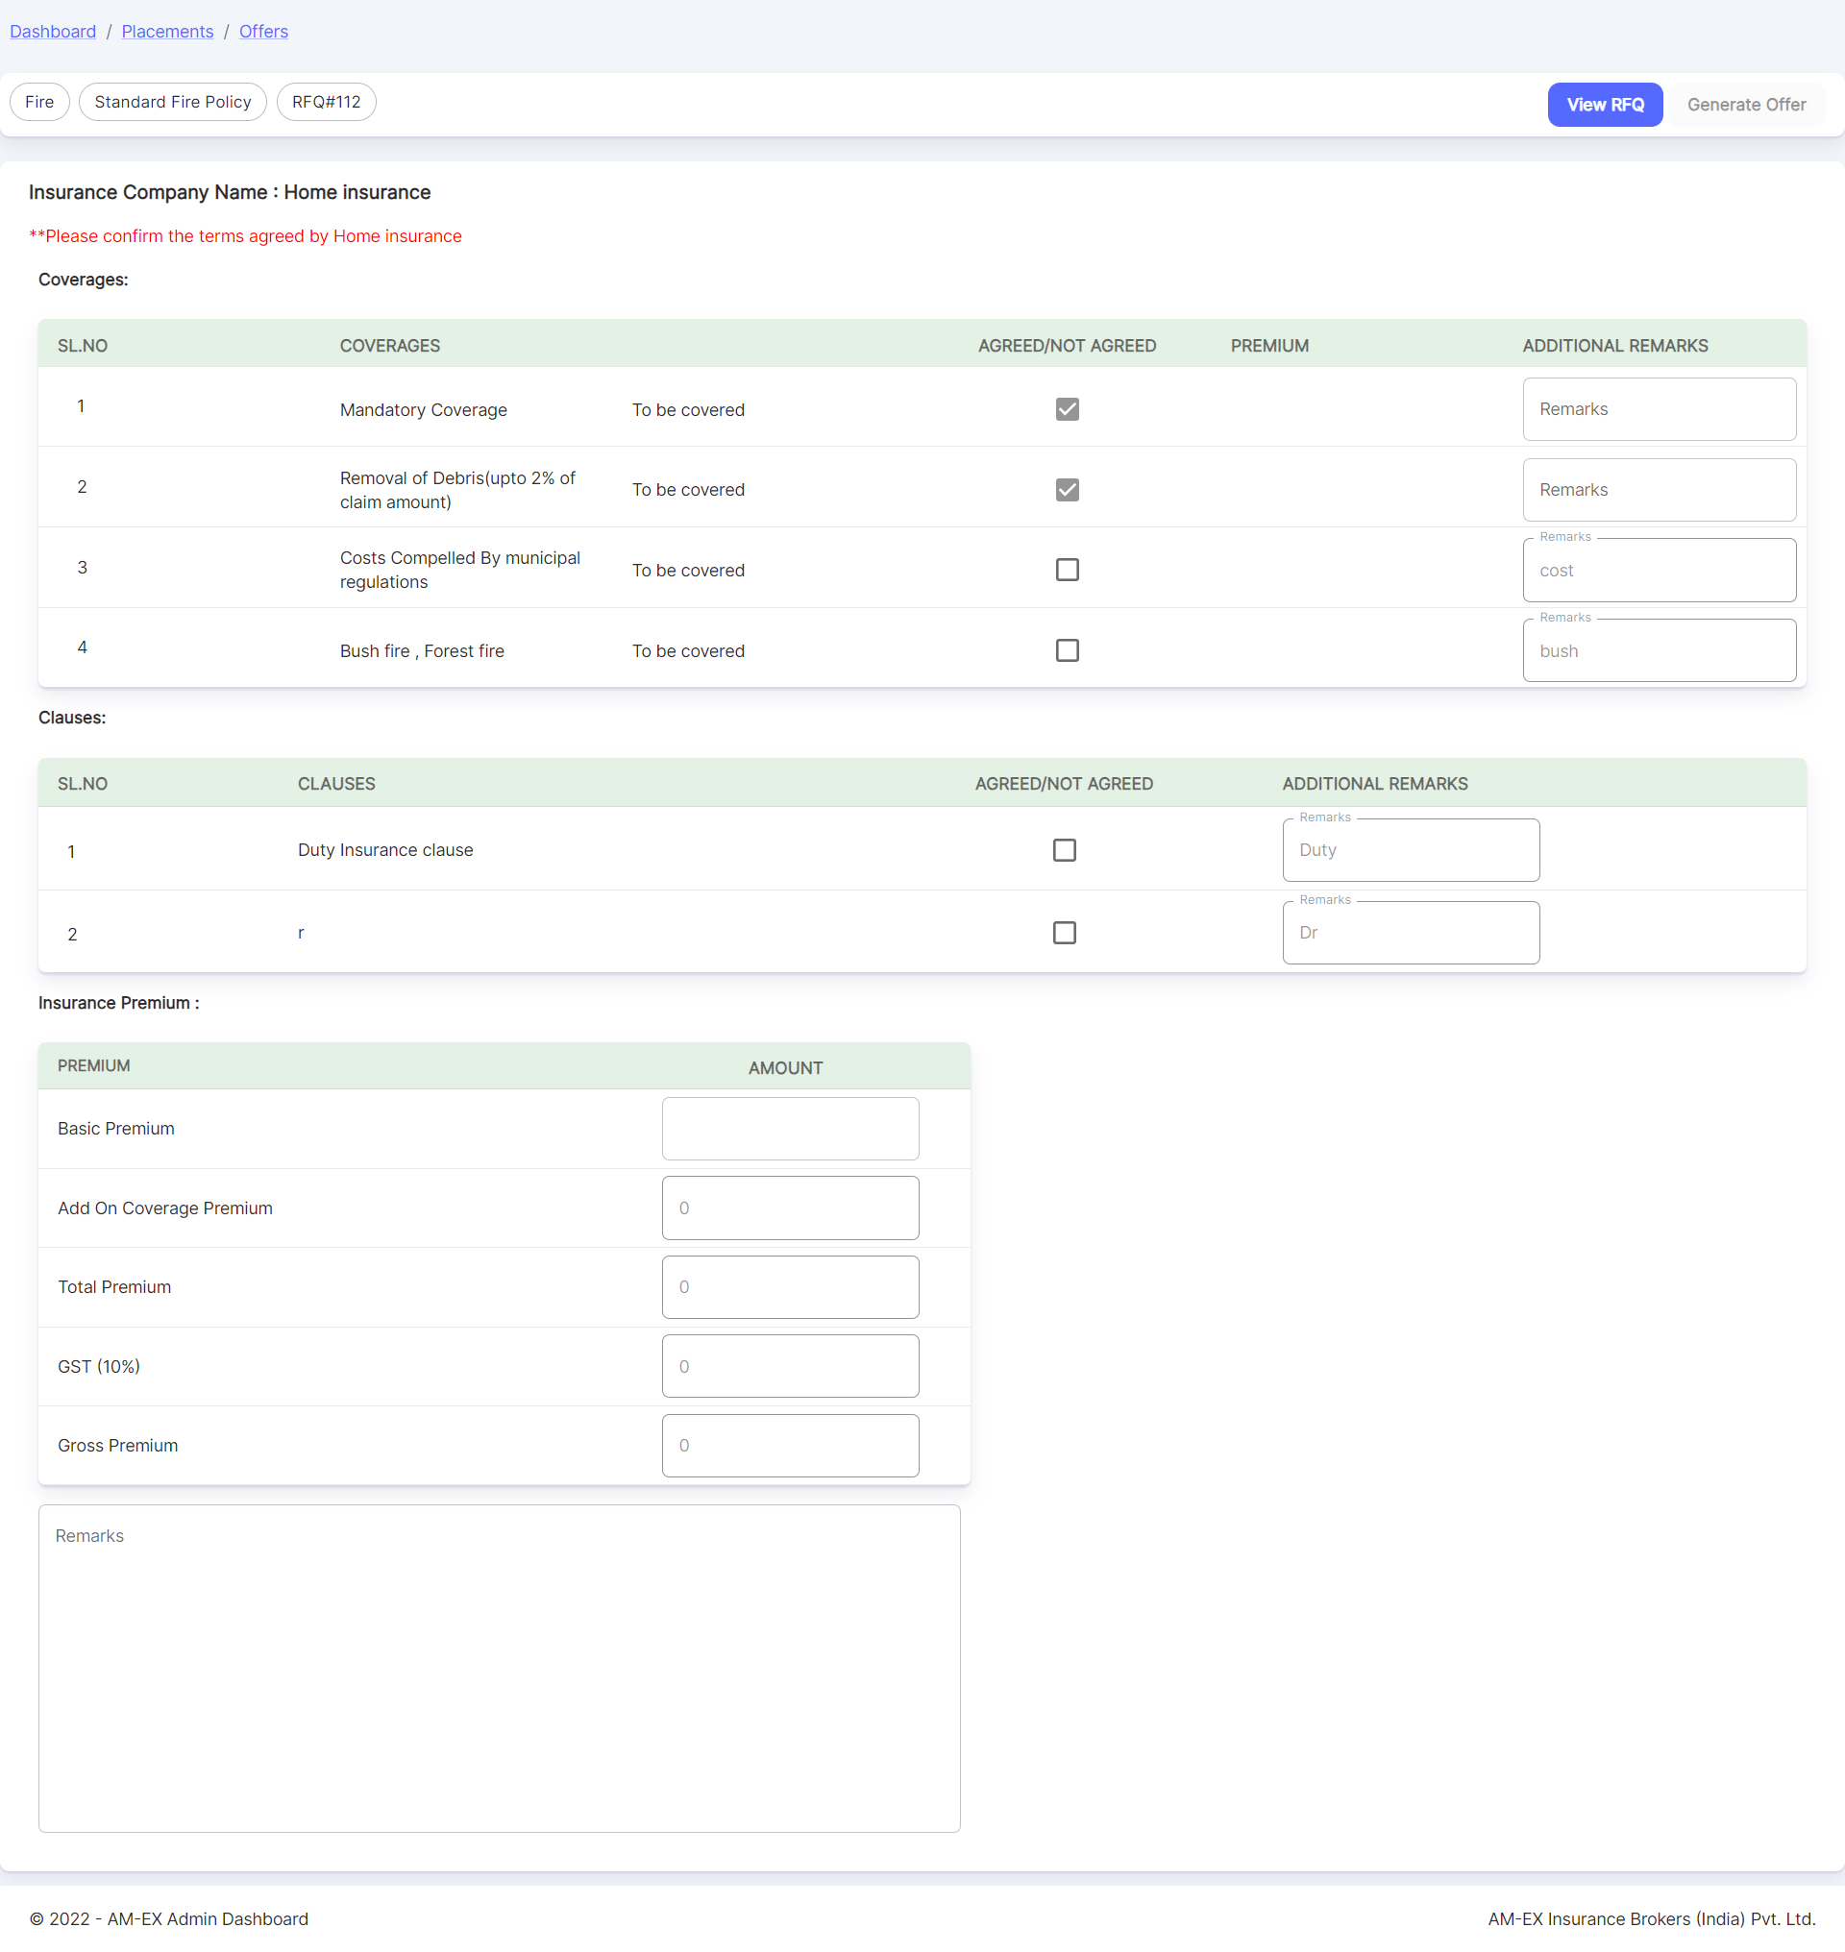

By clicking **View RFQ**, all the details associated with the respective RFQ will be displayed in a separate tab as shown below.

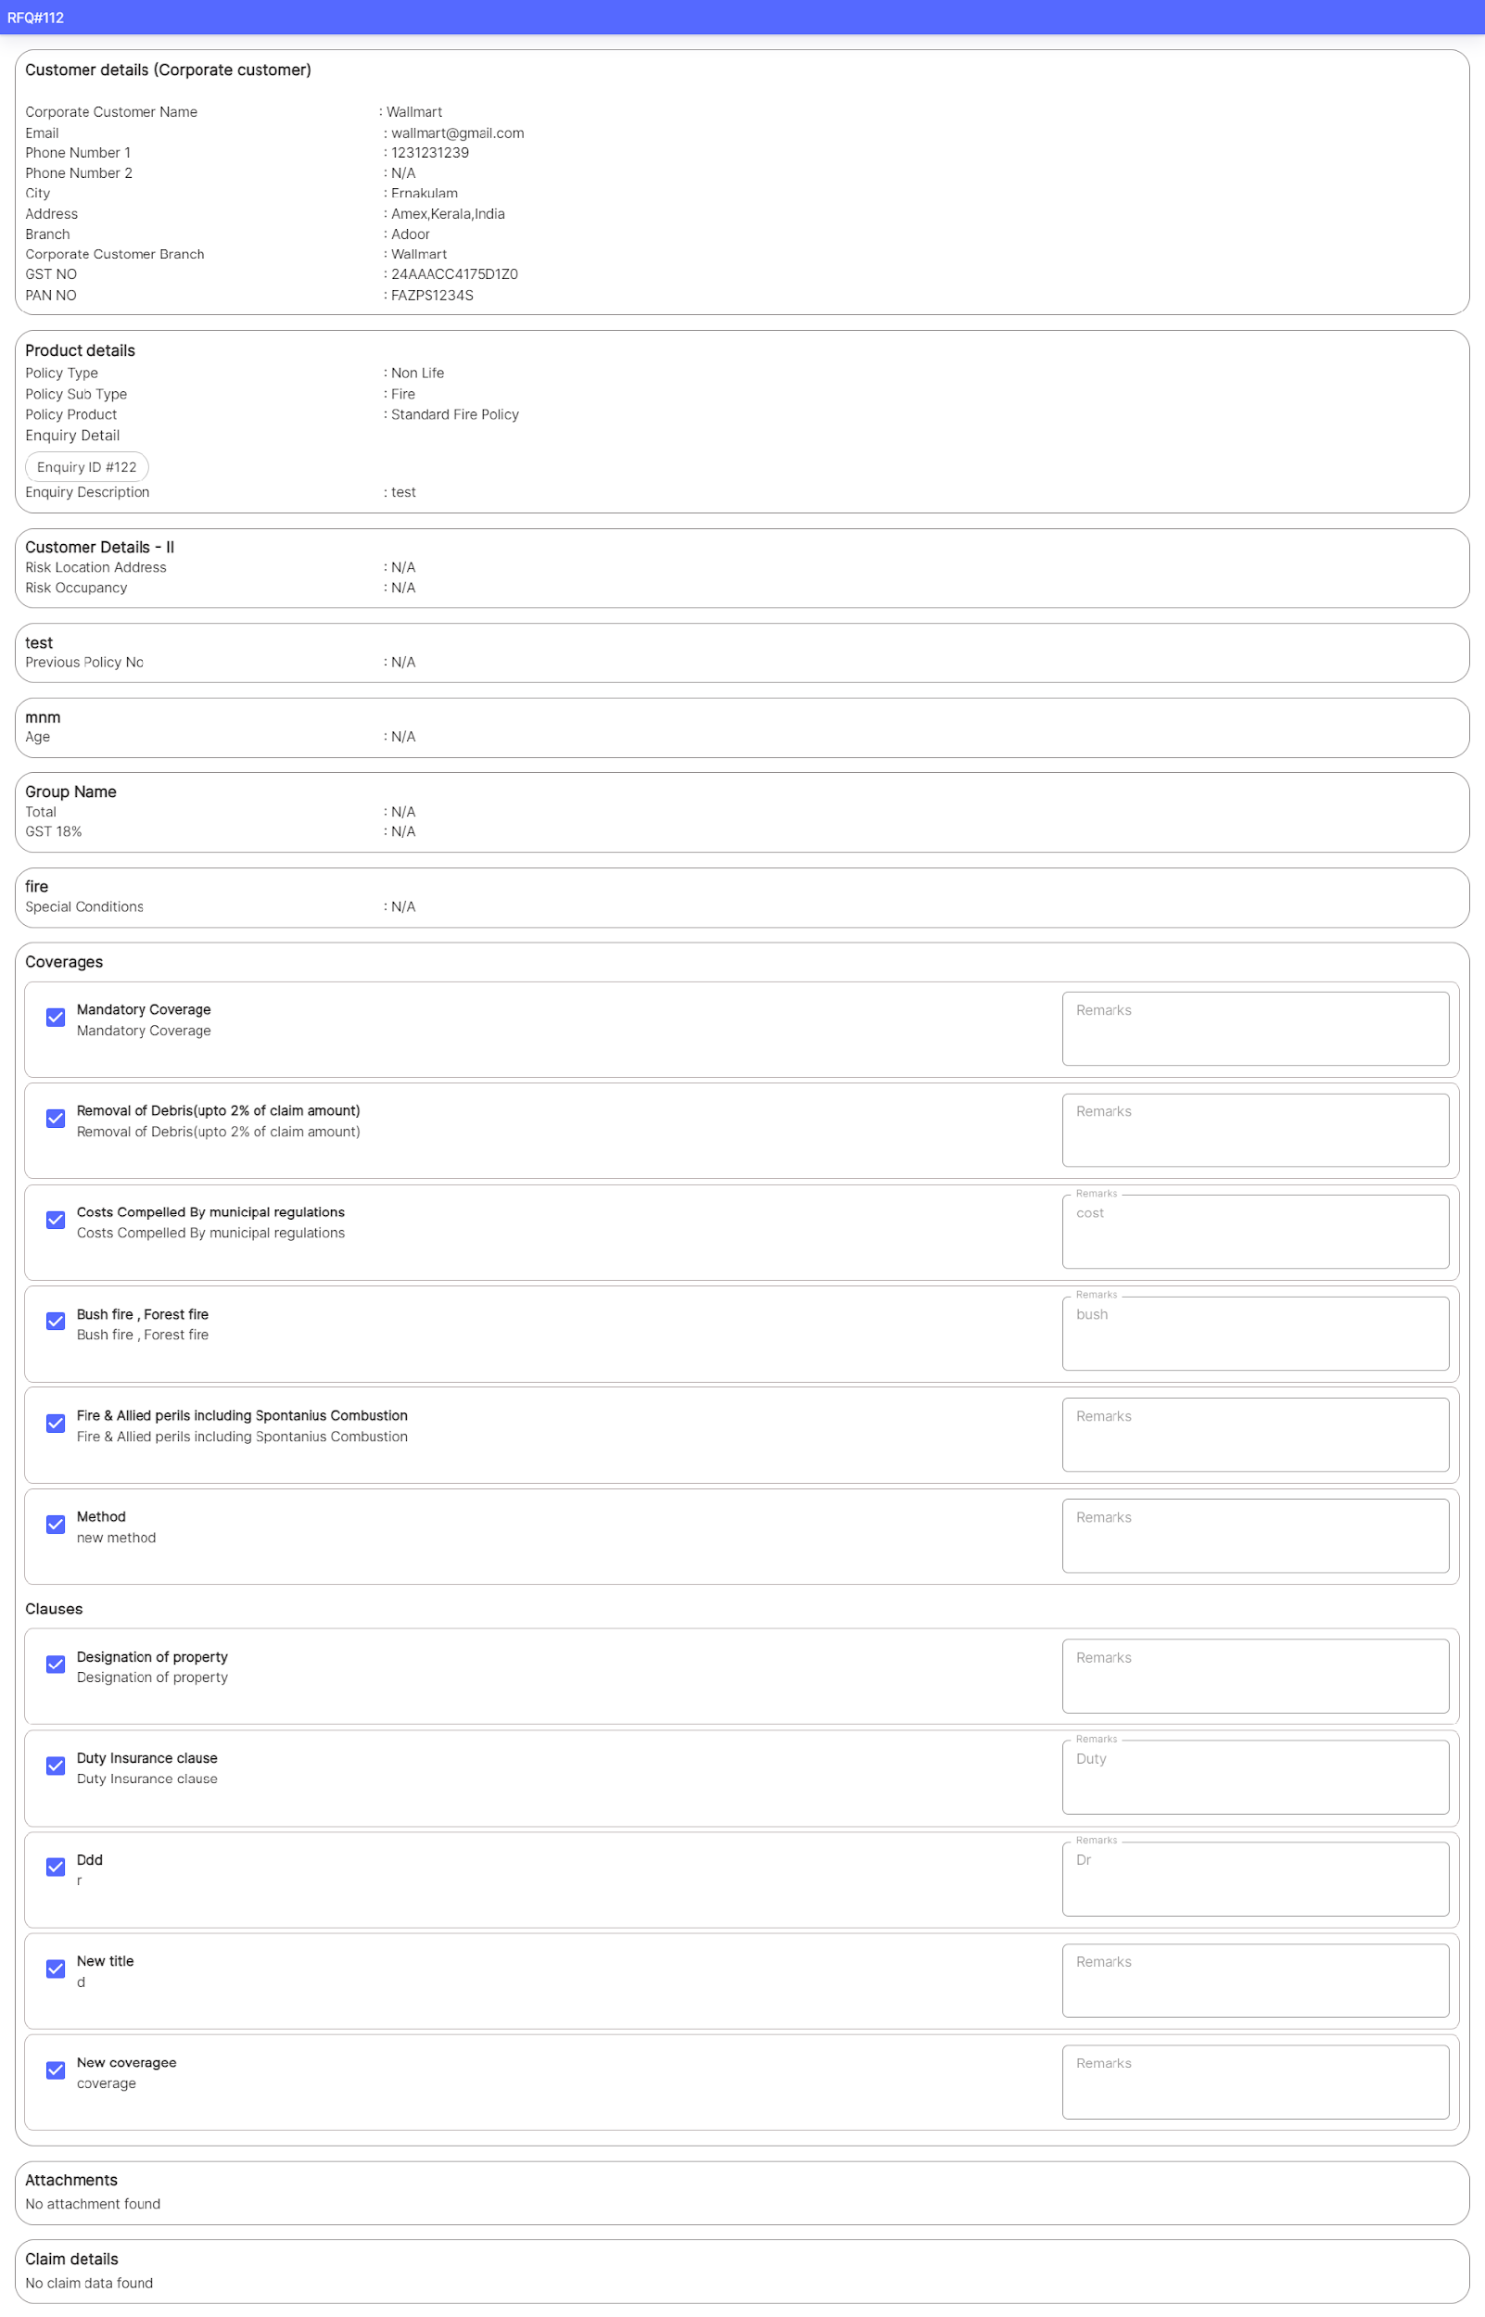

Once Generate Offer is selected, then Offer Count is updated!

**(current UI in application below screenshot)**

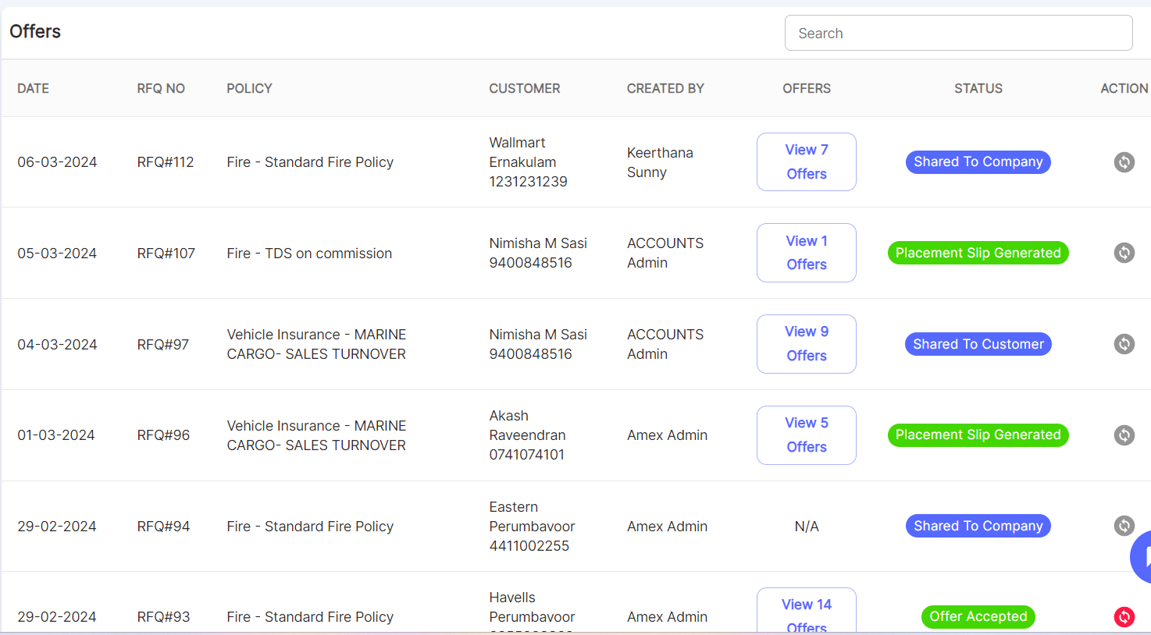

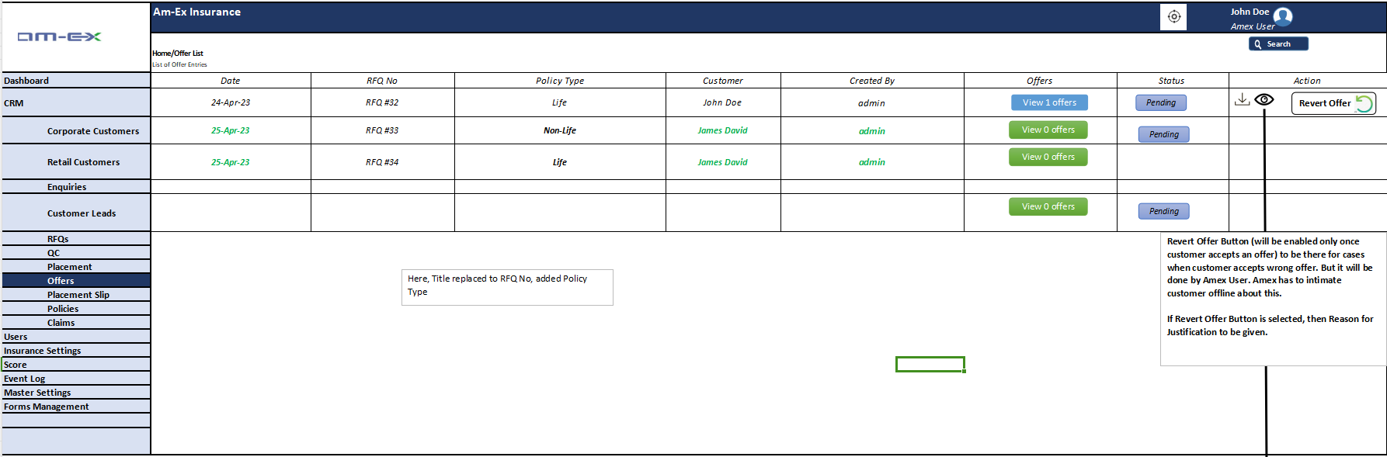

When **View** is selected against an RFQ Offer, it will take us to the below screen with list of offers:

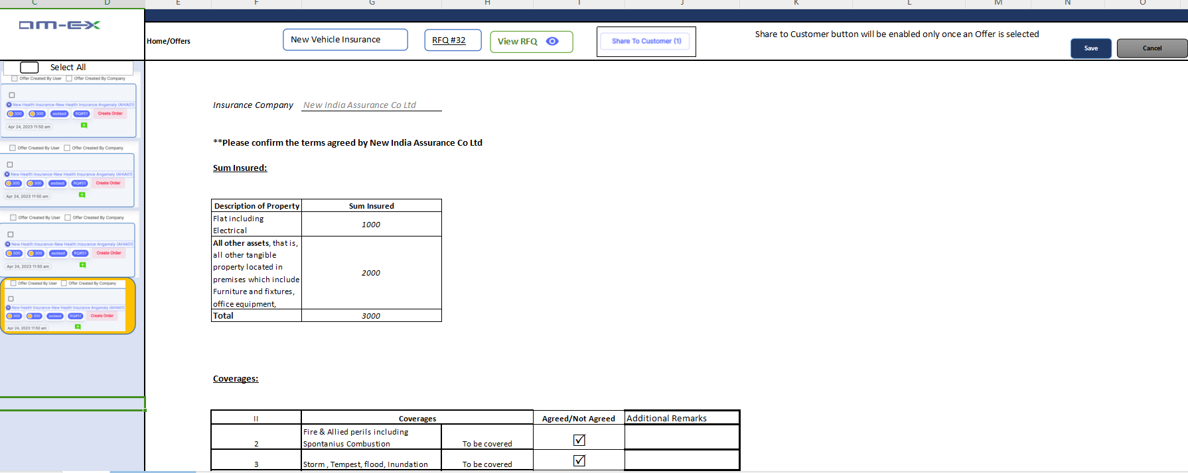



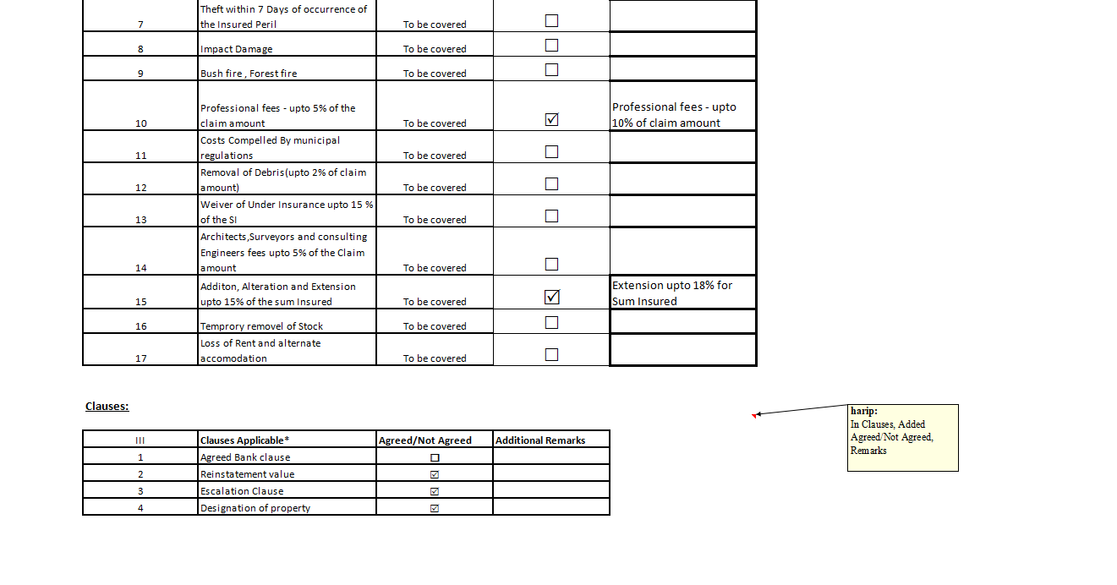

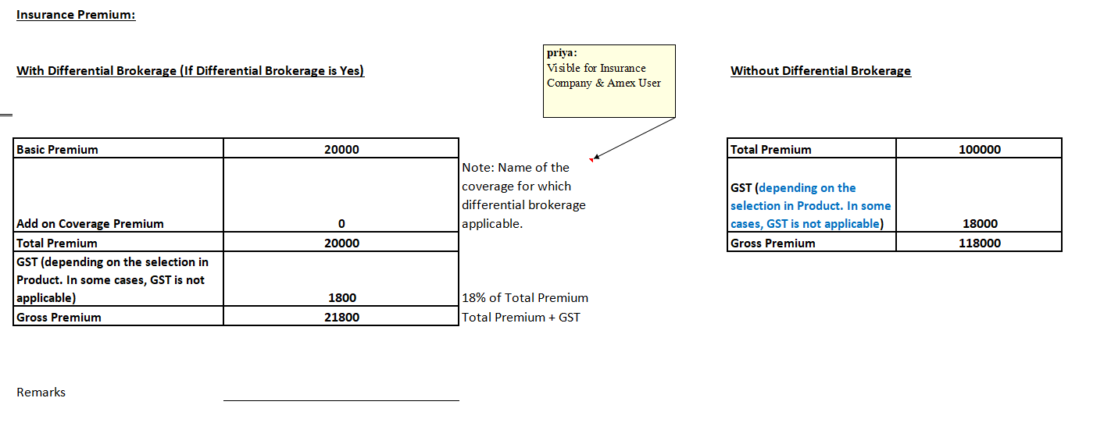

When User clicks on Offer Count (eg: View 7 offers), the below screen appears:

It will show all the offers generated against the respective RFQ.

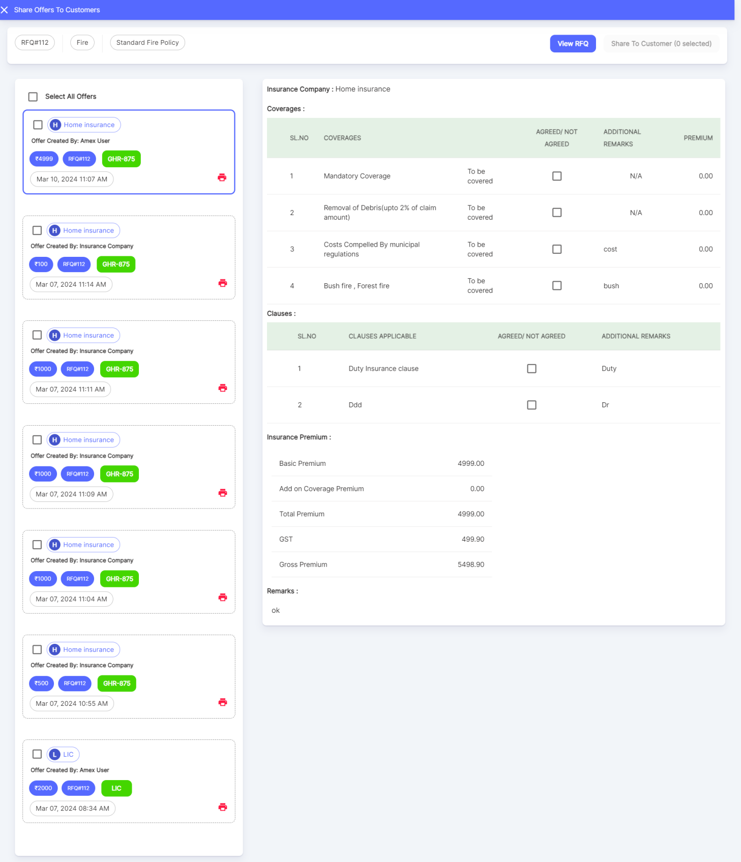

Once an Offer is selected, then only the Share to Customer button is enabled.

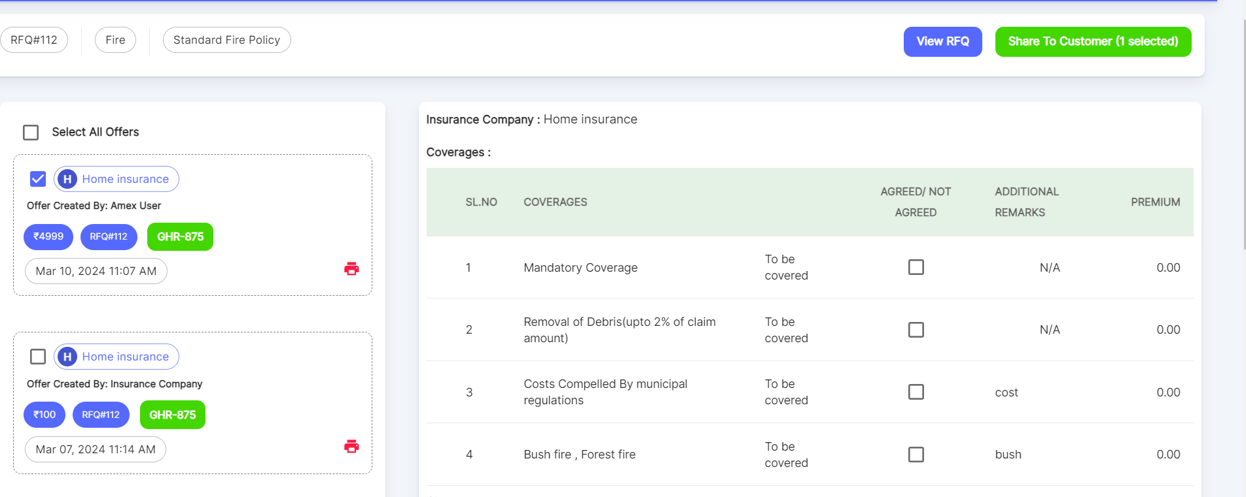

When Share to Customer is selected, below screen appears:

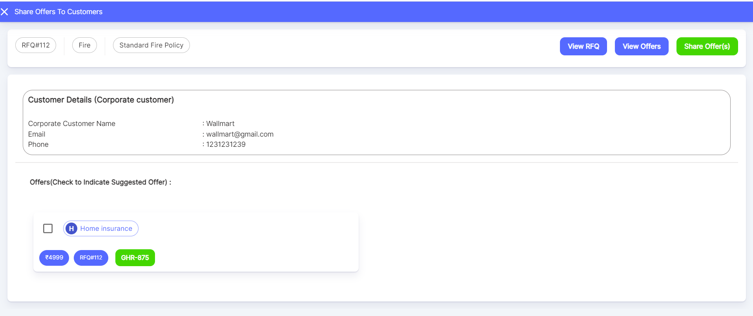

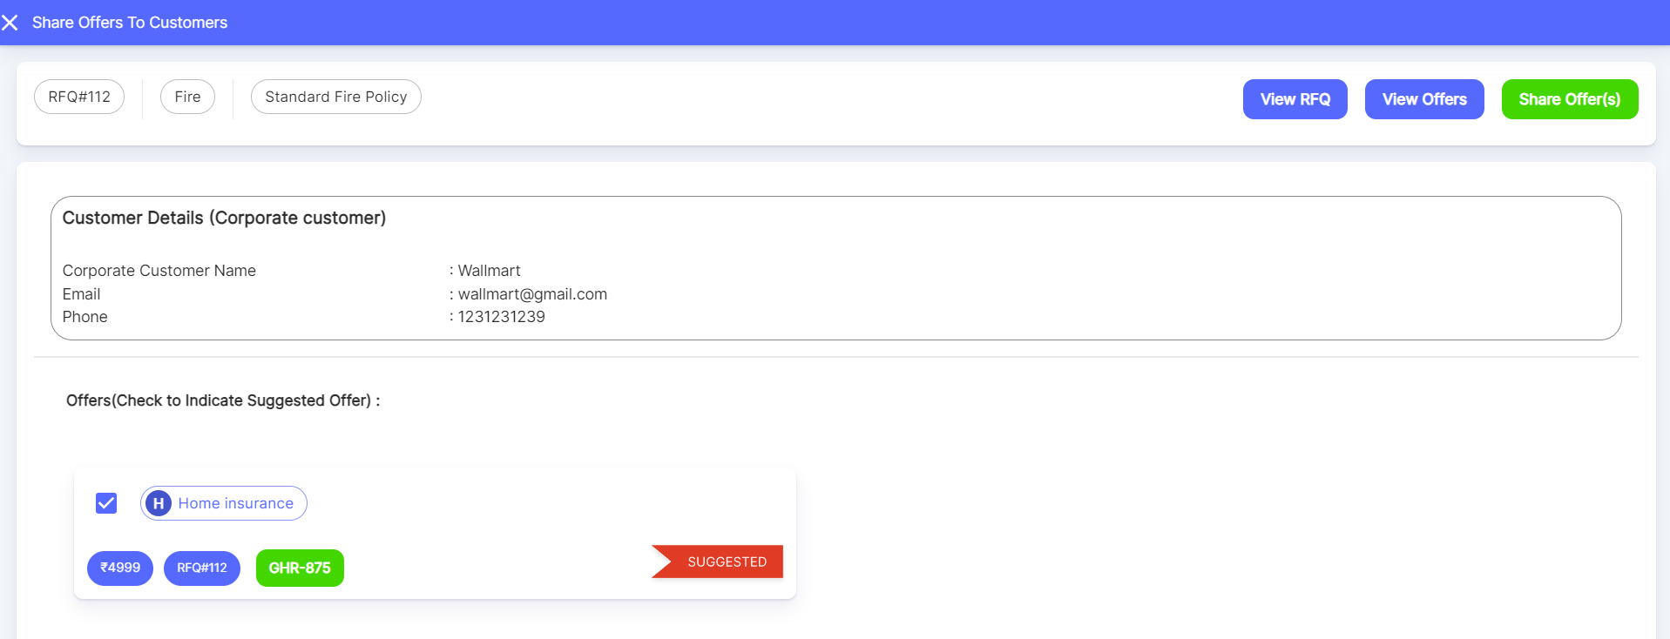

If we wish to send this as a Suggested Offer, then click the check box.

View RFQ will show the details of RFQ as a separate tab. View Offers will show the Offer details within the same page.

Once Share Offer is selected, offer will be shared to the customer.

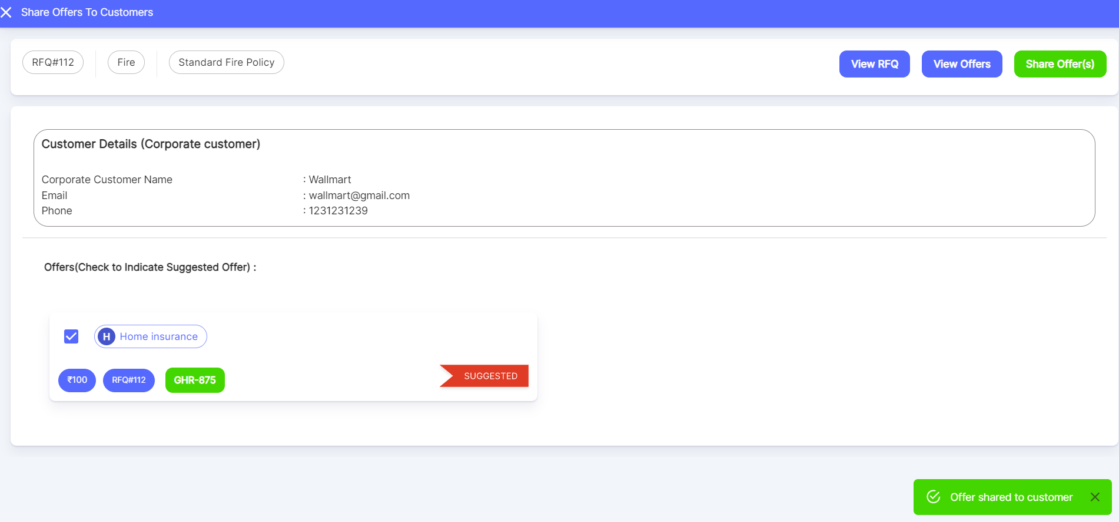

Once an offer is shared, it will display in the UI as below: The details will be sent to Customer email once an offer is shared.

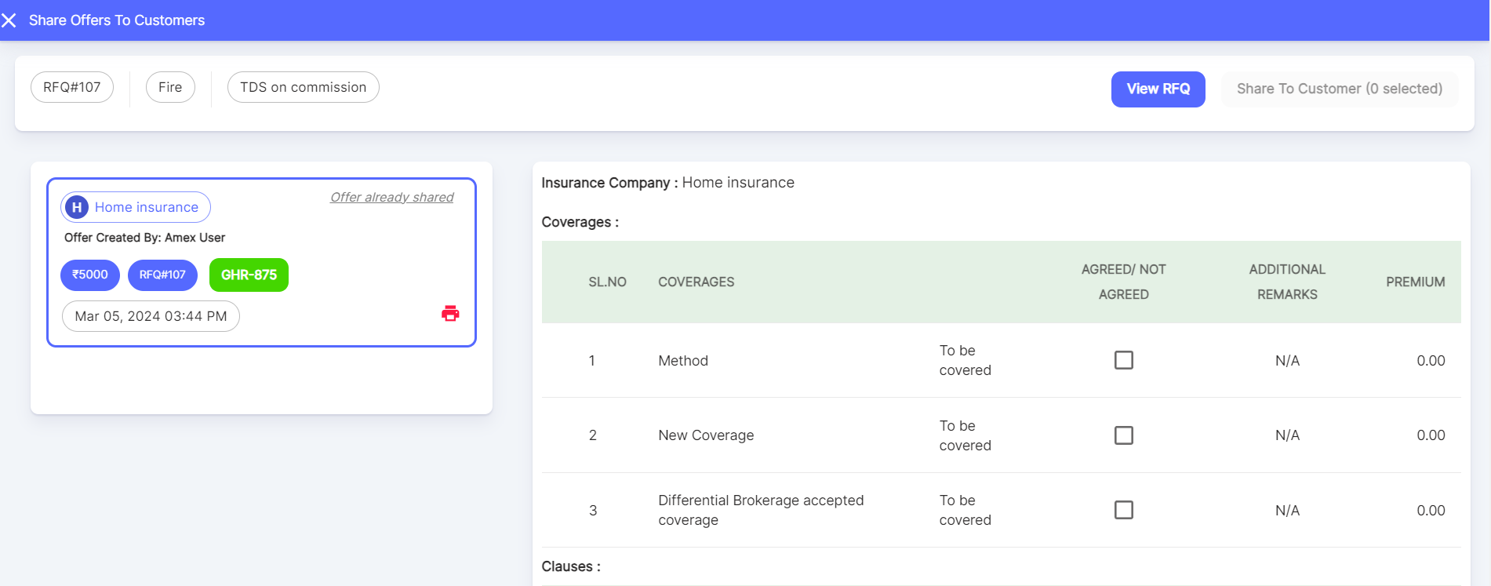

Client Query: Will there be a provision to provide a link to the insurance co. to provide us with the quote?

Based on the discussion with the client at this phase, Amex users require permission to manage the quote. We can provide this provision to the insurance company in the next phase.

The offers received along with a Suggested Offer can be shared to Customer.

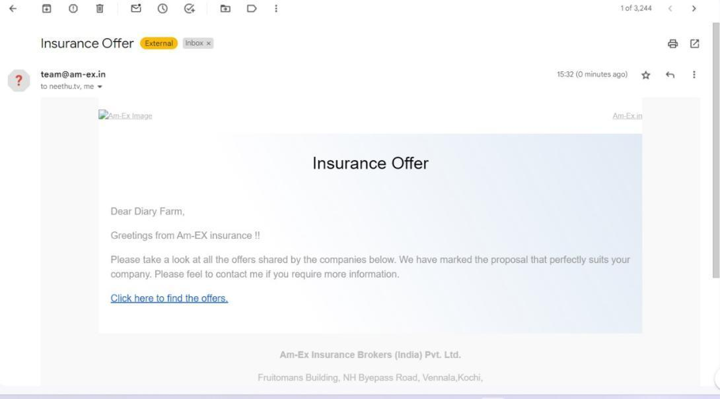

Once the offers are shared to the Customer, then they can select an Offer by clicking the email link.

When Customer clicks on the link, then it opens in a separate tab as Comparison View of Offers shared by different Insurance Companies

Offers - Comparison View

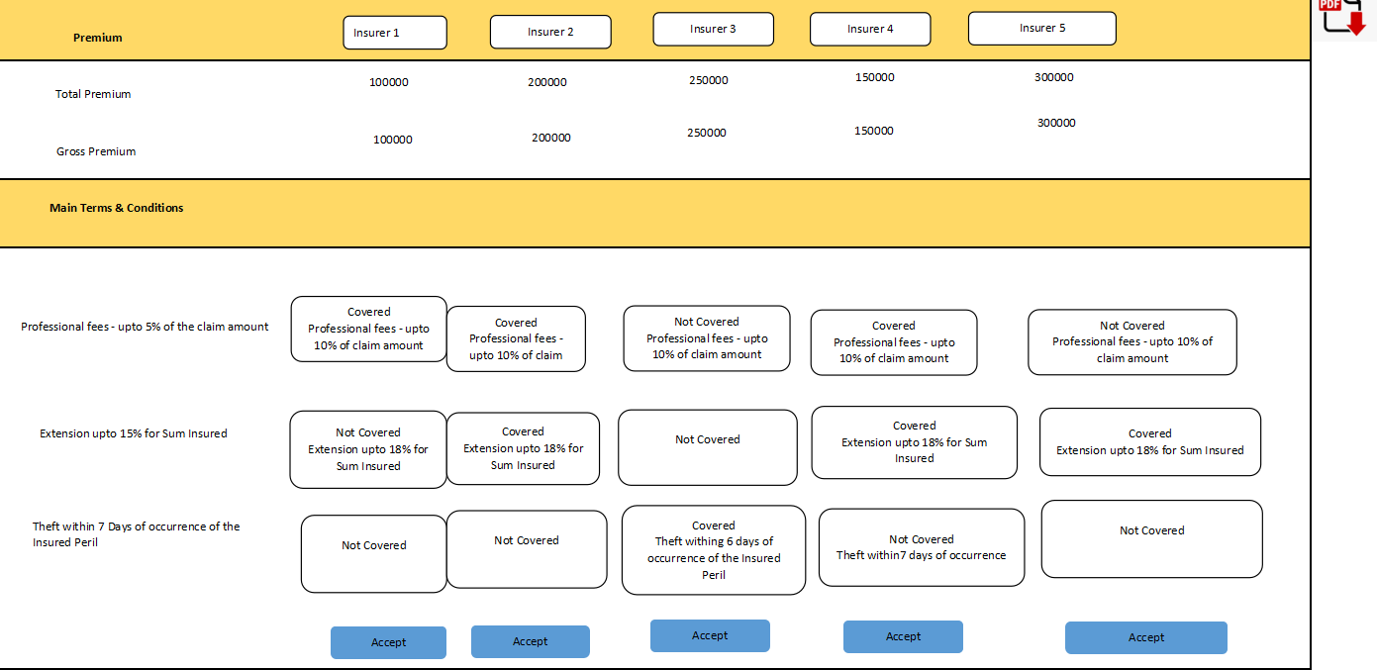

Current UI - Offer Comparison (This screen is visible to customers only. When a customer clicks on the offer link from email, it will ask for OTP and then this screen will appear).

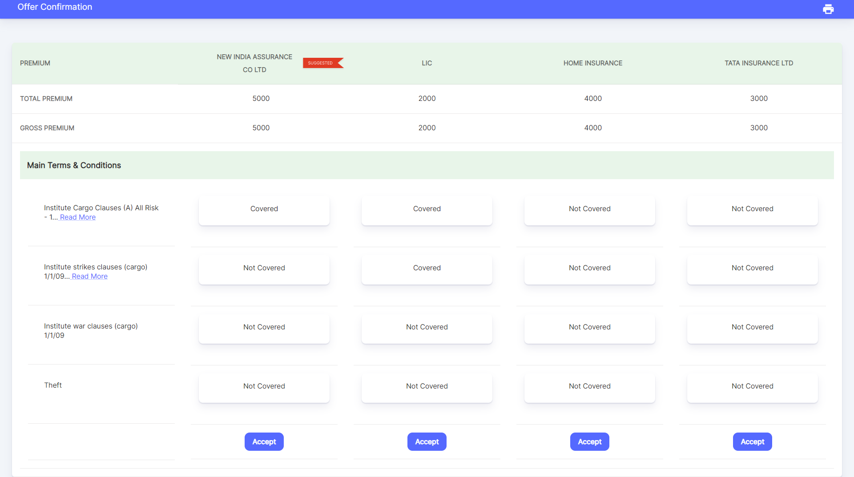

Note:

All Coverages related to the respective RFQ will be displayed in the Comparison View.

Clauses & Coverages which are enabled as mandatory in Product, cannot be unticked in RFQ

There should be a PDF download feature for the offers either as a Print Preview with download pdf feature.

Only customers can accept the offer from a comparison view. Display all coverages with agreed/not agreed

Once accepted, the placement button will be enabled against the accepted offer.

Once Accepted, notification should be sent to the person who sent this offer (Amex User)

Once an Offer is Accepted, then the rest of the Offers will be greyed out. Then In Placement Slip, Create Placement Button will be enabled against the Accepted Offer.

If offers are not accepted, then revised offers to be sent. Editing should be possible until an offer is accepted.

Once an offer is accepted, no editing is possible for any of the offers against the respective RFQ

Client Query: Once an offer is generated what is the mode of sharing while clicking the share option?

Response: Generated Offer Comparison should be shared to the Insured. Need to send a link via email and it will be a web link with OTP login via email. We will display the Offer Comparison in the redirected link and Insured should be able to accept an offer from the comparison sheet. Download as PDF feature should be given.

Client Query: Is there a link sent to the customer to select and approve the offer from the customer side itself using OTP?

Yes, there is a link sent to the customer as a Comparison View. Using it, customer can accept the offer from the comparison view.

* 1. **Placement Slip:**
* A Placement Slip in insurance refers to a document that is used in the process of placing an insurance policy or coverage with an insurance company.
* It is typically used in the context of reinsurance, which is a form of insurance that insurance companies use to transfer a portion of their risk to other insurance companies, often called reinsurers.
* Once the Customer wishes to select an Offer out of all the offers shared, then they can confirm the offer that needs to be placed.

Once an Offer is accepted, then only the **Create Placement** button will be enabled against the Accepted Offer (**In Offer Screen**).

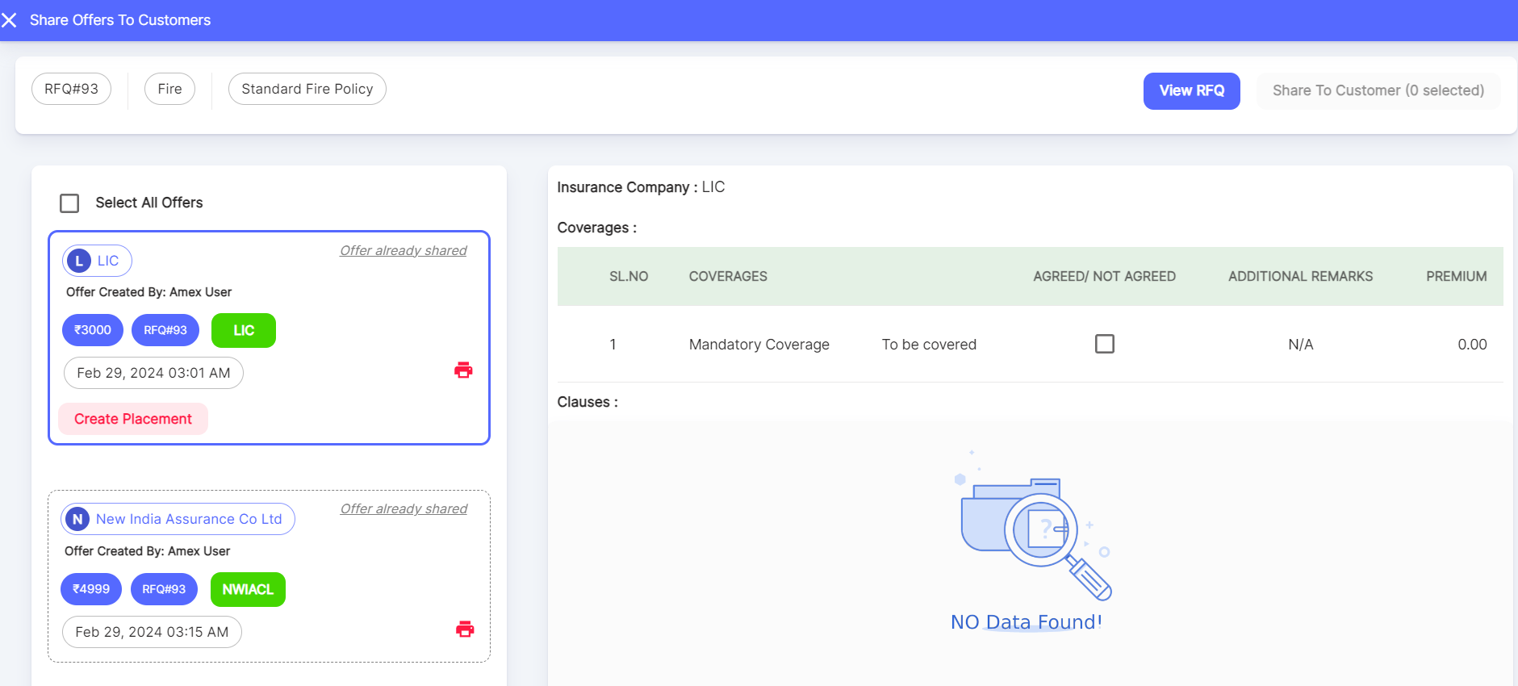

When Create Placement is selected, below screen appears:

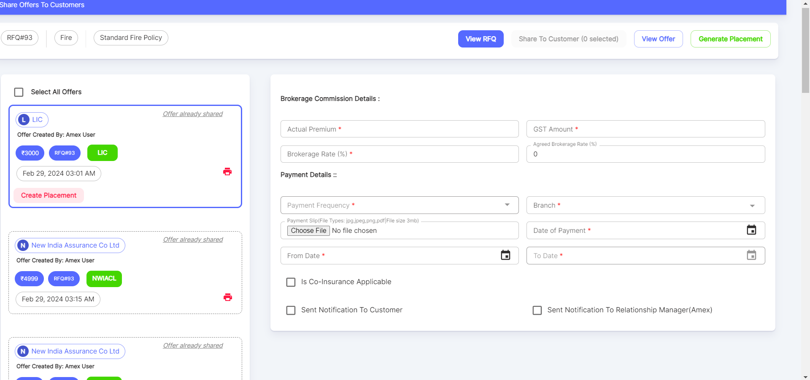



(MockUpScreens-PlacementSlip)

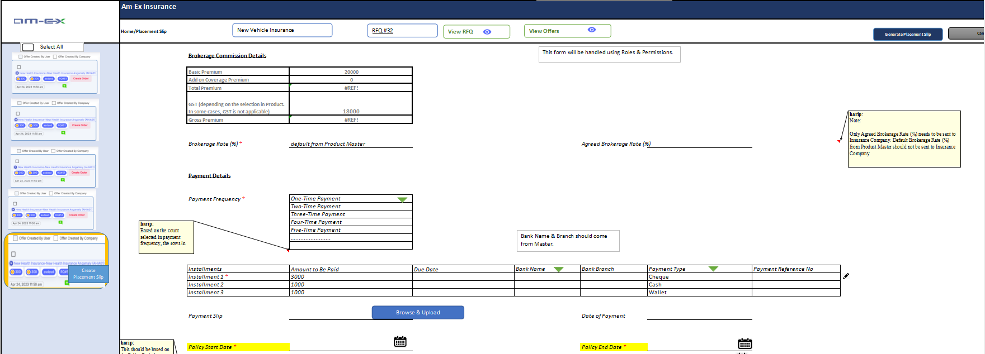 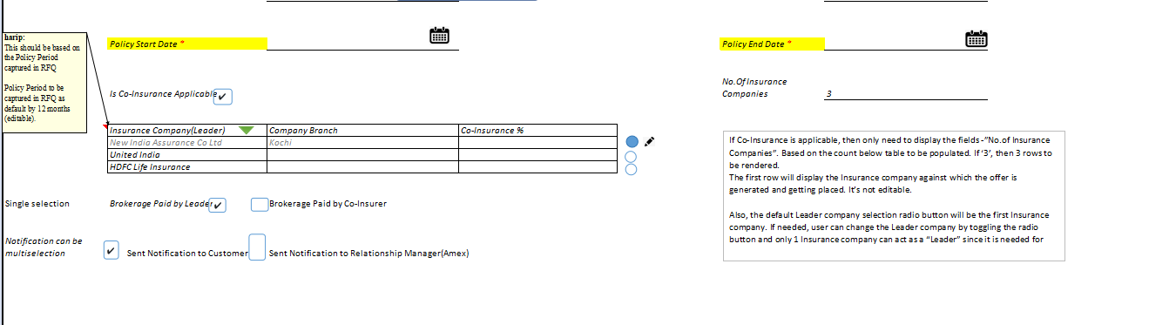

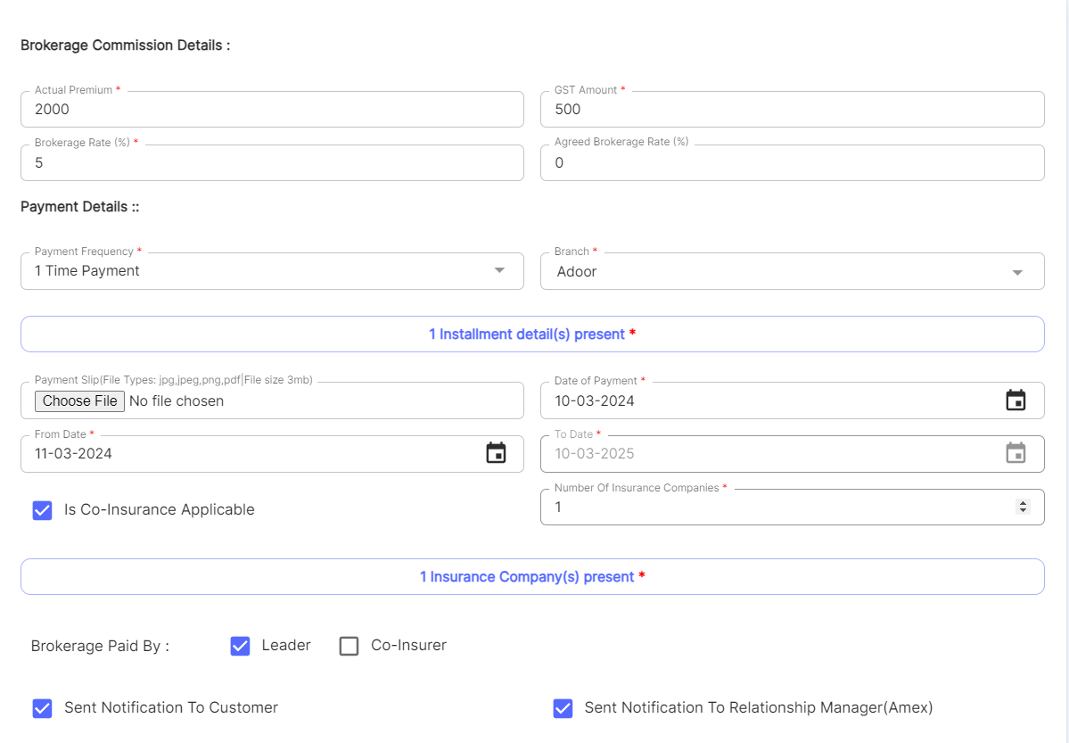

(The Brokerage commission section UI will change. It will be like the mock up screen added above)

When Generate Placement Button is selected, the below pop-up appears:

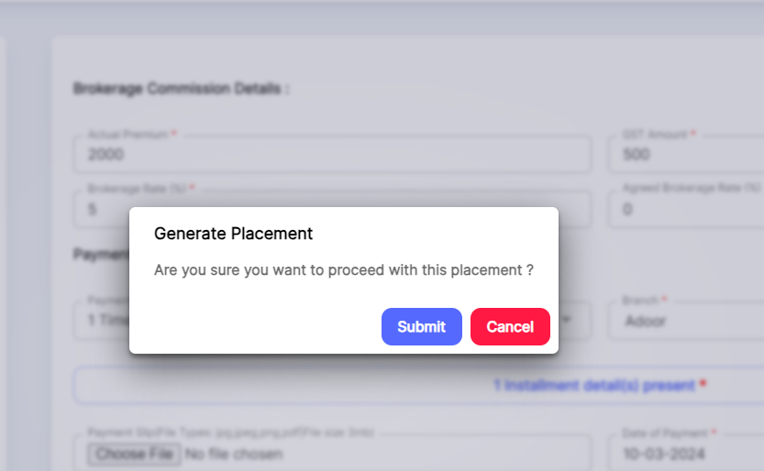

Once Submitted, the RFQ #93 will appear in the Placement Slip List.

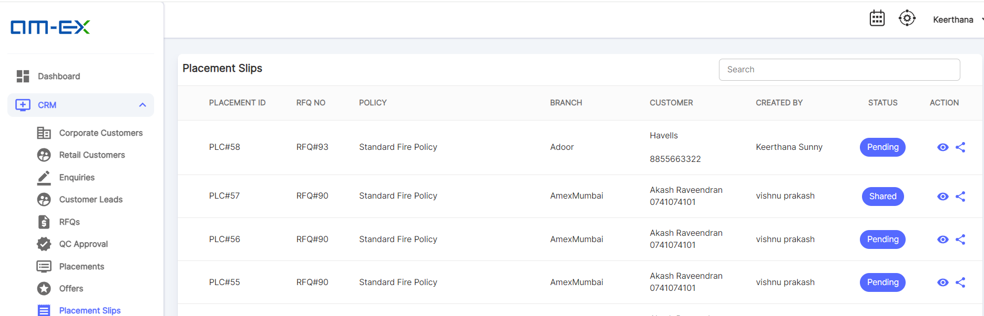

When Share button is selected, below screen appears:

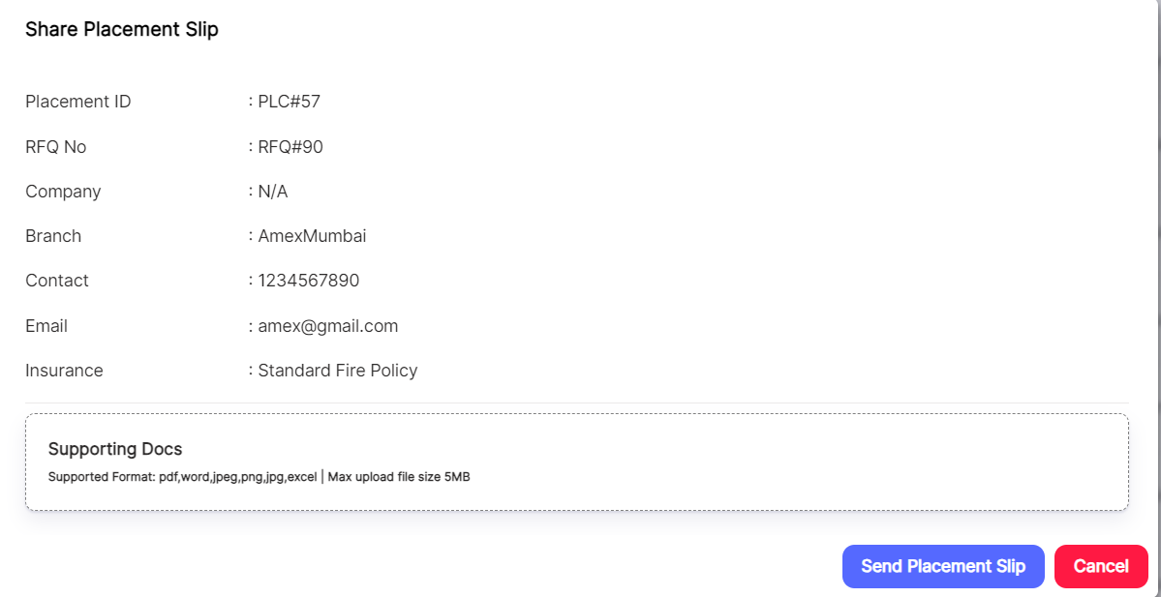

When Send Placement Slip is selected, below screen appears:

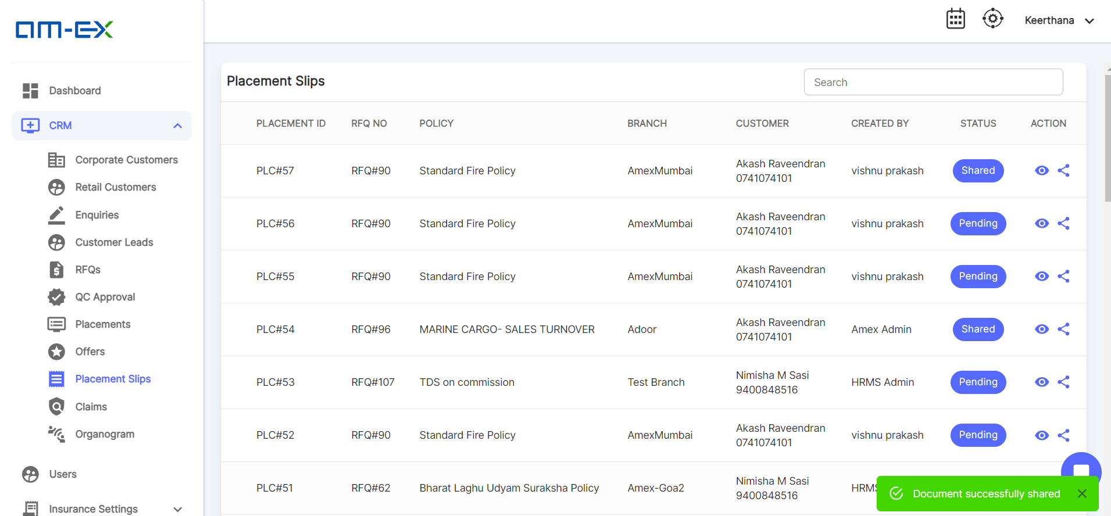

When **View Placement Slip** is selected, below screen appears with the RFQ Details, Offer Details & Placement Slip Details:

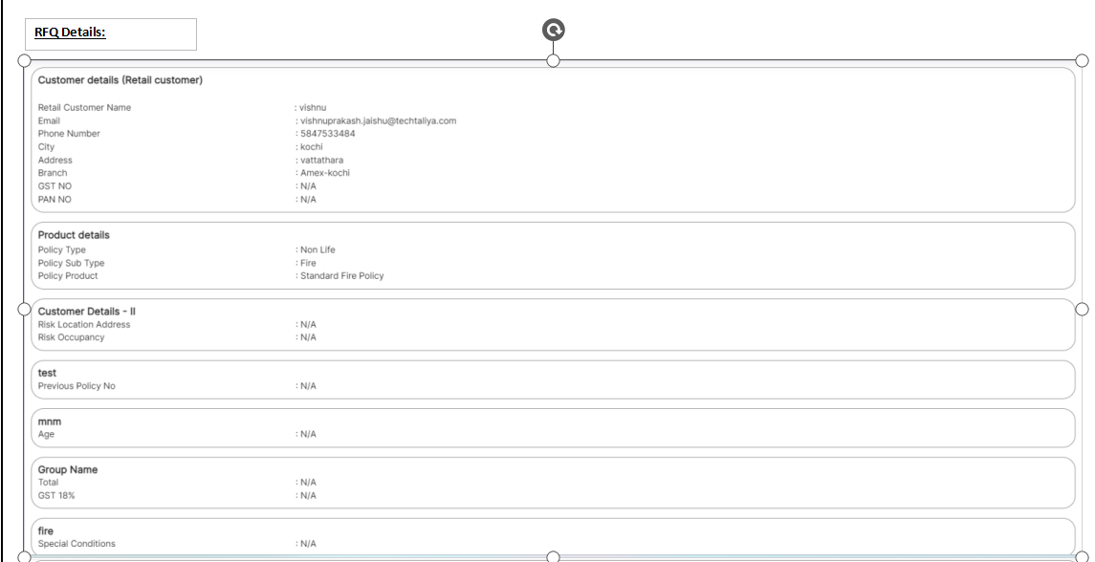

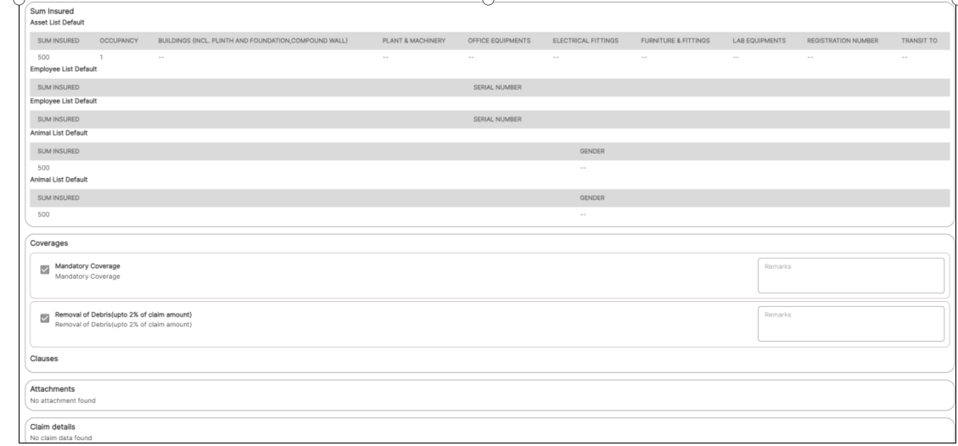

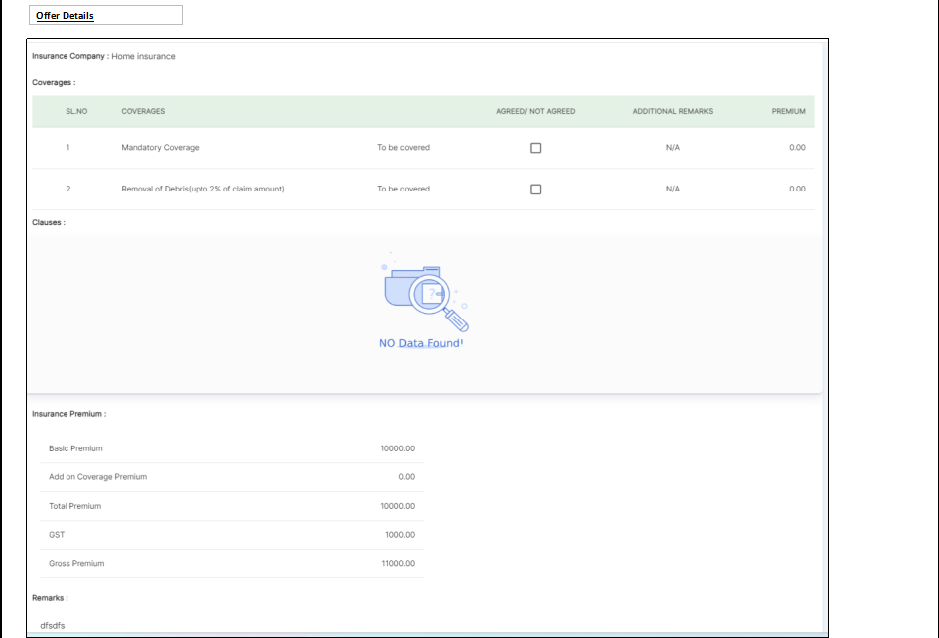

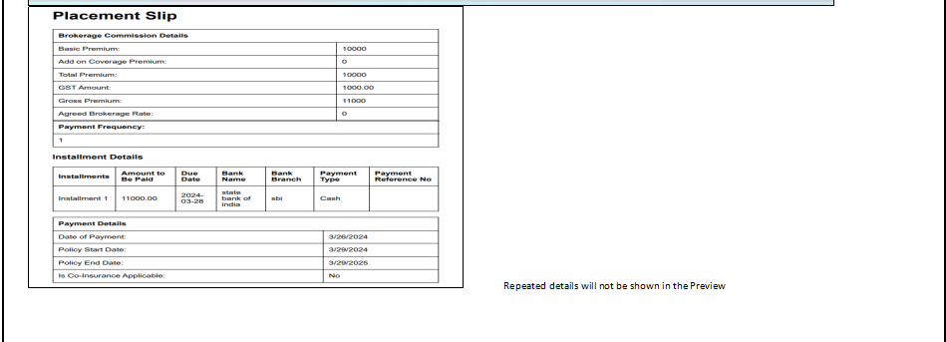

There is a PDF download feature and Print option as well.

* After the Offer gets placed, then a Placement Slip needs to be generated which will be kept as a final reference for Policies and further procedures.
* In the Placement Slip, all details regarding the RFQ, Brokerage details, Payment details etc should be there. Keep Placement ID as a reference.
* Placement Team can share this to the Insurance Companies.

Apart from the basic RFQ details, the other details are Brokerage, Payment Details as shown in the above screenshots.

Here are the general steps that follow the generation of a placement slip:

* Underwriting: On receipt of the placement slip, insurance company will issue the policy as per agreed terms. The actual Underwriting happens while RFQ is received by the insurance co. and only a procedural thing happens at policy creation.
* Policy Issuance: If the underwriting process is successful and the insurer decides to provide coverage, a formal insurance policy is issued. The policy document is prepared based on the information gathered during underwriting, and it includes all the specific details of the coverage.
* Premium Payment: The policyholder is required to pay the premium as specified in the policy document. The premium is the cost of the insurance coverage, and the payment terms and frequency (monthly, annually, etc.) are outlined in the policy.
* Policy Delivery: The insurance company delivers the policy document to the policyholder. This can be done electronically or through a physical copy, depending on the insurer's practices and the preferences of the policyholder.
* Review and Understanding: It is crucial for the policyholder to carefully review the policy document. They should ensure that they understand the coverage, the limitations, the exclusions, and any other terms mentioned in the policy. If there are any questions or concerns, the policyholder should contact the insurer or their insurance agent for clarification.
* Effective Date: The policy specifies the effective date of coverage, which is the date from which the insurance protection starts. The policyholder should be aware of this date, as coverage for events that occurred before this date may not be provided.
* Claim Process: If a covered event or loss occurs during the policy period, the policyholder can initiate a claim according to the procedures outlined in the policy. The insurer will then assess the claim based on the terms of the policy and the circumstances of the loss. It's important for both the insurer and the insured to adhere to the terms of the policy and to communicate any changes or updates

Note: The placement takes place after payment is made and the insurance co. issues policy once they receive the placement slip

* + 1. **Policies**
* A policy is a legal contract between an insurance company (the insurer) and the policyholder (the insured).
* This contract outlines the terms and conditions under which the insurer will provide financial protection and compensation to the insured in the event of specified risks or losses occurring.
* The policy serves as a reference document for the claims process.
* It outlines the procedures the insured must follow to file a claim and specifies how the insurer will handle the claim, including the process for evaluating the loss and providing compensation.
* Note: Policy delivery will be to Amex, and Amex will give it to the customer after checking by QC team. In case of discrepancy, QC will interact with the insurer and effect required endorsements.

Please find the below screenshot to see how Placement is being done.

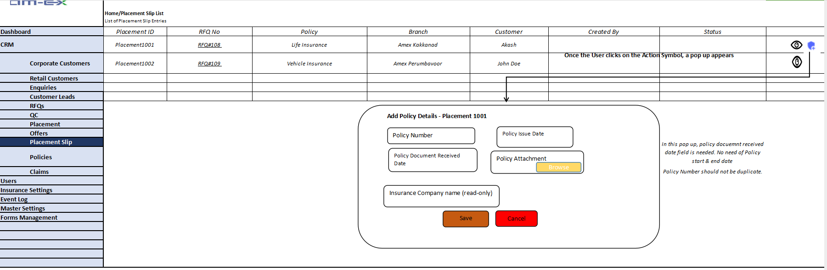

* The Placement Slip document will be used in the Policy.
* After filling the Policy details, it will get updated to the Policy document.
* Once Policy is generated, it needs to undergo QC Approvals. QC Status needs to be checked after changing the policy.

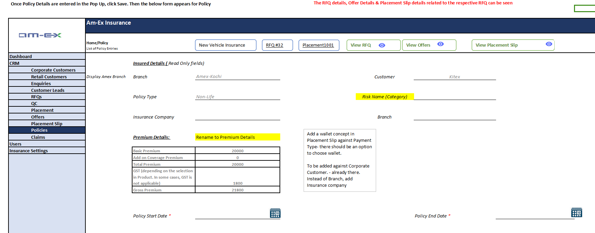

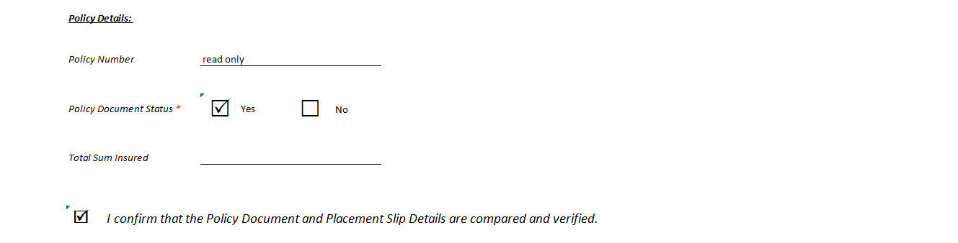

Once the Save button is selected, Policy details will be saved and it will appear in the Policy List.

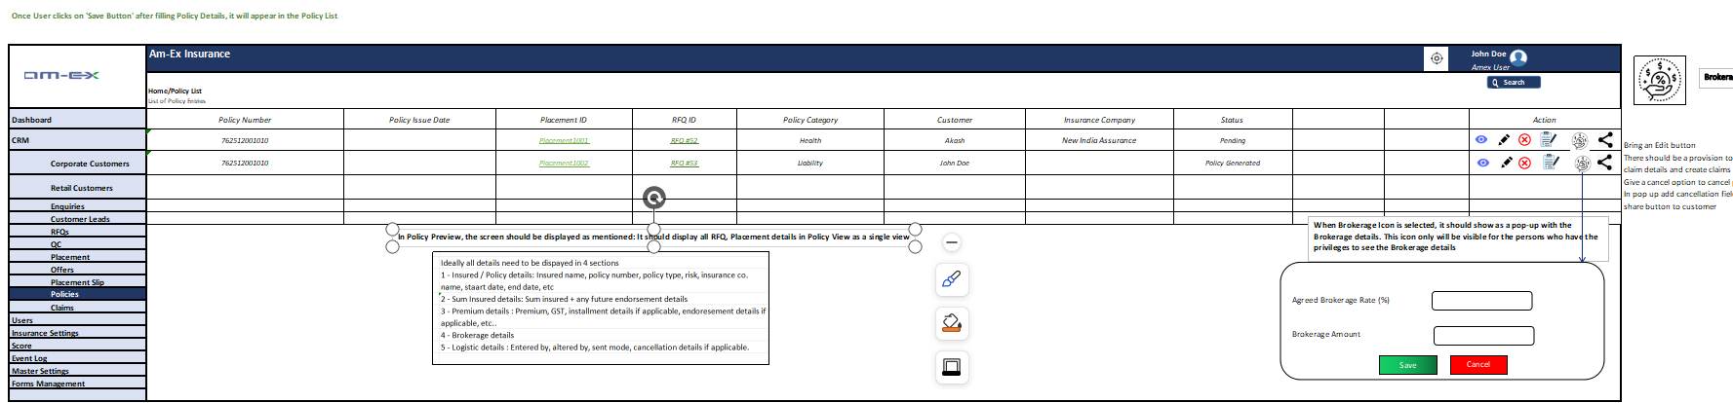

Please note that the Brokerage Icon will be visible to the person who has the privileges. For those who doesn’t have the privilege, this button will not

be visible.

When Edit icon is selected, the below form appears with some additional fields which are visible only in Edit Mode:

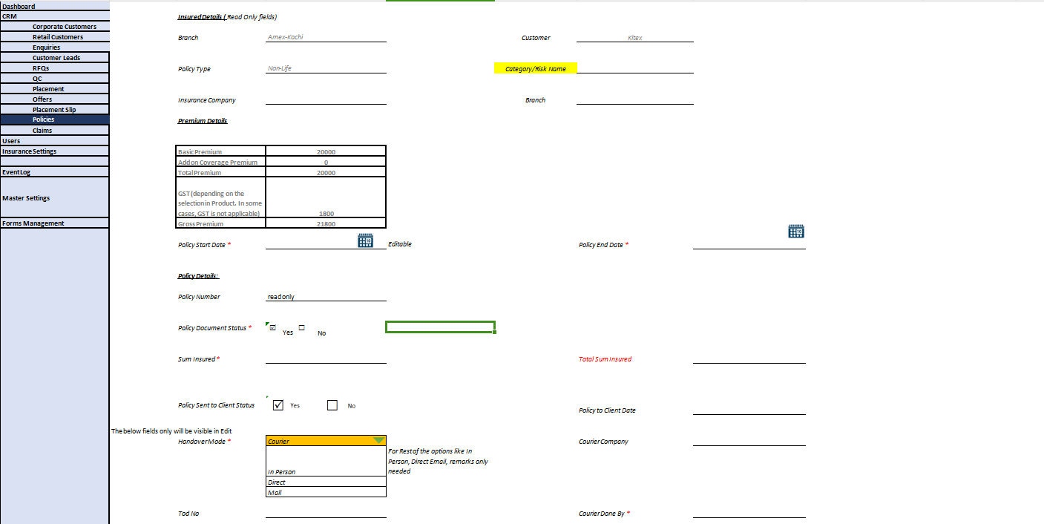

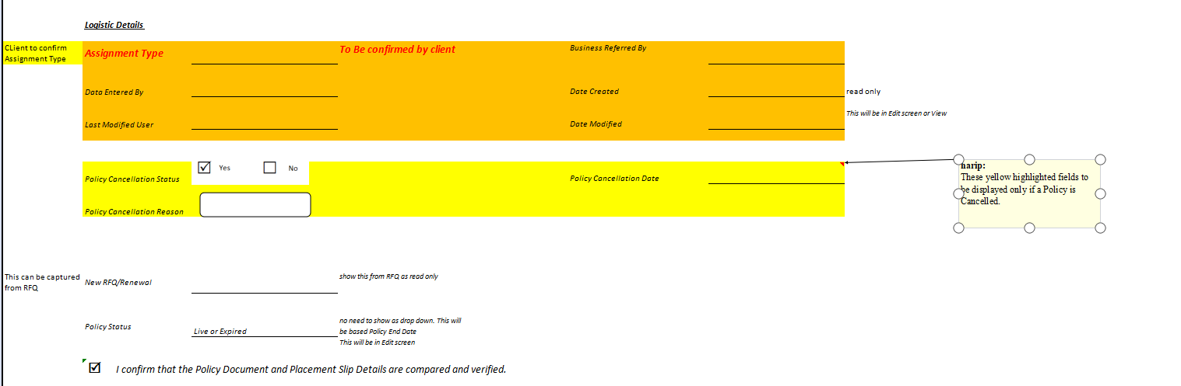

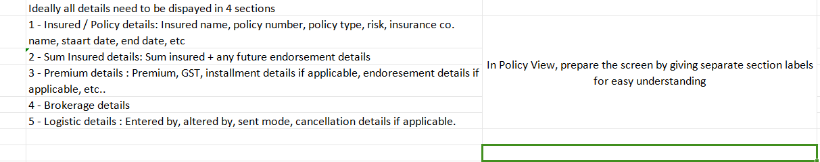

When Policy View is selected, it should display RFQ Details, Offer Details, Placement Details, Policy Details, Endorsement & Renewal Details









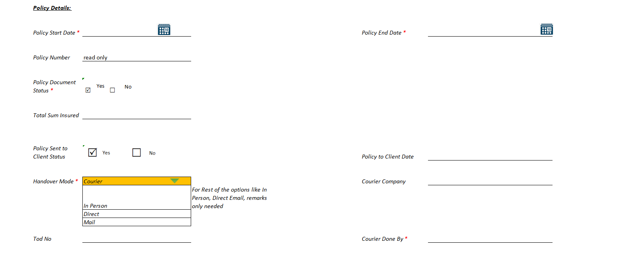

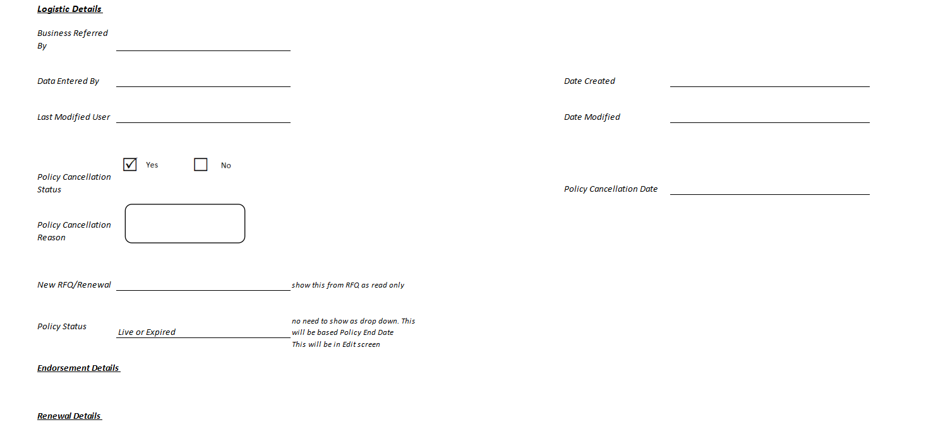

Once Saved, Policy will be generated & it will move to QC Approvals

Policy QC to be planned for next release only. For this release, until Policy Creation is planned as discussed and agreed in our client discussion on March 6, 2024

Policy QC, Claims, Endorsement & Renewal to be discussed & finalized

-----------------------------------------------------------------------------------------------------------------------------------------------------------------------------------------------------------------

* + 1. **Organogram**
* An organogram, also known as an organizational chart or org chart, is a visual representation of the structure and hierarchy of an organization.
* It shows the relationships between various roles, positions, departments, and individuals within the organization, highlighting how they are organized and how they interact with each other.
* 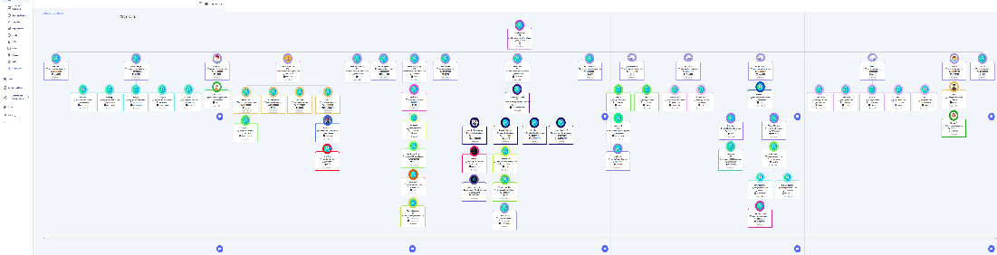

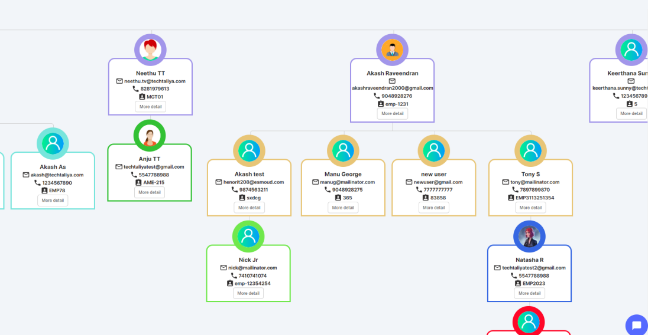

* 1. **Users**

In the Users Module, admin or the respective user with the privileges can add Users & capture the Personal Details, HR & Office Details.

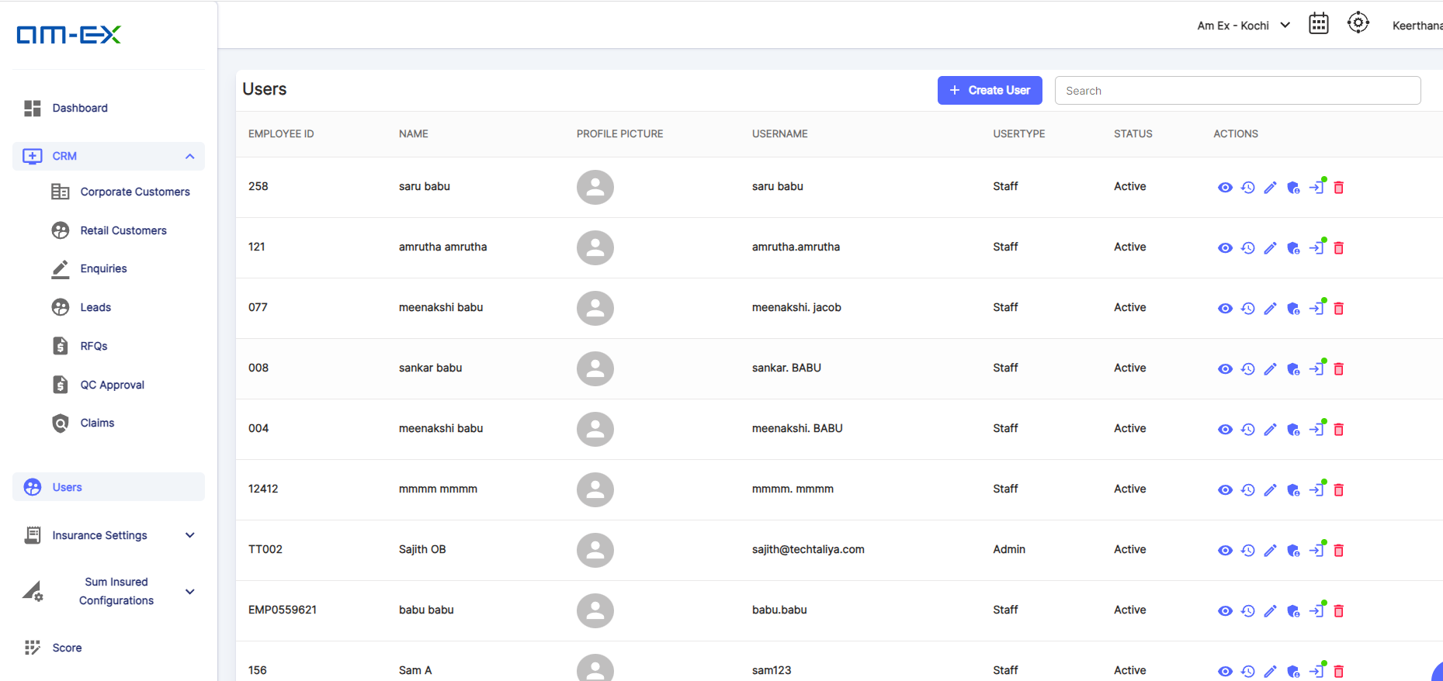

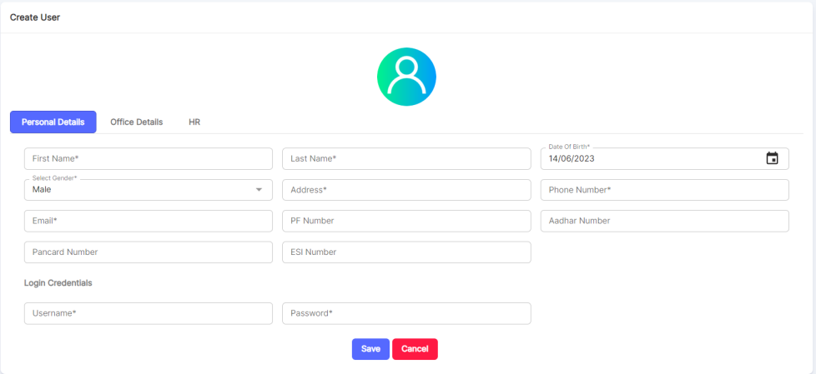

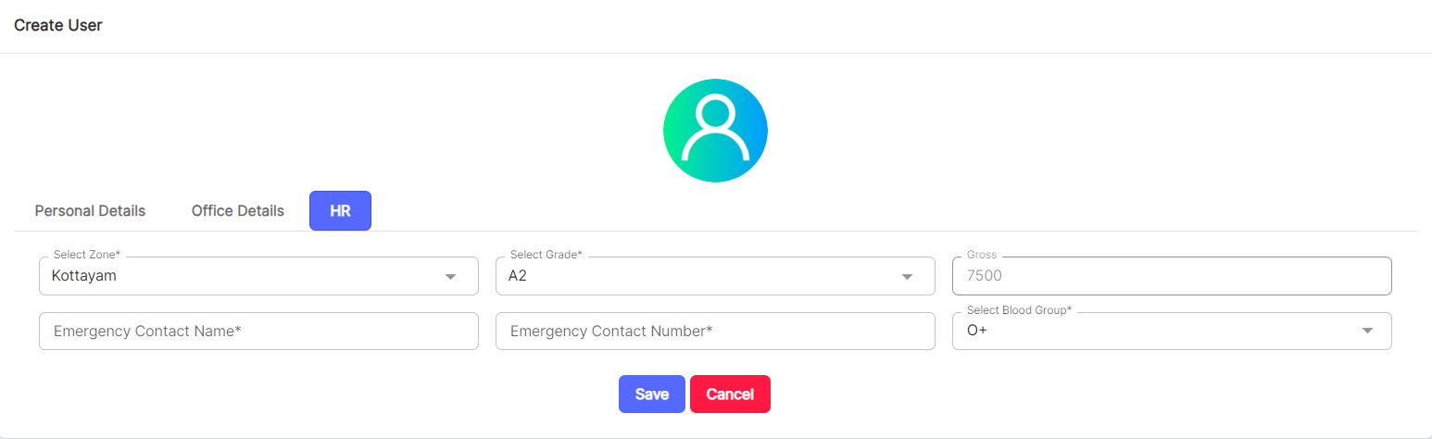

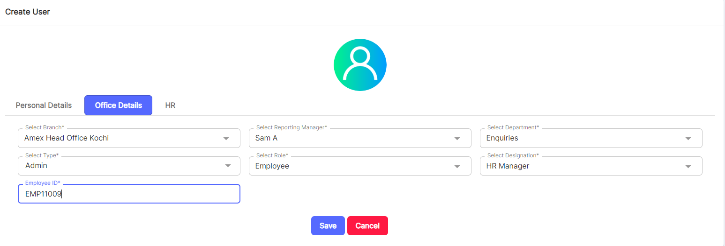



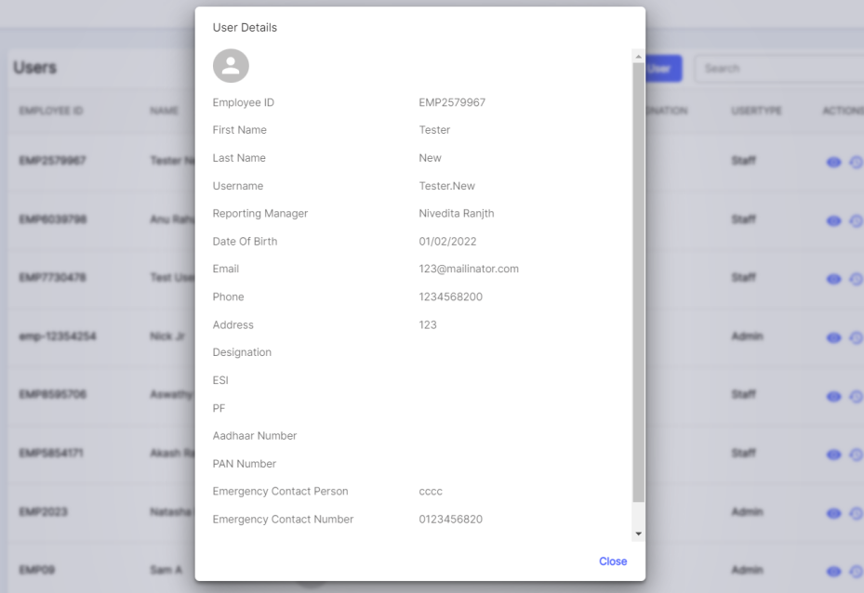

**Event Log:**

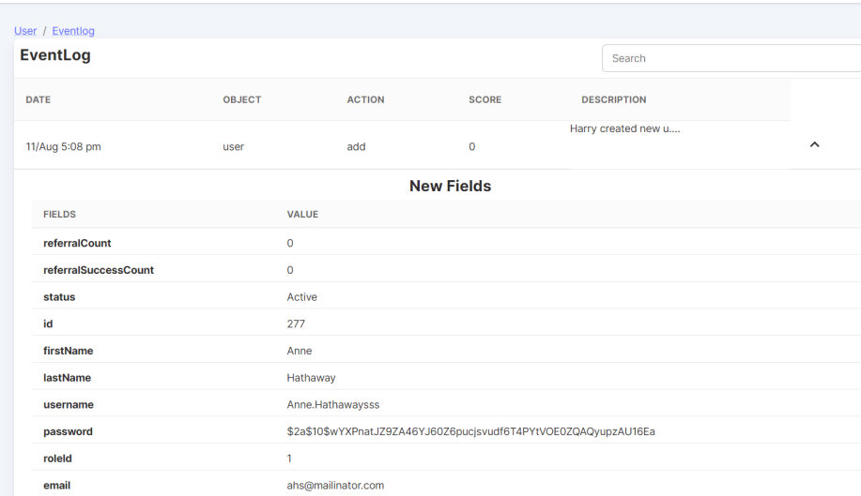

**Edit User:**

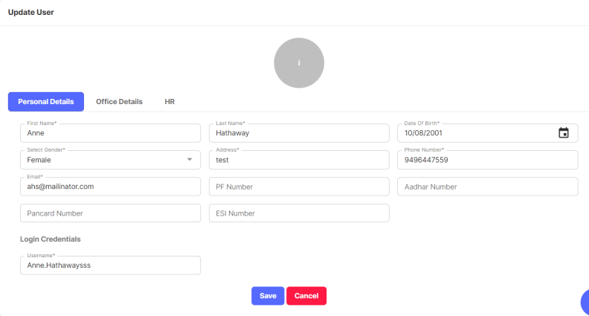

**Configure Branch Permissions:**

Using this feature, we can configure the Branch Permissions against a User.

Either full access can be given or can give custom permissions as well.

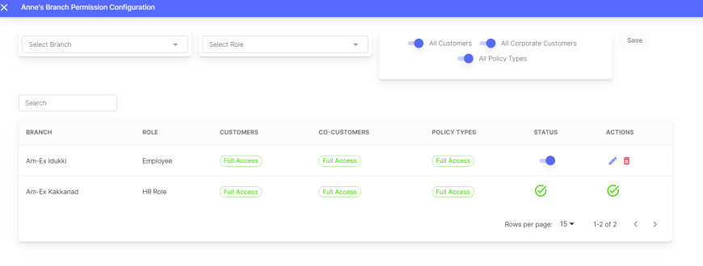

* If full access is not needed, then disable the full access & then a pop up appears to select the respective privileges needed as shown below.

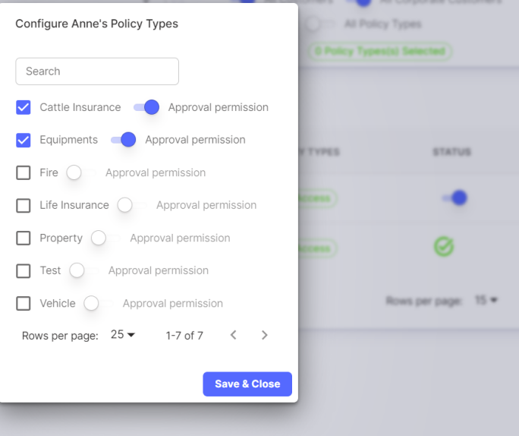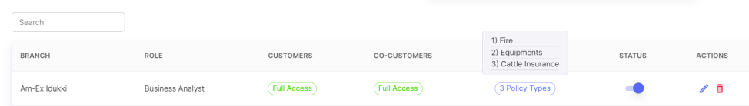

**Edit Login Status:**

Login Status can be enabled or disabled using this feature.

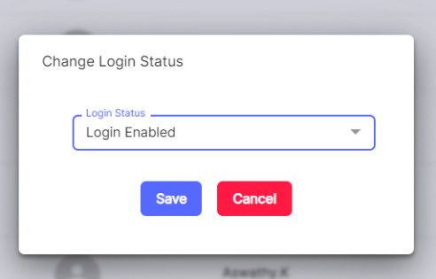

**Change Password:**

If user needs to change their existing password, then click on change password icon against the respective user.

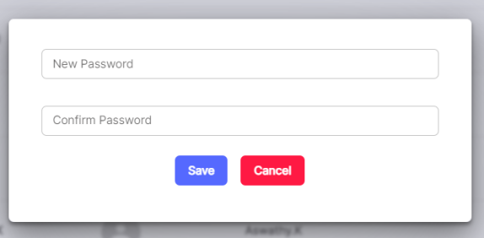

* 1. **Insurance Settings**

Under Insurance Settings there are different types of classifications:

* Master Categories
* Categories
* Products
* Insurance Companies
* TPA  
  Risks & Clauses
* Industries
* Insurance Zone Categories
* Insurance Zones
  + 1. **Master Categories**

If Master Category needs to be created for a Policy, then it can be created under this section. Under a Master Category, sub category can be mapped which will be done in Category section. Life & Non-Life will remain in the Master List as such and it cannot be deleted. If needed, user can add in addition to the two items.

Non-Life to be set as default at the time of RFQ Creation pop-up.

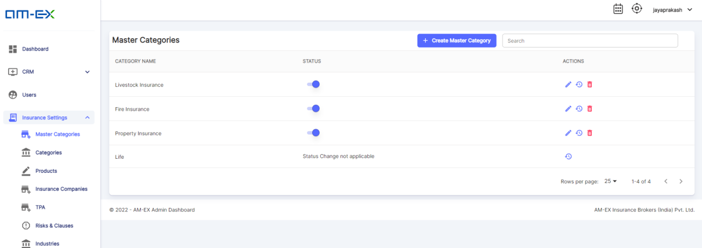

Click on Create Master Category. Then a form appears to enter the details:

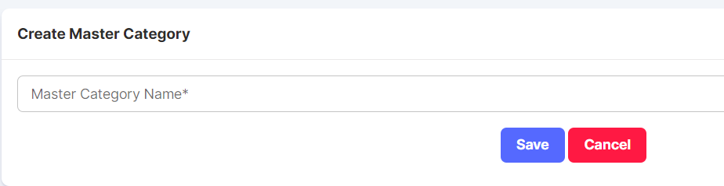

Once Saved, the Master Category will appear in the list.

The Status can be enabled or disabled based on the usability. There is an Edit, Event Log & Delete feature as well

* + 1. **Categories**

Under Category, Admin can create the sub categories which needs to be mapped against the Master Category.

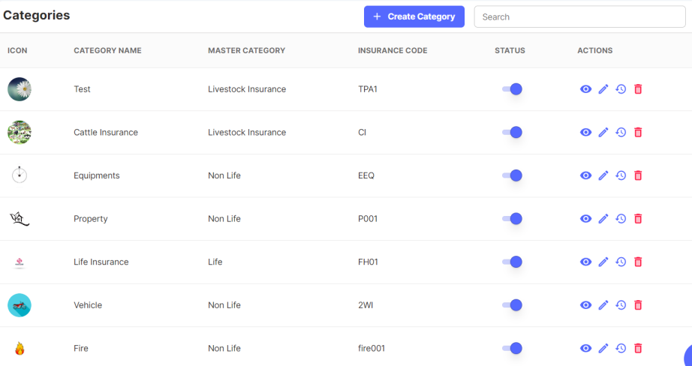

When Create Category is selected, a form appears to map Category against a Master Category which is already created in the Master Category section.

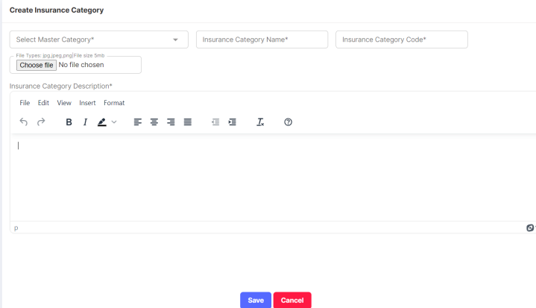

As shown in the list, status can be enabled or disabled. The Actions Possible are Preview, Edit, Event Log & Delete.

* + 1. **Products**

An RFQ is created against a Product. Multiple RFQs can be created for a Product.

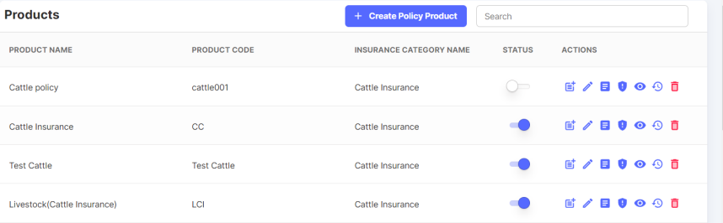 

When Create Policy Product is selected:

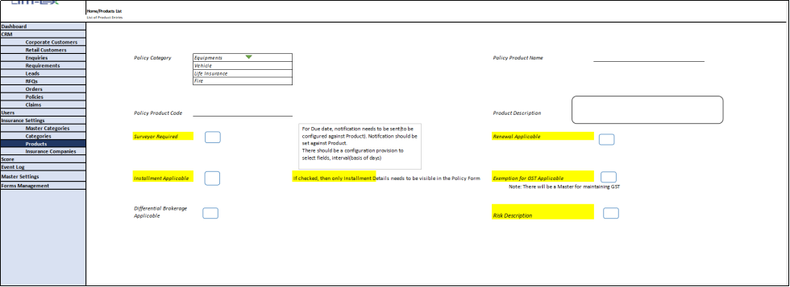

The Actions possible are:

* Create Product Template
* Edit Policy Product
* Supporting Docs
* Assign Product Clauses
* View Policy Description
* View History
* Create Checklist
* Brokerage Calculations
* Delete

**Create Product Template:**

Product Template for RFQ can be created here.

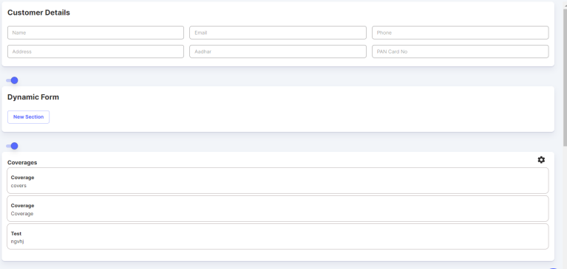

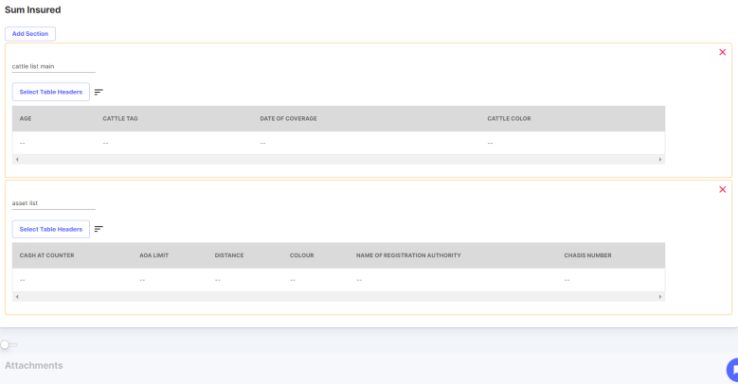

The sections can be enabled or disabled based on the Product Template requirements.

**Update Policy Products:**

If any editing is needed after Product creation, then this edit feature can be used.

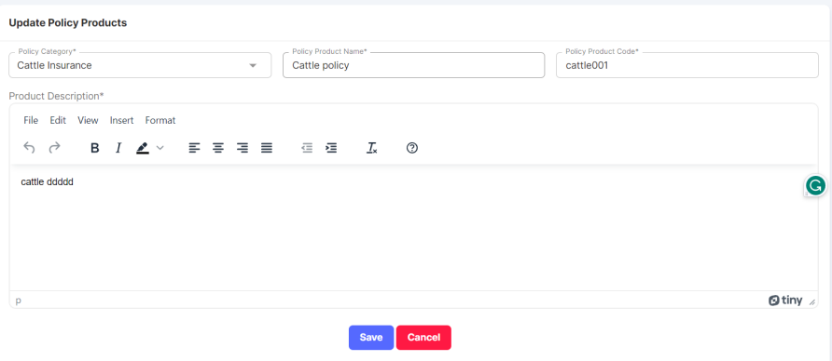

**Supporting Documents:**

The documents for Policies, Claims & Renewals are defined in the Supporting Docs.

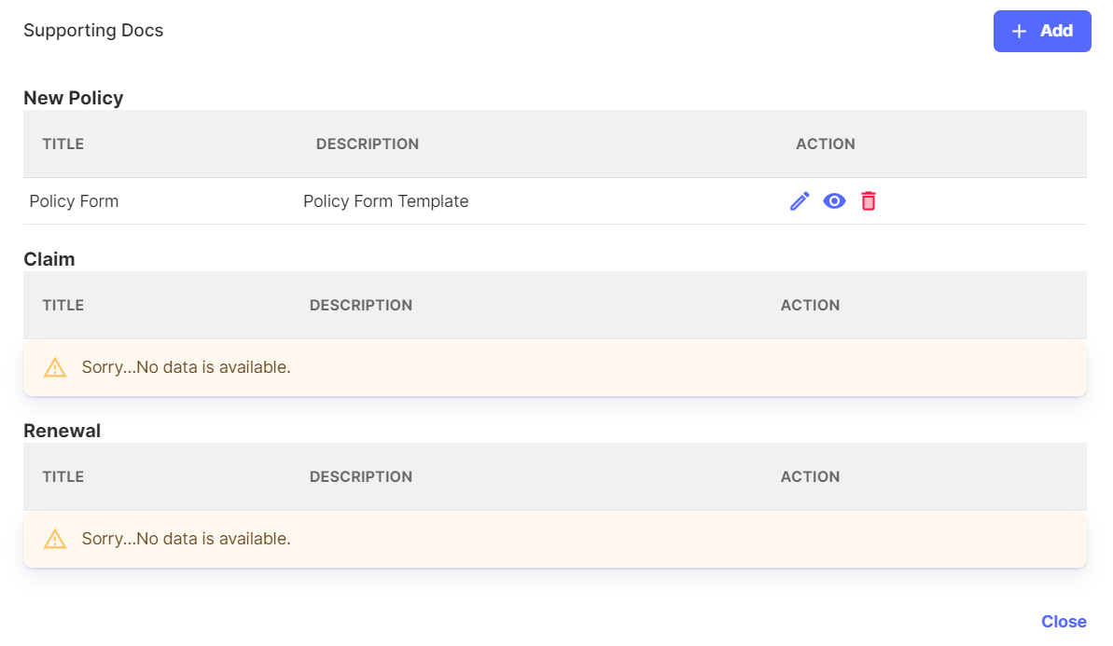

Click on Add. A pop-up appears to select the type of document along with title.

Type can be New Policy, Claim & Renewal. User need to select the type & upload documents.

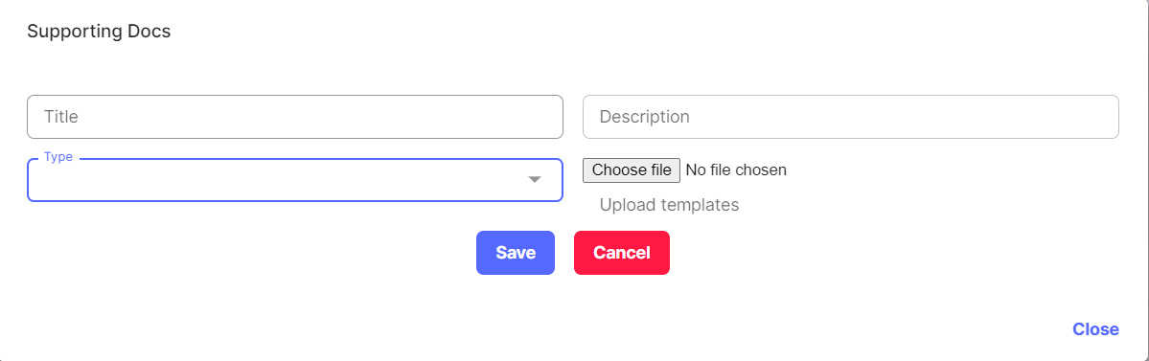

**Assign Product Clauses:**

Product Clauses & coverages can be selected here. There should be at least one mandatory coverage for a product.

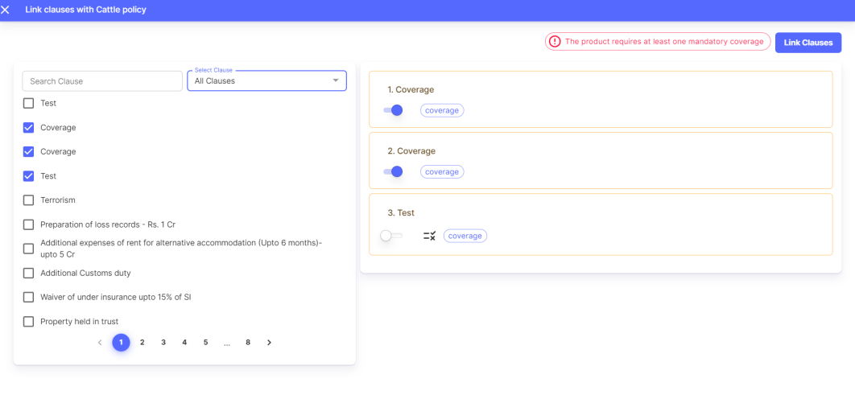

Once Link Clauses is selected, then below message appears:

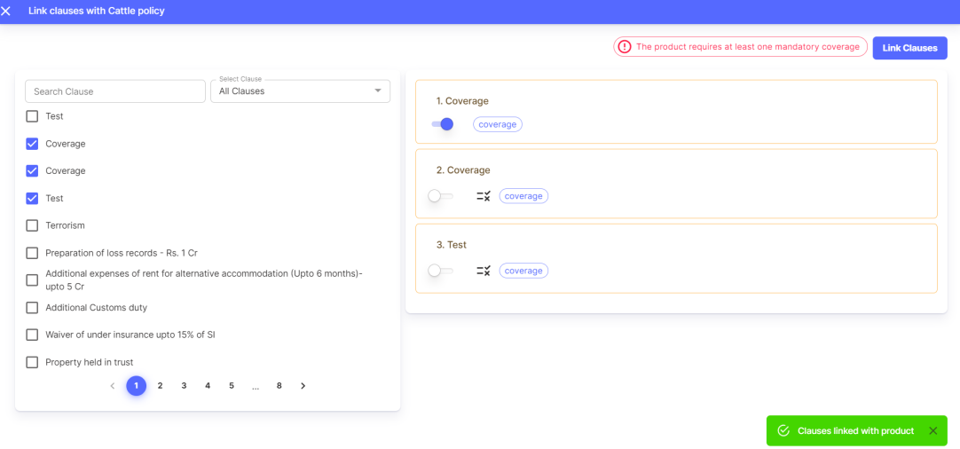

Preview, Event History & Delete actions are also possible.

* + 1. **Insurance Companies**

Insurance Companies can be created under this section.

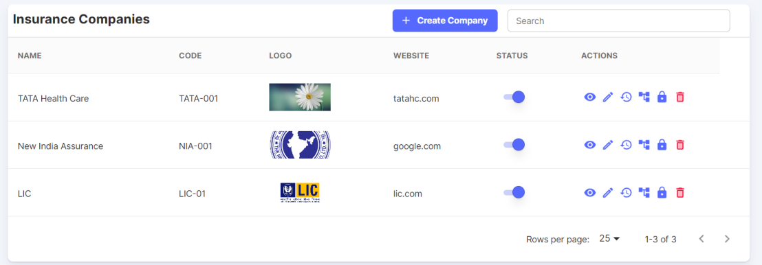

Click on Create Company. The below screen appears:

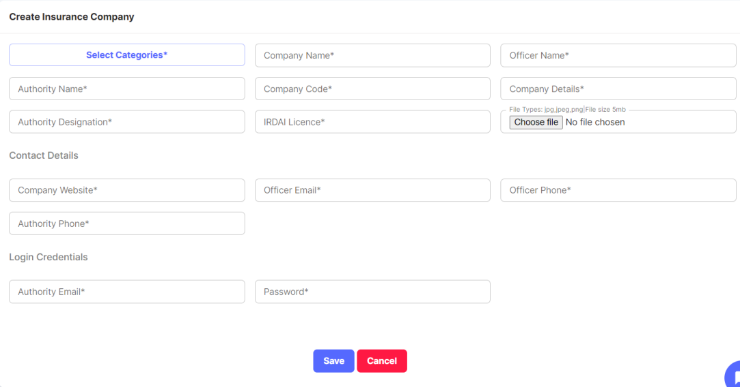

There is an option to select the Categories which are already created. When Select Categories is clicked, then a pop up appears to select the categories.

After filling the details, click on Save.

Actions possible are:

View More, Edit Company, View History, Company Branch, Change Password & Delete.

View More:

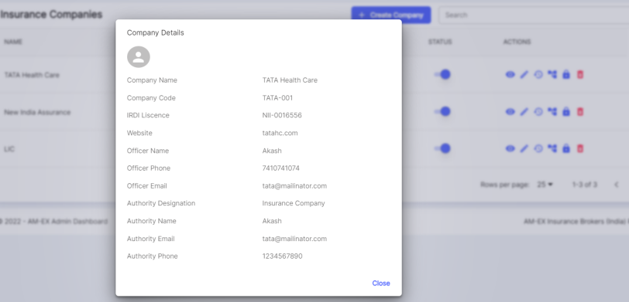

**Edit Company:**

If there are any changes needed in the Insurance Company, then click on Edit Company.

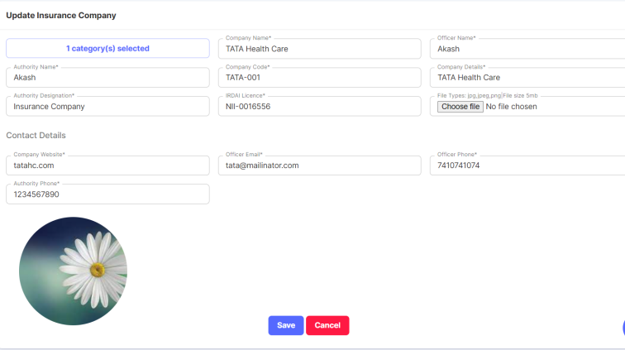

**Event Log:**

This feature works like a history of the activities done.

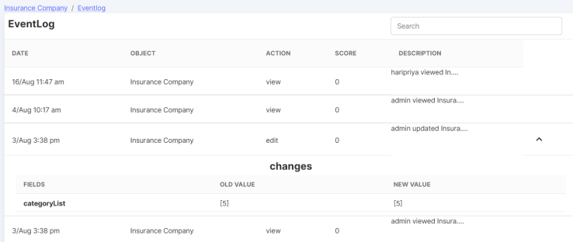

**Company Branch:**

Insurance company branch can be created against an Insurance Company.

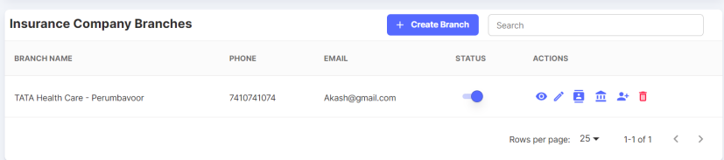

Click on Create Branch.

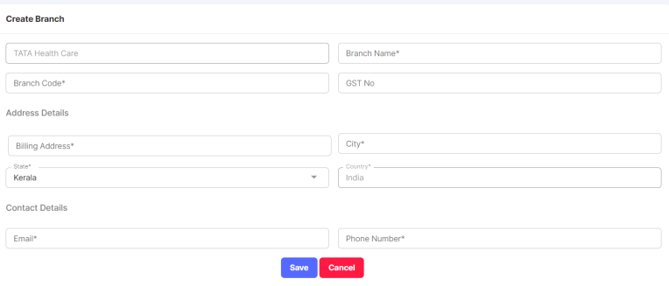

Actions possible in Company Branch are:

View More, Edit Branch, Branch Contacts, Bank Branch Accounts, Create Company User & Delete.

**Branch Contacts:**

Branch Contacts can be created for an Insurance Company Branch.

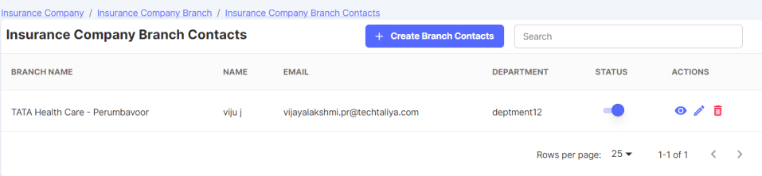

Click on Create Branch Contacts.

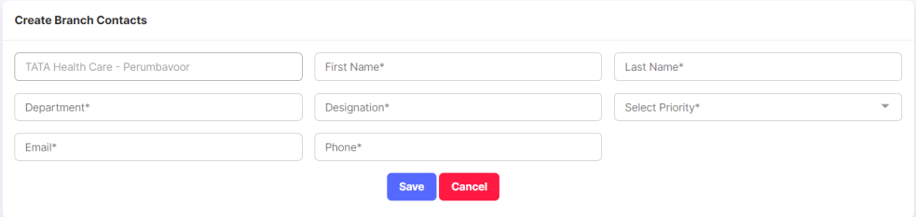

**Branch Bank Accounts:**

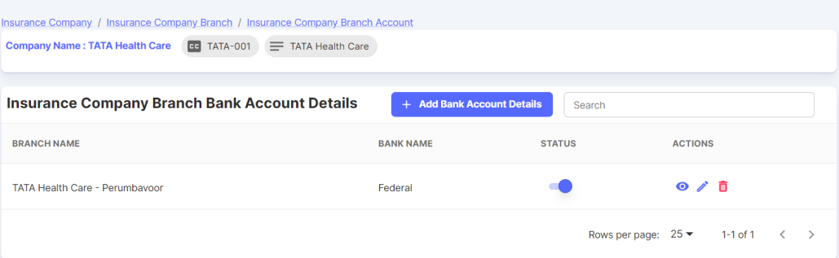

Branch Bank Account details are captured. Click on Add Bank Account Details.

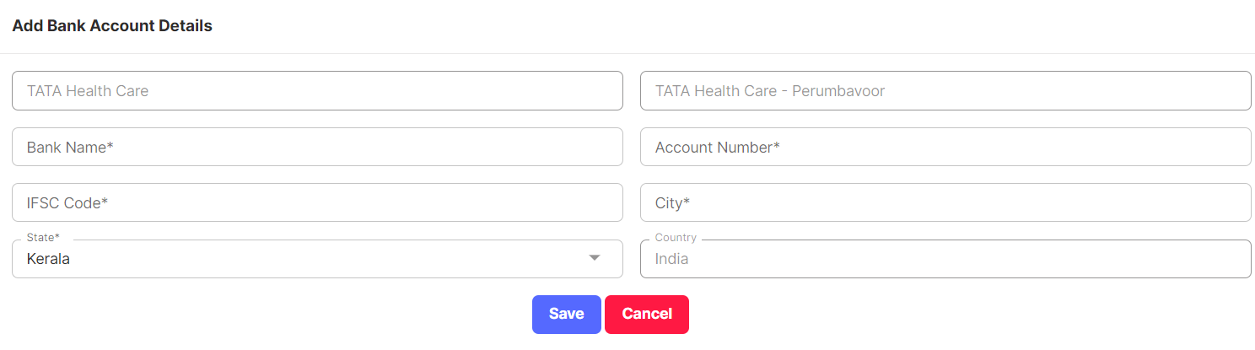

**Create Company User:**

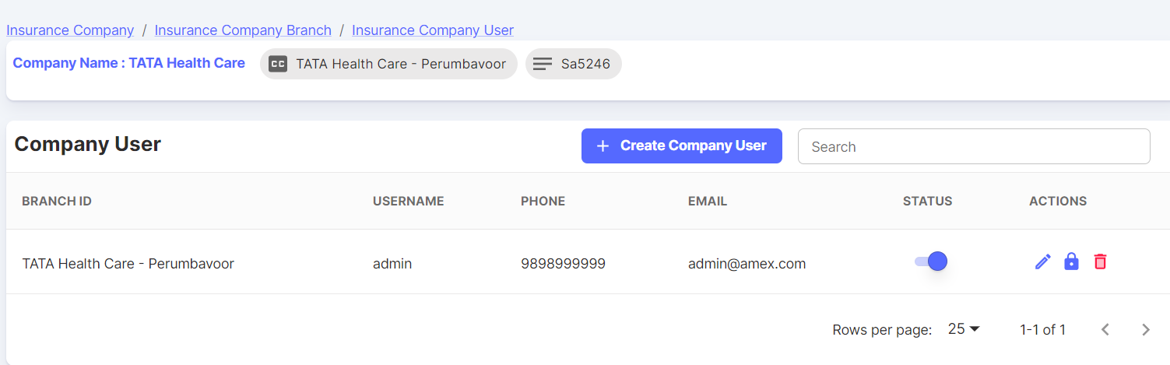

Company User can be created for a Company Branch.

Change Password & Delete feature also available.

* + 1. **TPA**
* TPA stands for "Third-Party Administrator," and in the context of insurance, a TPA plays a crucial role in managing various administrative and operational aspects of insurance policies on behalf of insurance companies.
* TPAs are often contracted by insurance companies to handle certain tasks, allowing the insurance company to focus on underwriting, risk management, and other core functions.
* One of the primary functions of a TPA is to manage the claims processing process.
* TPAs assist insurance companies in policy administration tasks such as issuing and renewing policies, handling endorsements or changes to policies, and ensuring accurate record-keeping of policyholders' information.
* TPAs often serve as a point of contact for policyholders' inquiries and concerns.

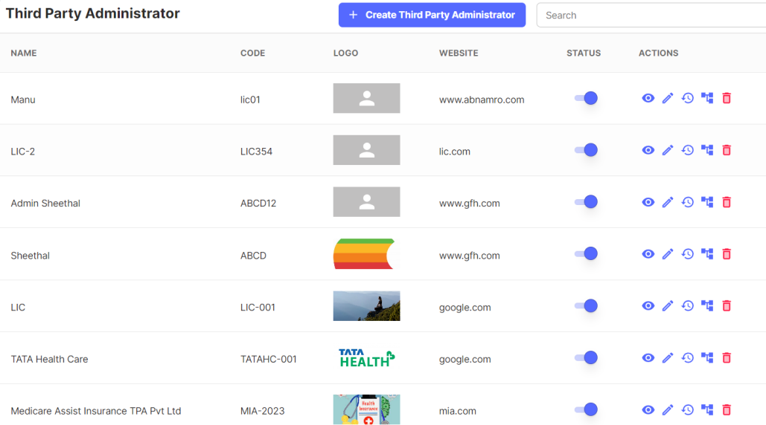

Click on Create Third Party Administrator. Then a form appears as shown below. After filling the details, click on Save.

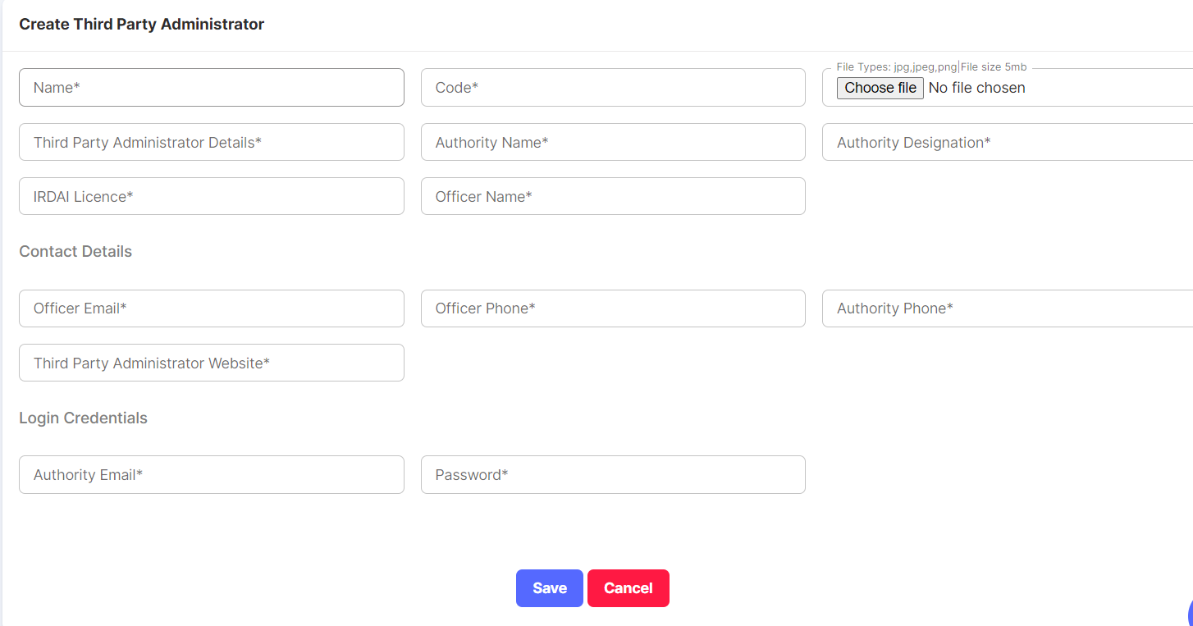

Actions possible in TPA List are:

View More, Edit Third Party Administrator, View History, Third Party Administrative Branch & Delete

**Third Party Administrative Branch:**

TPA Branch can be created against a TPA.

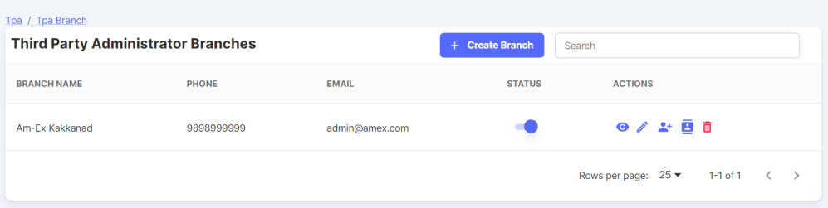

Click on Create Branch. Then a form appears as shown below. After filling the details, click on Save.

**TPA User:**

Similar like how we created a Company User for Insurance Company Branch, we can create a Third-Party Administrative User as well.

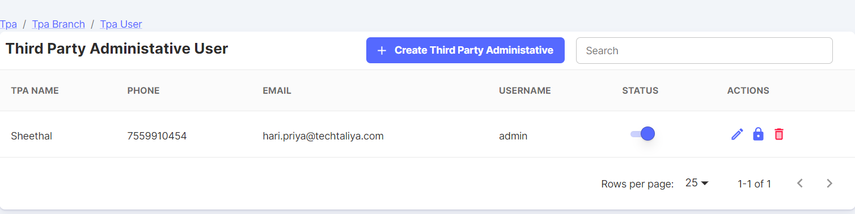

Click on Create Third Party Administrative. Then, a form appears to enter the TPA User details.

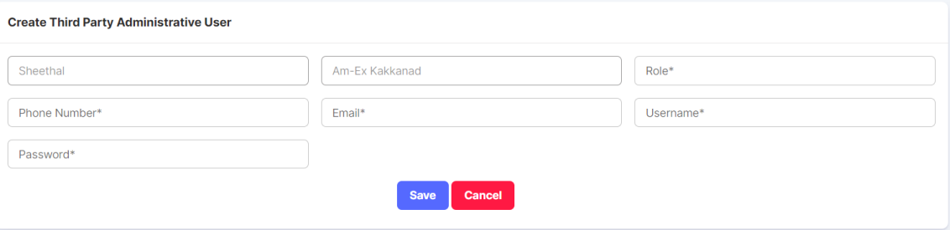

**TPA Branch Contacts:**

TPA Branch Contacts against a TPA Branch can be handled here.

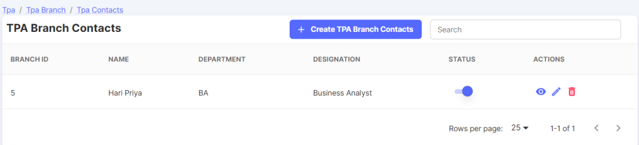

Click on Create TPA Branch Contacts. After filling the respective details like First Name, Last Name, Priority (Priority 1, Priority 2…) etc, click on Save.

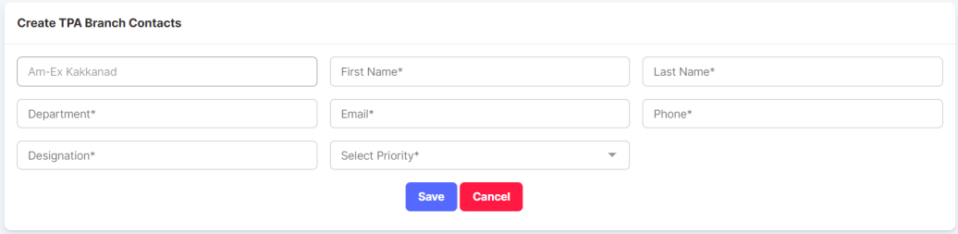

* + 1. **Coverages & Clauses**

Clauses & Coverages can be created here.

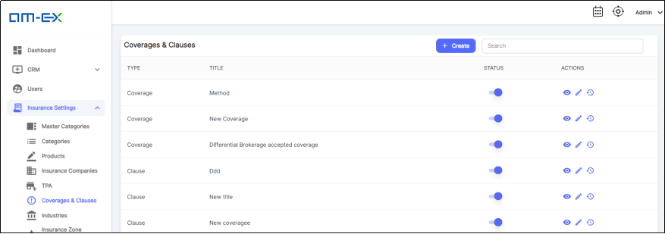

Click on Create Coverages & Clauses. A form appears & click on Save after entering the details. Type can be Clause & Coverage.

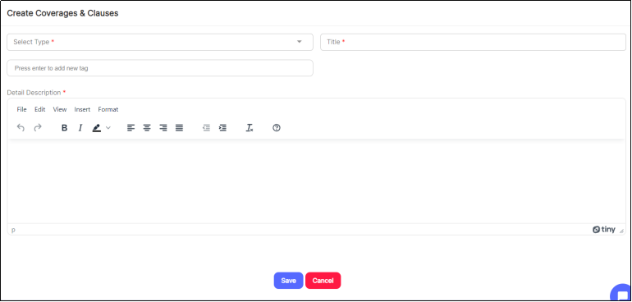

* + 1. **Industries**

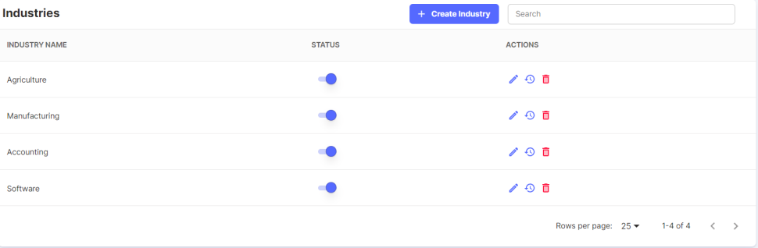

Click on Create Industry.

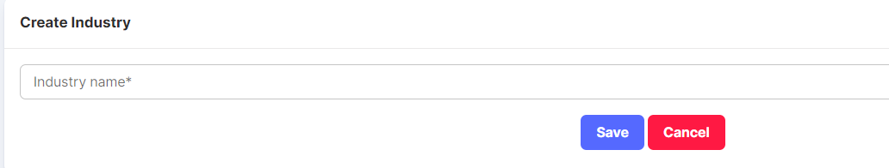

* + 1. **Insurance Zone Categories**
* In general, insurance companies may categorize different geographic areas or regions into zones based on various factors such as risk exposure, claims history, local regulations, and other relevant considerations.
* These zones help insurers assess and price insurance policies accordingly.

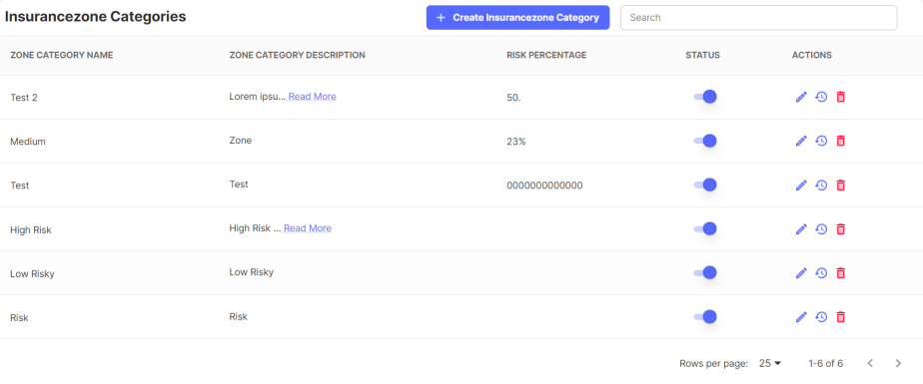

Click on Create Insurance Zone Category.

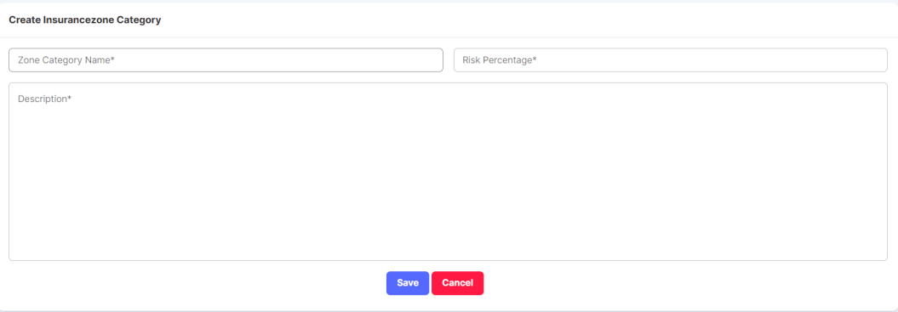

After Save, the details will appear in the list.

* + 1. **Insurance zones**

As Insurance Zone Categories are created, the Insurance Zones needs to be mapped under these Zone Categories.

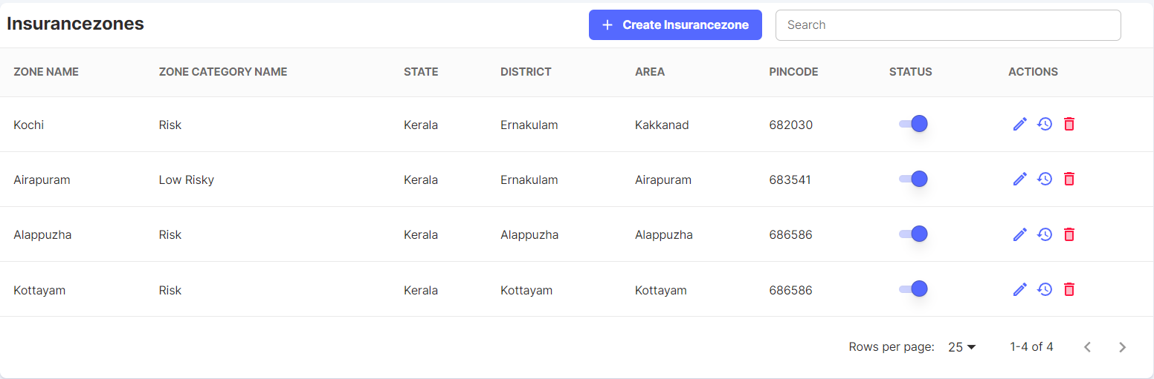

Click on Create Insurance Zone.

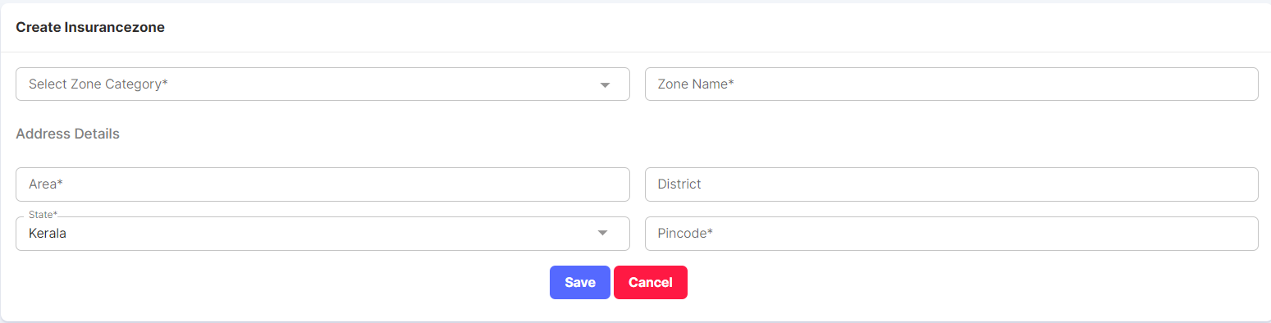

Note: This can be added in next phase. Report generation should be there for Performance Appraisal like how many clients are there, no. of RFQs generated, how many of them converted to customers, etc based on the requirements. It will be like an Employee Performance report to track what is the total cost, no of hours he worked, revenue generated, comparison to previous years, type of policies he sourced for each category, etc.

* 1. **Event Log**

It is similar to an Activity History which shows what all actions are being done by whom and when.

It captures the Date, time along with the module the action is being done.

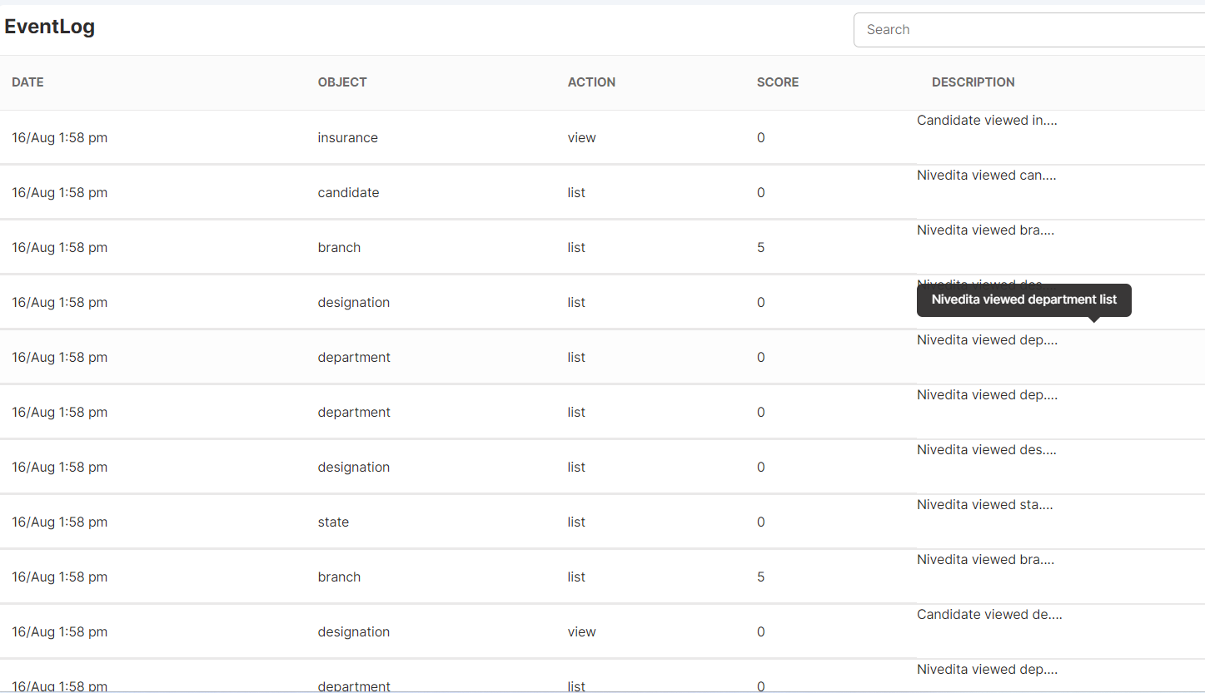

**SYSTEM ADMIN MODULE**

Under System Admin Module, Dashboard & Master Settings only will be visible & is visible to Admin only.

* 1. **Master Settings**

Under Master Settings, there are different types of classifications which will be depicted below.

* + 1. **Branches**

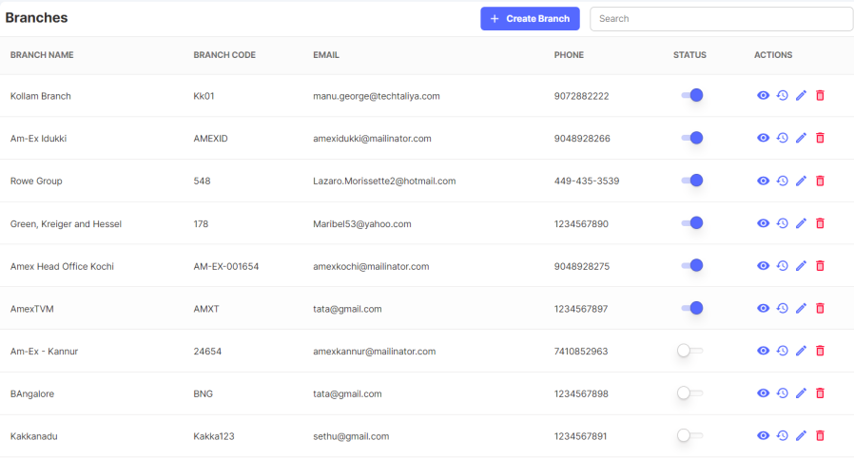

* Branch is a physical location or office where an insurance company conducts its business operations.
* Insurance companies often have multiple branches spread across different geographical areas to provide services, handle customer inquiries, process claims, and sell insurance policies in person.

Click on Create Branch.

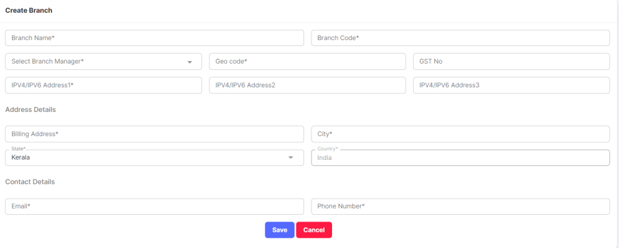

After filling details like Branch Manager, Branch Code, etc. Click Save.

* + 1. **Departments**

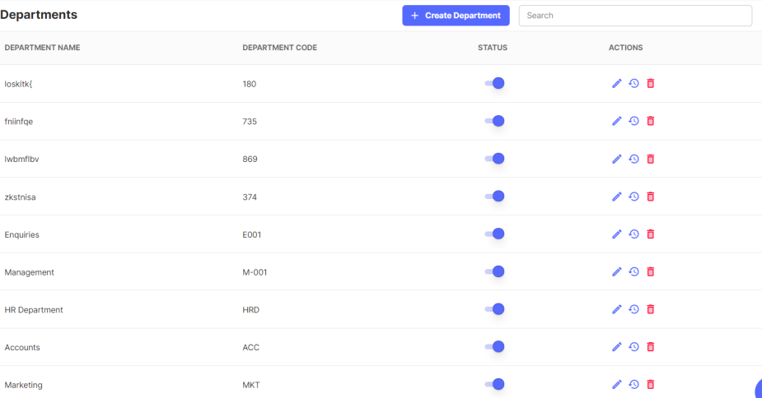

Click on Create Department.

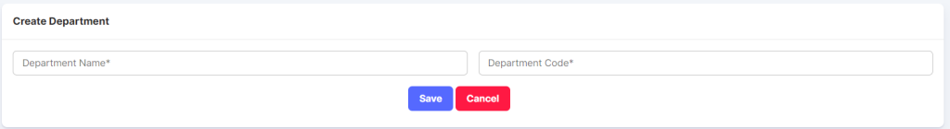

Department Name & Code can be added. If any department needs to be remained inactive, then disable it using Status toggle.

* + 1. **IP – Blacklist**
* An IP blacklist refers to a list of specific IP addresses that have been identified as sources of malicious or unwanted activities on the internet. By blacklisting them, you can restrict access to applications from those IPs.
* IP blacklists are commonly used for security and spam prevention purposes.

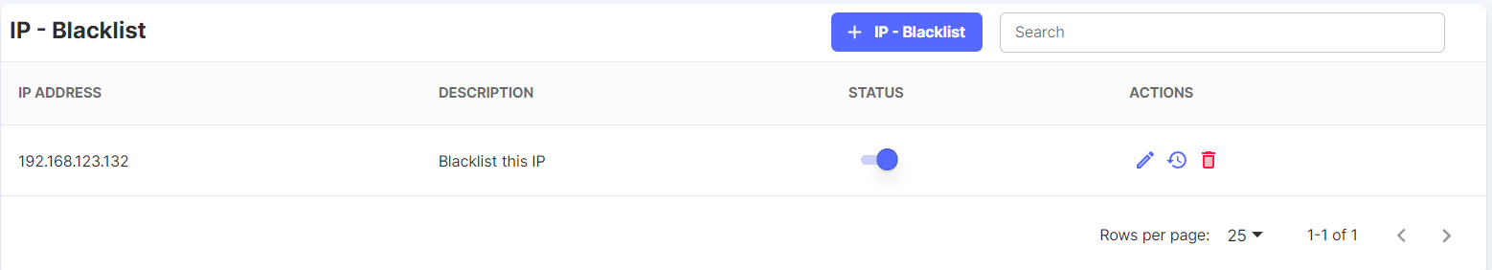

Click on IP-Blacklist button

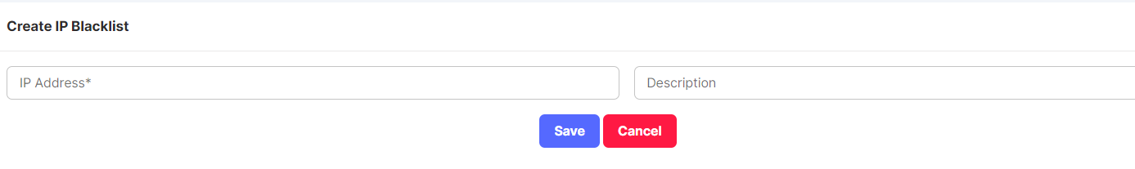

* + 1. **States**

Click on Create State. Then a page opens up.

Enter State Code & State Name. Once Saved, details will appear into the State List.

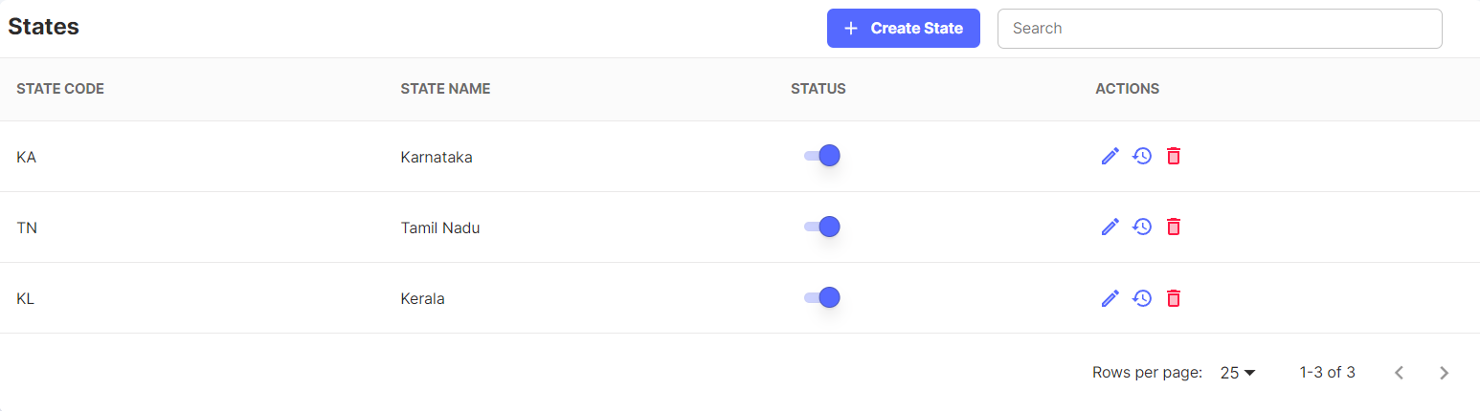

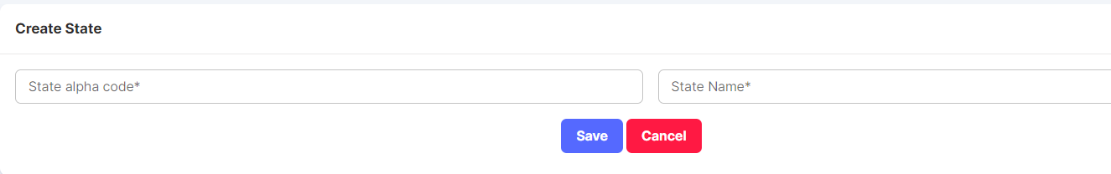

* + 1. **Districts**

Districts can be created & can map under the States created.

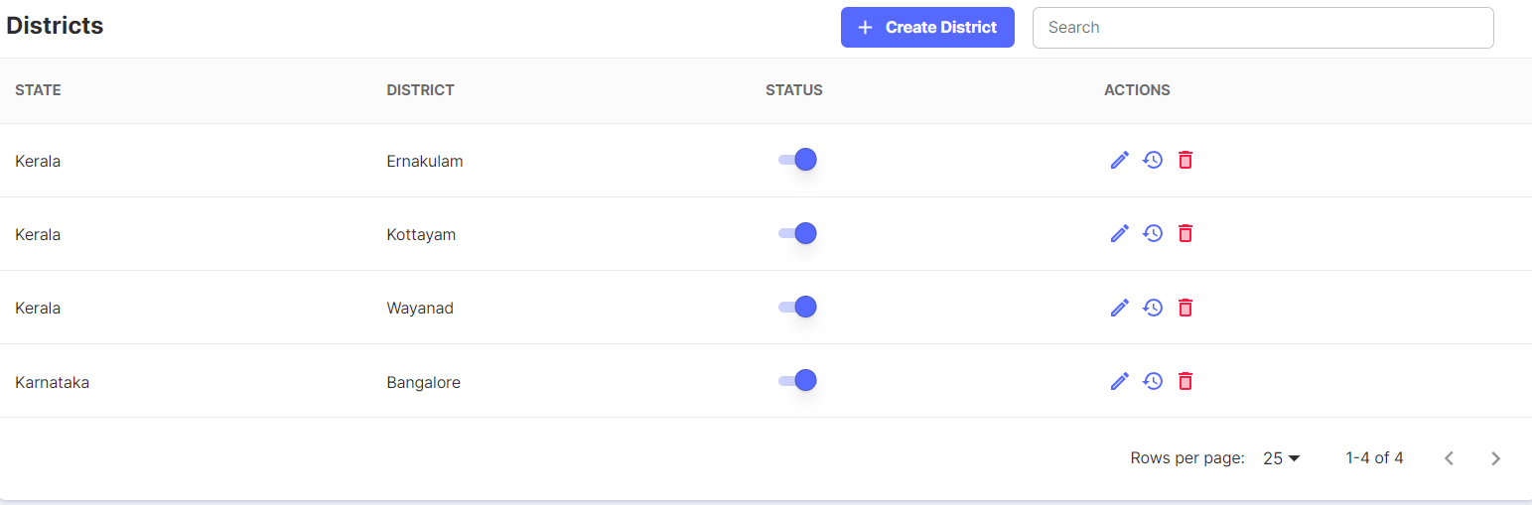

Click on Create District. Select the State from drop down which is already created. Click on Save.

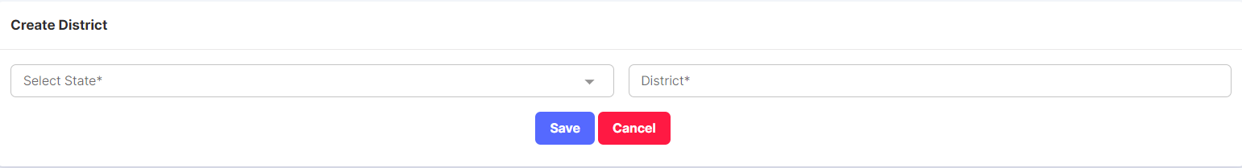

* + 1. **Stages-Leads**

The stages created here are used in the Leads section

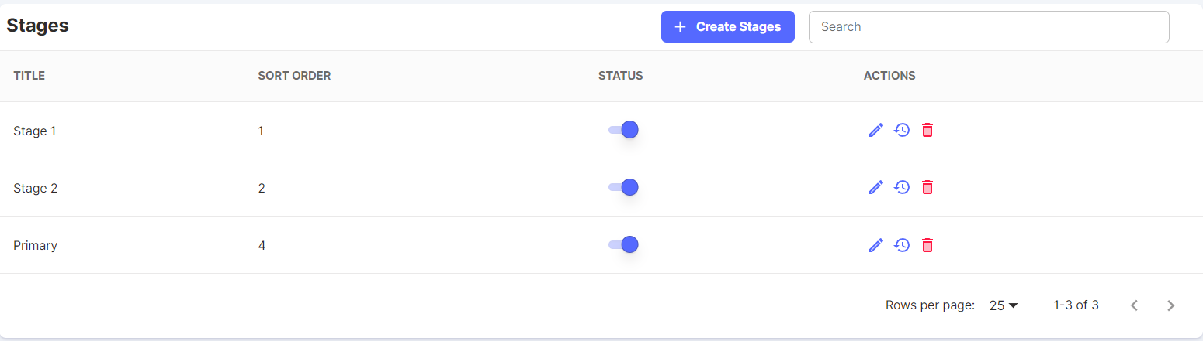

Click on Create Stages.

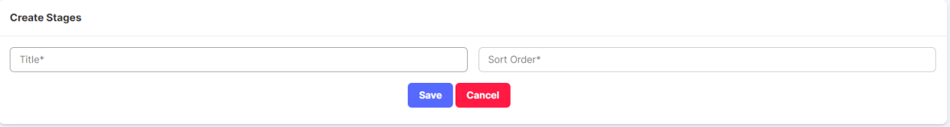

* + 1. **Dynamic Configurations**

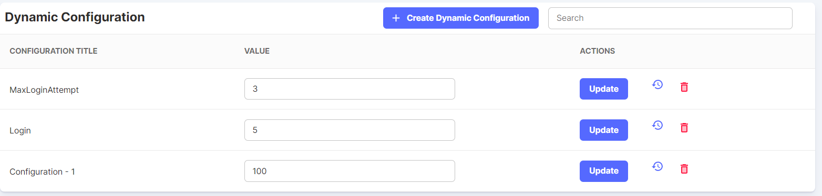

Click on Create Dynamic Configuration.

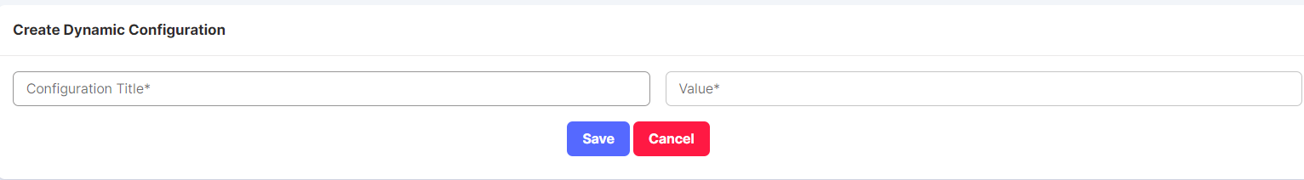

Once created, the dynamic configurations can also be updated by changing the Values.

* + 1. **Holiday Settings**

Holidays can be created for a Branch.

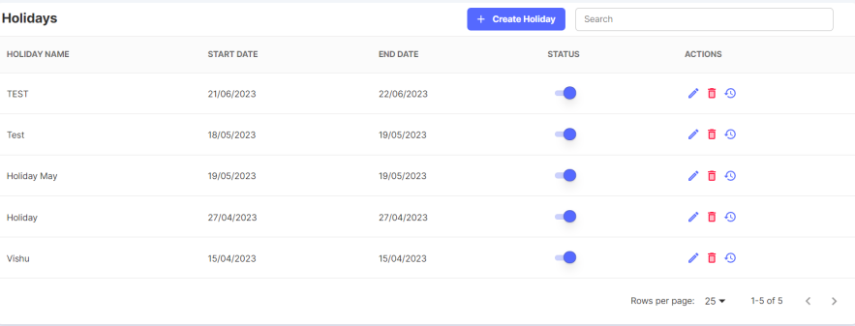

Click on Create Holiday.

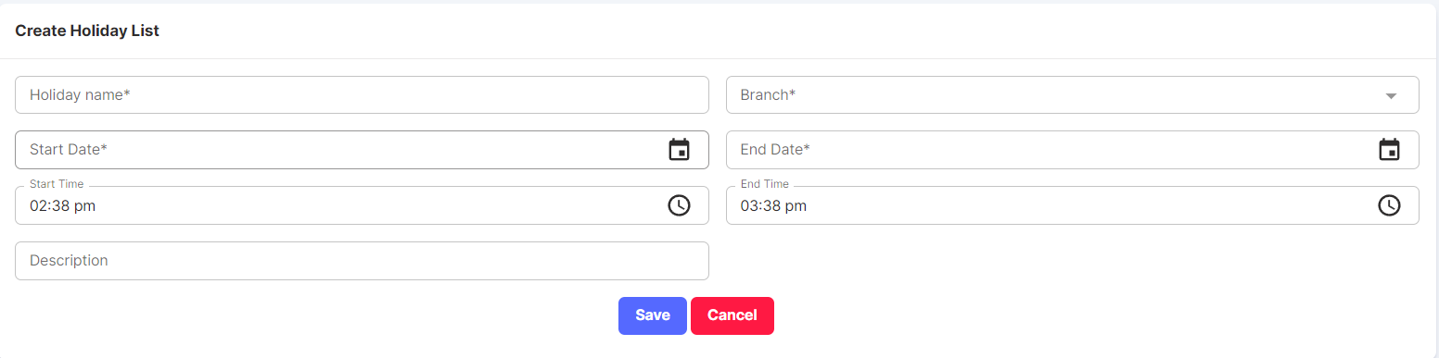

* + 1. **Newsletters**

Newsletters serve as a communication tool used to disseminate information, updates, insights, and content to a targeted audience.

They can be sent electronically via email or in print format.

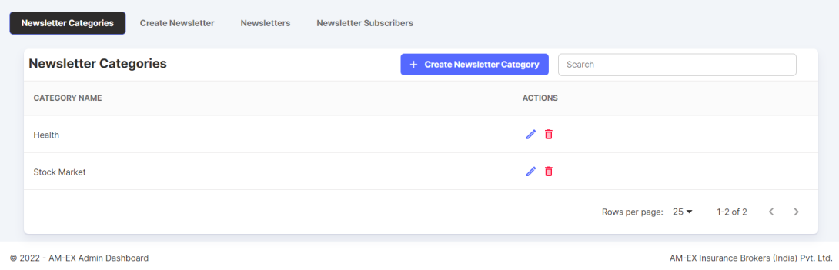

Newsletter categories can be created.

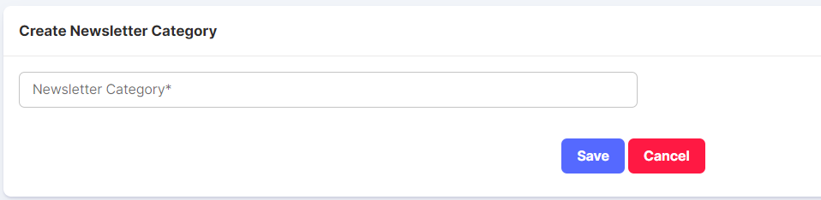

Under Create Newsletter, newsletter can be created against Categories.

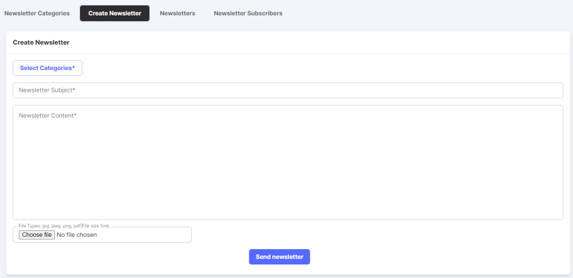

Click on Send Newsletter & it will be sent via email.

Under Newsletters, it will show the created newsletters list with Preview & View History options

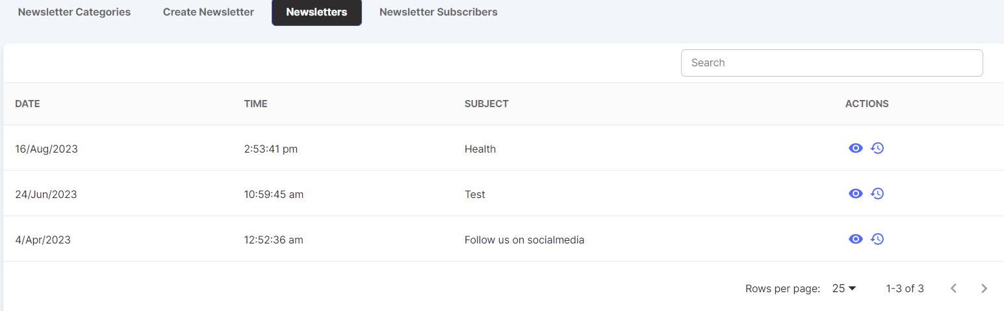

Under Newsletter Subscribers, it shows the list of people who are subscribers to the newsletters

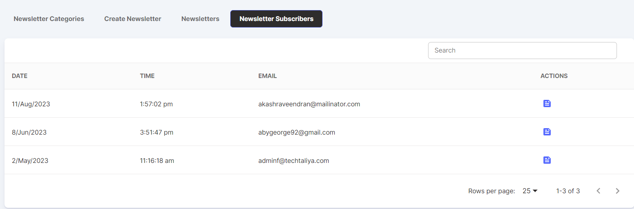

If you click on the Actions, then it will show the Categories of Newsletters you are subscribed with.

* 1. **Questionnaire**

A questionnaire is basically used, when an event is conducted, we need to send feedback form to the respective customers or companies etc.

Also, there are 2 sets of Questionnaire - Score Based & Feedback Based

Score Based is typically for candidates to know the score based on the predefined questions which are defined in the Questionnaire

Feedback form is specifically to share to customers, Insurance Companies etc.

Under Questionnaire there are 4 sub types:

* Questions
* Questionnaire
* Assessments
* Assessments Summary

**🡪 Questions:**

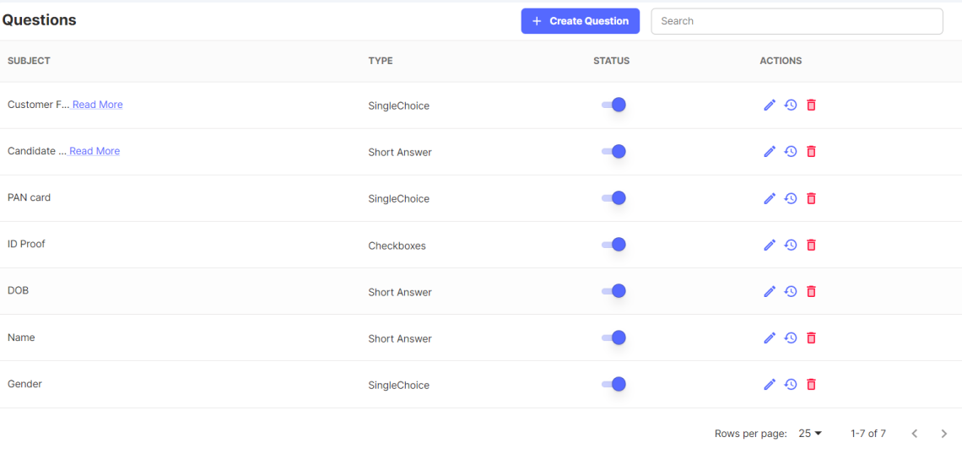

Click on Create Question

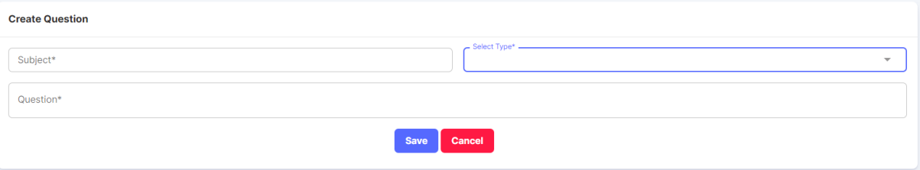

Type can Short Answer, Paragraph etc.

When Update Question is selected, below screen appears.

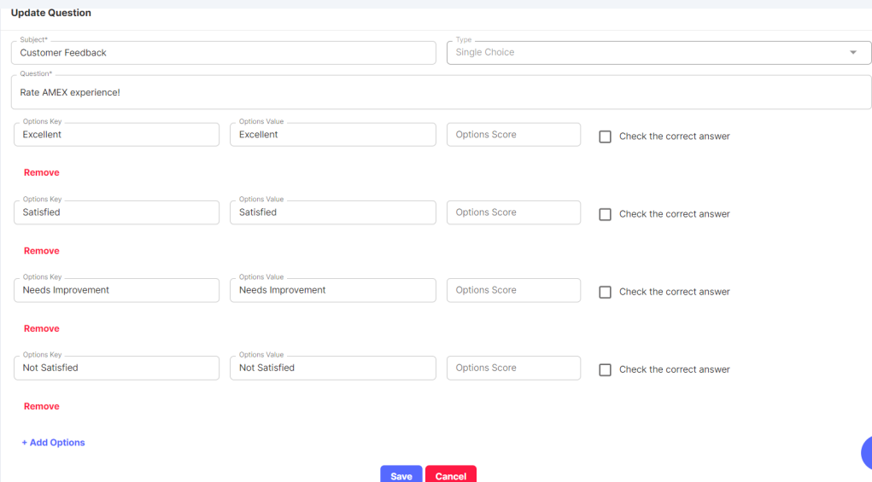

**🡪Questionnaire:**

Under Questionnaire, question needs to be created against Category.

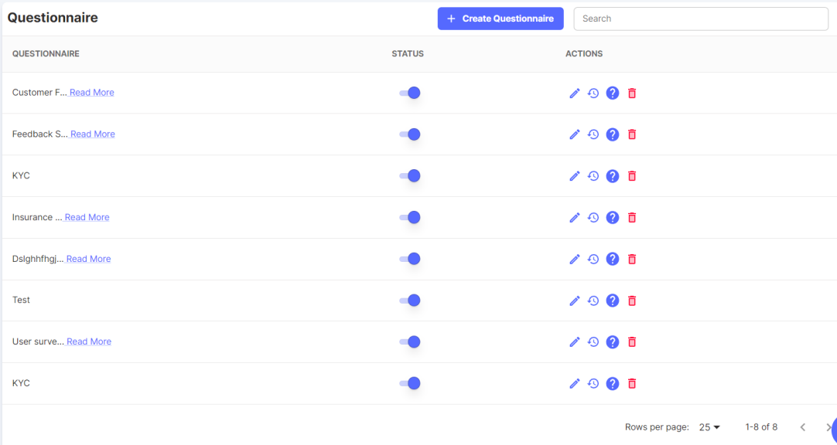

Click on Create Questionnaire.

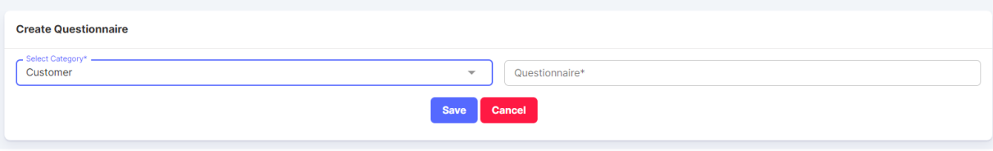

The Actions possible are View, Edit Questionnaire, View & Edit Questionnaire, and Delete.

**View & Edit Questionnaire:**

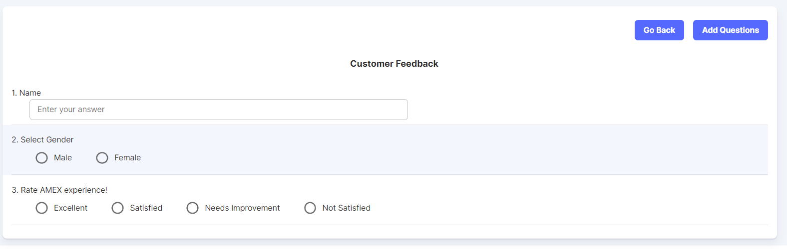

When Add Questions is selected:

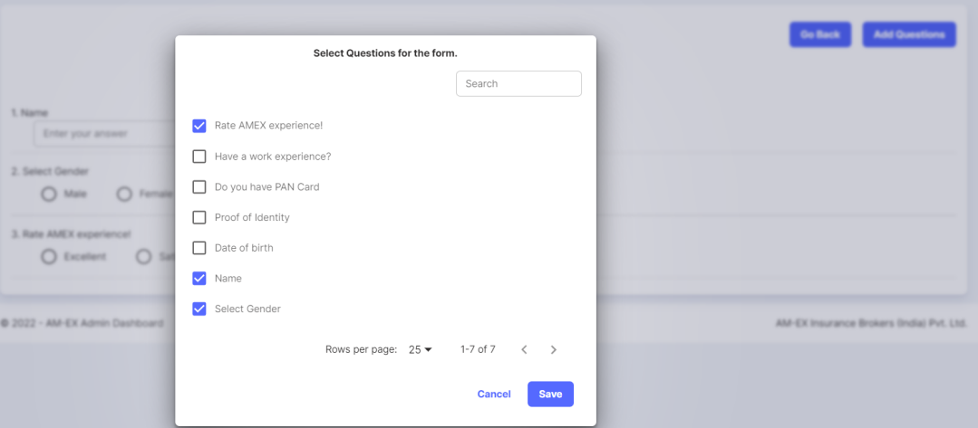

🡪**Assessments:**

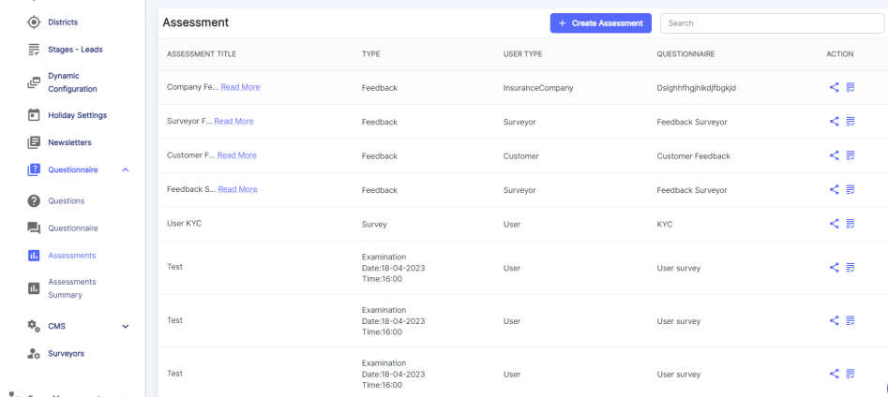

Click on Create Assessment. Type can be Examination, Feedback, Poll, etc. Based

on the Type, fields might change.

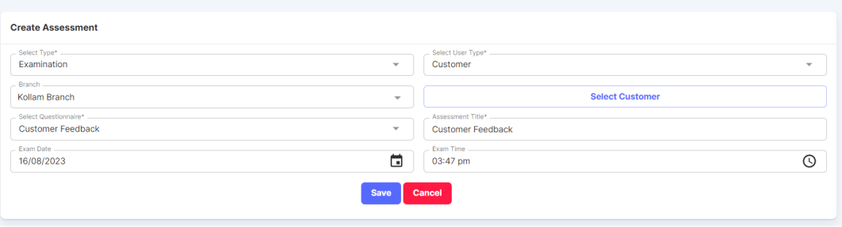

Once Assessment is created, you can share it with the Insurance Company.

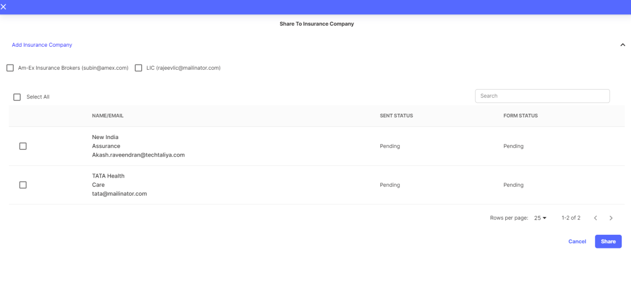

Mail Screenshot of how Questionnaire shared with customer looks like:

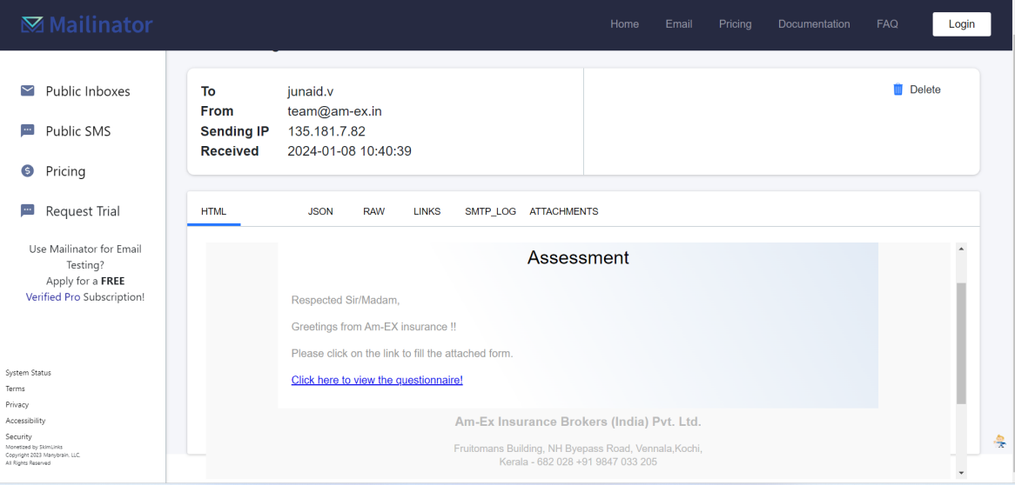

Once you click on the link in the email, then it will redirect you to Questionnaire page (please find sample screenshot):

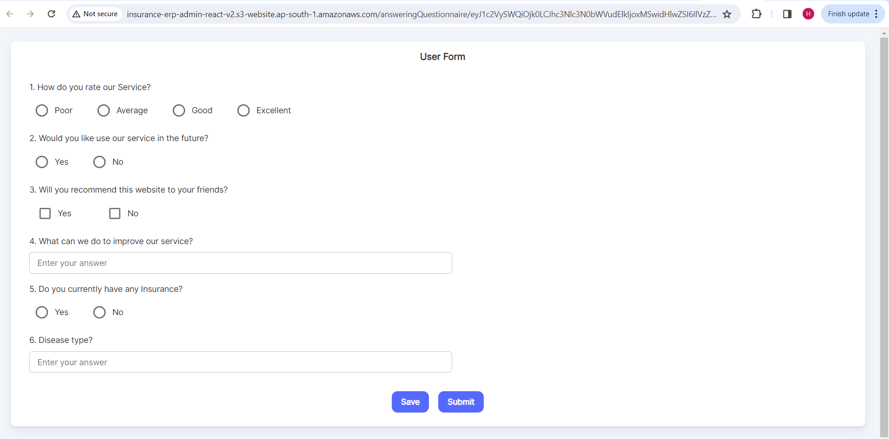

Also, there is a provision to View & Review Responses

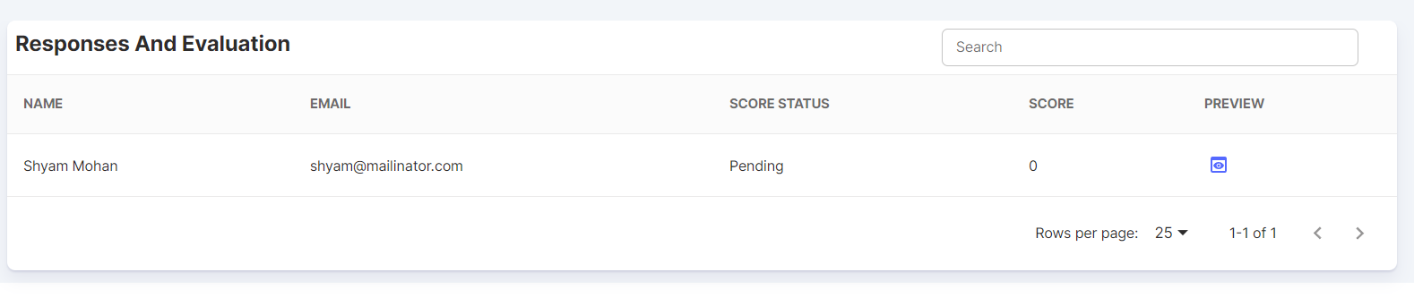

When Preview is selected,

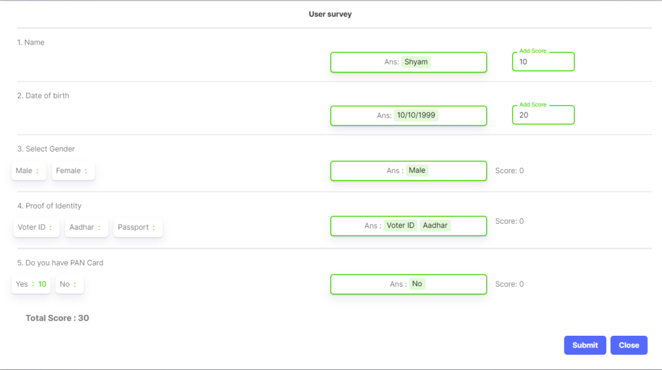

🡪**Assessment Summary:**

A summary of Assessments is displayed here.

There is a Preview feature and Response Summary Action as well.

When Response Summary is selected, it will show the Questions & Options along with the responses.

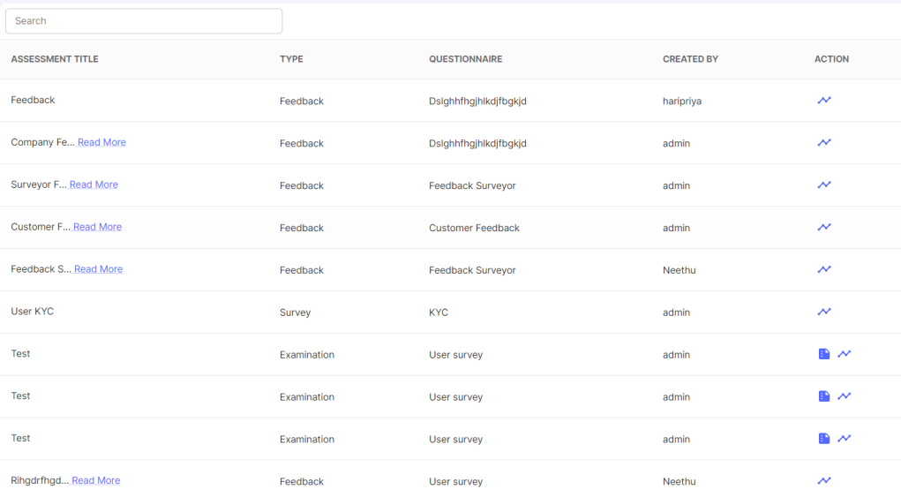

**Response Summary:**

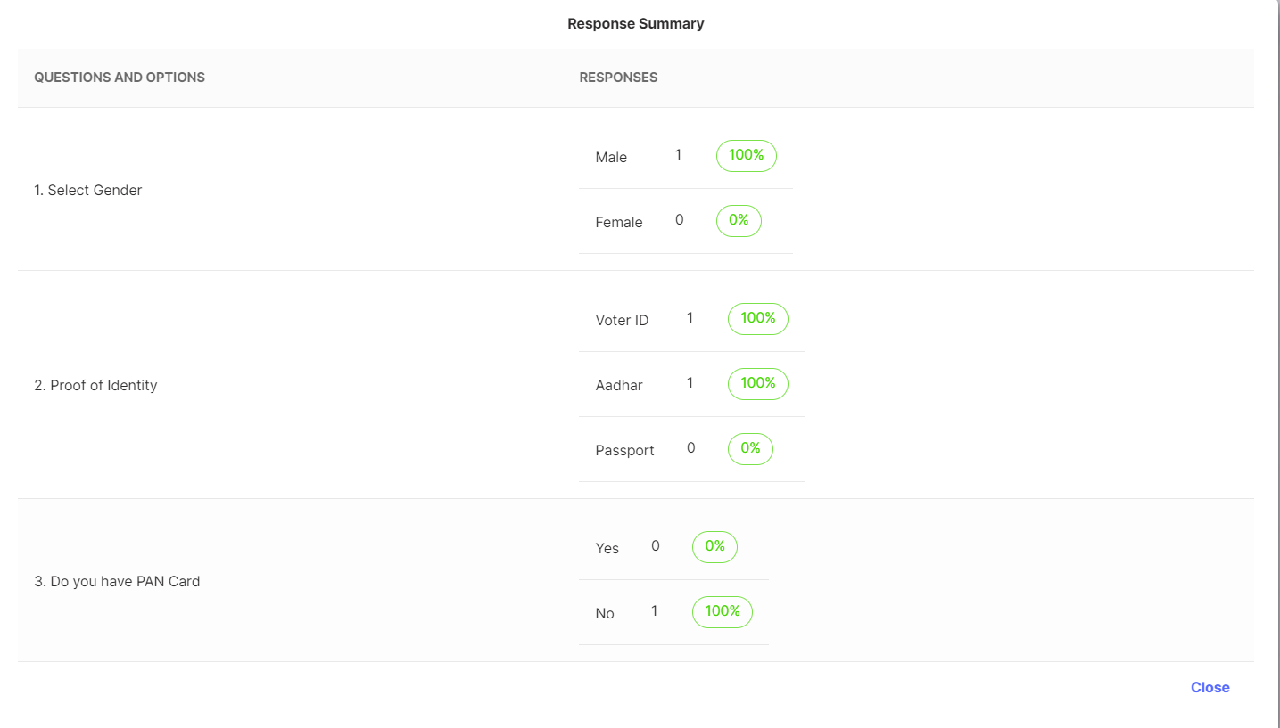

**2.8.1 CMS**

CMS stands for Content Management System. Under CMS Module, there are 4 types of classifications.

* Category
* Sub Category
* Article

🡪**Category:**

Click on Create Category. A page appears to enter the Category Name.

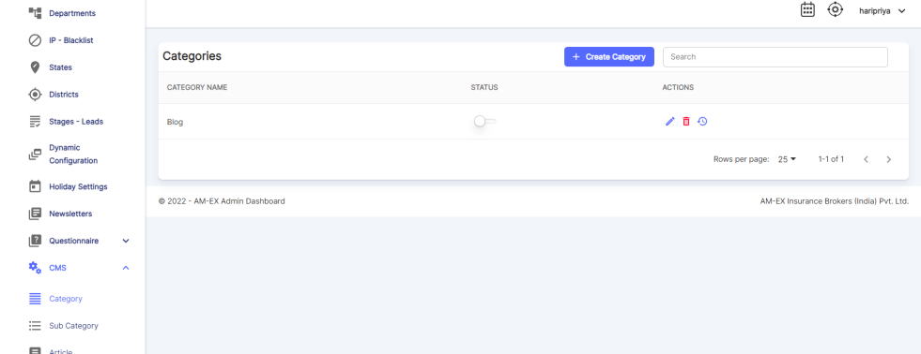

🡪**Sub Category:**

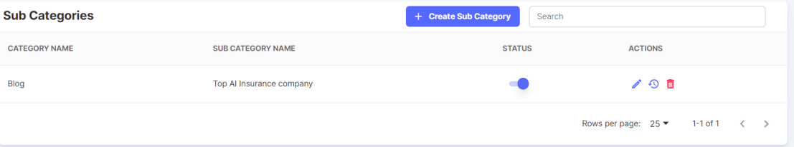

Against the Category, Sub Categories can be created.

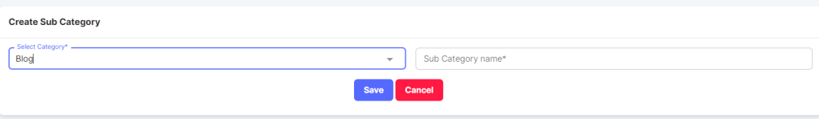

**🡪Article:**

An article can be created against the created Category & Sub Category.

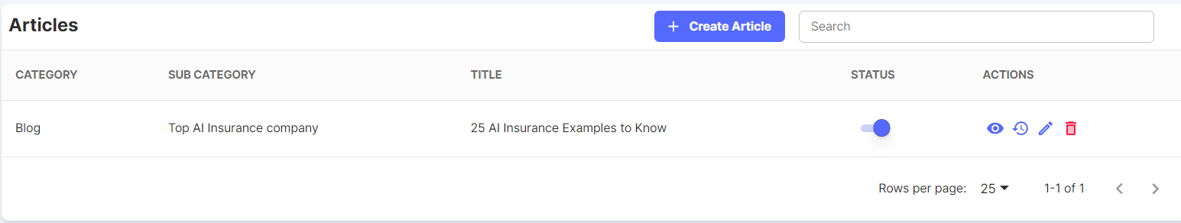

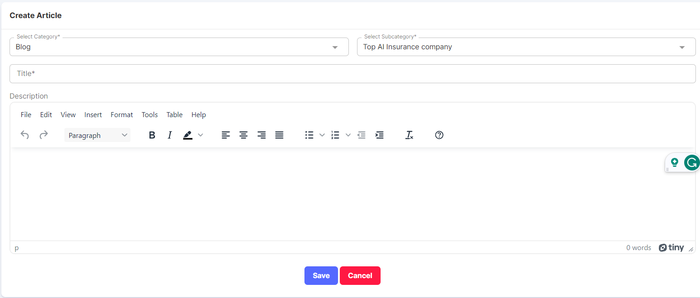

**2.8.2 Surveyors**

* A surveyor is an individual who assesses and evaluates various risks associated with insurance policies.
* They play a crucial role in the insurance industry by conducting surveys, inspections, and investigations to determine the insurability of a property, item, or entity, as well as to calculate the appropriate insurance premiums.
* Surveyors investigate insurance claims to verify the details provided by the policyholder.
* In the event of a covered loss or damage, surveyors assess the extent of the loss and determine the compensation amount.

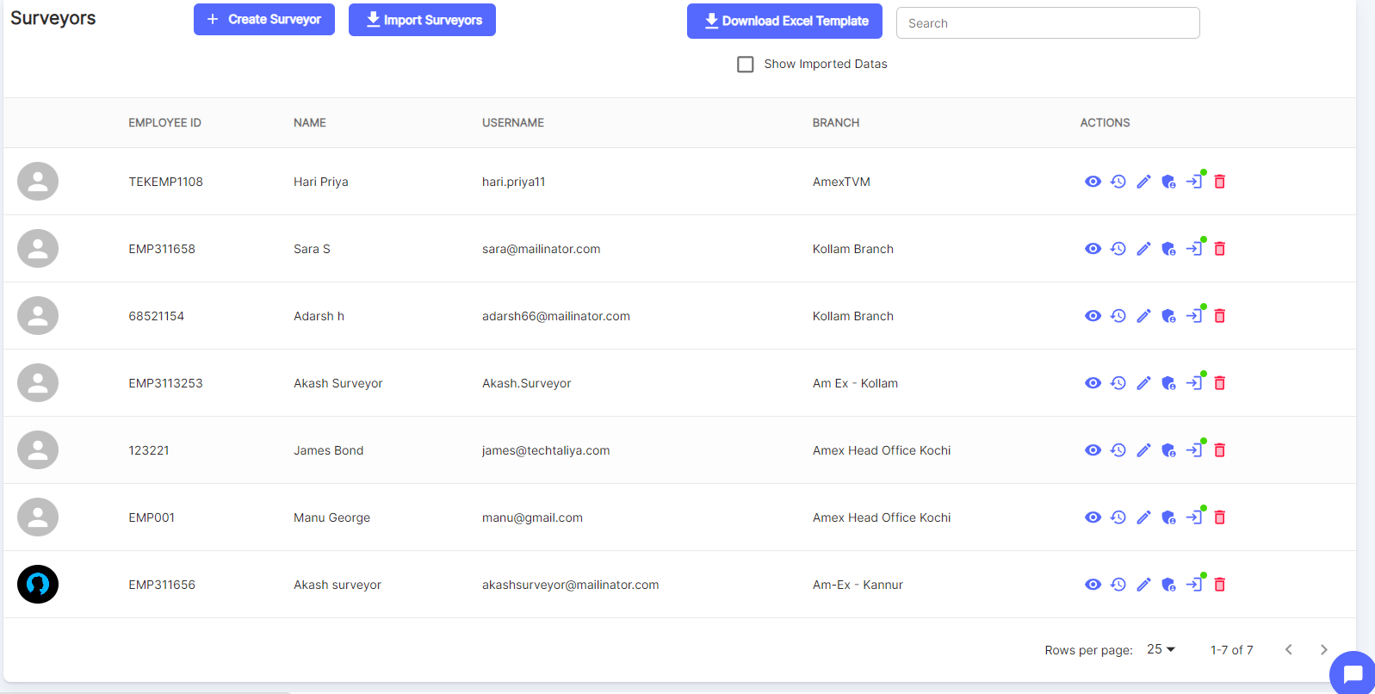

Click on Create Surveyor.

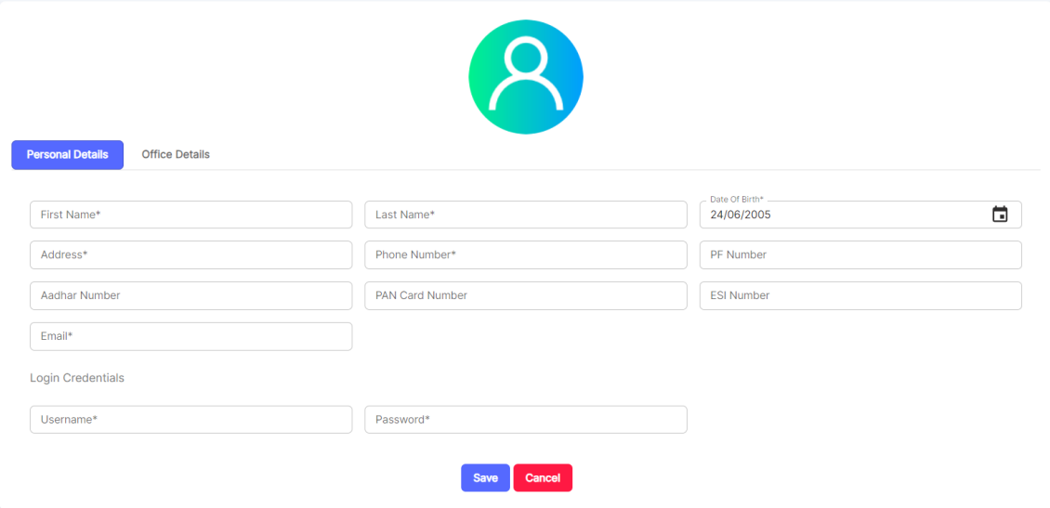





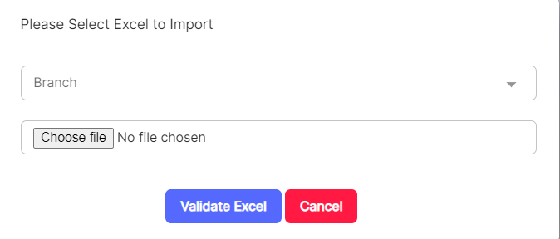

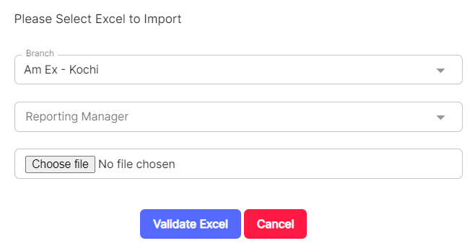

The possible actions are:

View More, View History, Edit Surveyor, Assign Policy Types, Edit Login Status, Change Password & Delete.

**View More:**

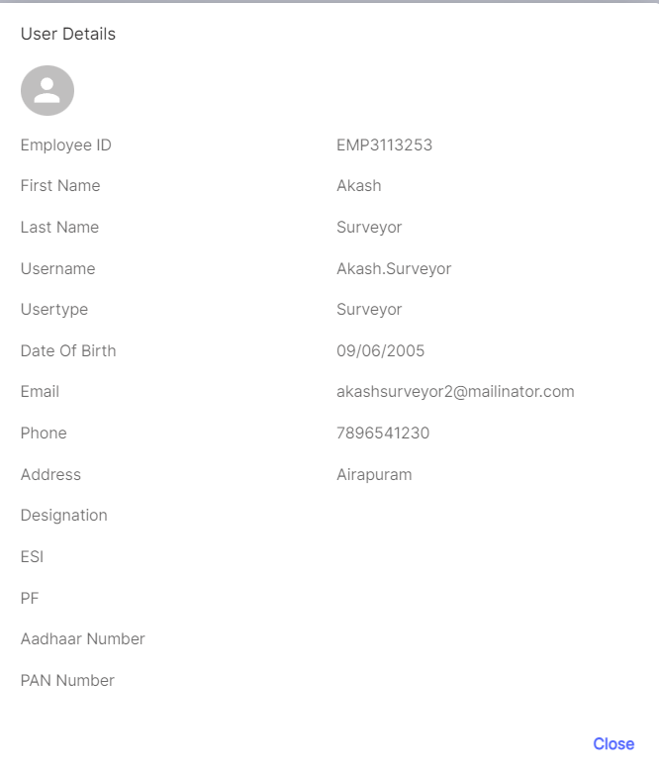

**Edit Surveyor:**

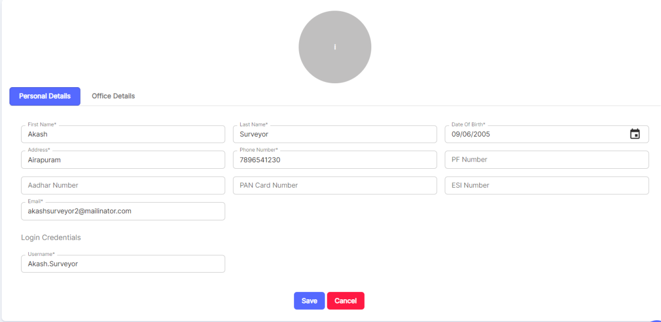

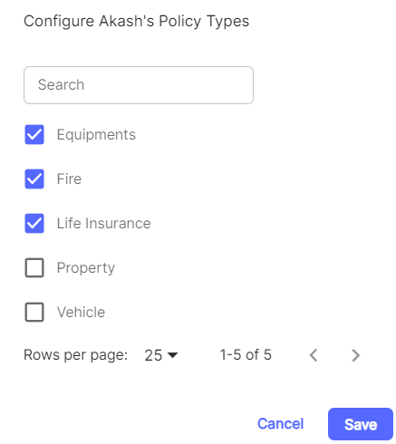

**Download Excel Template:**

If Download Excel Template is selected, then the template which is already set earlier gets downloaded.

Example:

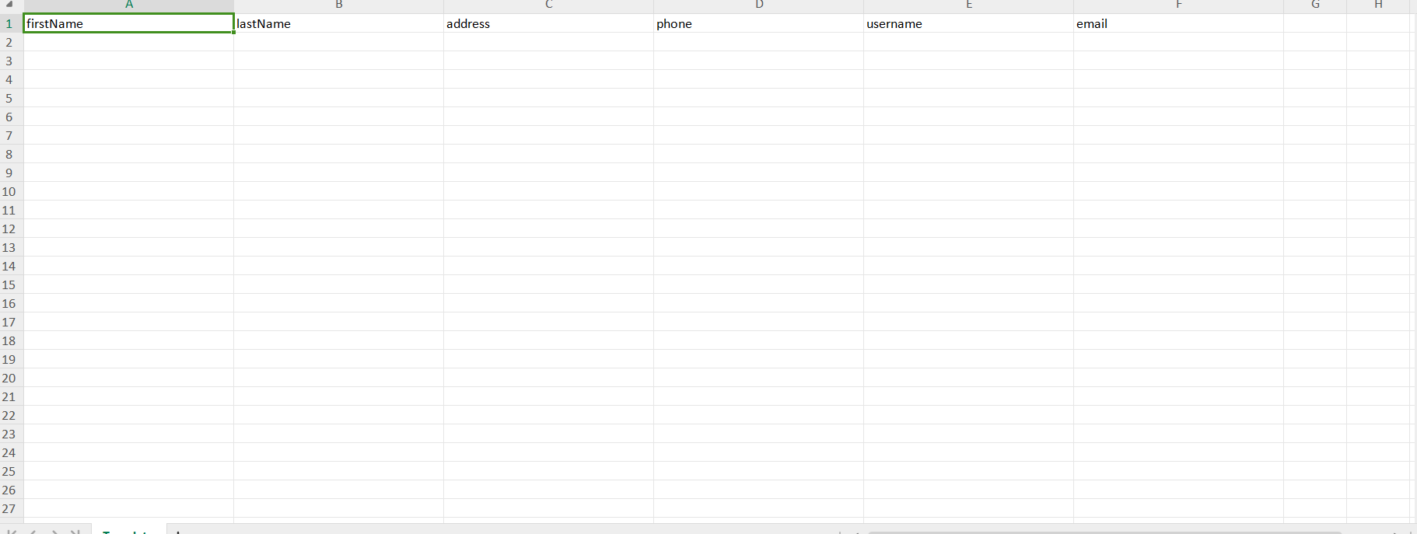

**2.8.3 Banks**

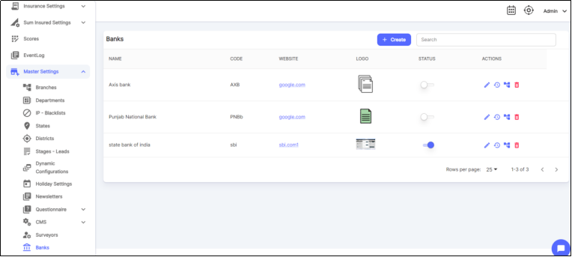

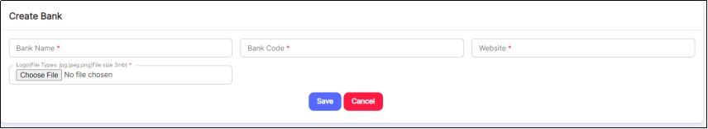

**2.9.0 Forms Management**

Under forms management, there is an option to add Master Input Fields.

* + - **Master Input Fields**

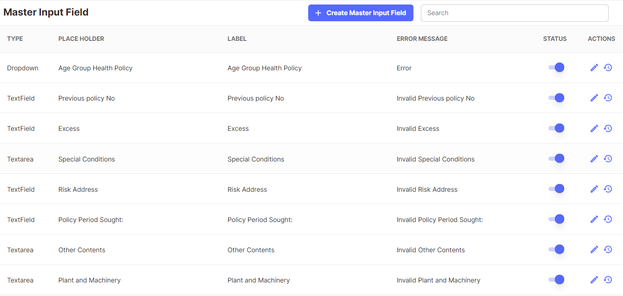

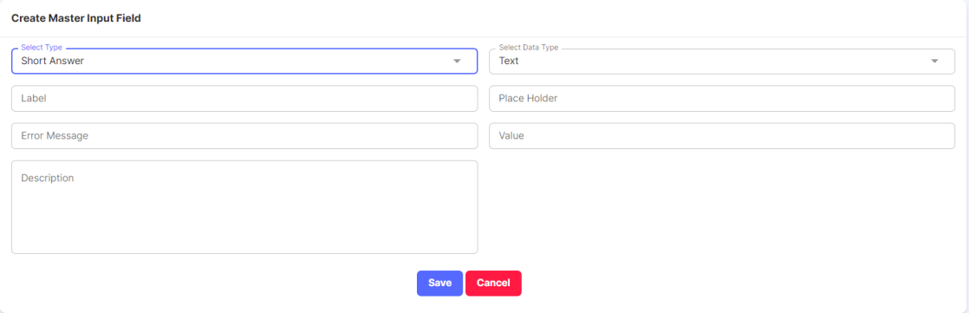

Type can be Single Choice, Paragraph Answer, Drop Down etc. Based on the Type, fields might differ.

* 1. **HRMS**
* The HRMS (Human Resource Management System) module plays a crucial role within an Insurance Enterprise Resource Planning (ERP) system.
* An ERP system is a comprehensive software suite that integrates various business processes and functions into a unified platform, enabling efficient management and data sharing across different departments.
* Here's why the HRMS module is important within an Insurance ERP:
* Employee Management
* Recruitment & Onboarding
* Attendance & Leave Management
* Payroll & Salary
* Employee Finance

All these will be handled in the HRMS Module.

In the below section, some of the modules are only visible to Employees based on Permission.

**Employee-HR Visibility:**

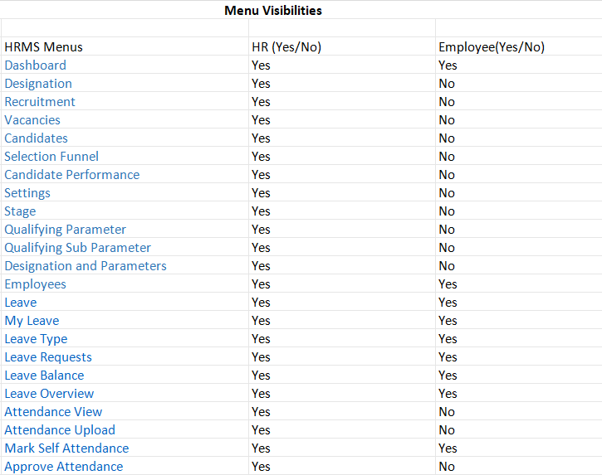

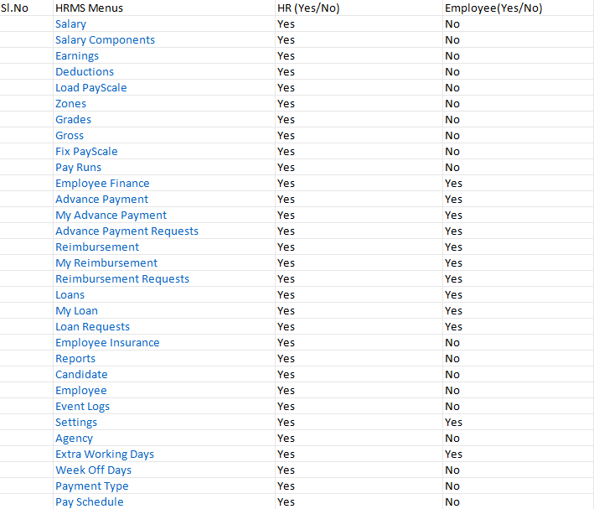

These Menu visibilities can be configured upon request.

**3.1.0 Dashboard**

In a Human Resource Management System (HRMS), a dashboard is a graphical user interface (GUI) that provides a consolidated view of various HR-related data and metrics in a visually appealing and easily understandable format.

* The primary purpose of an HRMS dashboard is to offer HR professionals and managers a real-time snapshot of key HR information, allowing them to make informed decisions, track trends, and manage various aspects of human resources effectively.
* Also, it shows the number of employees, candidates hired, total job vacancies, leave count, etc.
* In the HRMS Module, there are 7 dashboards.
  + - * 1. Total Employees
        2. Your Leave Counts
        3. Total Vacancies
        4. Hired Candidates
        5. Candidates Applied
        6. Candidates Hired
        7. Posted Vacancies

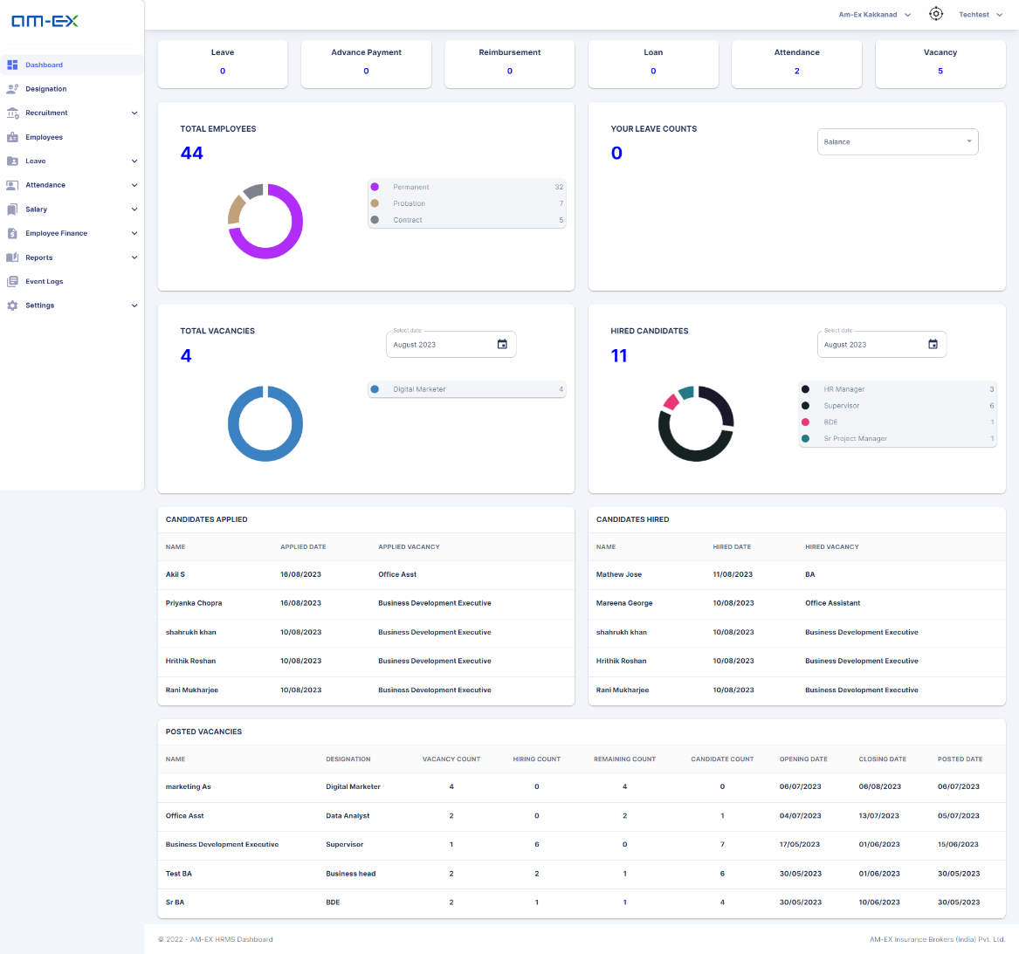

🡪Total Employees: It is similar to a doughnut chart which shows the number of employees in Permanent, Probation & Contract.

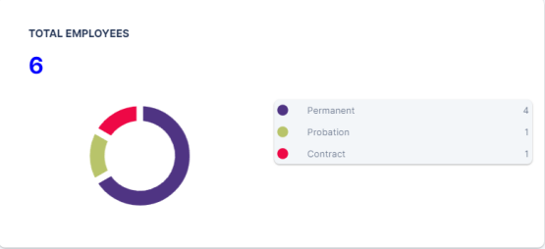

🡪Your Leave Counts: It is the pictorial representation that depicts the self-leave counts based on user login. It will show the leave counts of the logged-in user.

The filter can be used like Balance, Used & Allocated leaves.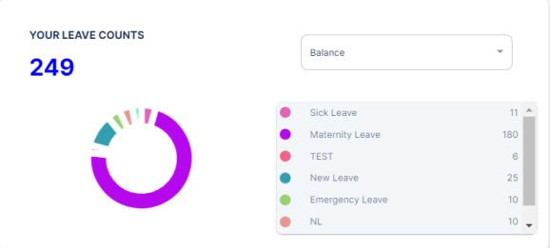

🡪Total Vacancies: It shows the total vacancies posted based on the date filter.

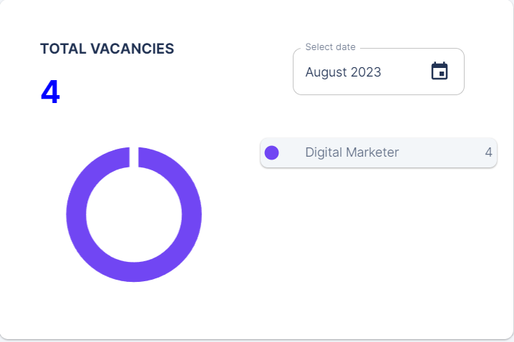

🡪Hired Candidates: In the doughnut chart, it shows the individual split of number of candidates hired for each post. There is a date filter as well to know the number of candidates hired during each month.

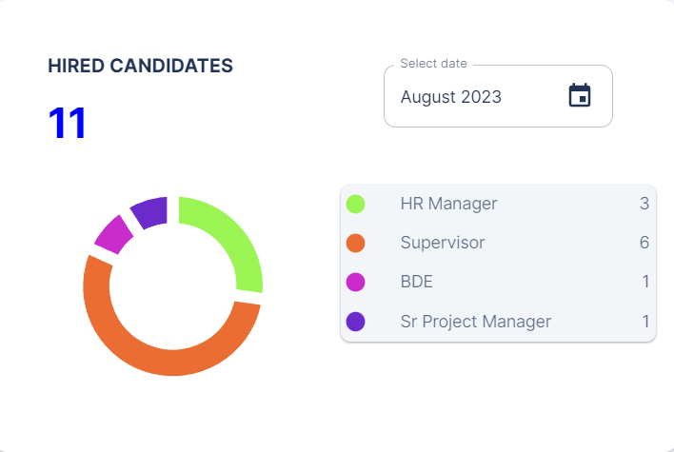

🡪Candidates Applied: It shows the list of candidates applied for the Vacancy post along with the applied date.

Note: Candidate details are captured by HR department by creating candidate. CV can be attached here. No more changes needed here. Think through how we can integrate it directly with Careers in Website - TBD in next phase only after receiving client requirements

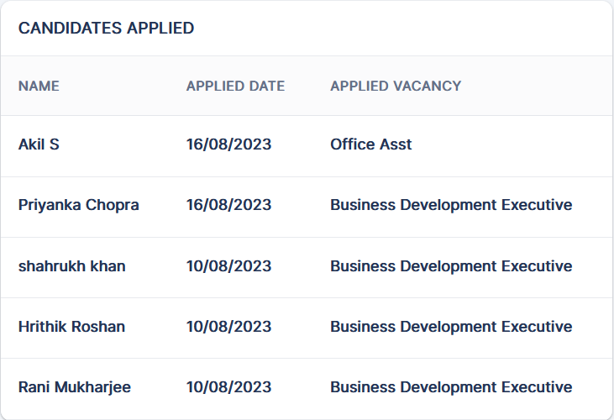

🡪Candidates Hired: It shows the list of candidates who had been hired for the Vacancy post along with hired date.

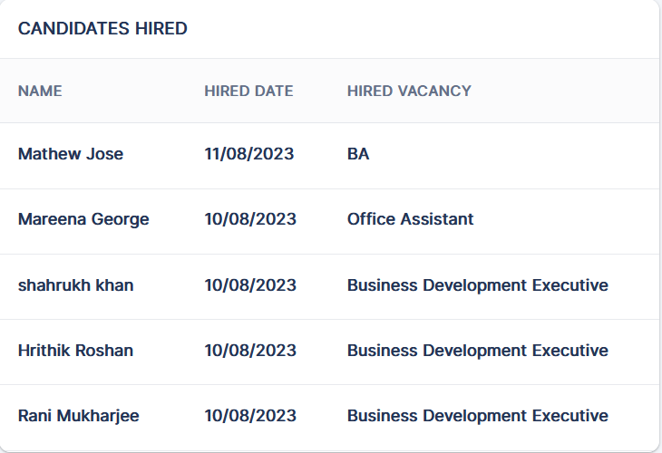

Posted Vacancies: It shows the total list of Posted Vacancies along with the Designation Name, Vacancy Count, Hiring Count, etc.

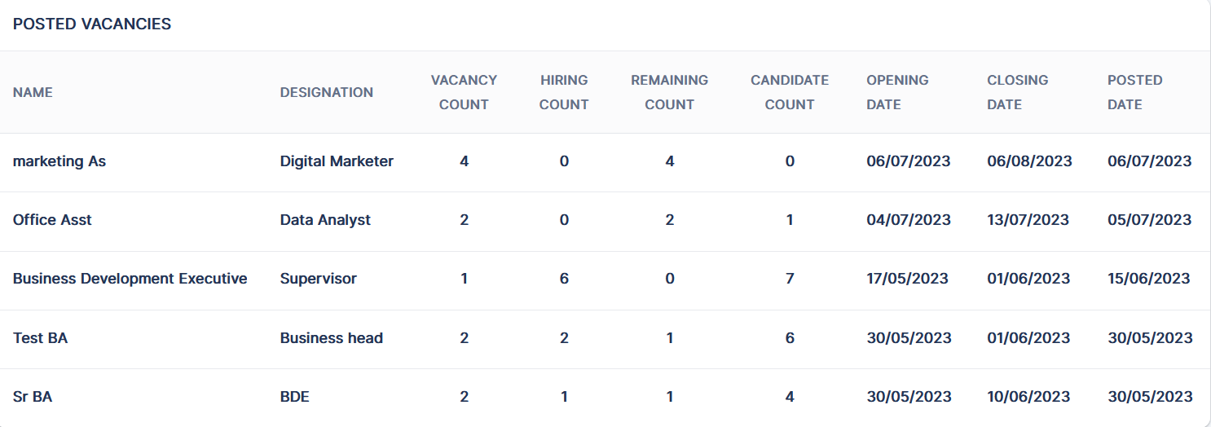

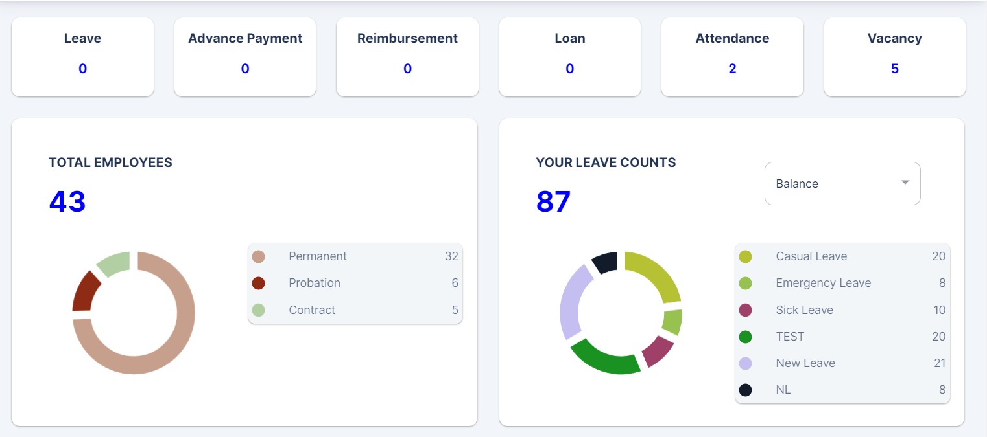

Above the Dashboard, individual blocks are shown with a count. We can click on each of the blocks & it will redirect to the appropriate page based on the selection.

**3.2.0 Designation**

HR can create designations for the respective department in an organization!

The department is created in the Admin Module & there is a dependency between the Designation & Department.

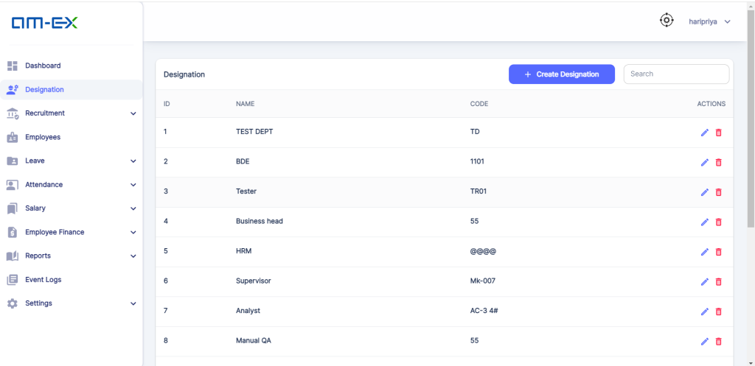

Click on Create Designation. When Create Designation is selected, the below screen appears to fill in the details like Designation Name, Code & Department

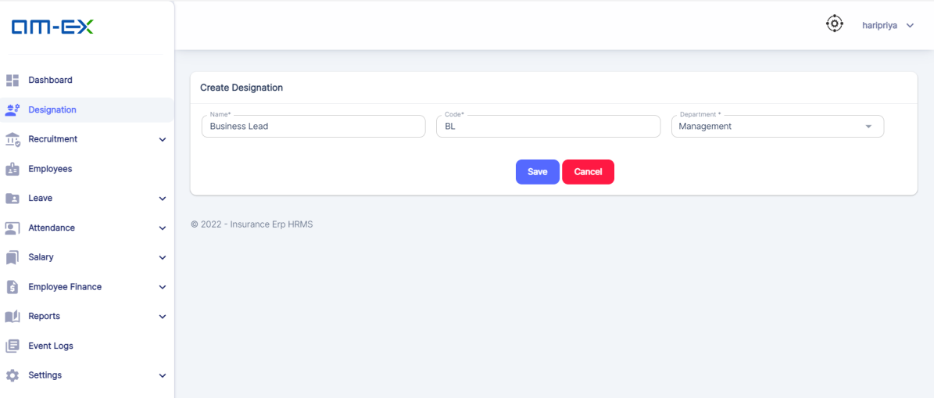

**Once details are entered & saved, Designation is added to the list.**

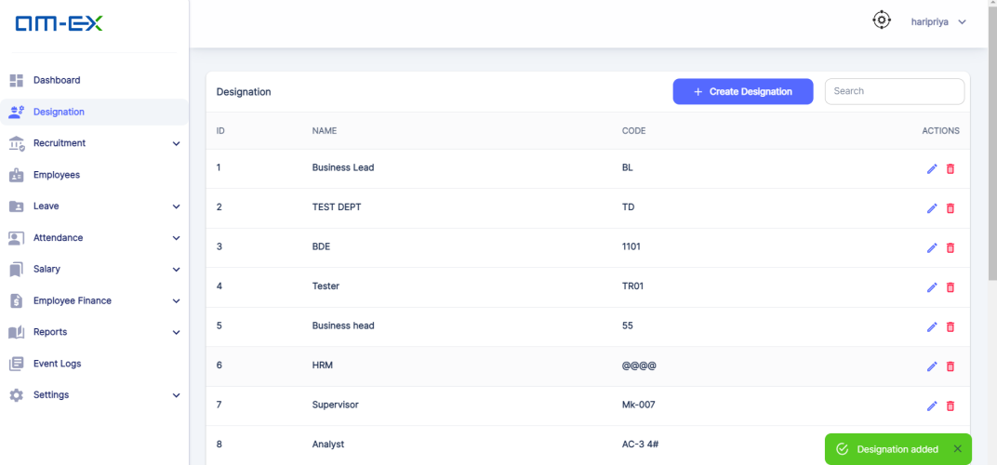

**3.3.0 Recruitment**

This is the module where HR can handle the Recruitment activities that are essential for an organization!

Through Recruitment, HR can hunt individuals from a talented pool of candidates.

Recruitment comprises 5 sub-modules:

* Vacancies
* Candidates
* Selection Funnel
* Candidate Performance
* Settings

This module covers all the stages right from the Vacancy Posting until a Candidate is finally enrolled as an Employee in the organization

Once a Candidate is Enrolled, then only they will appear in the Employee list

Also, it helps to manage the different Interview stages needed depending on the Post Vacancy

Moreover, it helps to keep a track of scores gained by the candidate which helps to monitor the Candidate's Performance in the Recruitment Process

Note: Client suggested that enrollment should happen with multilevel approvals - Here, logged in HR's Reporting Manager should approve it. HR has no role in approval. To confirm if team can proceed with current approach.

* + 1. **Vacancies**

Here, HR can create Vacancies in an Organization. They can post the Designation they are looking for along with the number of Vacancies.

Vacancy Status is also maintained. There are different types of Vacancy Status like:

*All

*Pending

*Approved

*Rejected

*Post

*Closed

Also, we can filter the Vacancies based on the Status & there is a Search Filter as well for easy access from the long list.

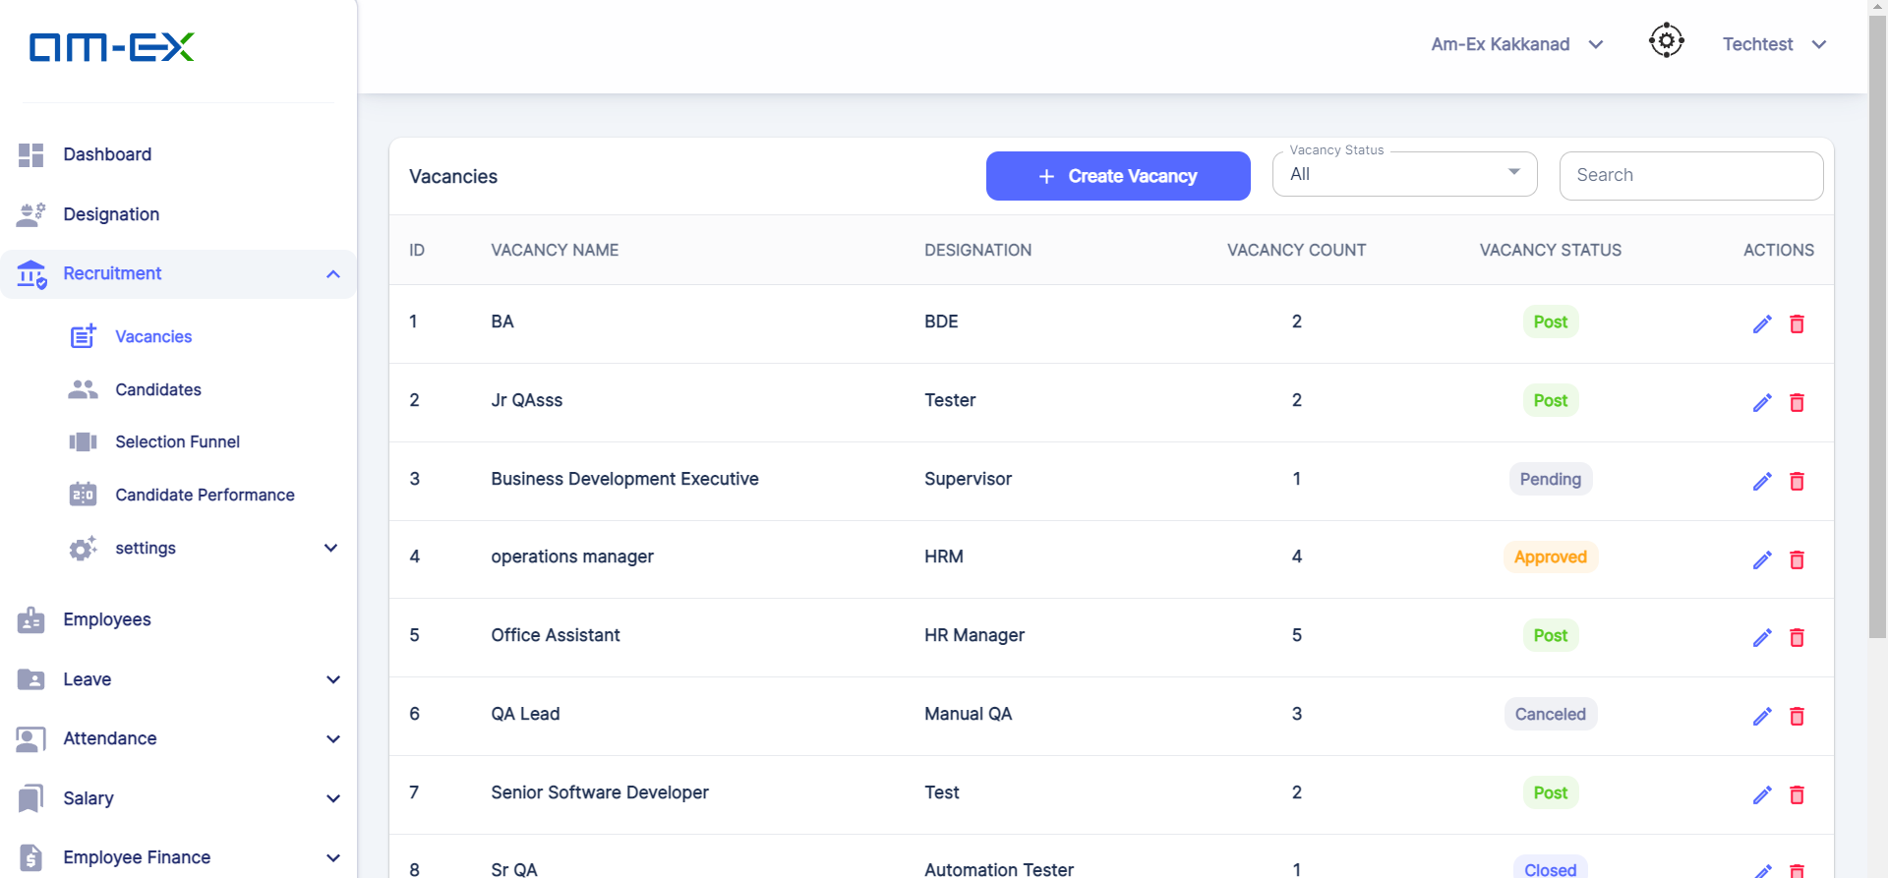

There is an option to do Branch Switching. The logged in user’s branch will be displayed at the top.

HR can filter vacancies in respective branches using the Branch Switching Method. The list will show the Branches where the logged in HR is involved with.

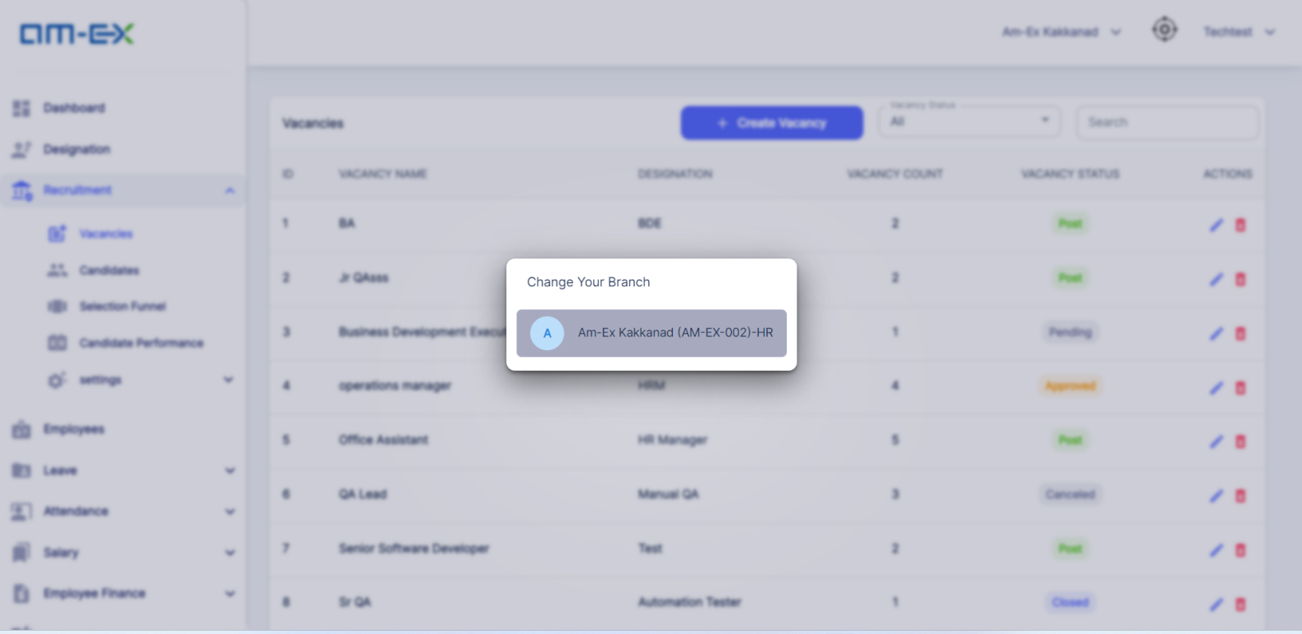

Click on Create Vacancy. HR can fill the respective details associated with Vacancy. Click on Save.

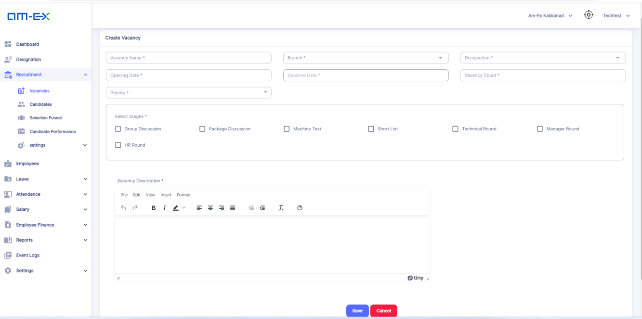

Note: Vacancy Name can be eliminated. Keep Designation & Dept

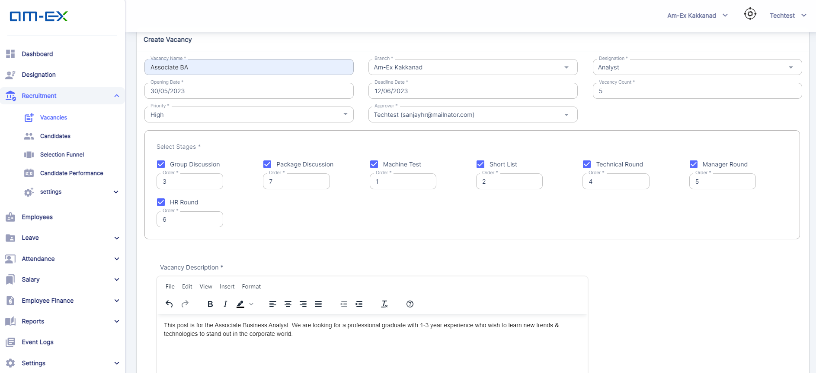

Once the details are Saved, a mail notification will be sent to the Selected Approver.

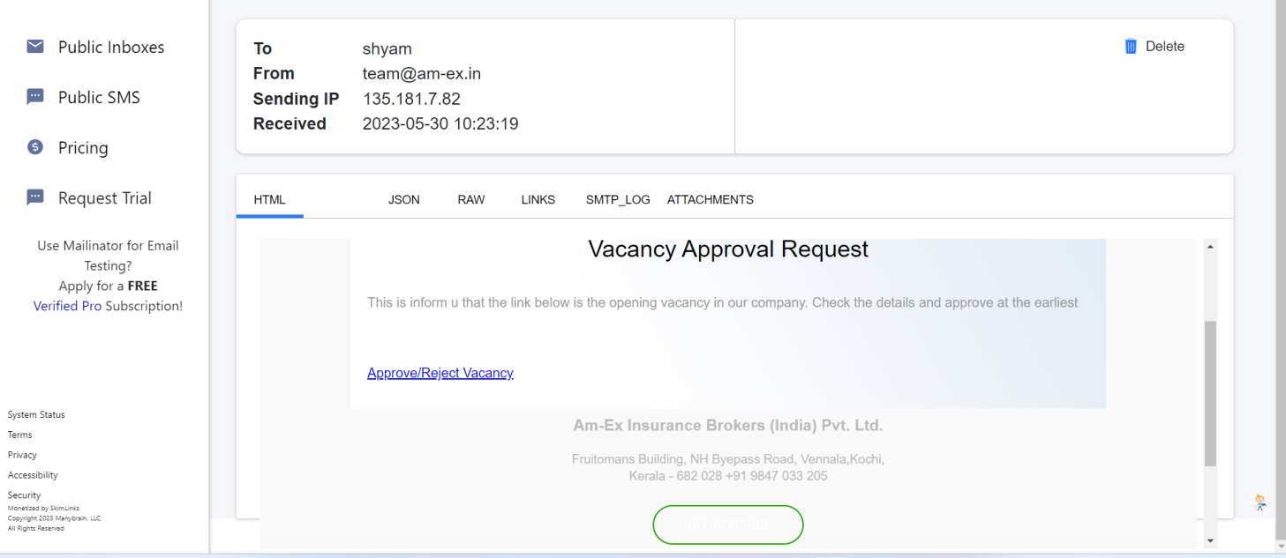

Once the Approver selects the link in the mail, then it redirects to update the Vacancy Status.

Note: Once Vacancy is created by HR, then it should go to approval for HR's reporting Manager (single level approval)

Vacancy Status are of 3 in Approval Stage: Post, Cancel & Close.

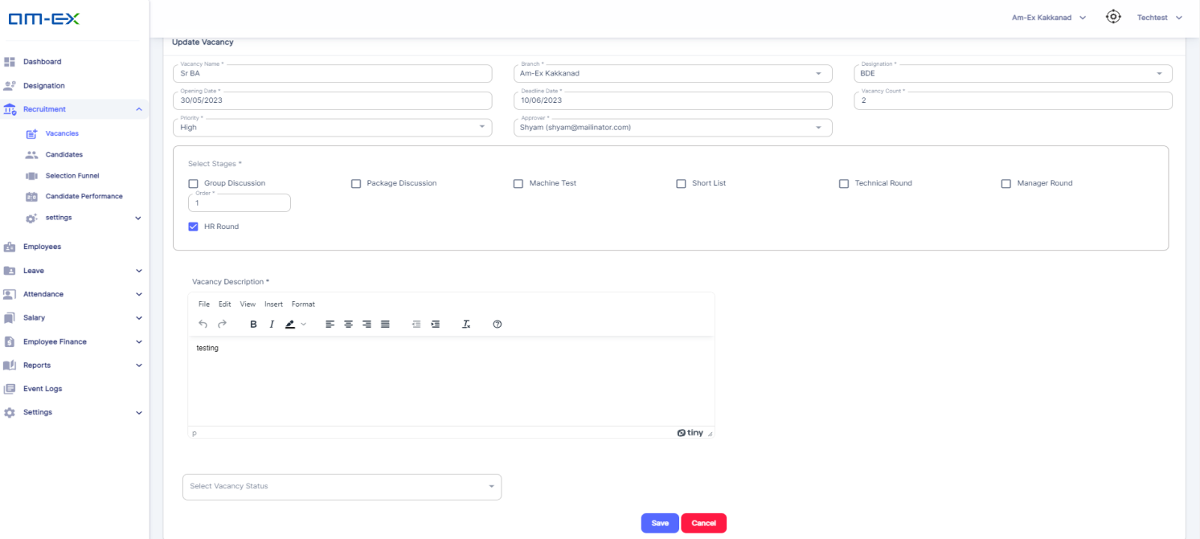

Once Vacancy Status is 'Posted', then it will get updated to the Vacancy List as well. Until the Status is in 'Posted' state, then only we can create a Candidate under that Vacancy. Till that, the Vacancy will not appear in the list at the time of Candidate creation.

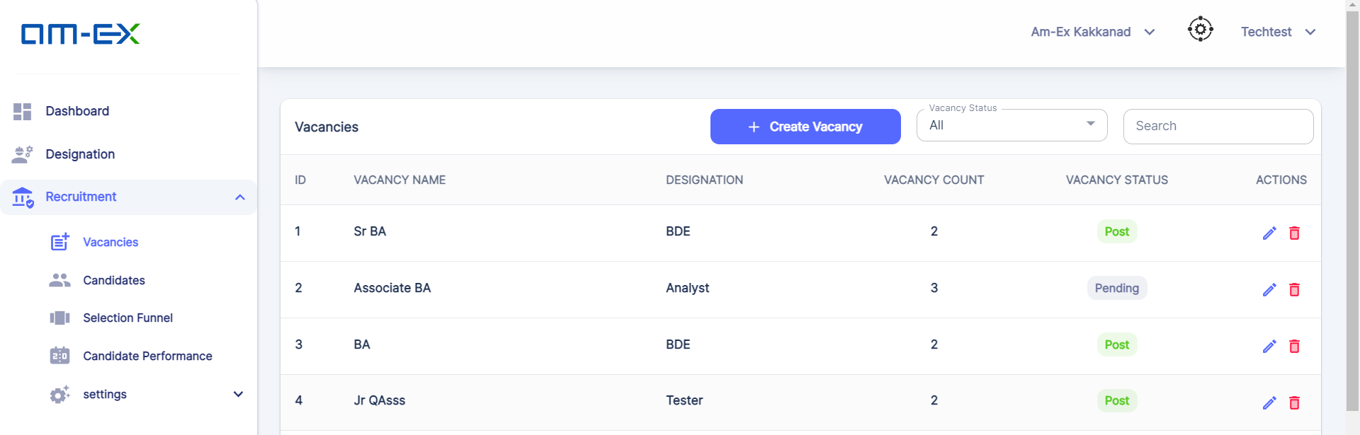

* + 1. **Candidates**

Once a Vacancy is Posted, HR can create Candidate & can map them under the desired Vacancy.

The Interview Process & different stages are handled from here.

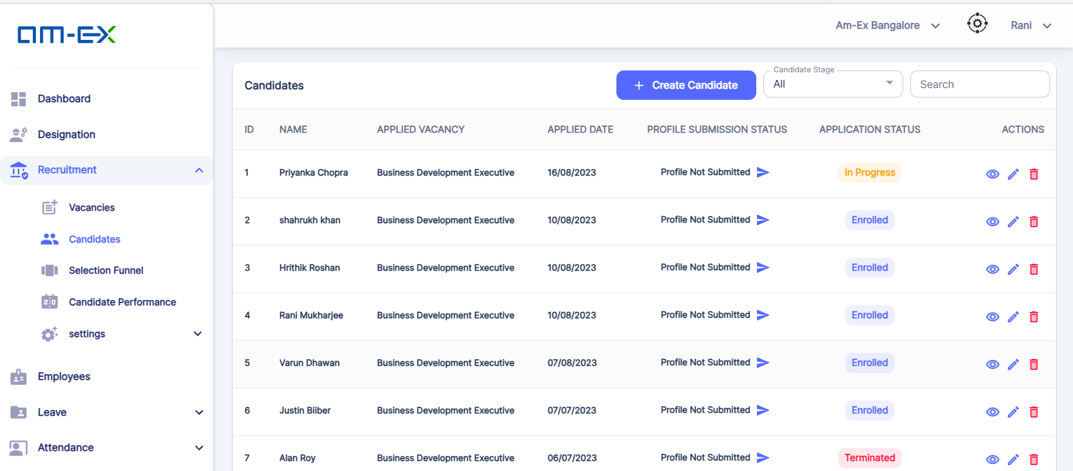

Click on Create Candidate

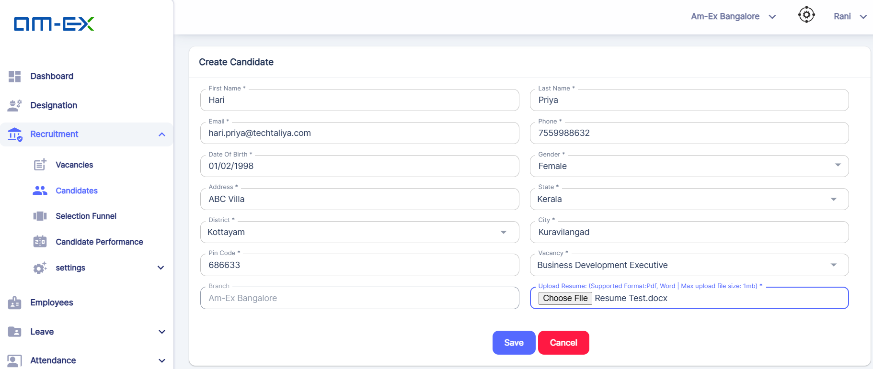

Once Saved, Candidate is Created. Now, HR can click on Start Process for continuing with the Recruitment Stages.

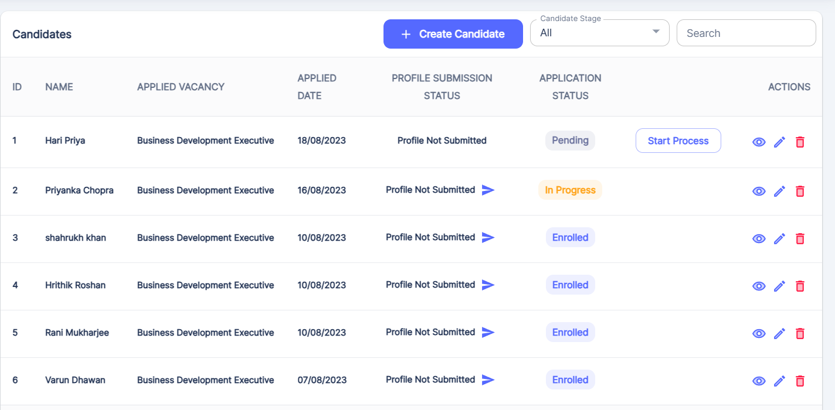

Once Start Process is selected, Application Status will change to 'In Progress' & a message appears as shown in the picture. Also, in the list there is View Candidate, Edit Candidate & Delete feature is there.

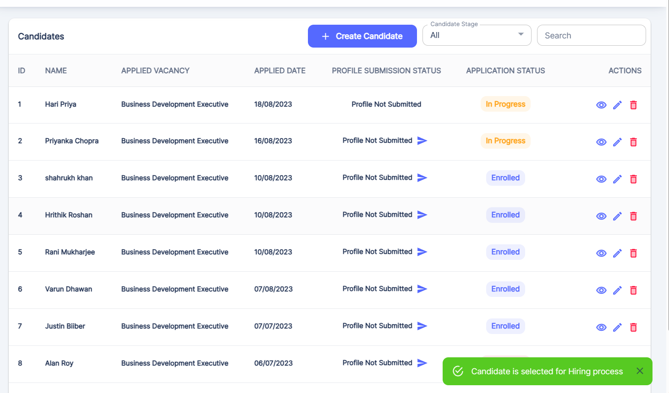

Candidates which are in In progress or Enrolled State cannot be deleted.

Mail Notification is sent to the candidate for filling their details like Education, Job, Experience etc.

Note: OTP login via email to be provided before candidate enter the education details & other info - Will be considered in next phase release only

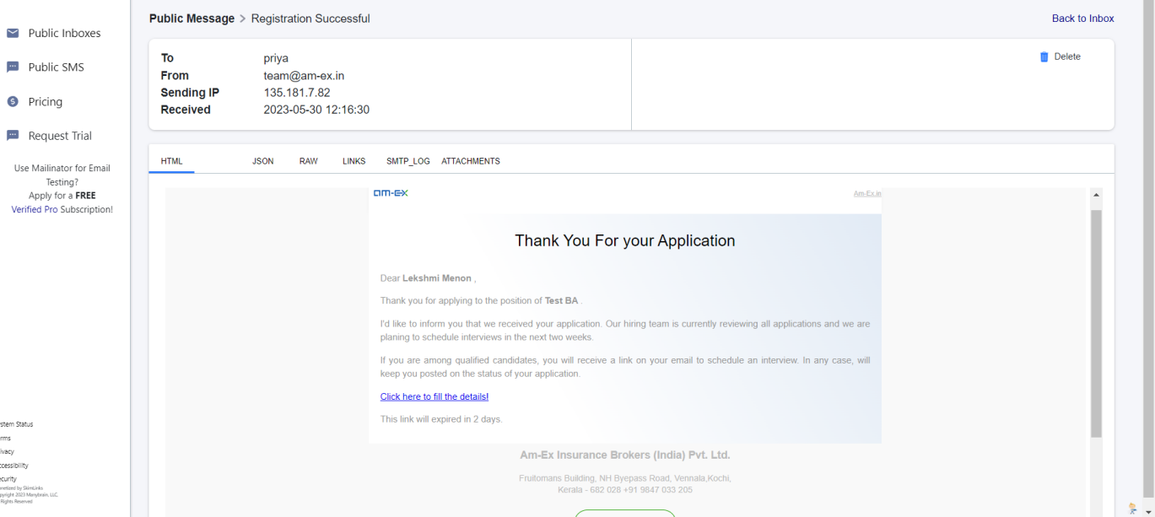

Click on the link in the email & then in the employee login we will be able to fill up the details.

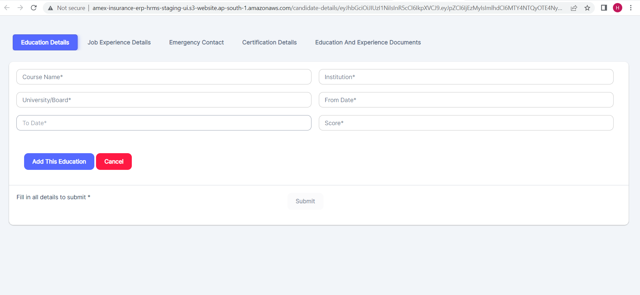

Note: Relationship field can be added against Emergency contact

Note:

Field names to be changed as mentioned. Educational details: course start date, course end date, percentage of marks should be the field names. This can be done in current release

Once details are added, click Add this Education, & it will be added as shown. Click on Submit & education details will get added

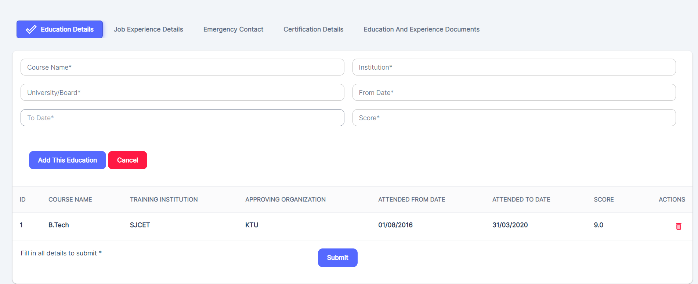

Once all details are submitted, the screen looks like as shown below. Candidate can Save it & the details will be updated successfully.

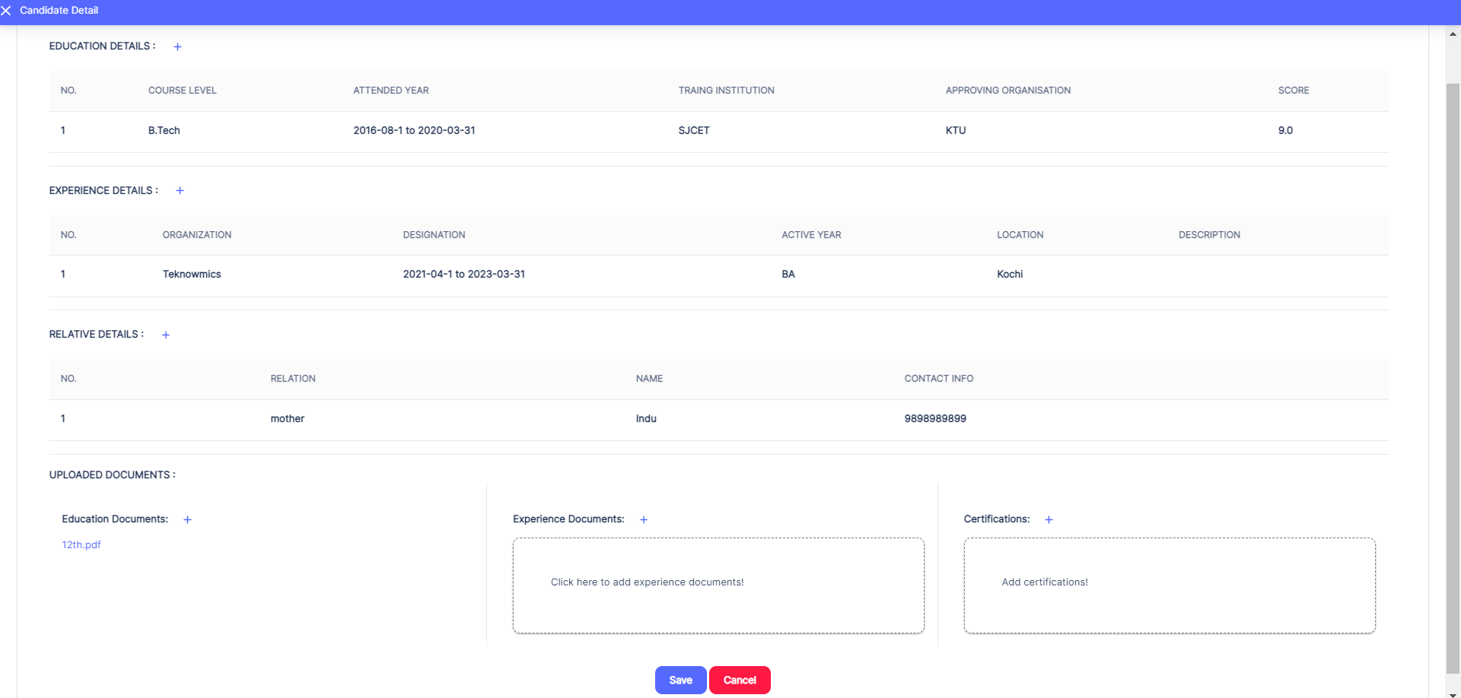

Note: Before Form submission, mandatory field to upload photo and also there should be a declaration that all information are true and correct and will be corroborated with certificates. This should be a tick box. - will be implemented only after phase 1 release.

Note: Provide snapshot for the entered details and allow edit once candidate confirms "submit", the form should get submitted. Print Preview feature to be provided as crisp. Will be implemented only after Phase -1 release

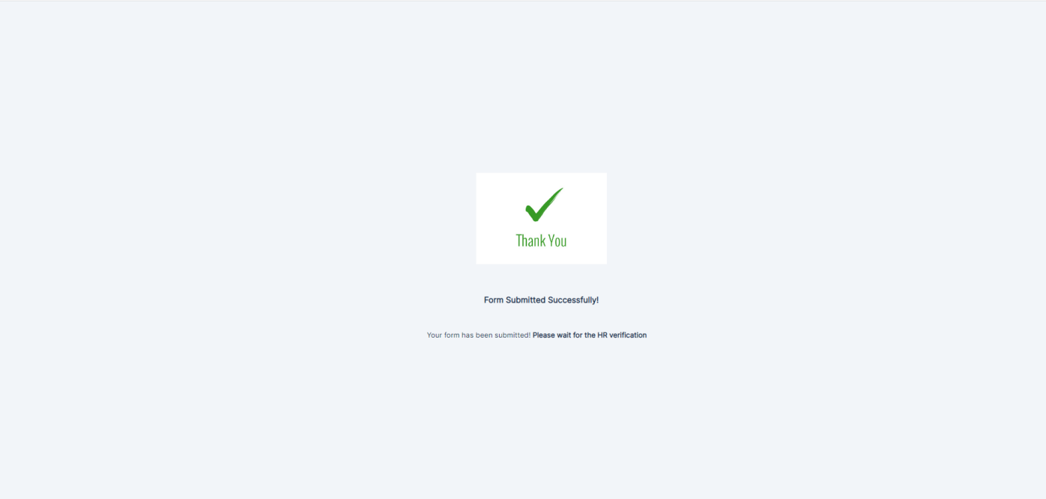

Also, HR can preview the Candidate Details & can add the Candidate Details directly by clicking on "Add Document Details" if in case Employee didn't add it through the Email link.

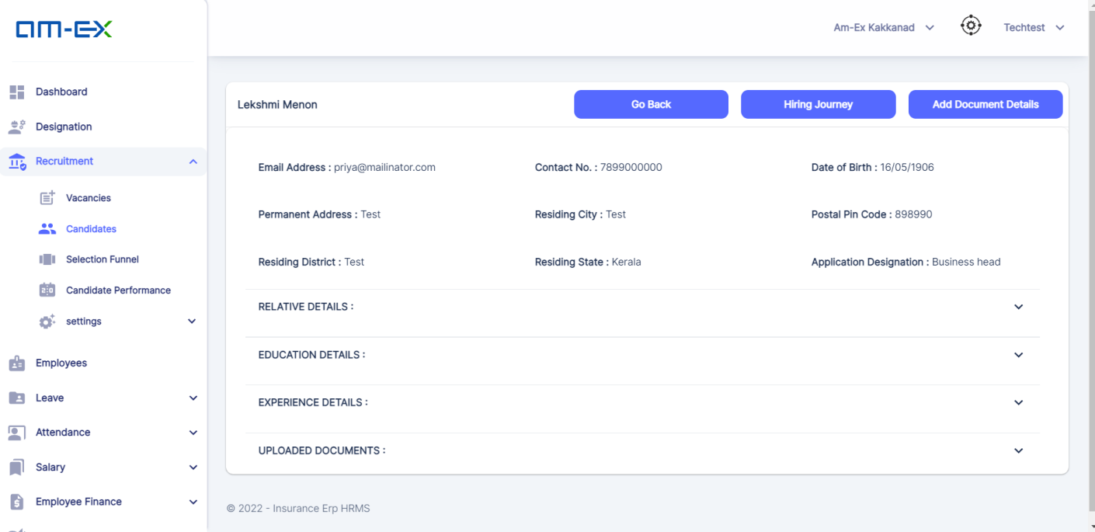

When Application Status is changed to "**Selected**", then **Generate Offer Button** will be enabled.

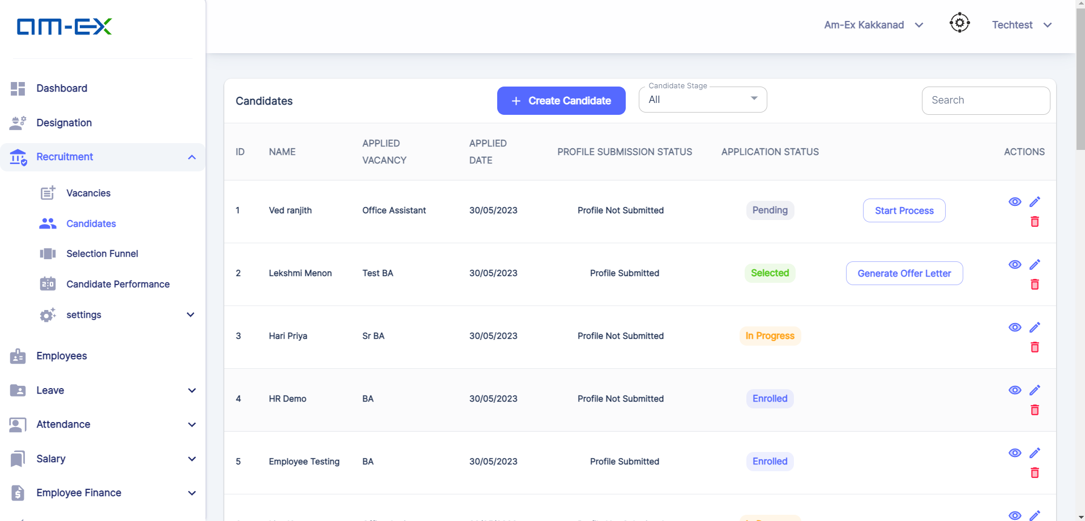

Note: It should be possible to reject the candidate with standard message at the stage where the candidate completes his application.

There is an option to Reject the Candidate at any stage. At the time of Reject, a mail notification with a standard message should be sent to the candidate. Rejected candidates list should be preserved in db. ‘Parting’ field should be added as drop down with values - negative, positive, NA. If flagged negative, that means "Not Interested in Future Also". If flagged Positive, that means candidate can apply again. If NA, new candidate. When new candidate is created, on submit, it should check backend and if found, message "Candidate History with Parting Notes Negative/Positive" based on what is existing. System should validate this in back end - will be considered only after phase -1 release

Provision to blacklist a candidate and provision to view all rejected candidates and also to have search function on multiple fields. Search filter for Parting, Date Range

* + 1. **Selection Funnel**

In this, it will show the list of Active Vacancies of the candidates who are ready for the Interview Process.

HR can initiate the Interview process against the respective vacancy by clicking the Action Button, after cross-verifying the details which Employee had submitted.

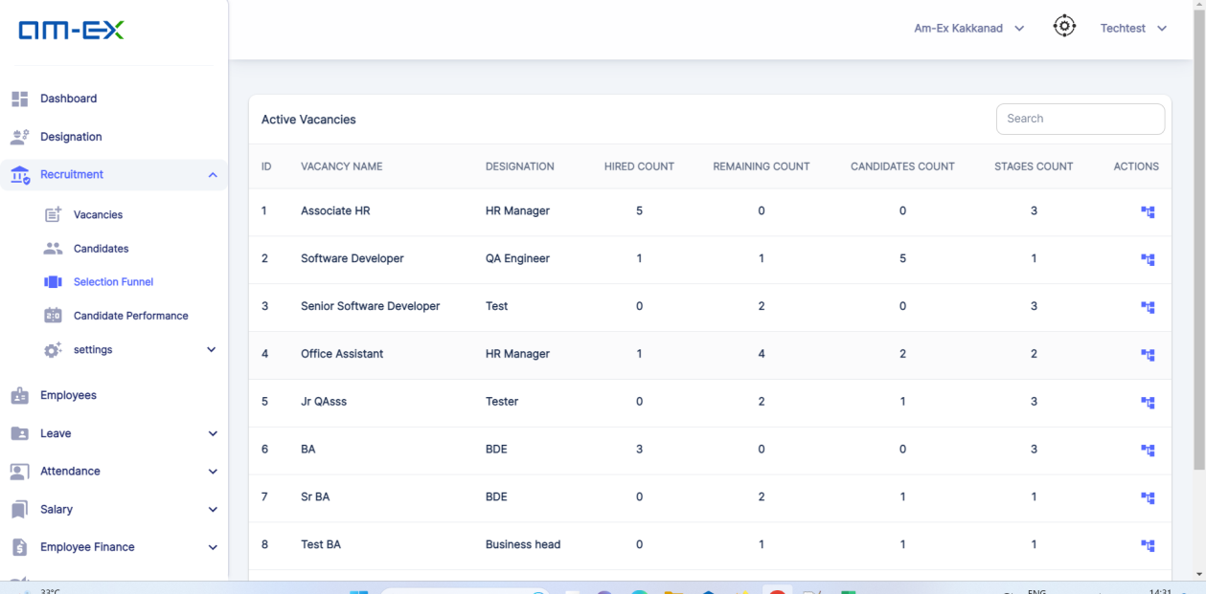

Click on the "View Selection Funnel" in Actions.

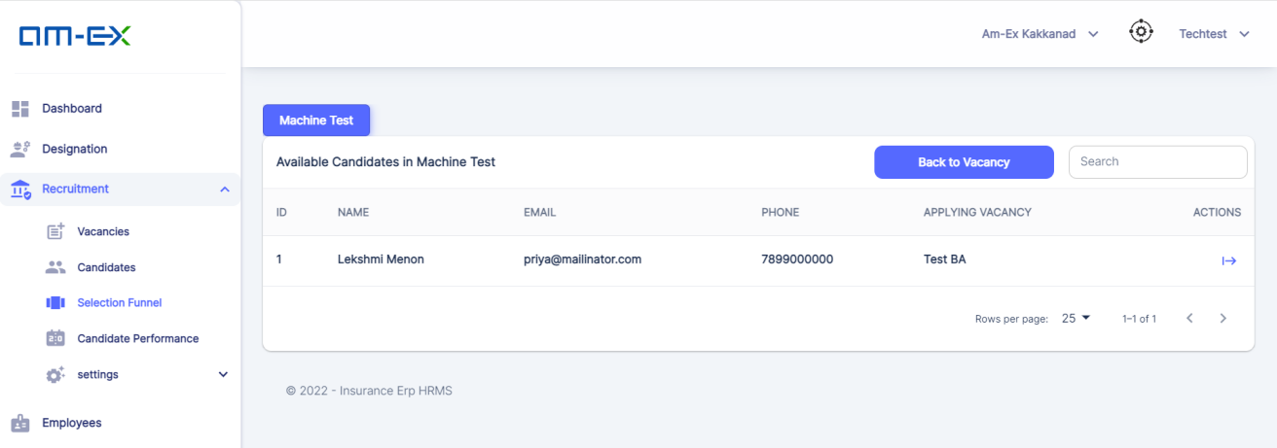

In the Actions, click on Start Interview. Once "Start Interview" is selected, the below page appears to select the Evaluators of the Interview & to mark the Status with Remarks regarding the Candidate Performance Also, need to rate the Candidate Performance on a scale out of 10 based on the performance at the Interview rounds

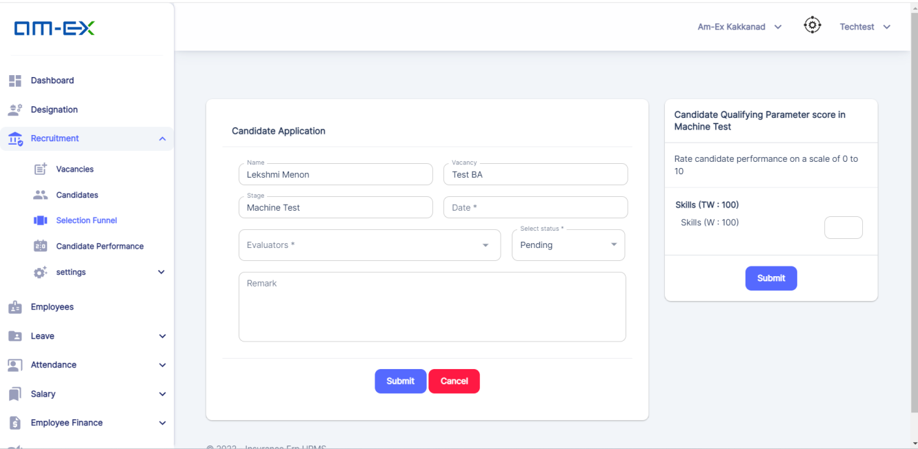

**Note: Refer Qualifying Parameter for reference**

**Once the Details are Submitted, Go to Candidate Performance against the respective Vacancy.**

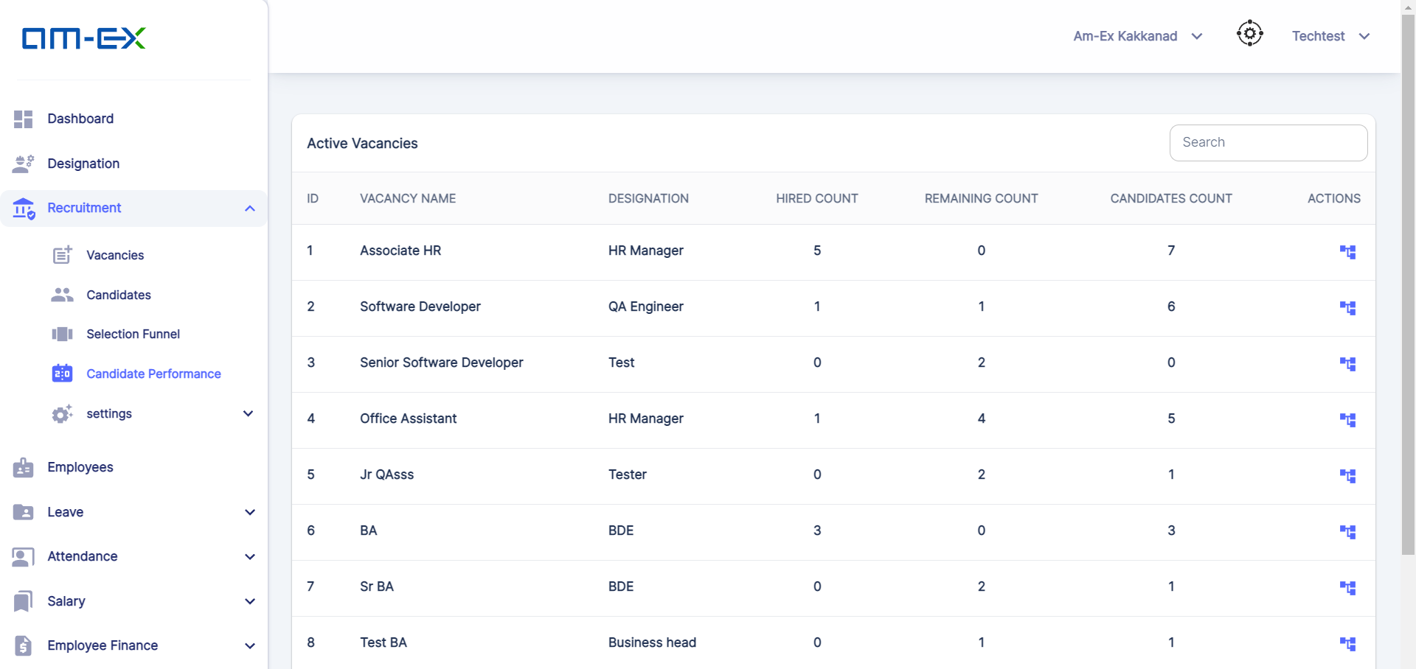

When "View Candidates" is selected against the respective Vacancy, it'll show the list of Available Candidates in the selected Vacancy

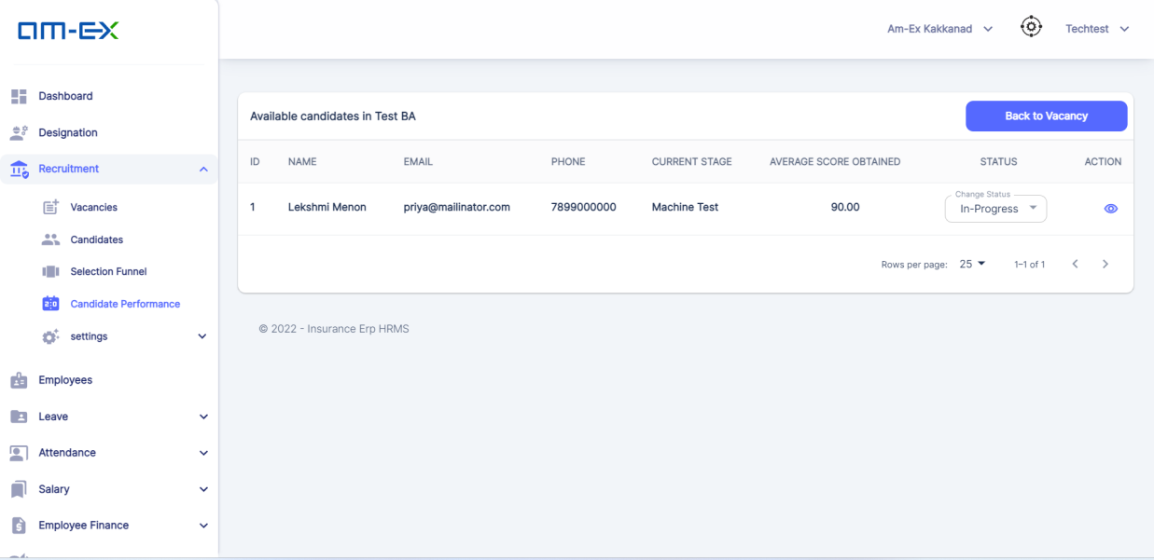 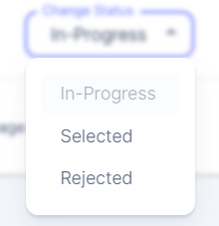

When Status is “Selected”.

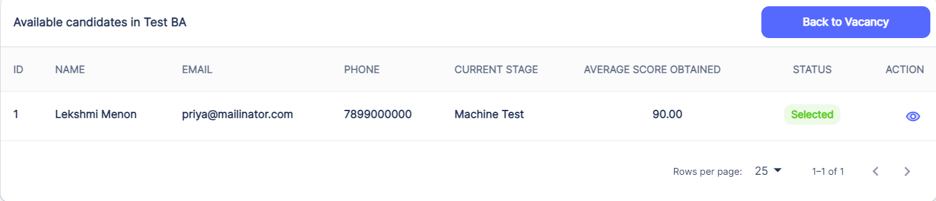

When Preview is selected, below screen appears.

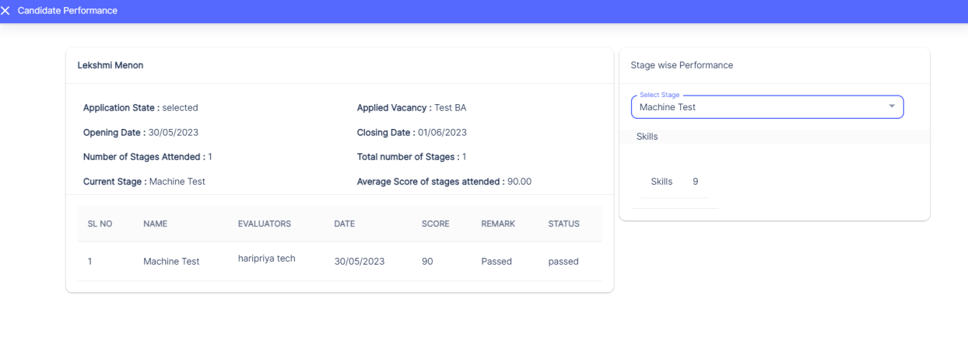

When Application Status is changed to "**Selected**", then **Generate Offer Button** will be enabled



When Generate Offer is selected.

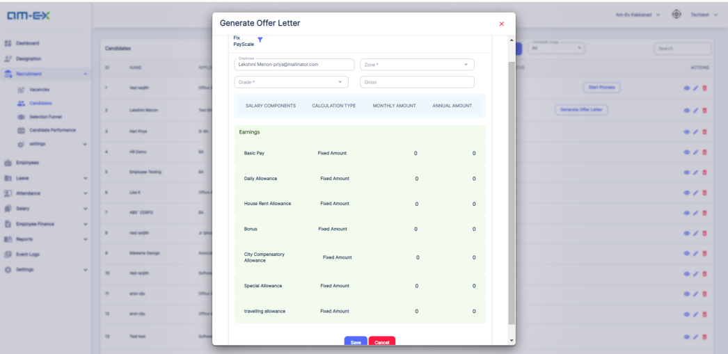 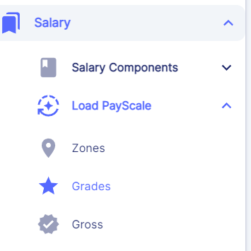 

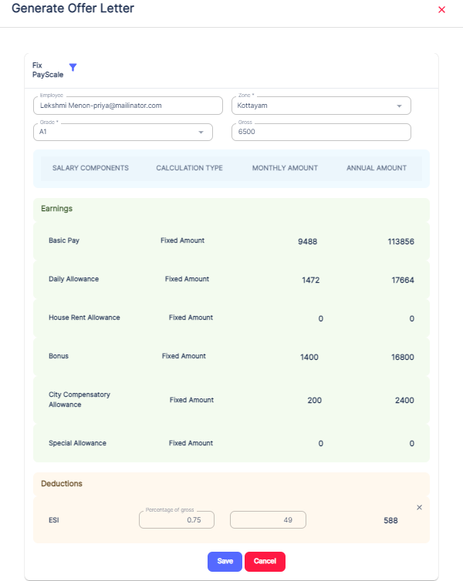 

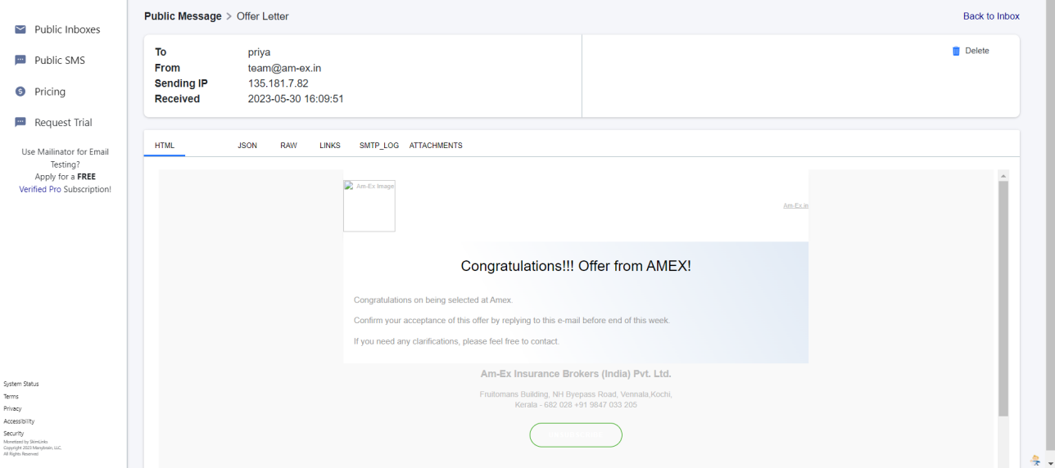

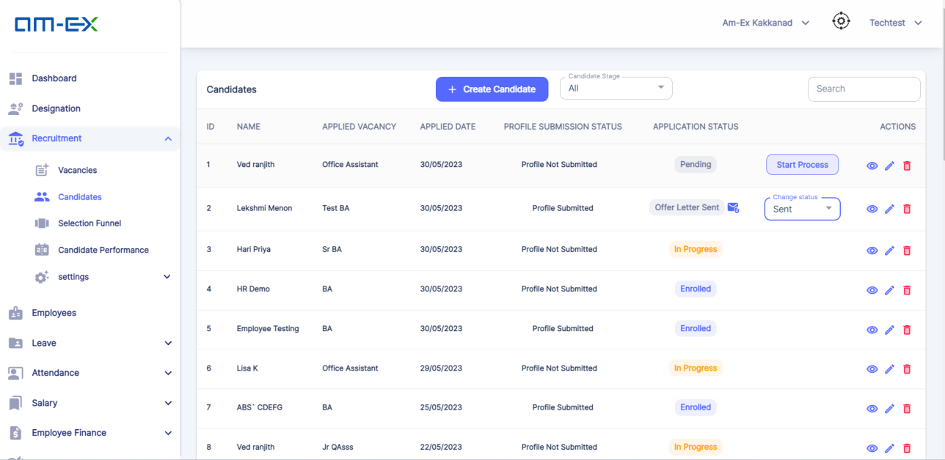 

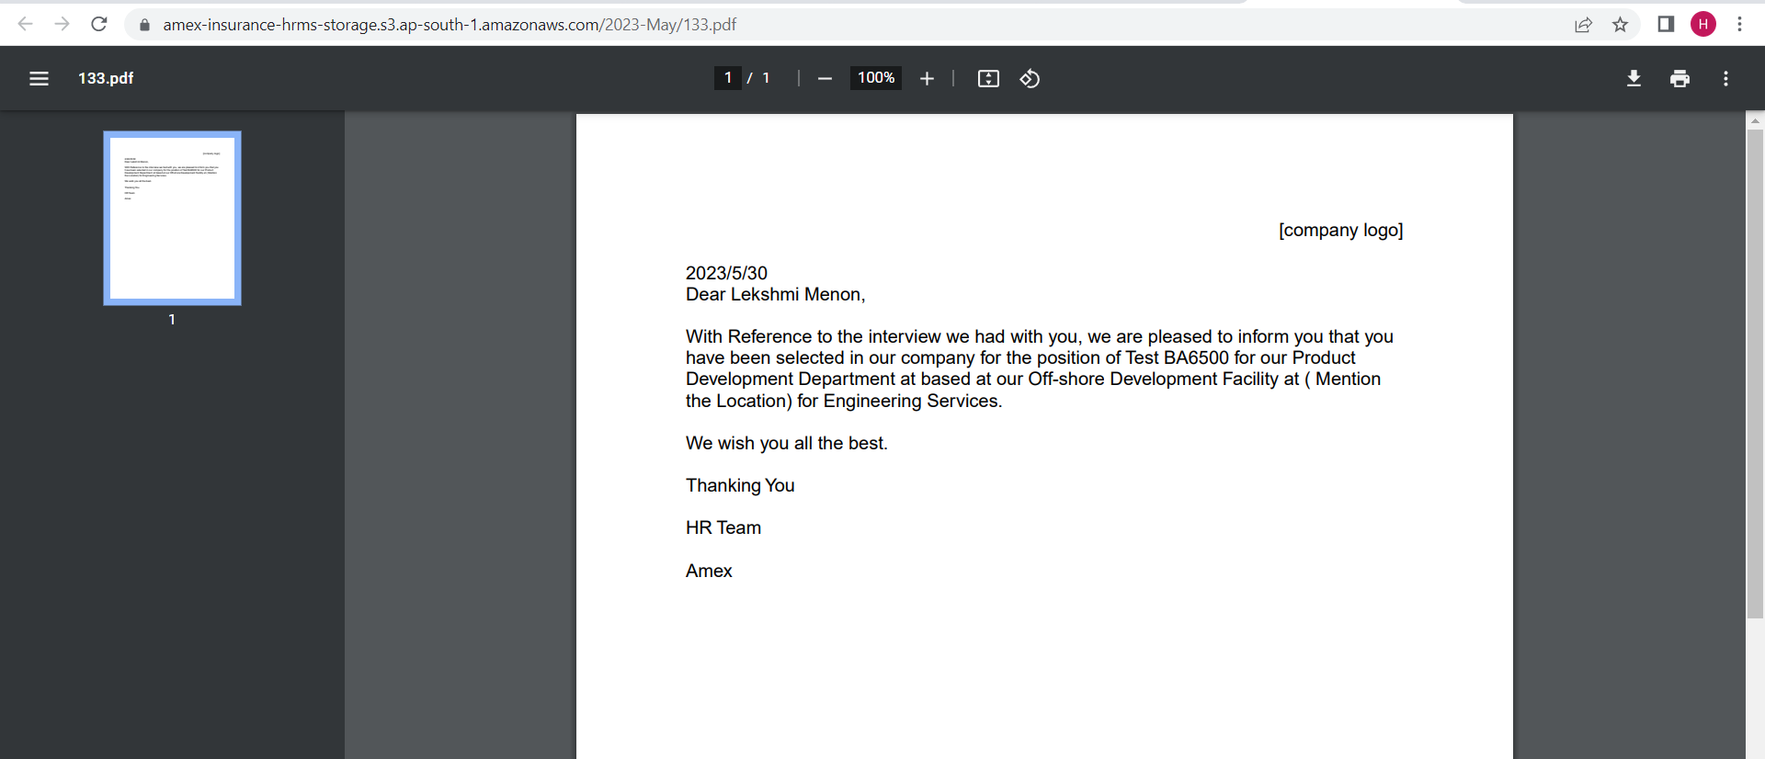

Note: HR's RM should be given the provision of offer letter approval. Amendments include changes in probation period, designation change, etc. Changes can be done via UI only. Offer letter amendments will be discussed at later phase

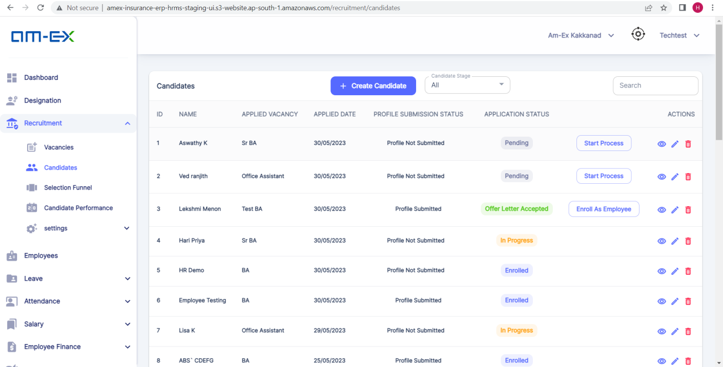 

Note: Under Candidates, Enroll as Employee, give label "Probation Period" before the Start date & End Date. Based on Employee Scheme, label should change

Default Role with minimum privileges is needed. Same role will be there for all employees at the time of enrollment. Rest of the Roles to be changed from System Admin Module. Login credentials will be there as such. User Type to be hidden at UI. It can be handled in backend for internal purposes. Role to be removed. PF/ESI is captured in Salary under Fix PayScale. At the time of Payroll generation, report can be pulled to download previous month's details. It should be able to view total PF deductions from date of joining Relationship field can be added against Emergency contact Asset Management privilege can be given to HR also. Asset Management Module is there





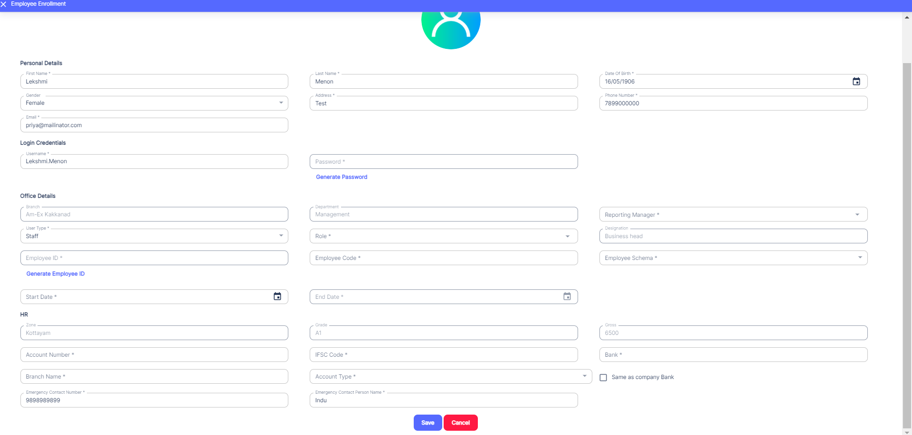

* + 1. **Candidate Performance**

In this module, it shows all the active vacancies and from the Actions it shows the score and status of each candidate who had applied for that particular vacancy.

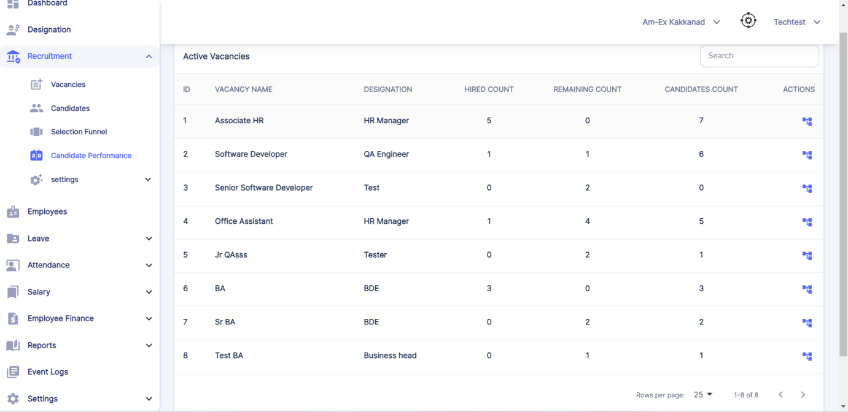 

When View Candidates is selected against a Vacancy, it shows the Available Candidates in that Vacancy.

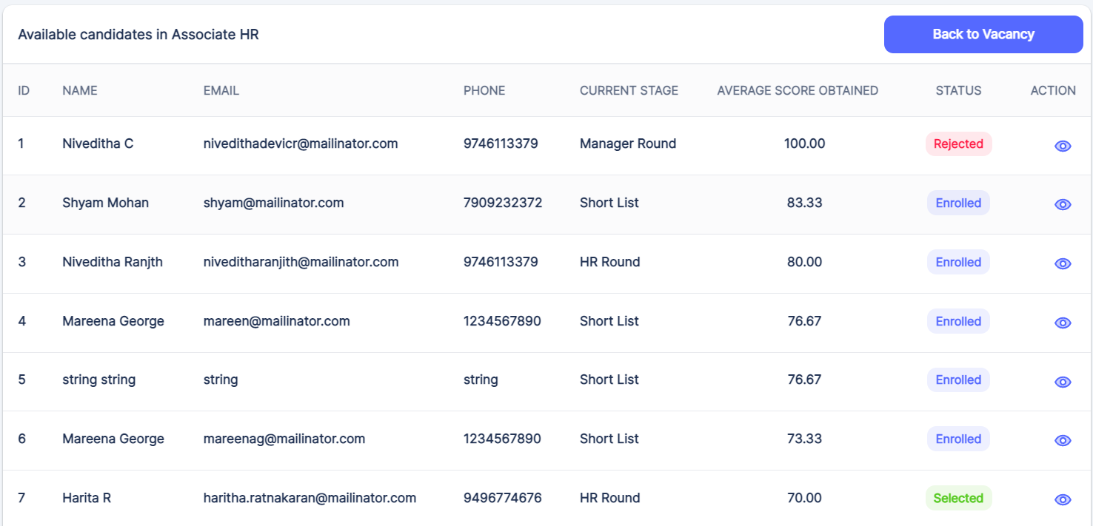 

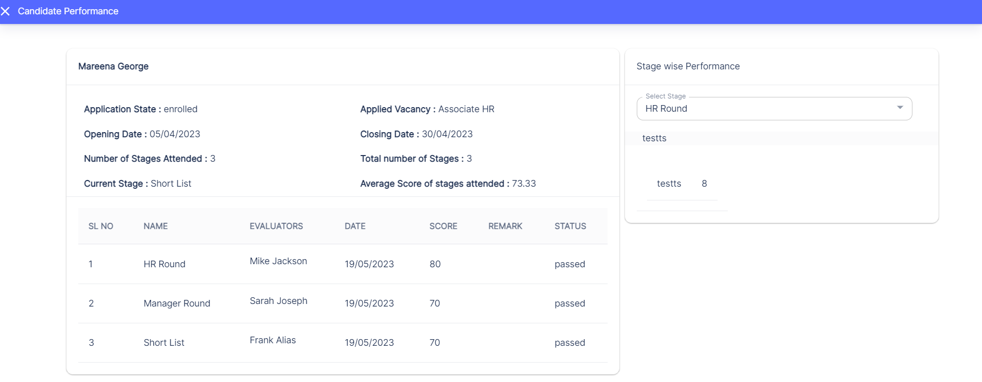 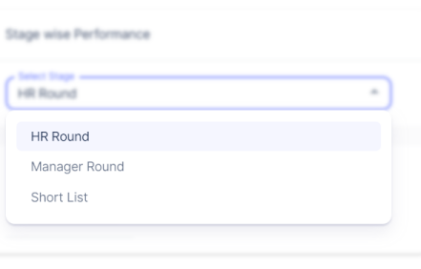

It shows the stages which are selected for this candidate's interview process

* + 1. **Settings (Recruitment)**

Under Settings, there are 4 sub-categories:

* Stage
* Qualifying Parameter
* Qualifying Sub Parameter
* Designation and Parameters
* Under Stage, HR can create the various stages that are needed for an interview process.
* Under Qualifying Parameter, HR can include the various skill sets needed for rating the candidate performance during the selection process.
* It's applicable in the Selection Funnel Module.
* Under Qualifying Sub Parameter, it is used to map some sub features which come under the main Qualifying Parameter.
* In Designation and Parameters, it's mainly used to select the relevant Qualifying Parameters against a designation & need to add weightage.

**🡪Stage:**

In Stage, HR can create the different stages that need to be included in the Recruitment Process of a candidate.

HR can do the necessary Edit & can even delete it if it's not needed in the Recruitment Stage.

The stages can be like GD, Machine Test, Technical Round, HR Round etc.

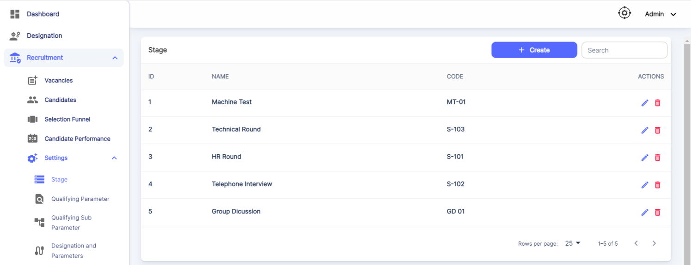

Click on Create Stage.

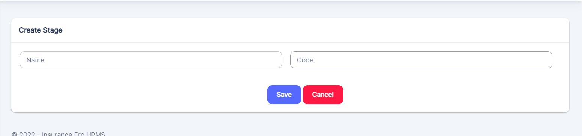

HR can enter the Stage Name & Code and can Save it. The details will get updated into the Stage Module.

**🡪Qualifying Parameter:**

In Qualifying Parameter, HR can add the parameters that are needed to evaluate the Candidate Performance in the Interview.

The parameters can be like Technical Skills, Soft Skills, Communication, Analytical Skills etc.

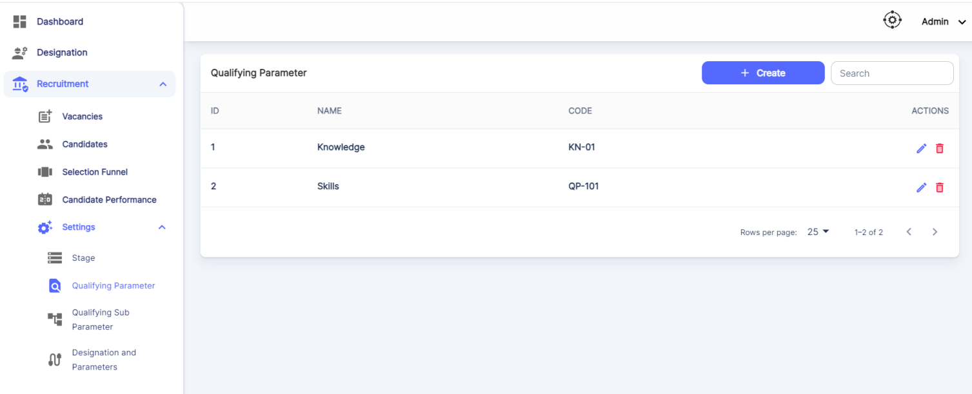

Click on Create Parameter.

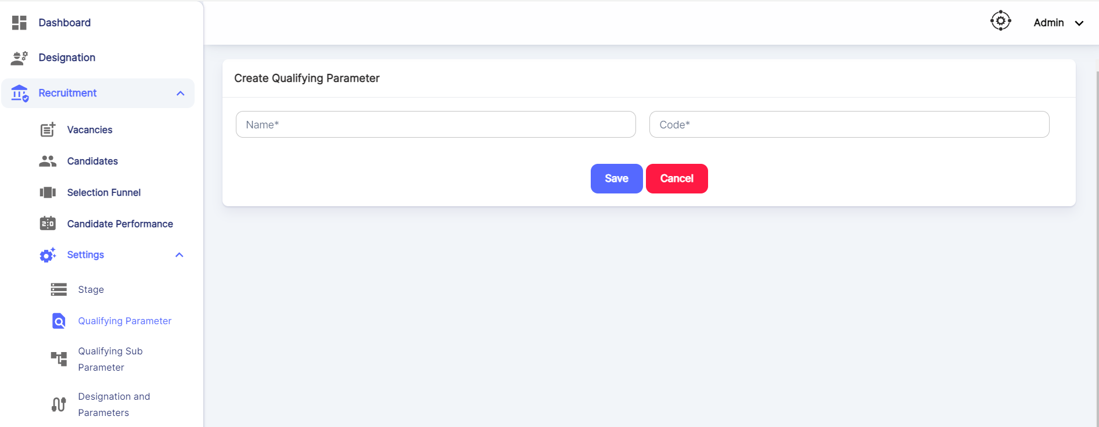

**HR can enter the Qualifying Parameter name along with the code and save it.**

**🡪Qualifying Sub Parameter:**

Qualifying Sub Parameter is used to map parameters under the desired Qualifying Parameter.

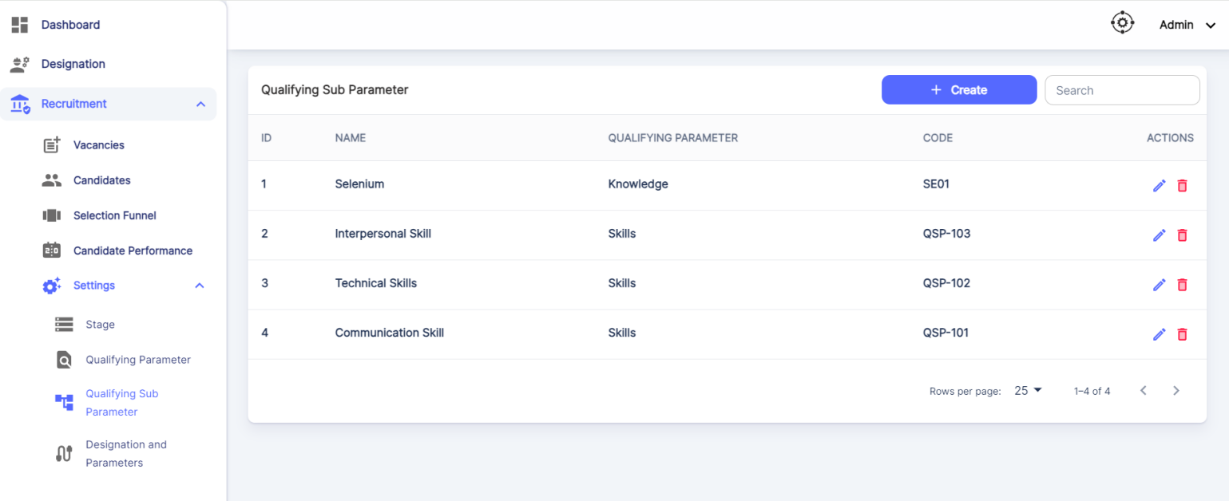

Click on Create Sub Parameter.

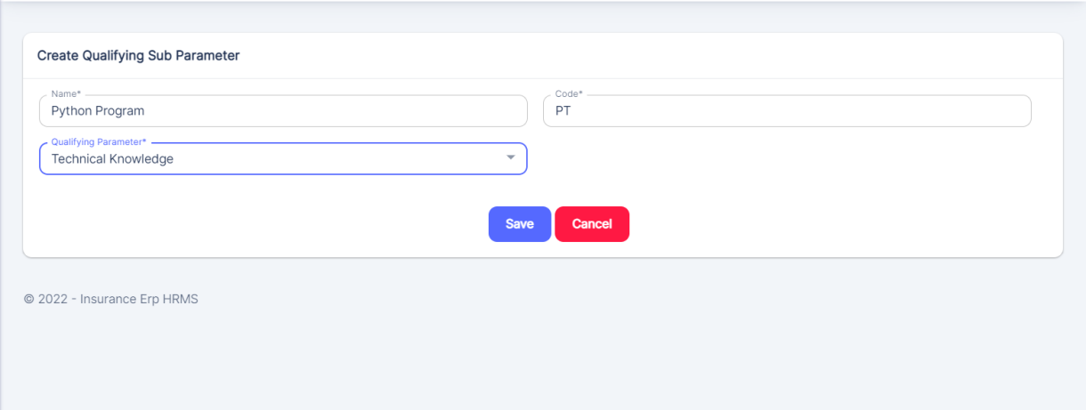

HR can add the Sub Parameter & can map it under the Qualifying Parameters listed. After Saving, if any Updations are needed, HR can edit it as well.

**🡪Designation & Parameters:**

HR can map Qualifying Parameters against each Designation. While mapping Qualifying Parameters with Weightage, note that the Weightage should be 100.

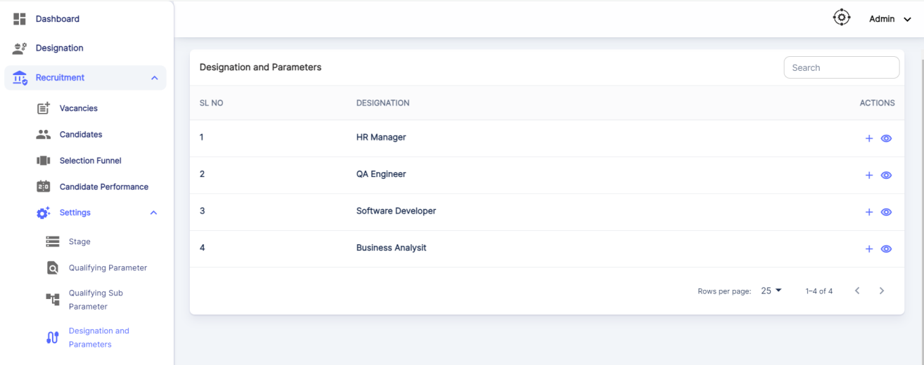

Click on the + icon which is to Add Qualifying Parameters.

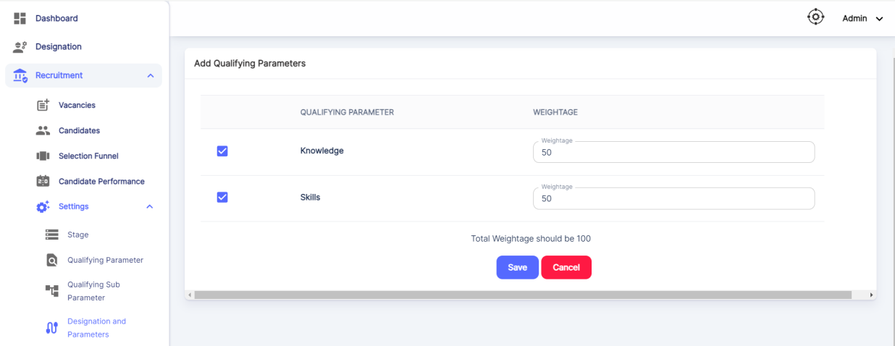



* 1. **Employees**

Once a Candidate is in Enrolled Status, those Candidates will appear in the Employee List.

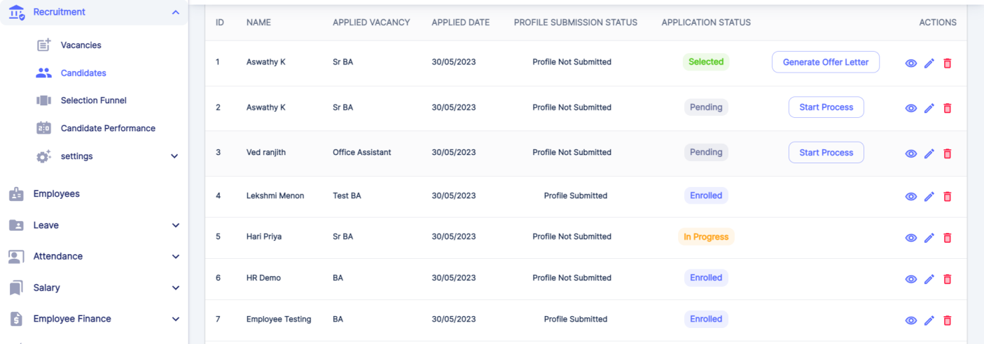

Those Employees in Enrolled Status will appear in the Employees.

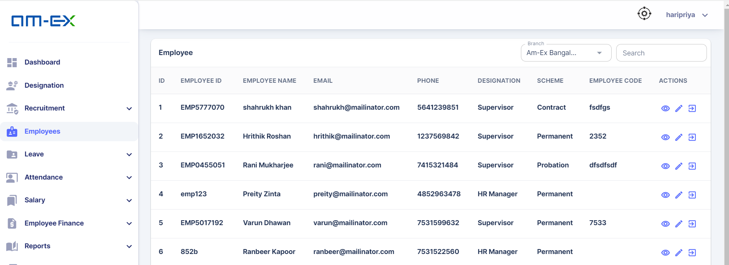

Actions possible by HR are:

View Employee Details, Edit & Employee Termination

**View Employee Details:**

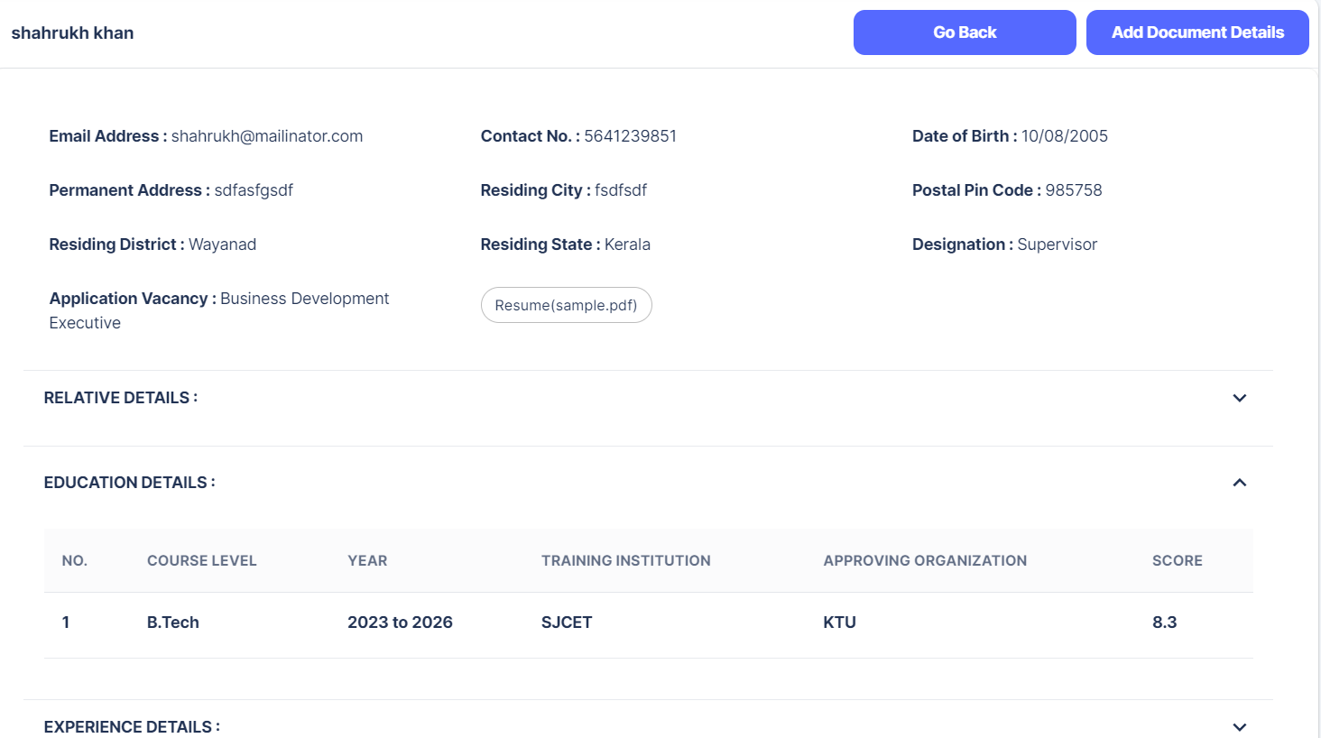

**Employee Termination:**

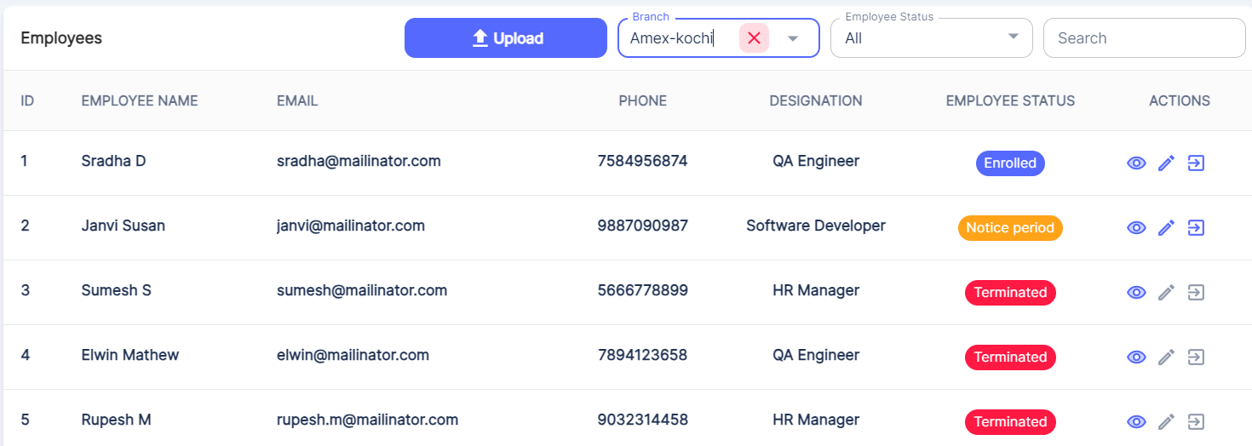

If an employee is moving out from the office, then click on Employee Termination.

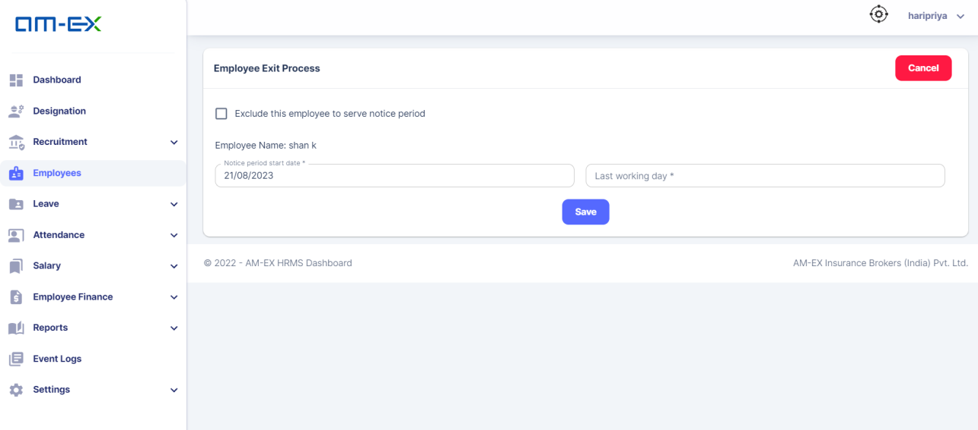

**If there is any Insurance, Assets or Loans for this employee,** then it needs to be closed first. So, all the pending details will be visible in the Employee Exit Process Page. Then only, Terminating this Employee action can be done.

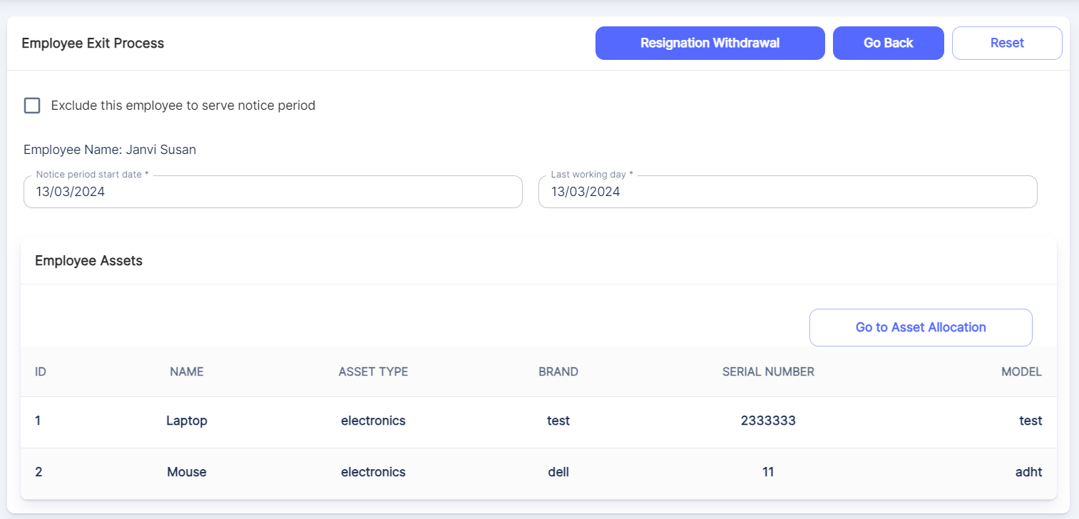

The Resignation Withdrawal button will be enabled until the last day of his resignation. Till that date, the employee can withdraw resignation.

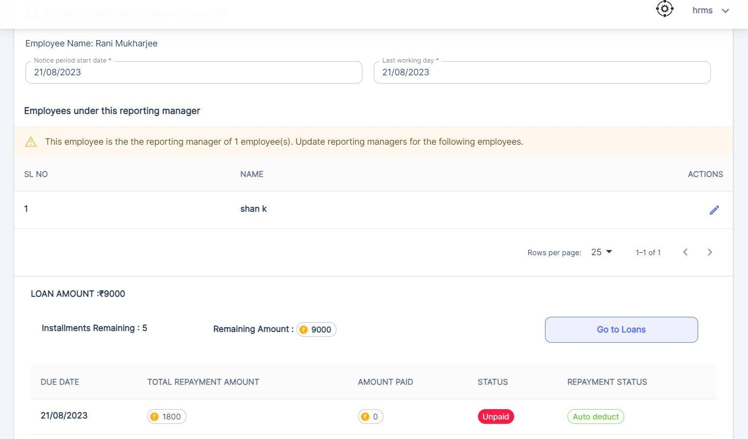

If a Reporting Manager is moving out from the organization, then the Reporting manager of the employees under her/him should be changed and a new Reporting Manager should be updated for those employees.

Also, as mentioned above, this case is applicable for Loans also. If this person is a loan approver for any of the employees under her/him, then the loan approver also should be updated for those employees.

Click on Go To Loans.

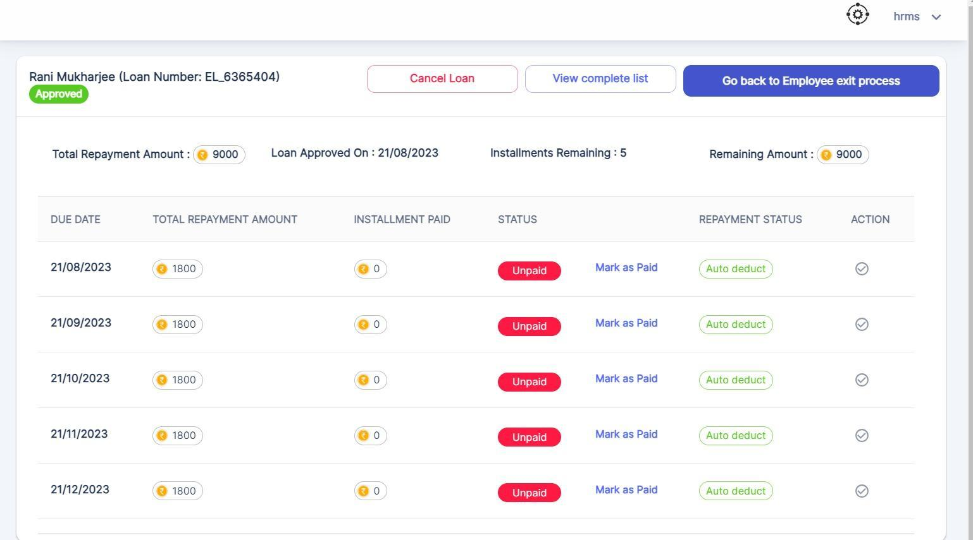

Once the Loan is closed, click Go Back to Employee Exit Process button. The same will be applicable for Insurance as well.

If Edit is clicked, then Reporting Manager of the Employee can be changed.

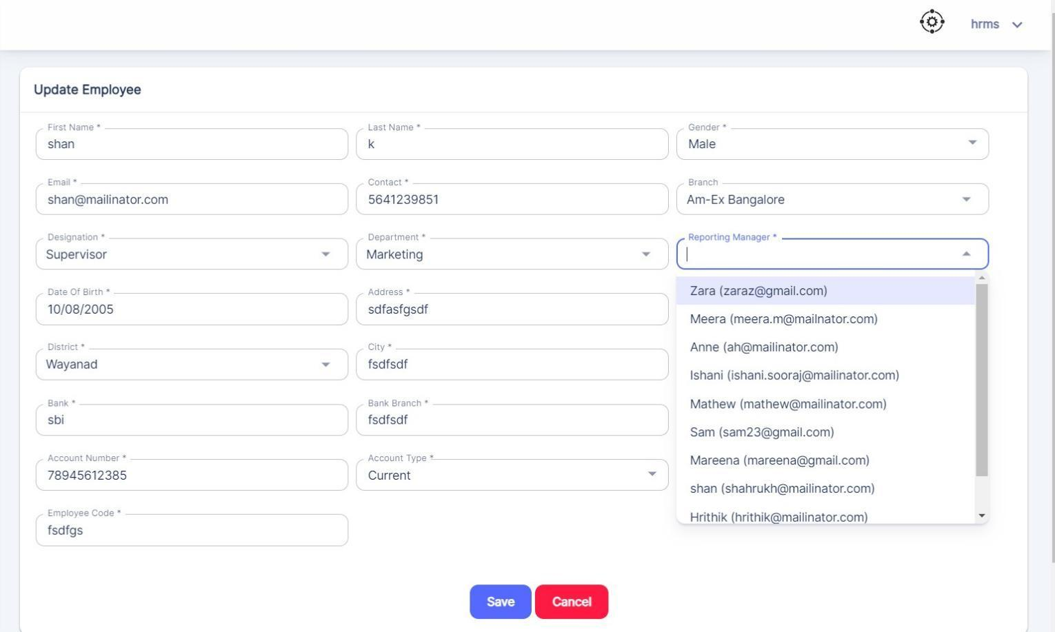

If the employee does not want to serve notice period, then check the Exclude Notice Period option.

If not, mark the notice period start date & last working day & save. Then below details will be shown in the same form.

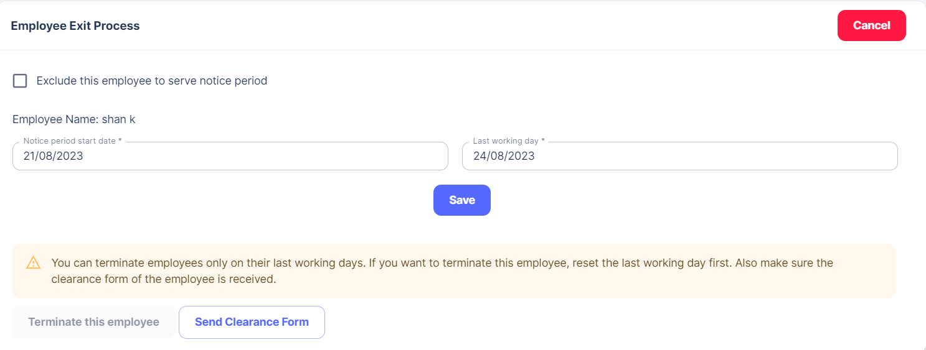

Terminate Employee button will be enabled only on the Last Working Day. Once details are saved, there is an option to Reset as well.

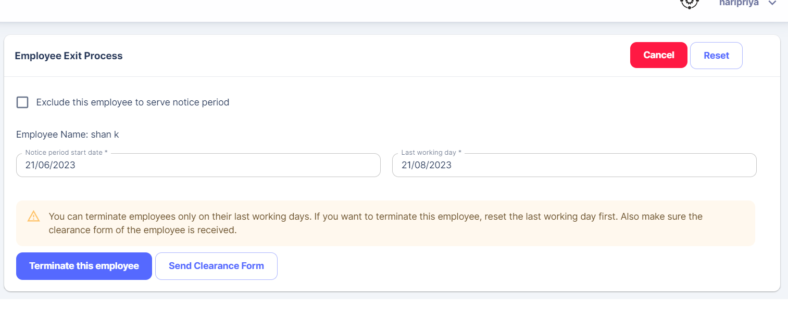

On the day of termination, a clearance form can be sent to the employee. Mail will also be sent to the employee.

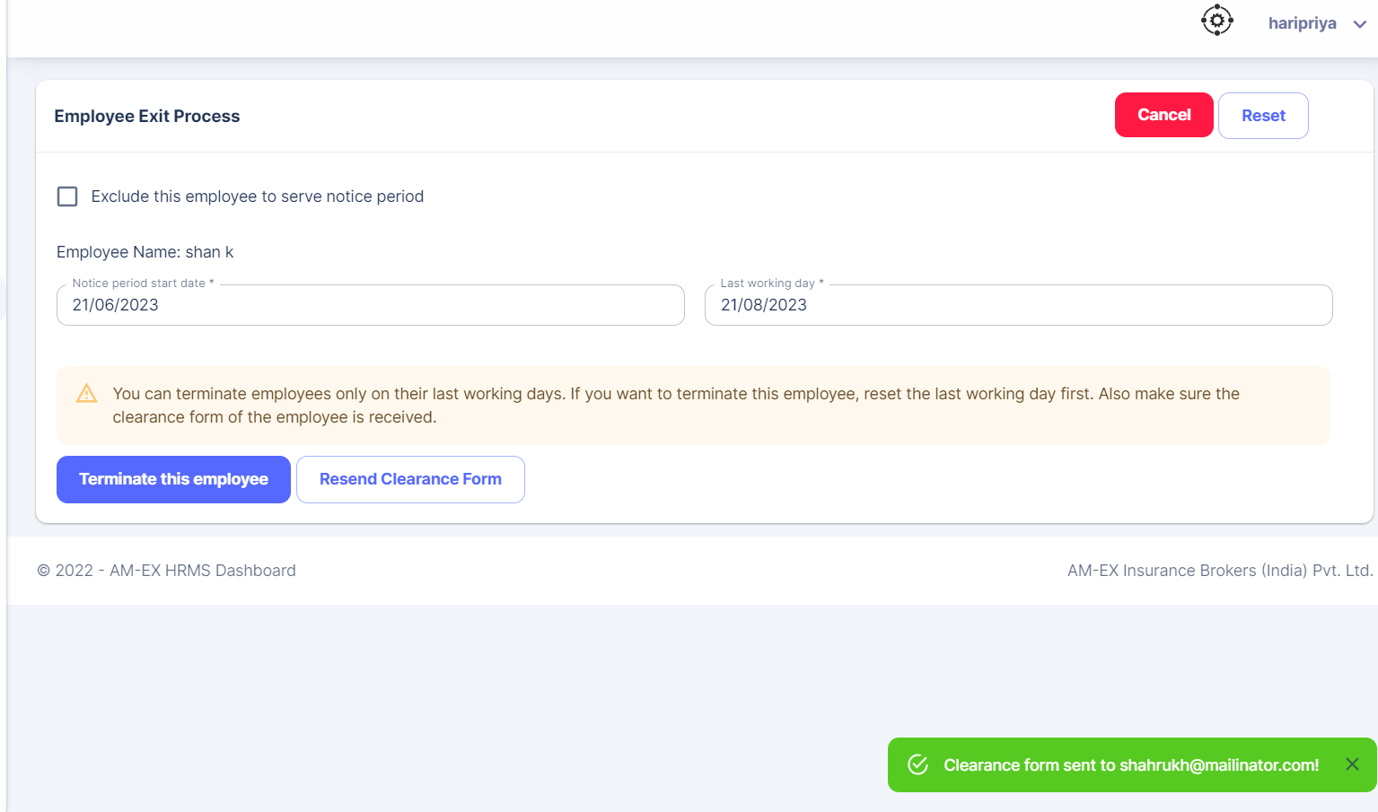

Once the Terminate this Employee button is clicked, the below pop up appears:

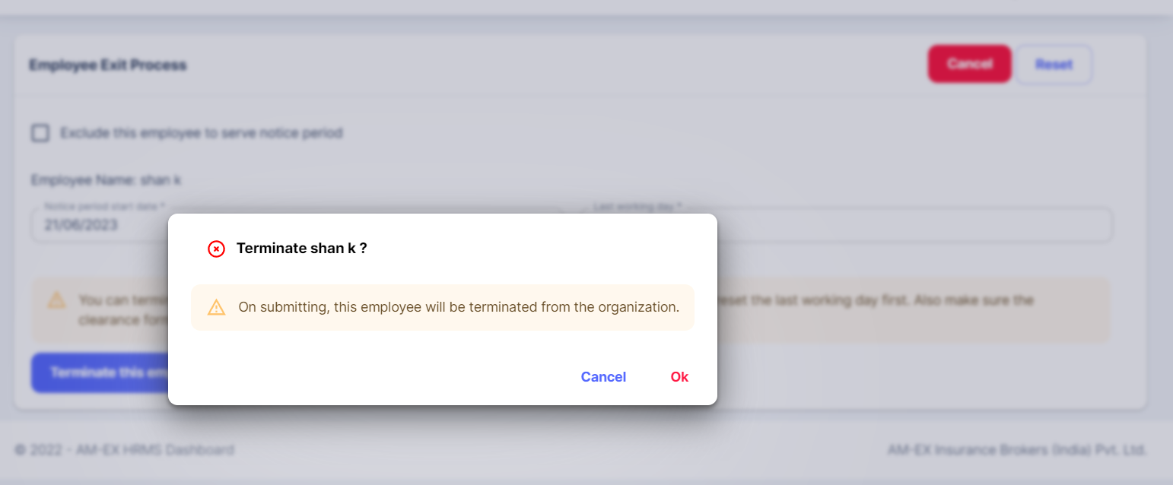

* 1. **Leave**

There are several leave policies followed in an organization & it may vary depending on the firm and their policy structures.

There are some common leave policies like Annual/Vacation Leave, Sick Leave, Comp Off etc.

In this section, there are mainly 5 categories for an HR:

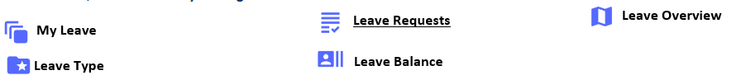

Maternity leave will be on hold & also the salary details. (On Hold)

* + 1. **My Leave**

HR or Employee can create the leave by clicking on "Create Leave".

Also, one can filter the leave based on the Leave Type (All, Sick Leave, Casual Leave, Maternity Leave, LOP), Leave Status (All, Pending, Approved, Rejected) & can select based on Date Range as well.

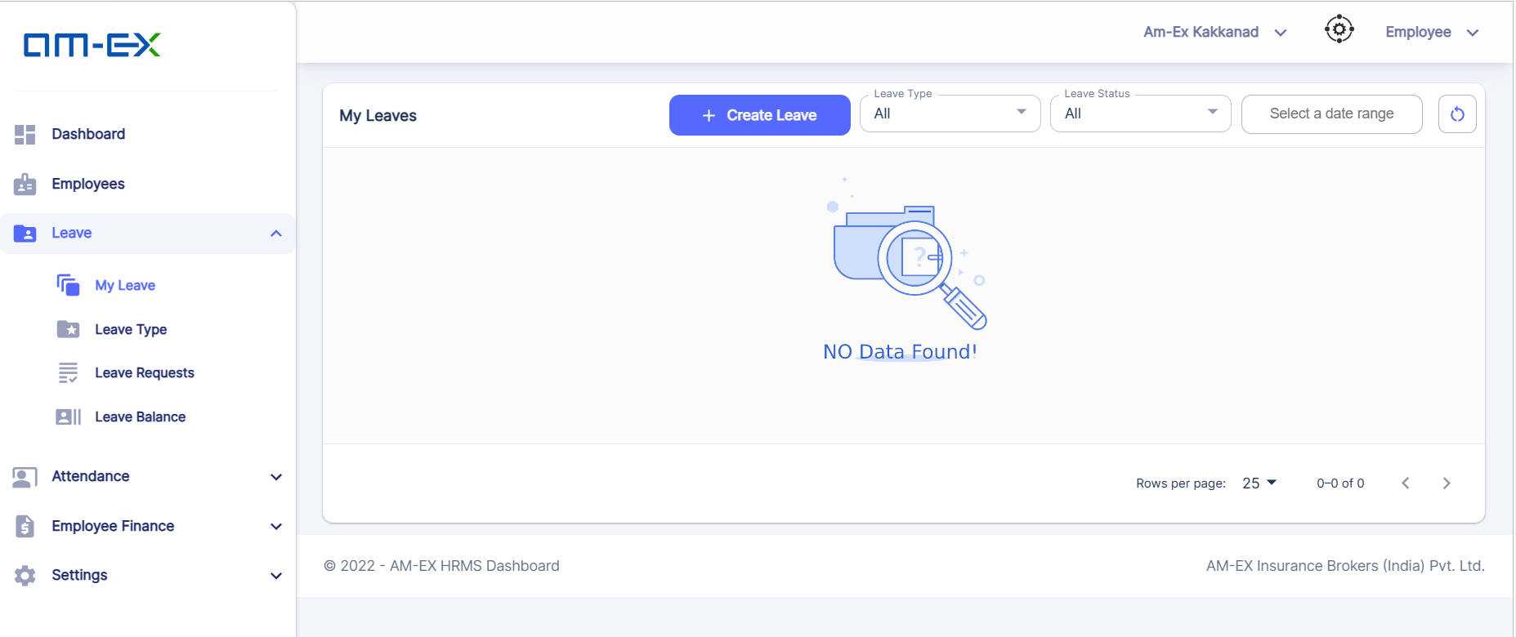

Click on Create Leave

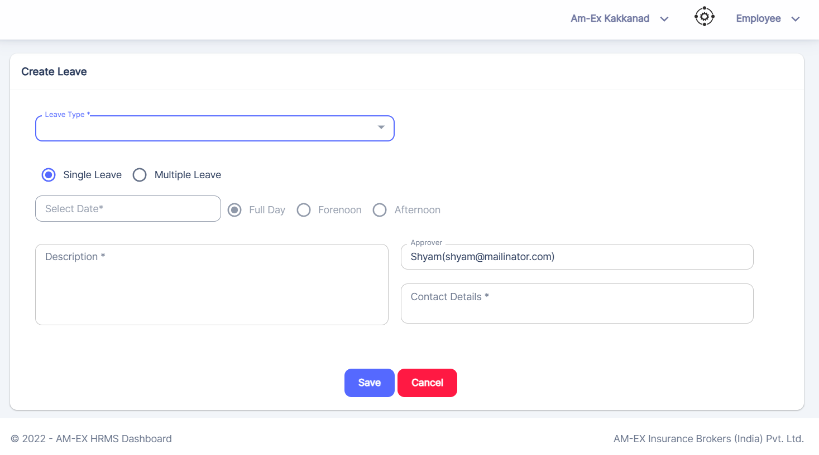

Example:

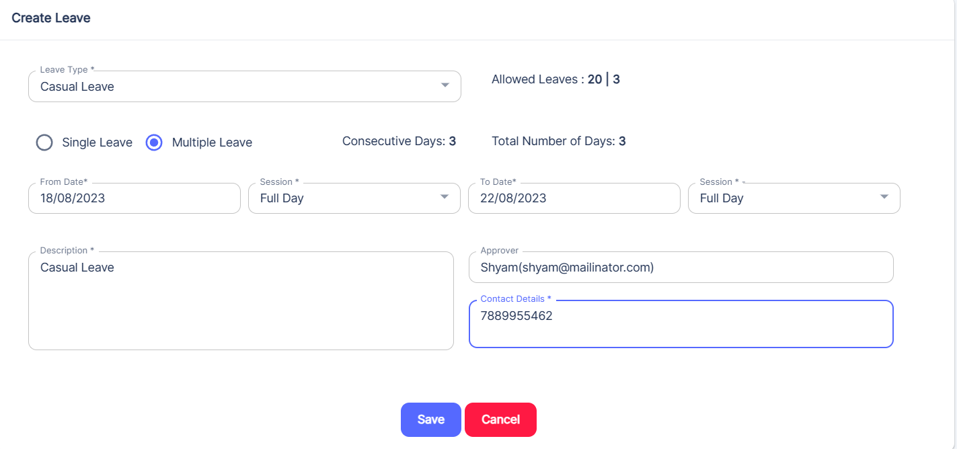

Once the details are filled, Click on Save button. Then, mail will be sent to the approver.



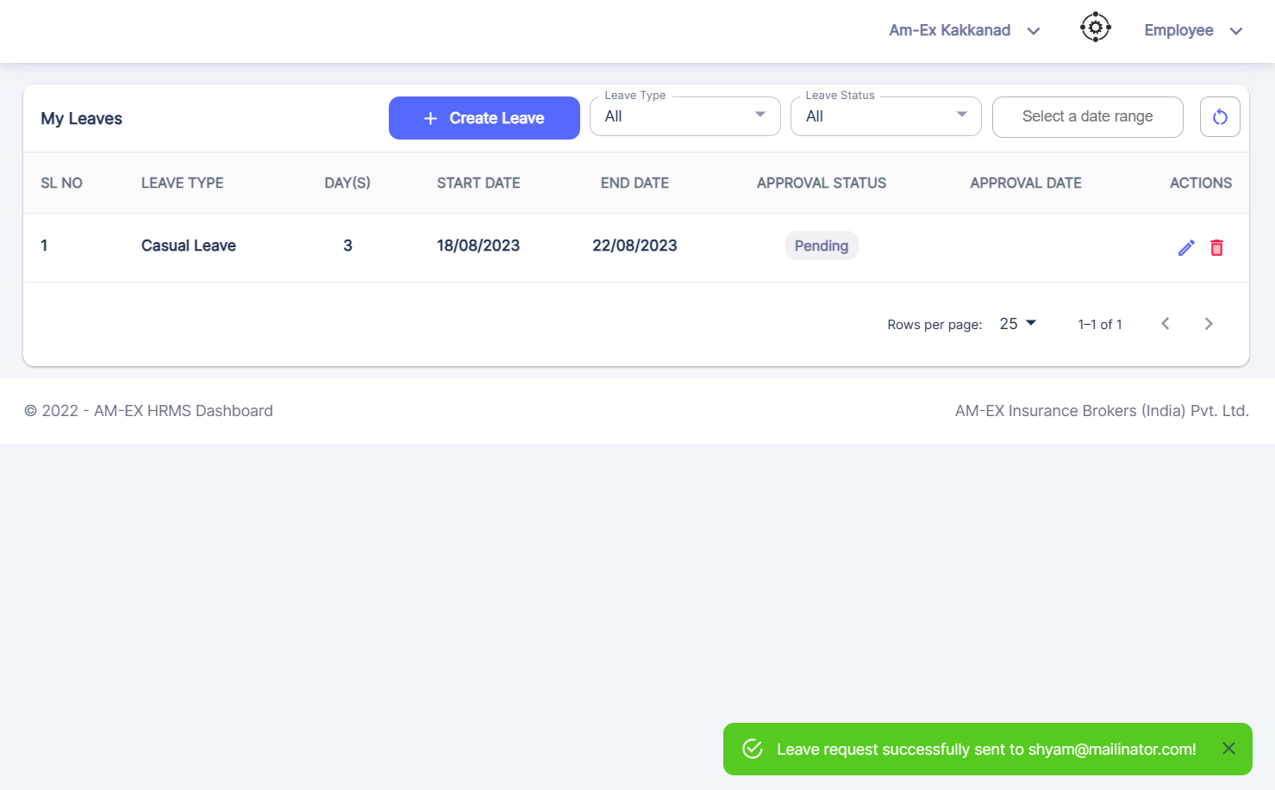

Mail will appear in the Approver Inbox.

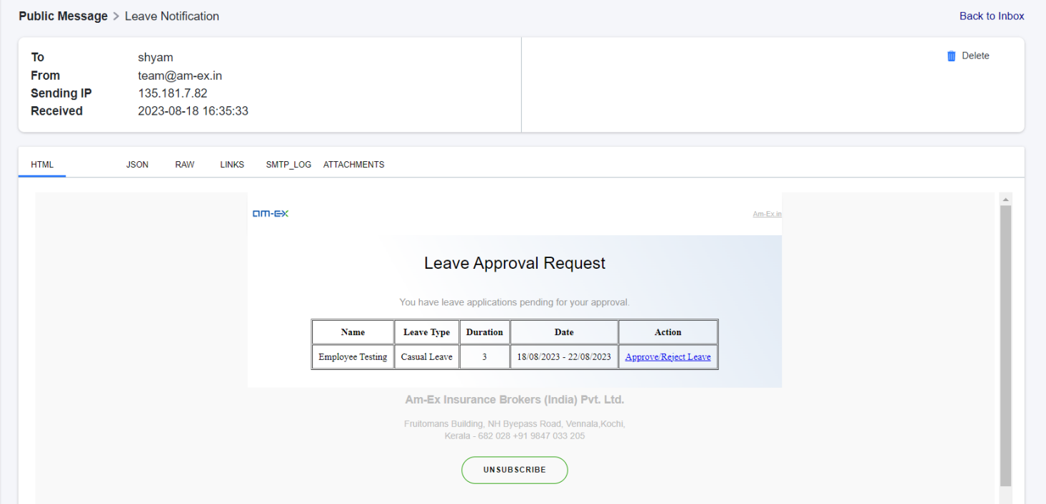

Now, login as Approver & select the decision.

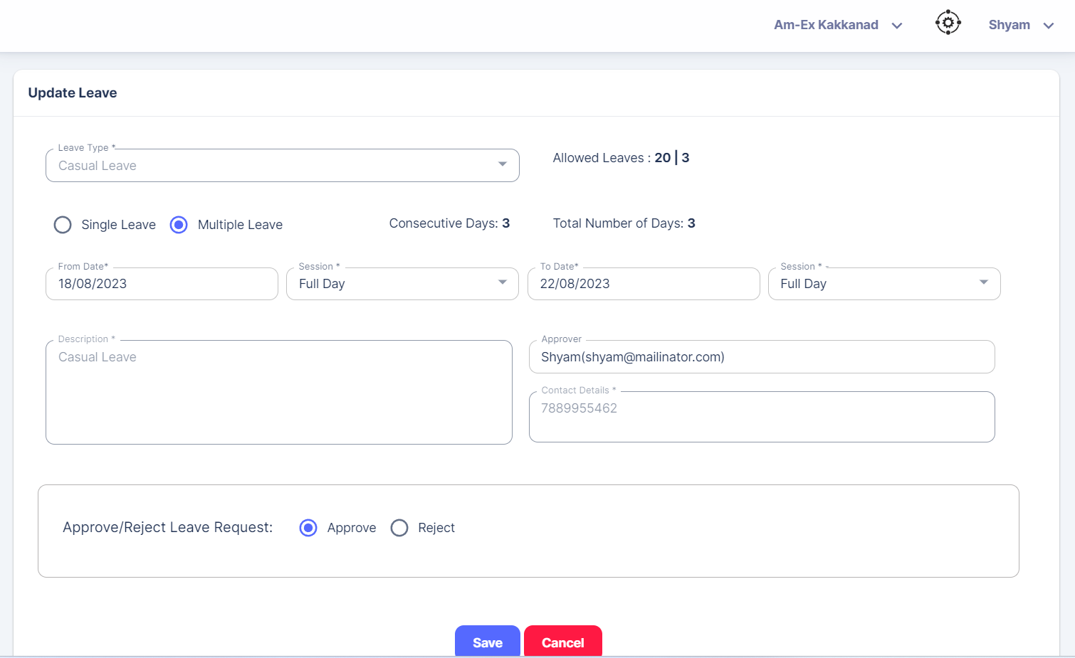

Note: When employee applies for leave, approval will be done by Reporting Manager. Mail should go to RM, HR as well.

Once Approved, status will appear in the list.

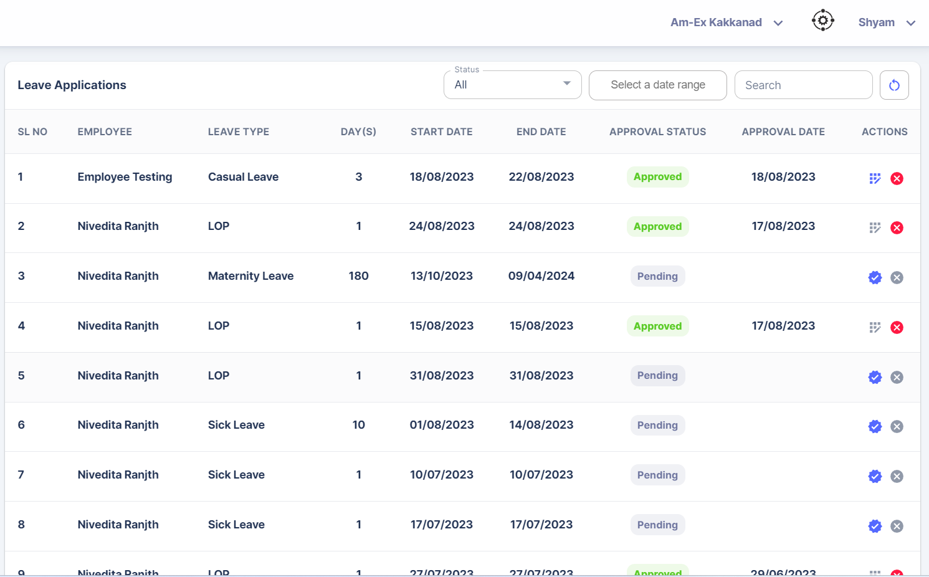

There is an option to Edit & Cancel Leave.

If we are Cancelling Leave, then below pop-up appears. Click on Submit. Then status will be Cancelled.

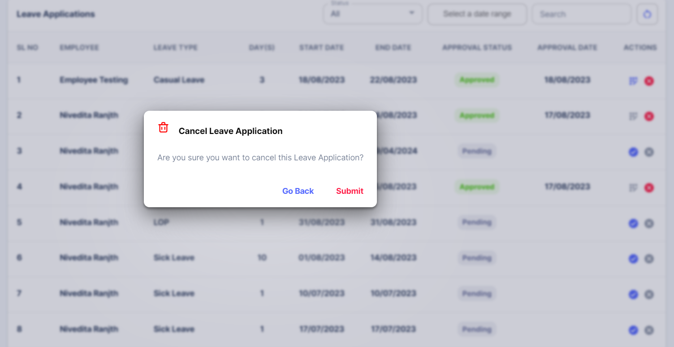

If any Editing is needed, for example, I need to update the date. Then below pop-up appears:

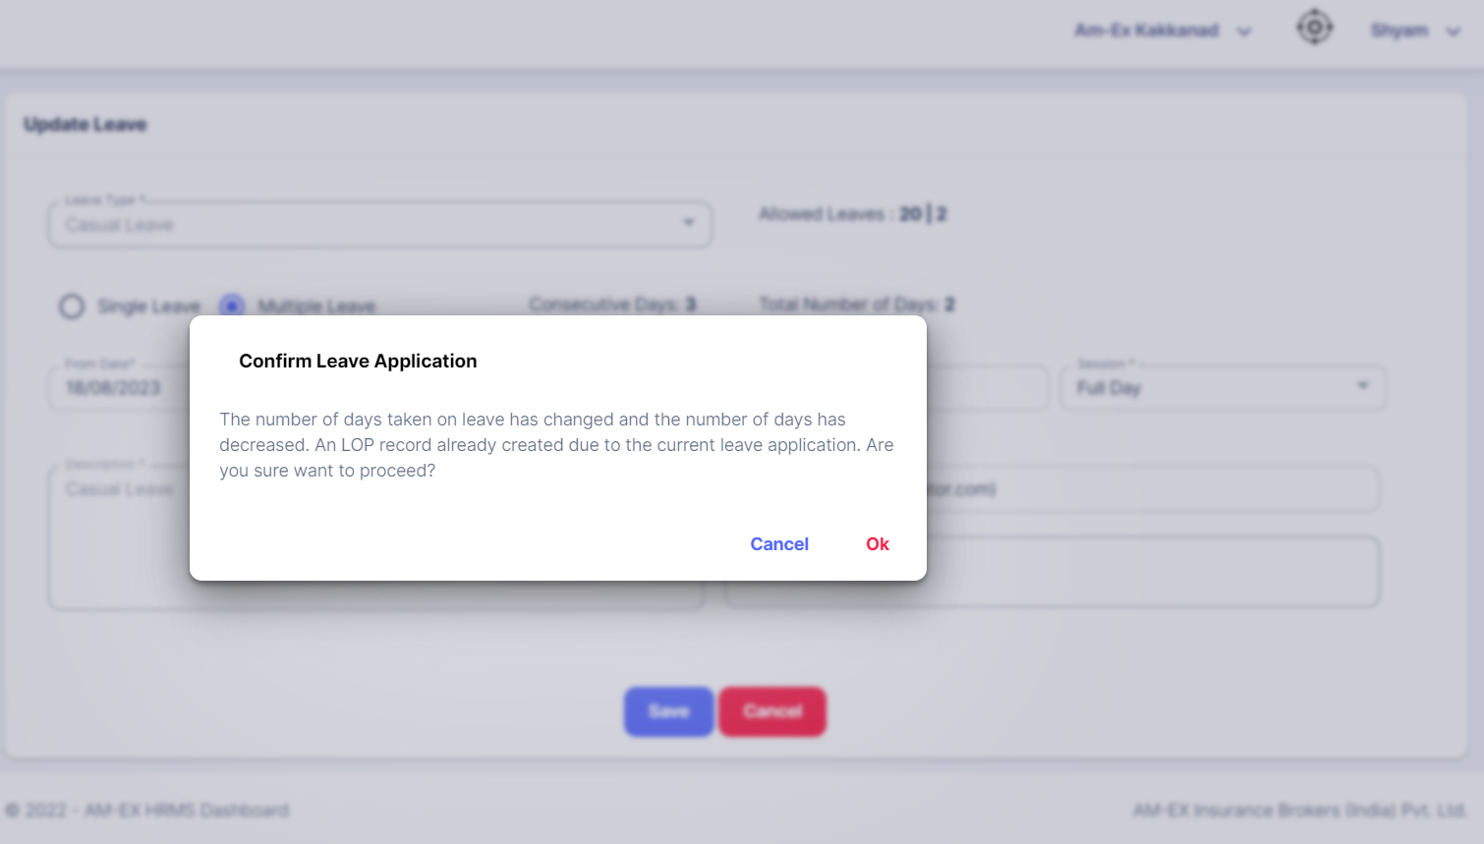

The changes will get updated to the list.

* + 1. **Leave Type**

HR can create the Leave Type from this module.

Leave Type is used while creating leaves from My Leave section.

Employee only can view it.

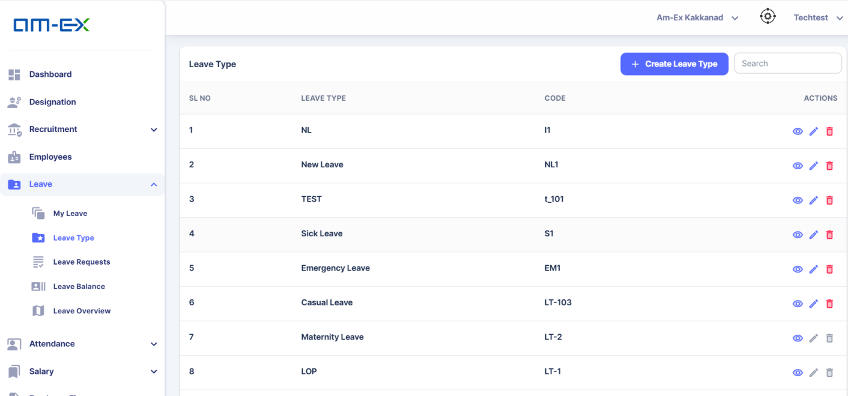

Click on Create Leave Type. In Leave Type, Half day is allowed. For Sick Leave, no half day. If needed, need to configure in Settings.

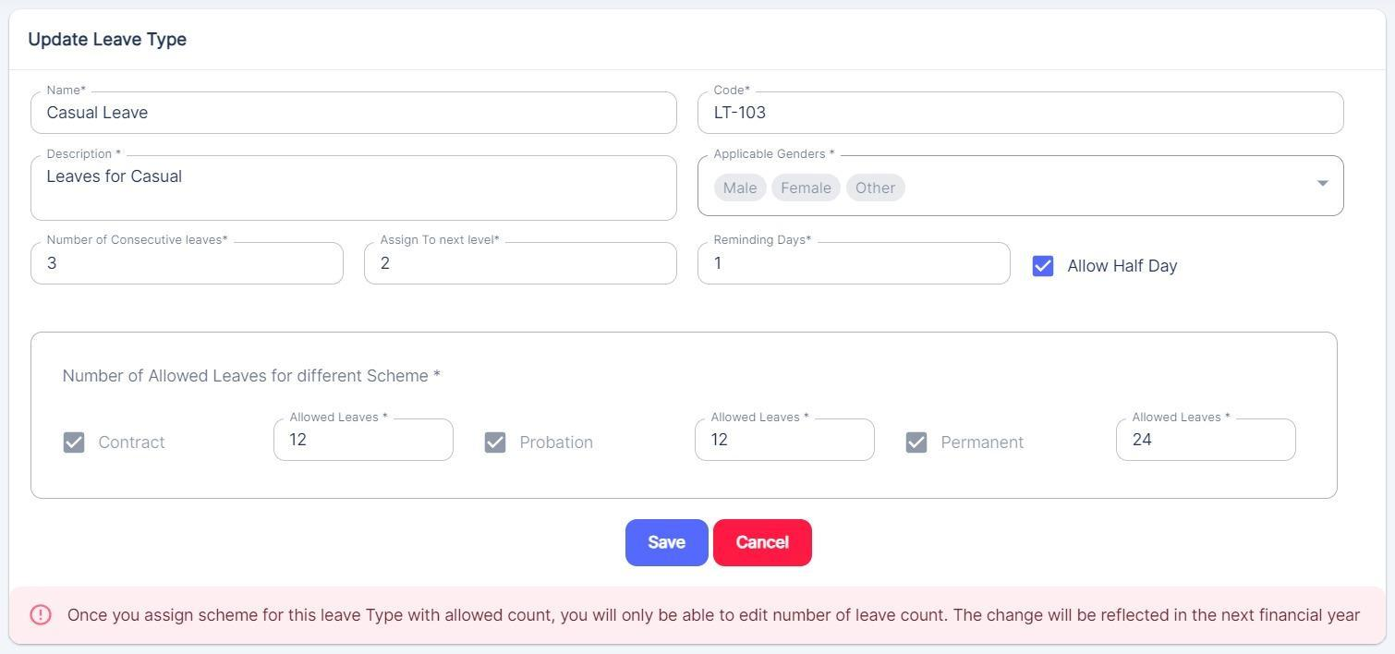

HR can create the leave type as shown by adding the values

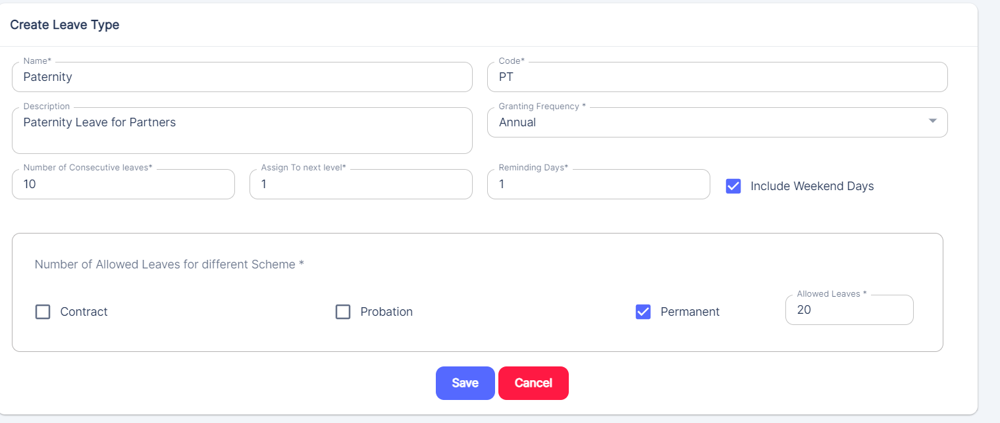

Also, after creating a Leave Type, HR can do further edits & deletion if needed!

* + 1. **Leave Requests**

In Leave Requests, it shows the list of requests which are raised by the employee in an organization

Reporting Manager will be able to see the list.

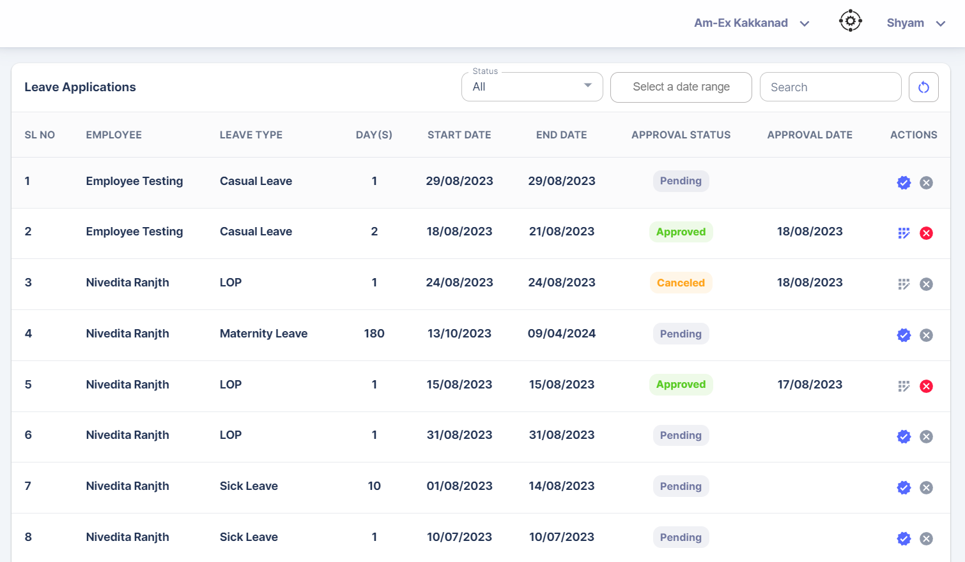

* + 1. **Leave Balance**

It shows the number of leaves remaining out of the allotted no of leaves.

For HR, there will be an option to select the Employee to know the leave balances.

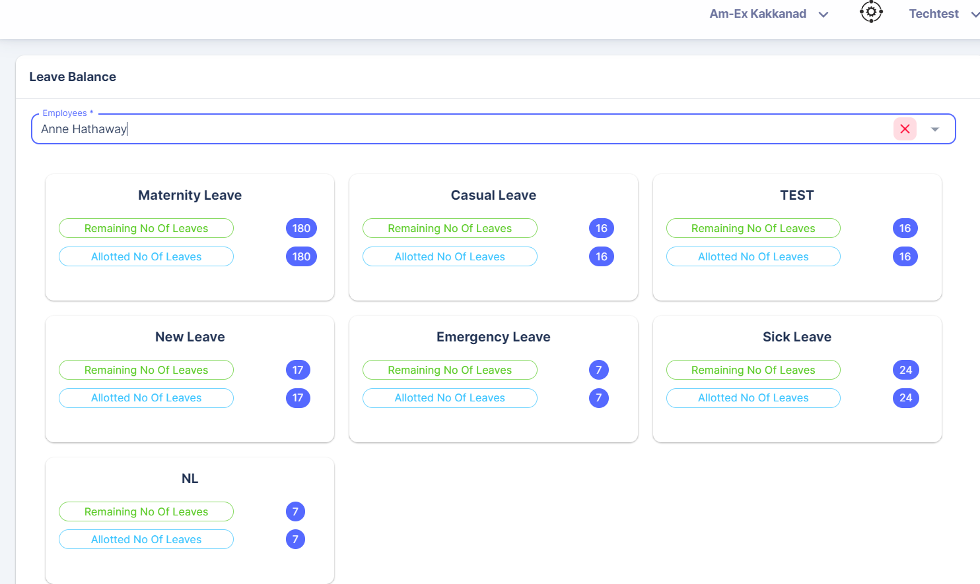

For Employee, they can only see their own leave balances.

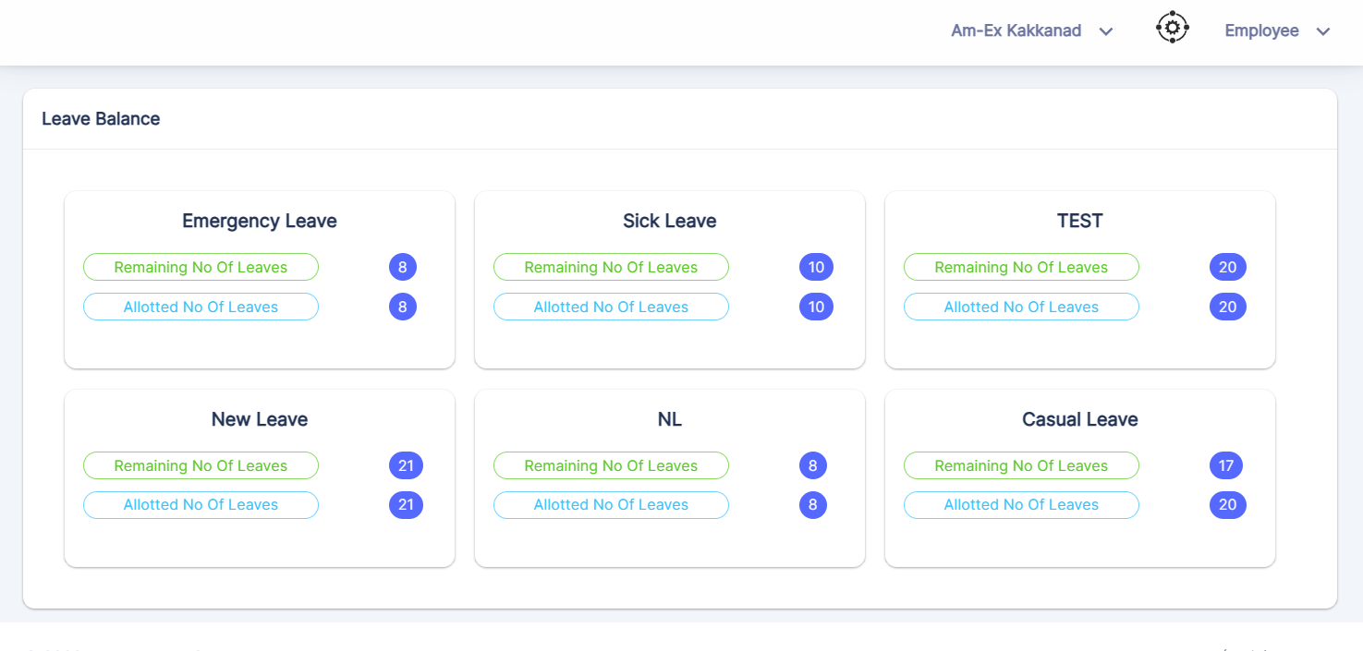

* + 1. **Leave Overview**

This menu will be visible only to HR & not Employee.

HR can see the no. of leave taken by each employee against a leave type.

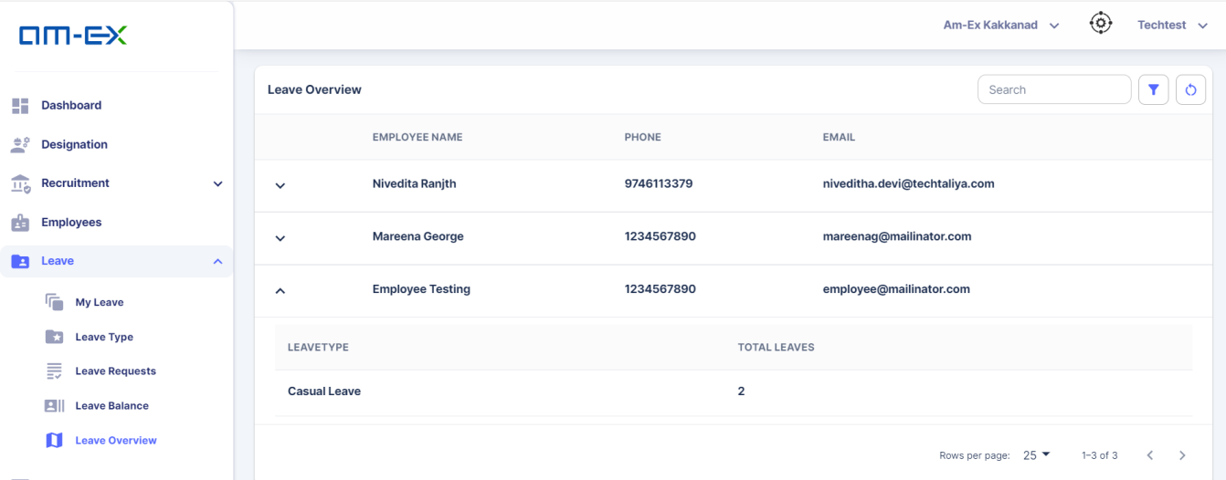

* 1. **Attendance**

In Attendance Module, HR have access to 4 sub modules.

* Attendance View
* Attendance Upload
* Mark Self Attendance
* Approve Attendance

For an Employee, they can only see Mark Self Attendance Menu.

* + 1. **Attendance View**

Using Attendance View, HR can see the attendance list of employees in an organization.

HR can filter the attendance records based on dates.

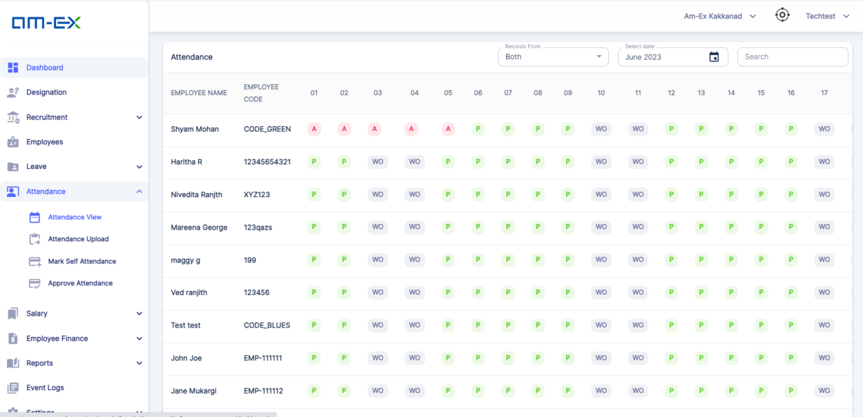

If there is any mismatch found in between Leave & Attendance, then a cross mark will be shown(X).

HR can filter the Attendance View with Options Leave, Attendance & Both along with dates.

* + 1. **Attendance Upload**

HR can either upload the attendance of employees against a Branch in Bulk Mode else can create it manually as well.

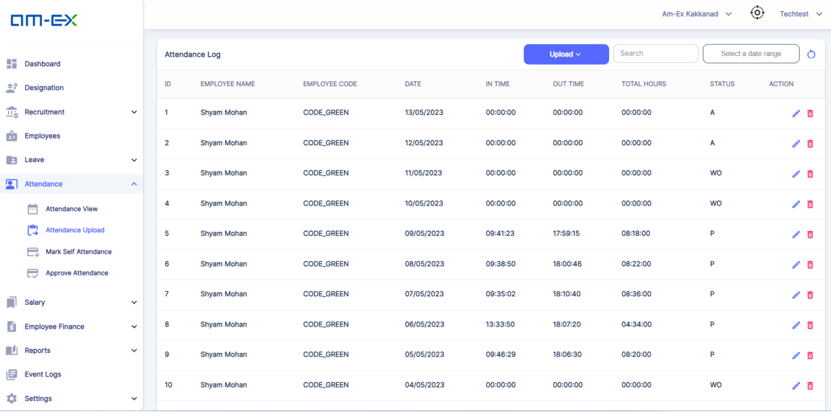 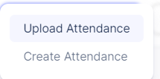

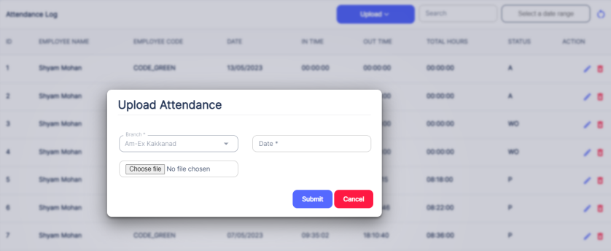

The format of Excel document is shown below:

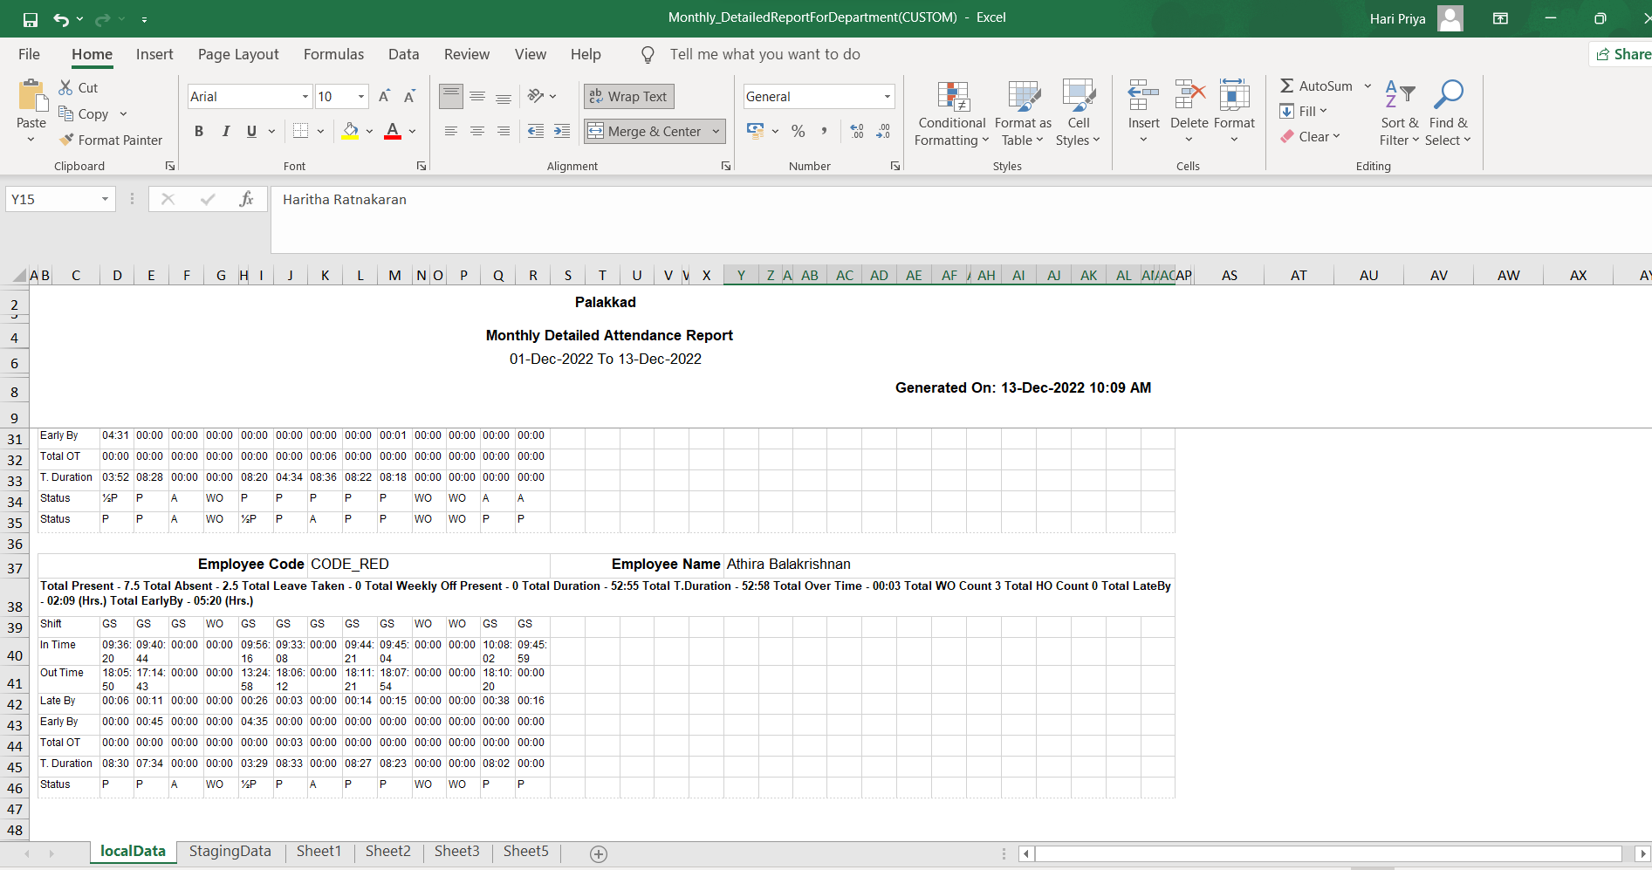

* + 1. **Mark Self Attendance**

If one forgets to mark attendance or punch, then they can mark self attendance.

It will get updated to Attendance List, once HR approves the request.

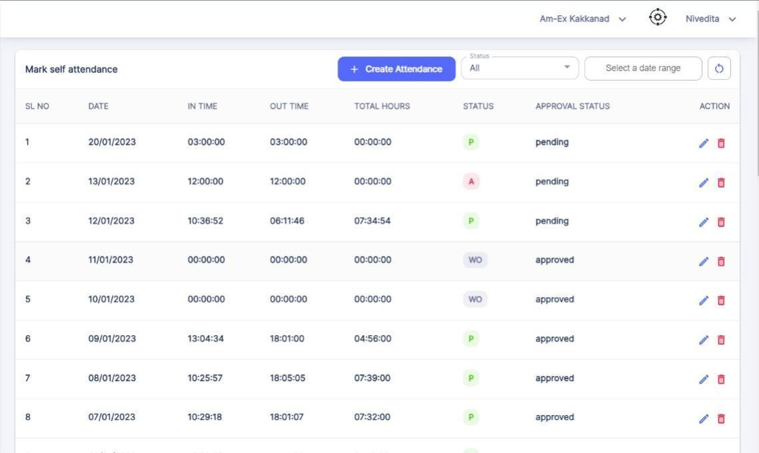

Click on Create Attendance.

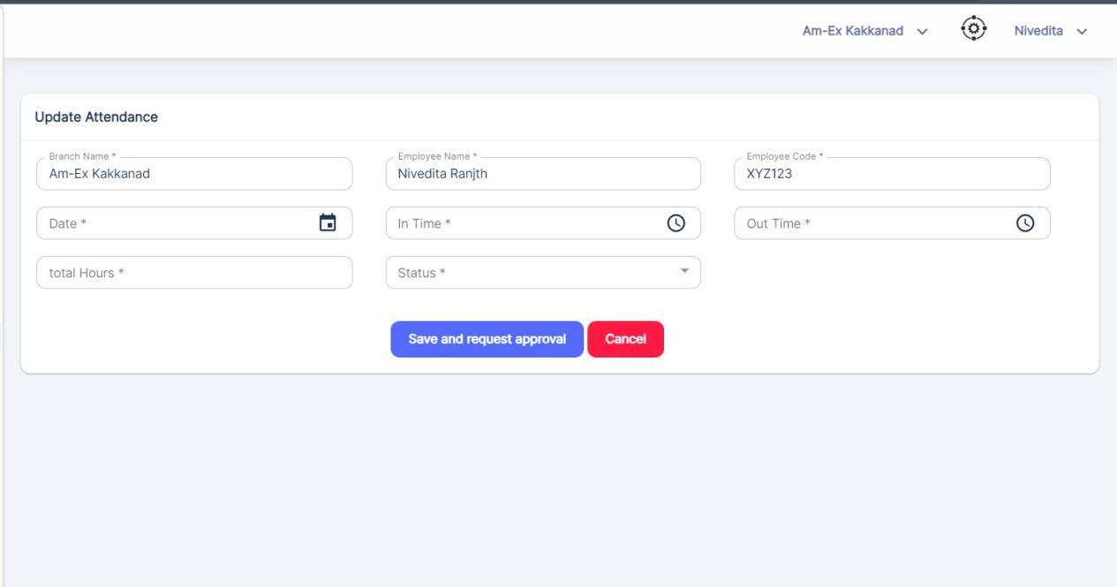

Once Save & Request Approval is selected, then it will go to HR & HR can Approve it.

* + 1. **Approve Attendance**

Once Self Attendance requests are raised by Employee, it will come to HR for Approval.

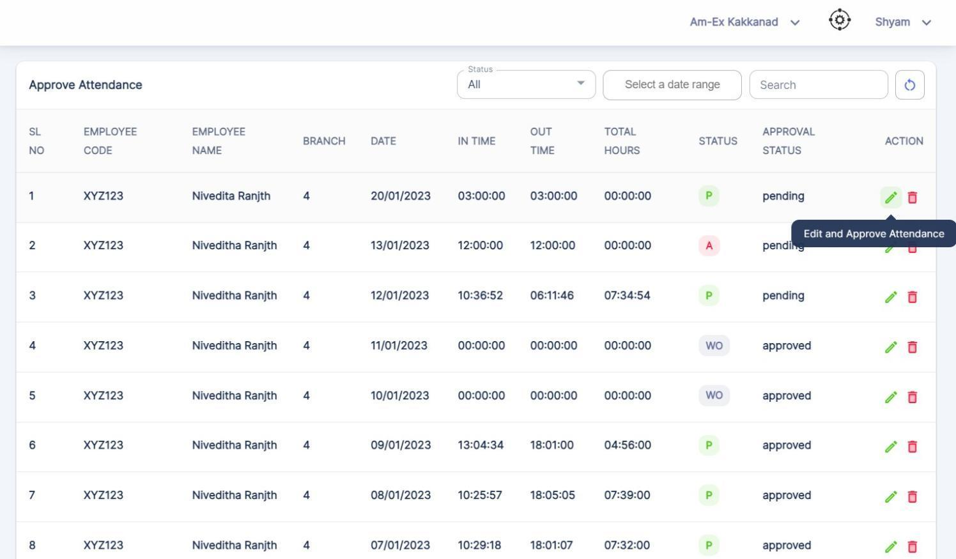

Click on Edit & Approve Attendance Button.

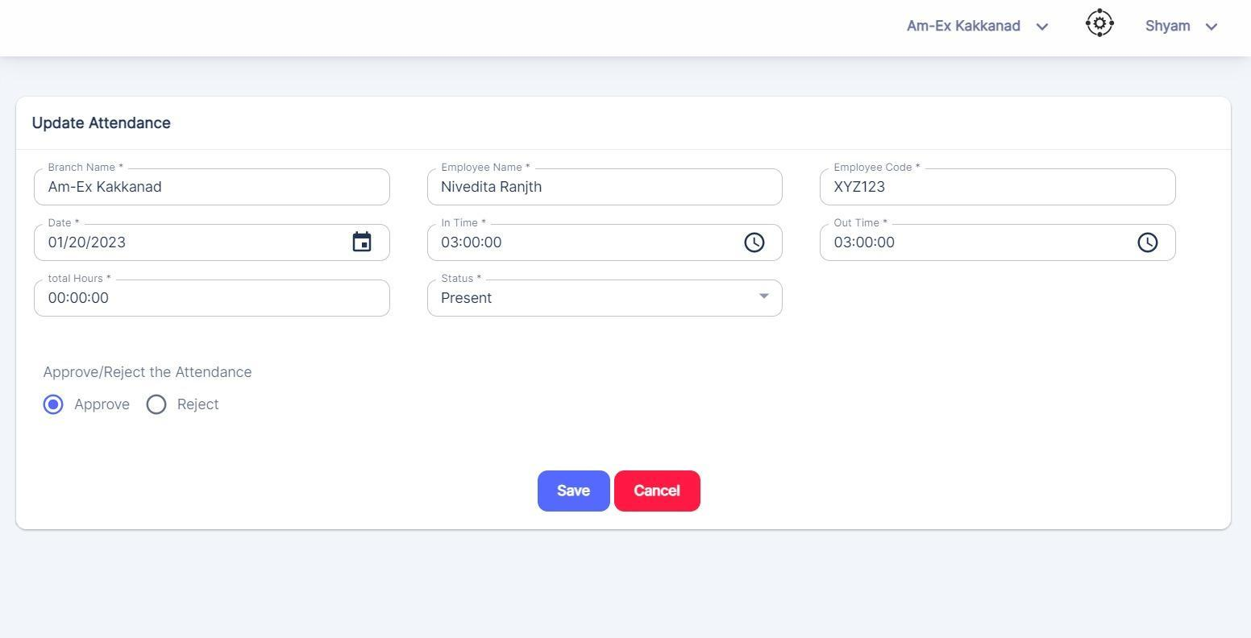

* 1. **Salary**

In any organization, HR needs to keep track of the Salary of employees.

Here, in Salary Module, there are 4 components:

* Salary Components
* Load Payscale
* Fix Payscale
* Pay Runs

> In Salary Components, the Earnings & Deductions that need to be incorporated in the Pay Slip of the Employee are captured

> Under Load Payscale, Zones, Grades & Gross is created which is used at the time of generation of the Offer Letter

> Under Fix Payscale, the Grade & Gross can be updated. PF/ESI is captured in Salary under Fix PayScale. At the time of Payroll generation, report can be pulled to download previous month's details. It should be able to view total PF deductions from date of joining

> Under Pay Runs, it will show the net amount that needs to be paid to the employees in an organization.

>As per Branch only, the data from Salary will be sent to Accounts Module.

* + 1. **Salary Components**

Under Salary Components, HR can incorporate the Earnings & Deductions of the Employee Salary on a monthly basis.

**Earnings:**

HR can include the Earnings of an Employee that needs to be incorporated in the Salary of an Employee on a monthly basis.

The Earnings can be in the form of OT, Travel Allowance, Bonus, HRA etc.

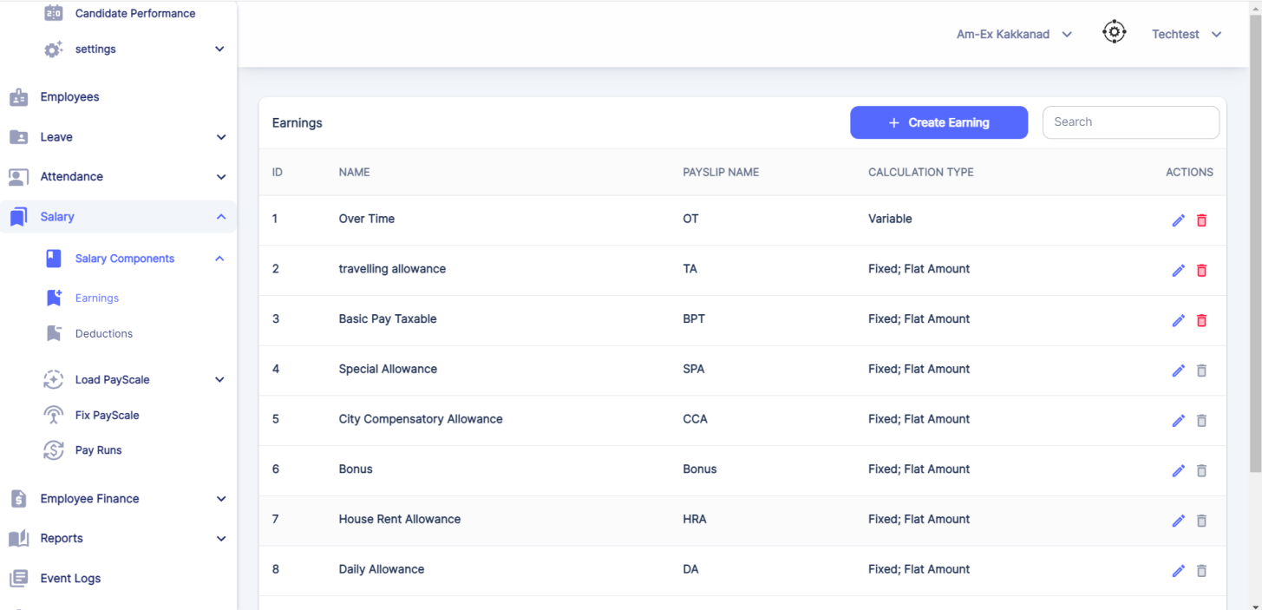

Click on Create Earning.

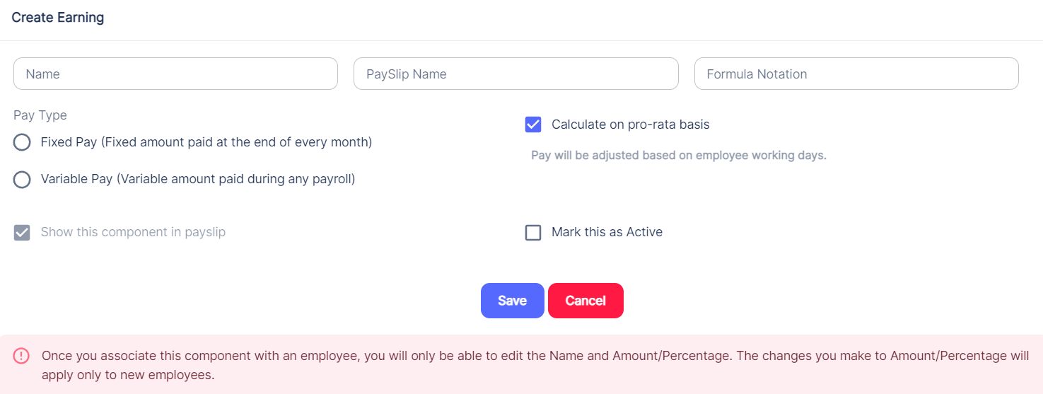

**Deductions:**

Similar like Earnings, there is Deduction as well.

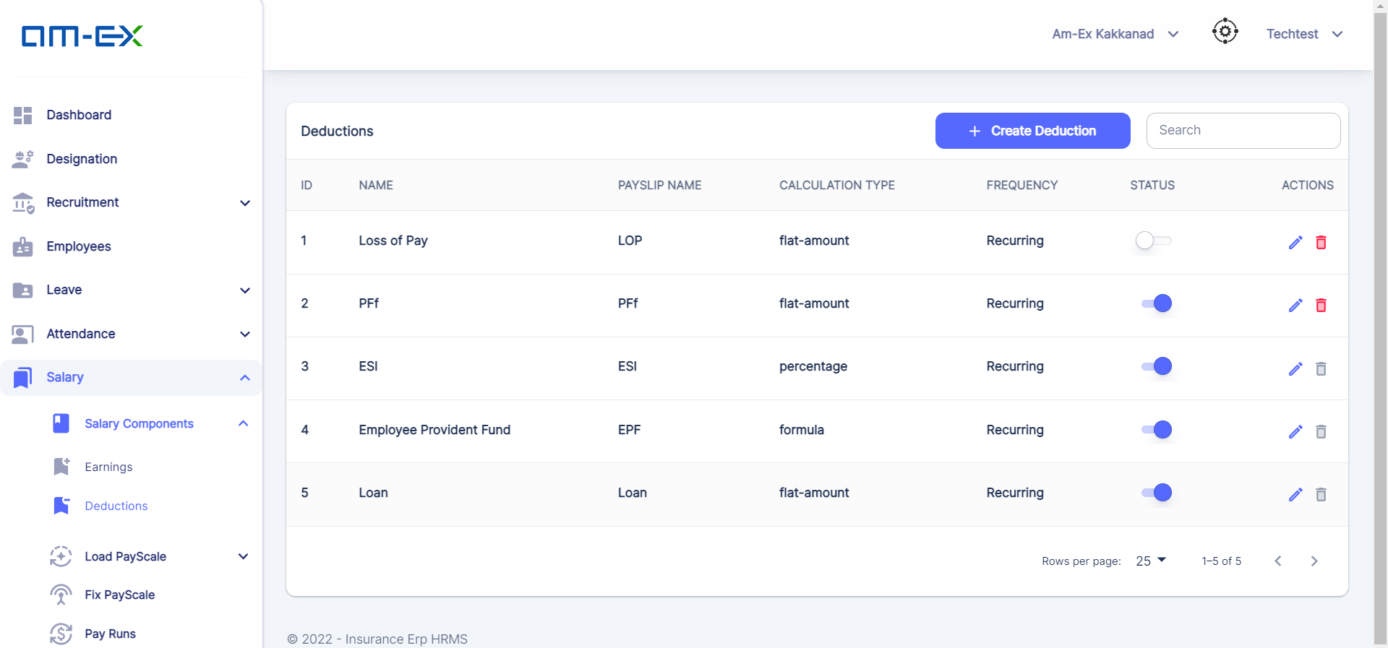

Click on Create Deductions

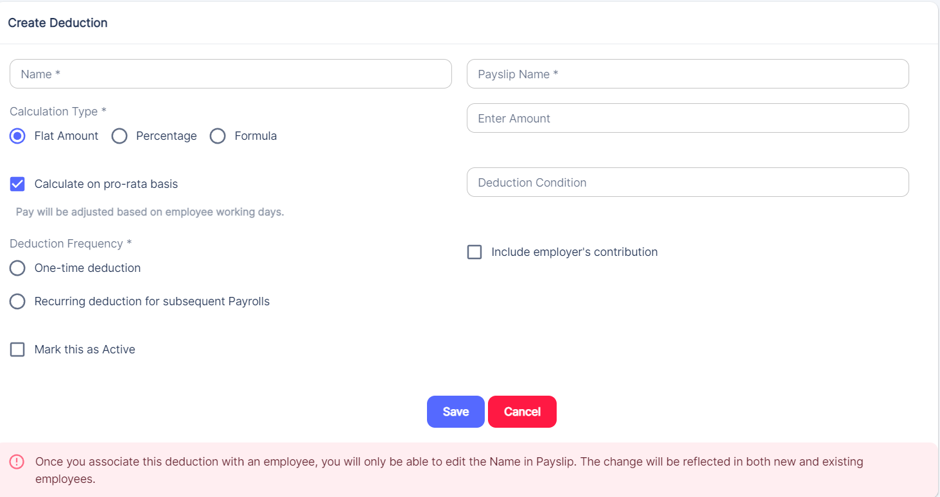

* + 1. **Load Pay scale**

A "Load Payscale" could refer to a salary structure where different components, such as basic salary, allowances, bonuses, and benefits, are added together to calculate an employee's total compensation.

Each of these components is considered separately and then "loaded" onto the employee's base salary to arrive at the final pay amount.

Under Load Pay Scales, there are 3 categories.

* Zones
* Grades
* Gross

🡪Zones:

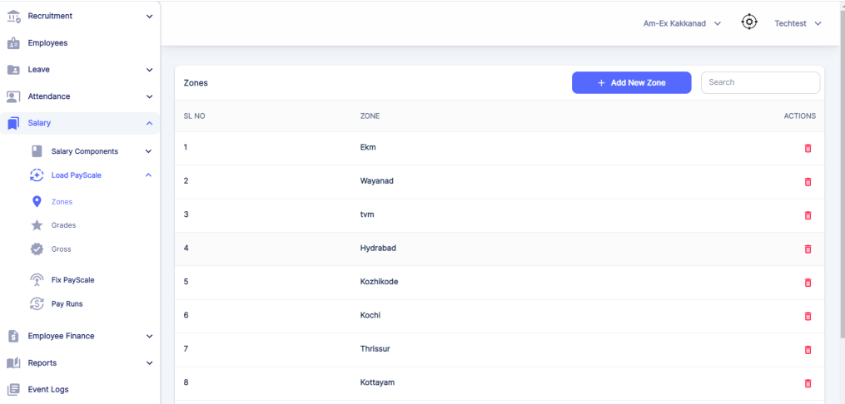 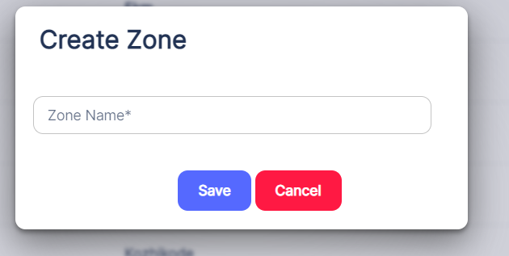

🡪 Grade:

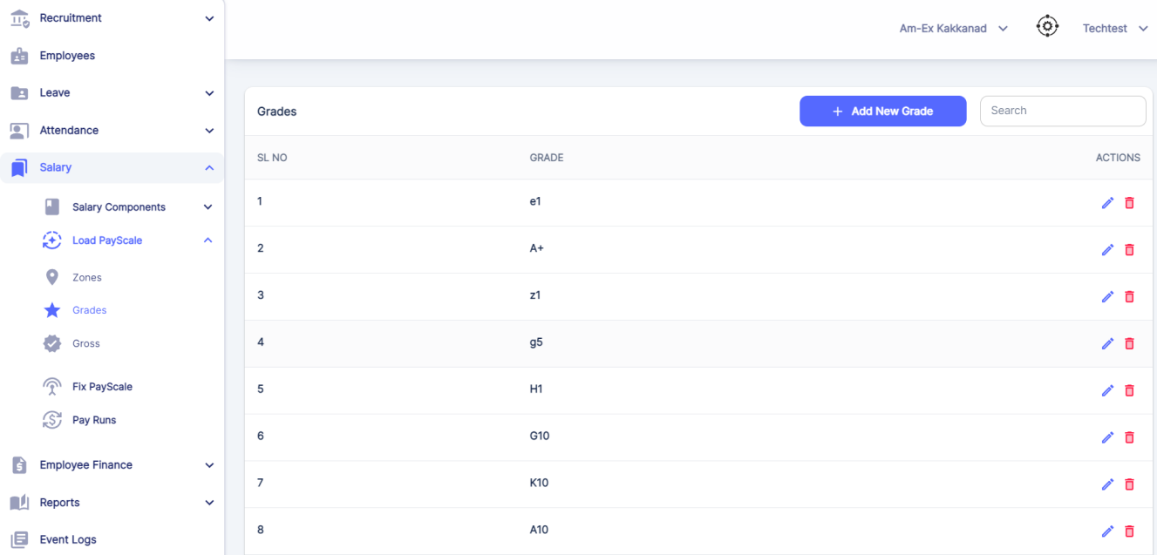 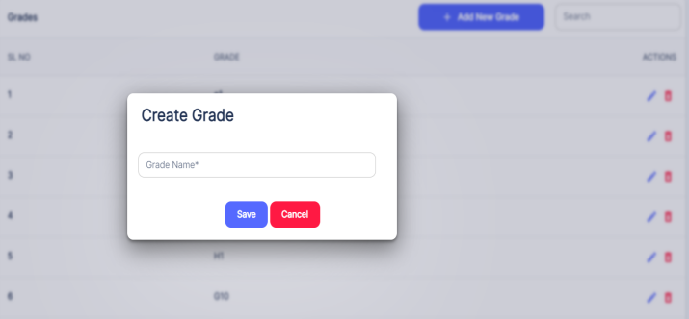

🡪Gross:

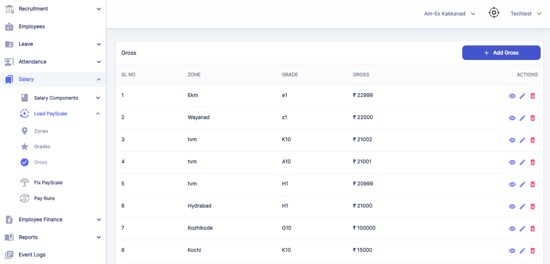

Click on Add Gross.

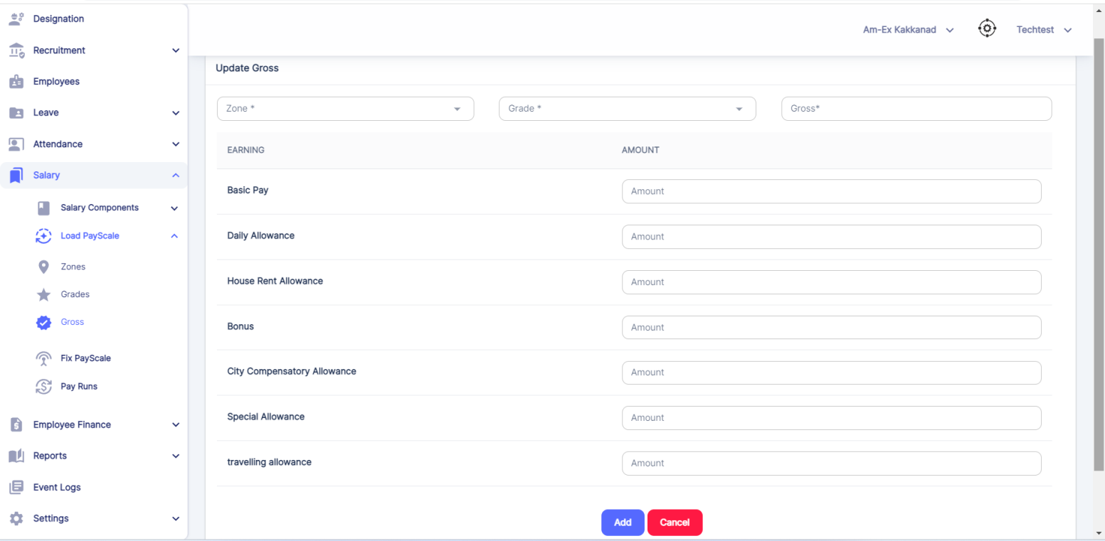

Once details are added, click on Add.

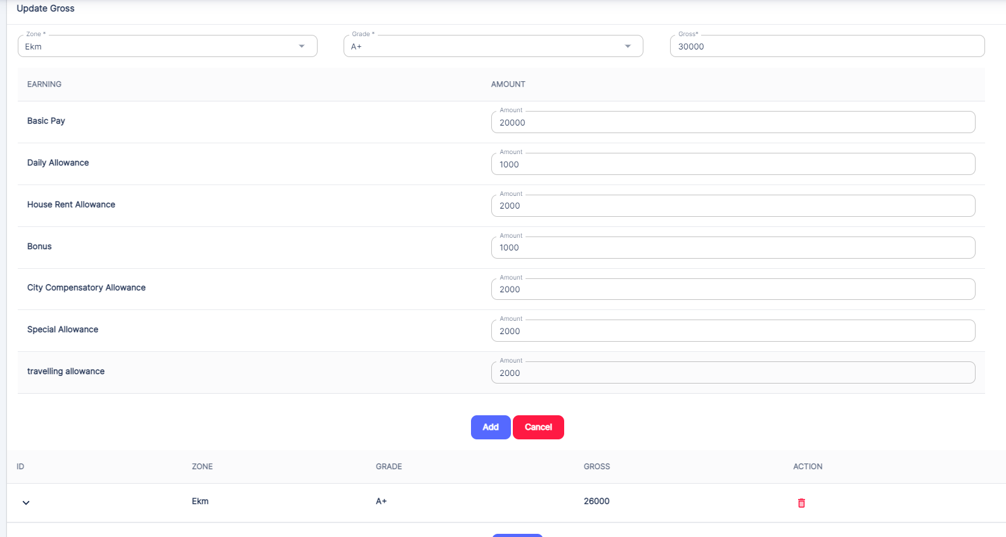

* + 1. **Fix Pay scale**

A "Fix Payscale" might be referring to a salary structure where the compensation is fixed and doesn't change frequently.

This could mean that employees receive a set salary that remains the same over time, regardless of performance, inflation, or other factors.

This is mainly used in determining the Salary Scale with the details of all the Earnings & Deductions in the salary which is available in the Employee Pay Slip

HR can filter it out based on the Branch as well. Grade, Gross & Zone are fetched based on the details, updated in the Load PayScale Module.

Note:

Performance Appraisal under Fix Payscale is not necessary as said by client. The Questionnaires from Insurance Module can be used here for Performance Appraisal. Using the Questionnaire Scores, superior can evaluate the appraisal process. Hierarchy of appraisal to be defined. For the time being, we will proceed with this and can define the requirements in next phase - TBD in Next Phase Only. No changes needed for current release.

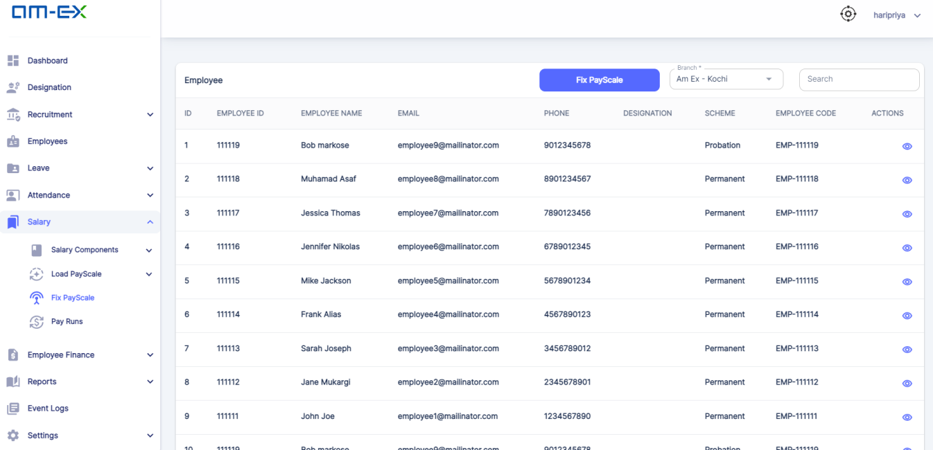

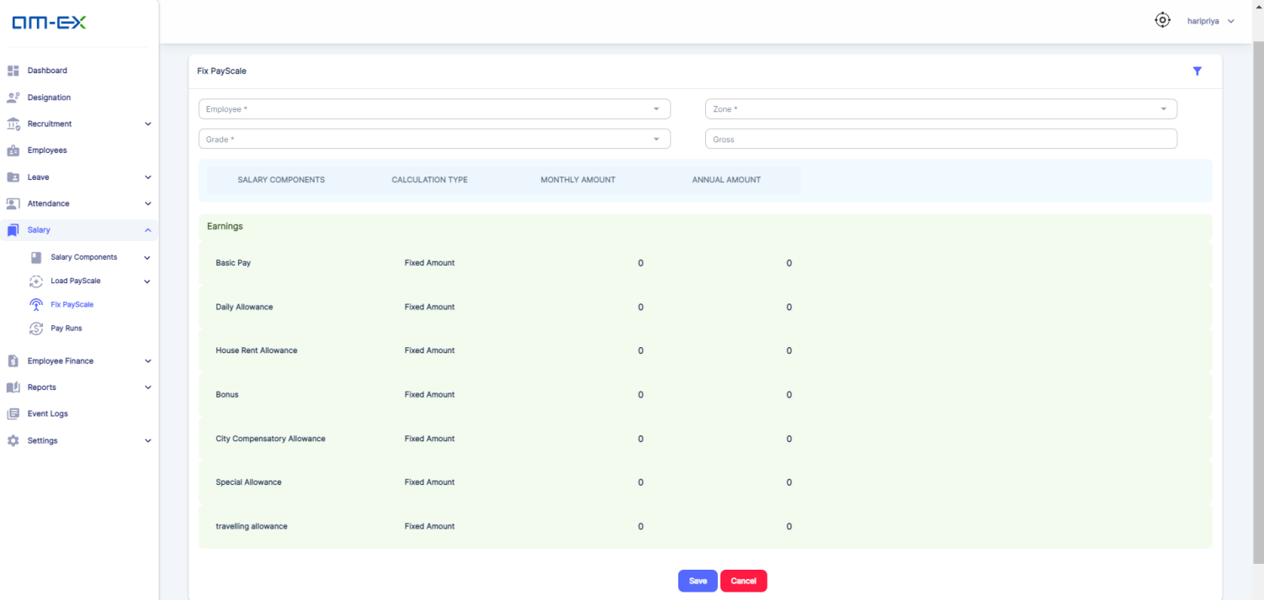

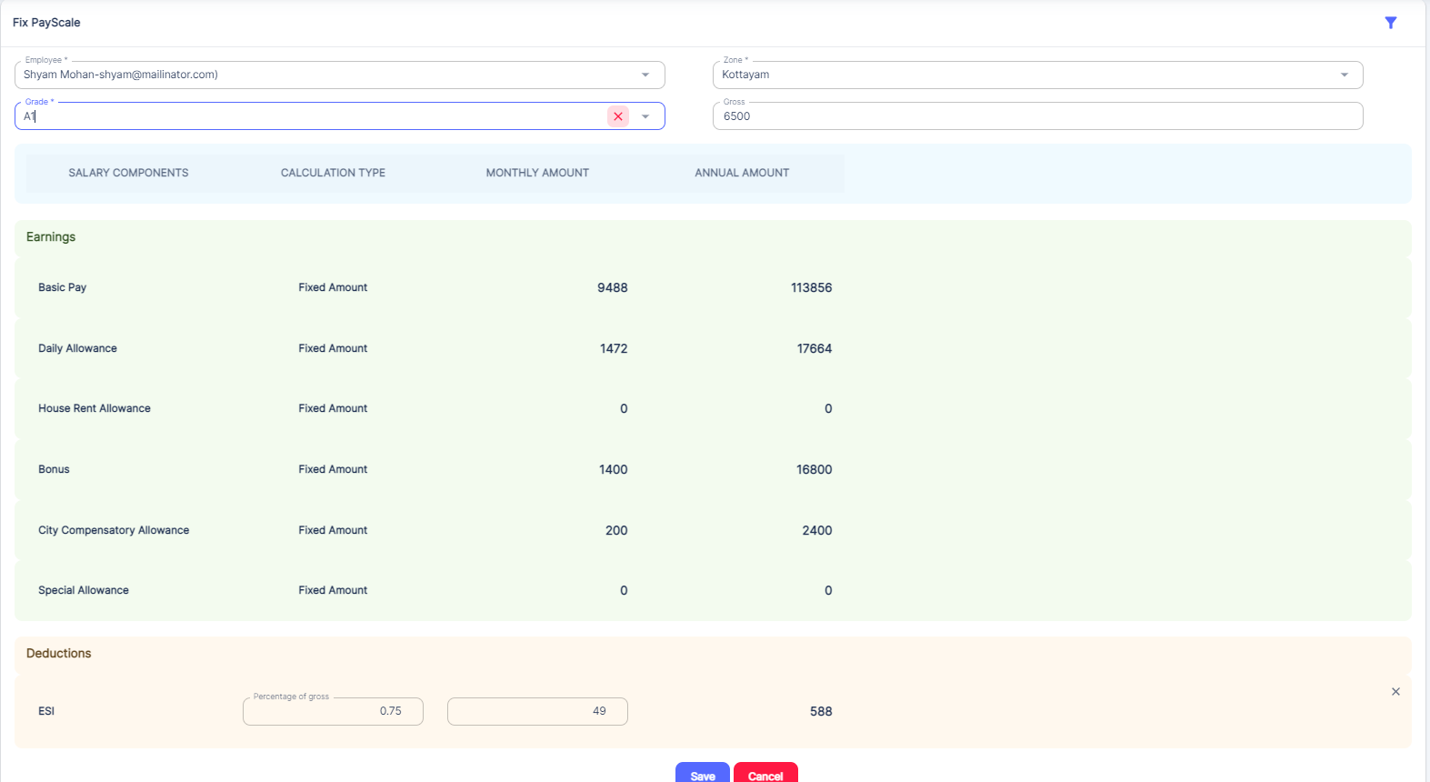





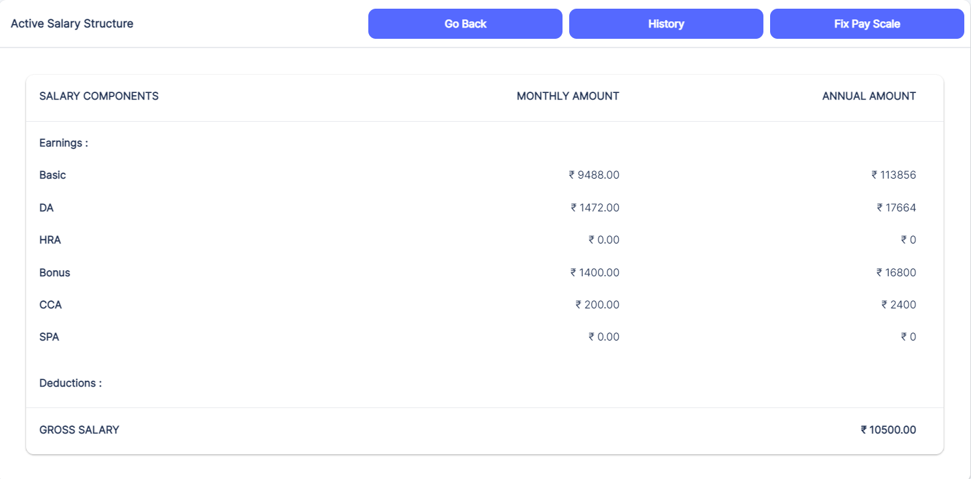

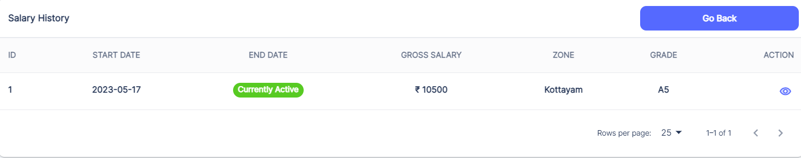

* + 1. **Pay Runs**

A "pay run" refers to the process of calculating and disbursing employee salaries and wages within an organization.

It's the systematic procedure of generating payroll, which includes calculating gross pay, deducting taxes, benefits, and other deductions, and arriving at the net pay that employees receive.

Pay Runs can be filtered on the basis of Branch selection.

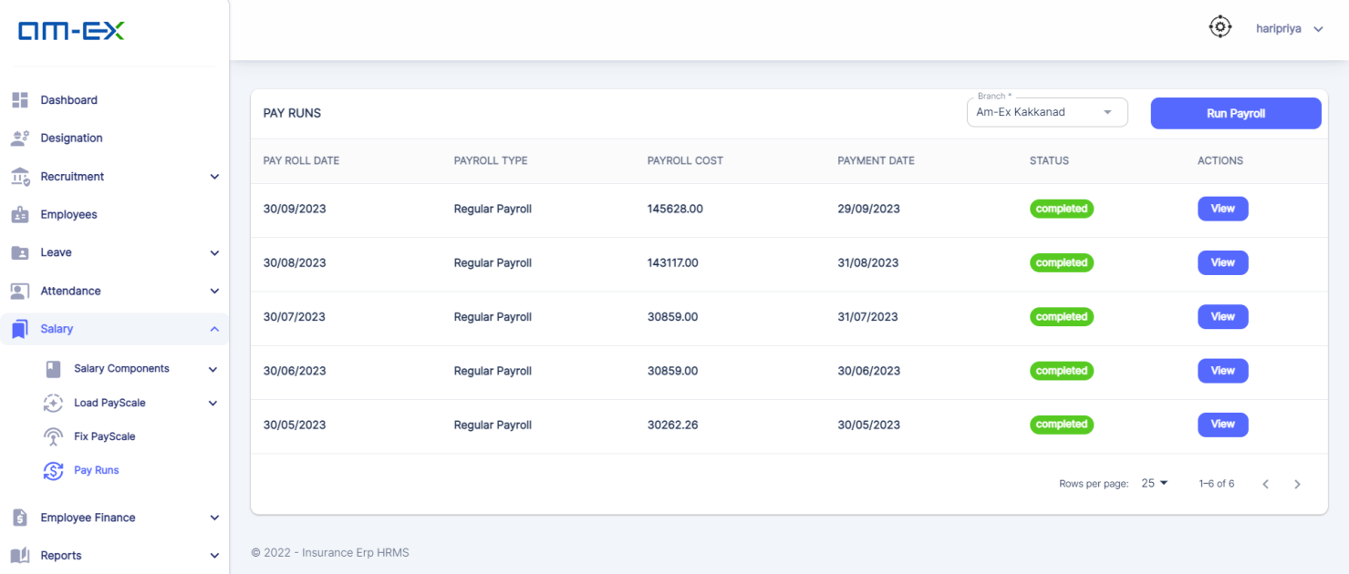

When Run Payroll is selected:

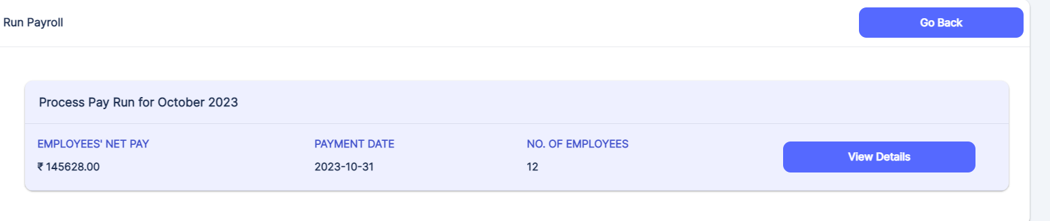

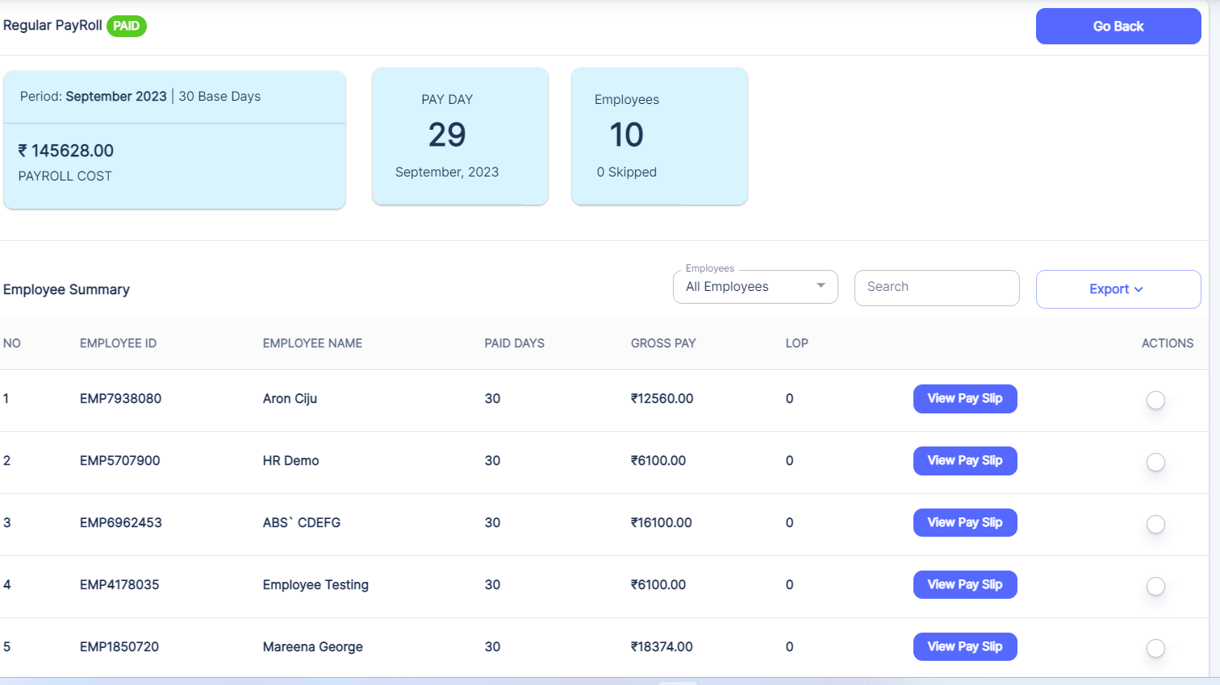

If the Status button in Action is enabled, then that Employee will be on Hold for that Pay Run. Salary will not be credited for this employee.

When **View Slip** is selected:

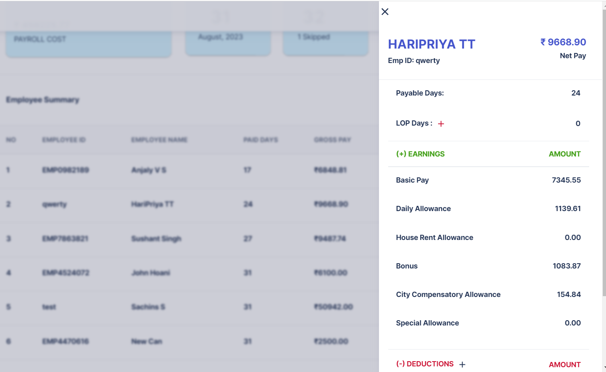

LOP Days or Deductions can be added by clicking on the + button.

Once this Pay Run is approved by HR, then Export button will be enabled.

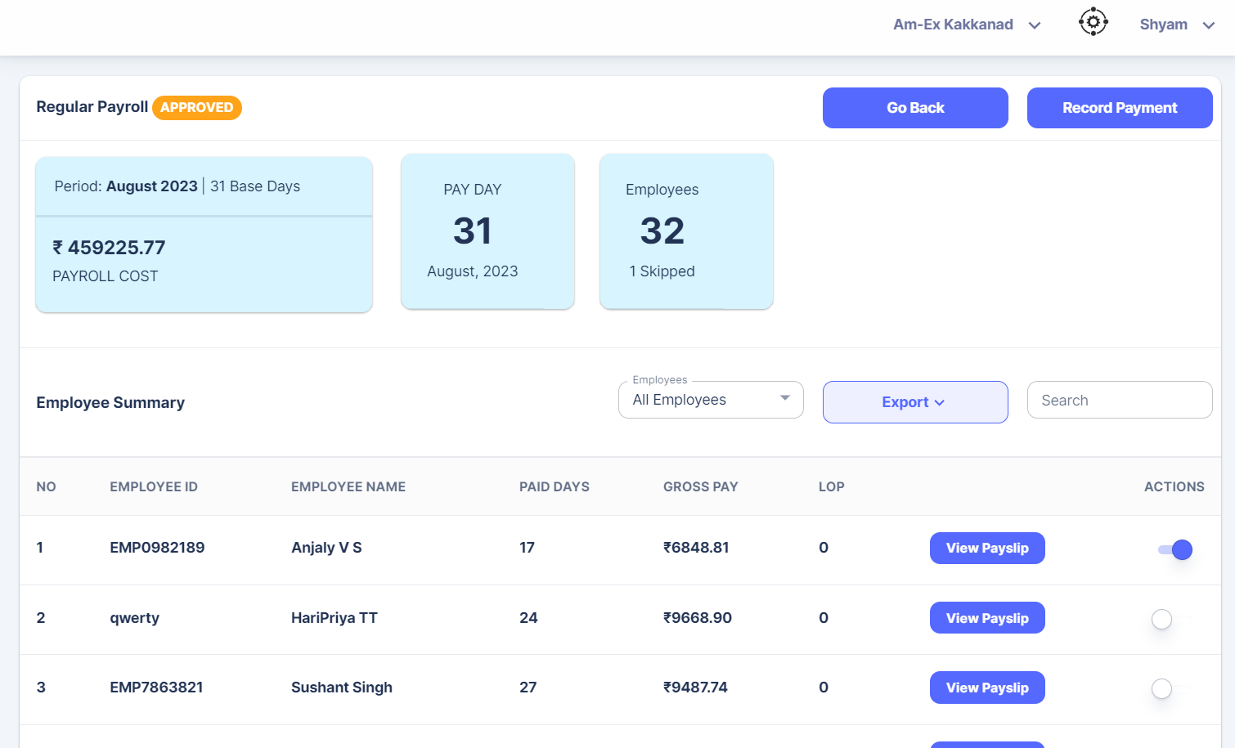

HR can download it & send to Accounts

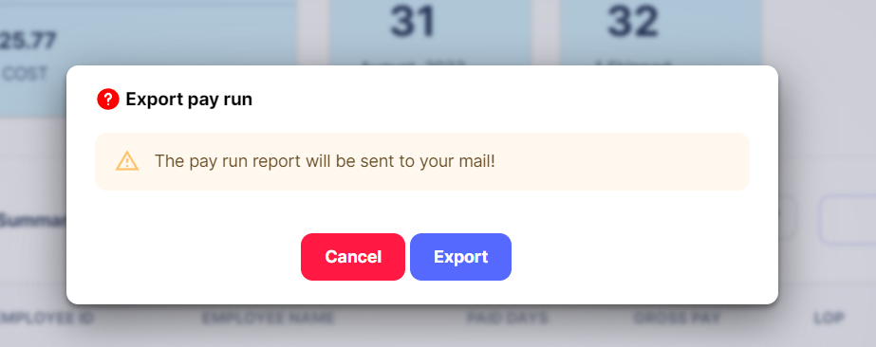

When Record Payment is selected, then the Pay Slip will be sent to all the employees.

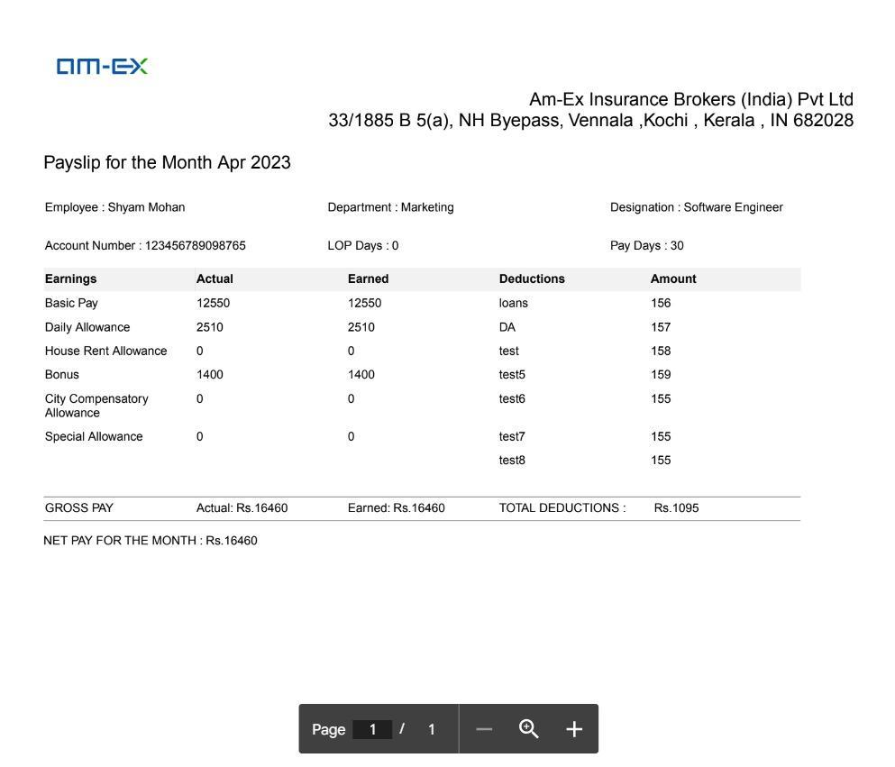

In the Export option, there are 2 options:

* Export Pay Run
* Export Pay Slip

If Export Pay Run is selected, then the logged in user will get a report of the Pay Run to the email.

If Export Pay Slip is deducted, then the employees will get their respective payslips to their email

The below 2 screenshots attached indicates the format for bank accounts:

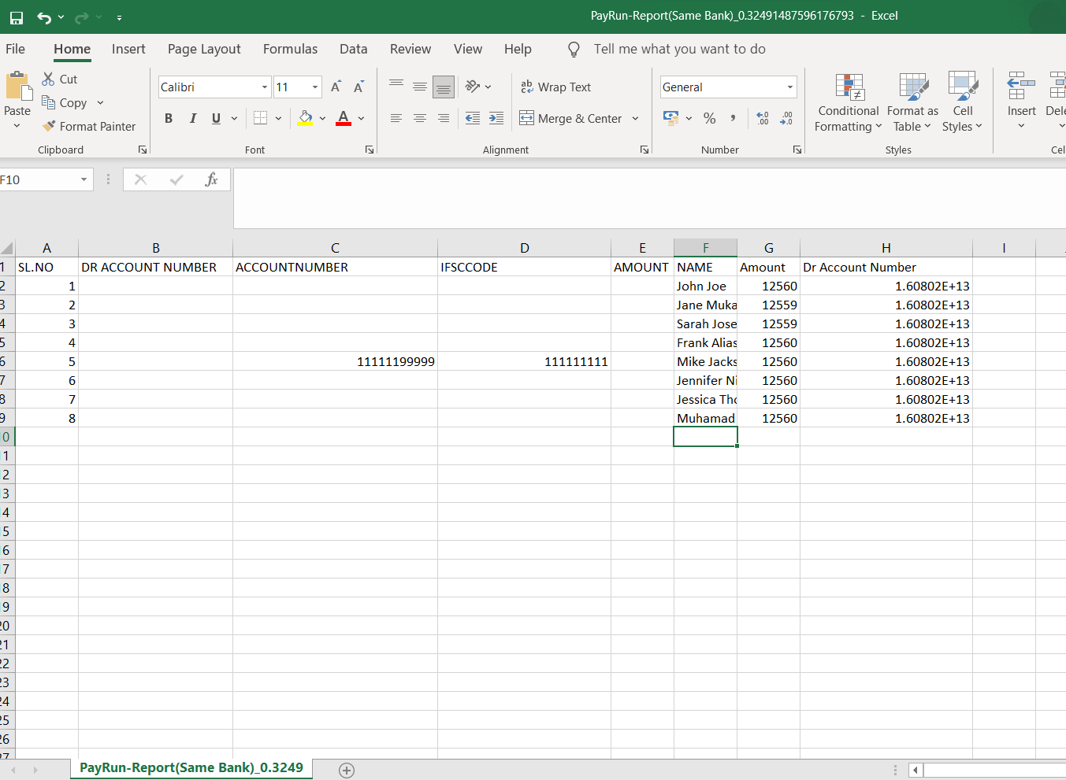

Format for Same Bank Account is shown above

If it is a different bank account, then pls find below image:

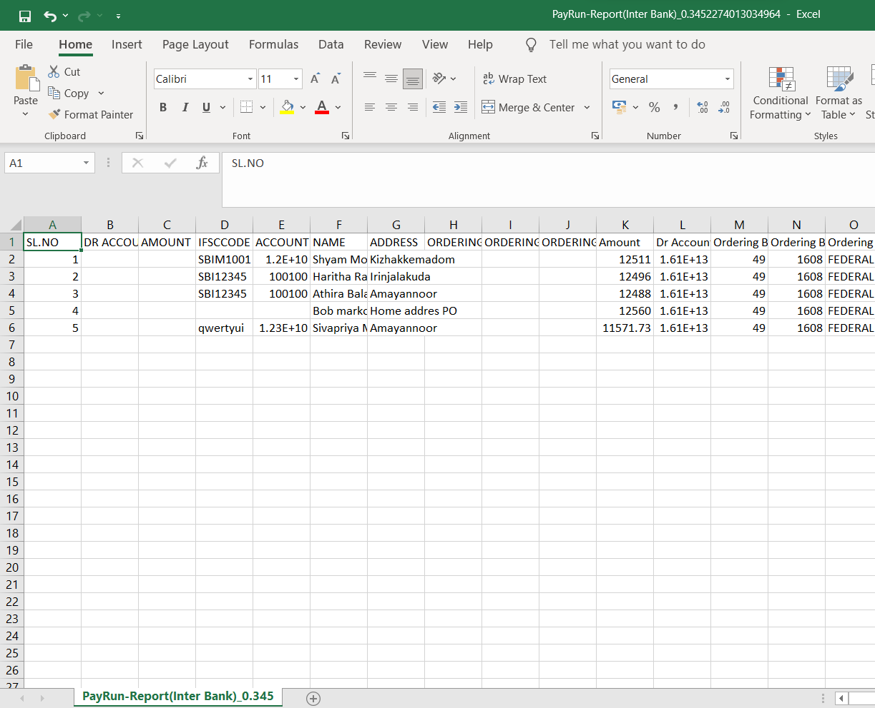

* 1. **Asset Management**

In Asset Management, HR can manage the assets in the organization. Under Asset Management, it is classified as:

* Asset
* Manage Asset
* Asset Allocate

**3.8.1** **Asset**

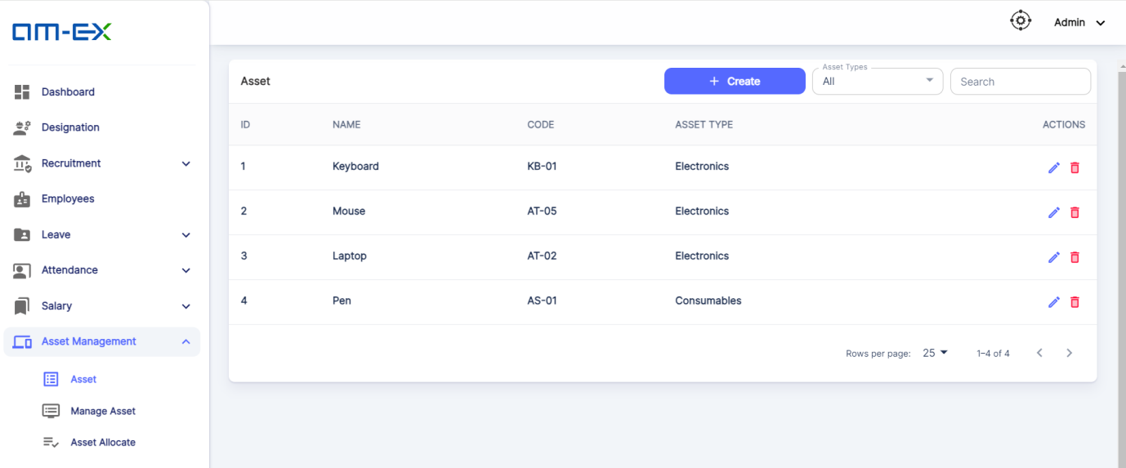

Using Asset Menu, one can create Assets under the organization. Also, there is a filter based on Asset Type. Asset Type can Electronics & Consumables.

When Create button is selected, the below screen appears:

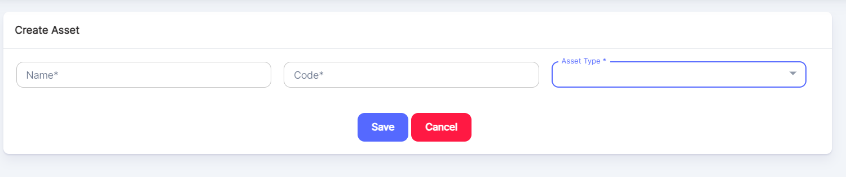

**3.8.2 Manage** **Asset**

Under this, HR can maintain the total count of the assets along with the specific details of the created asset under a specific branch.

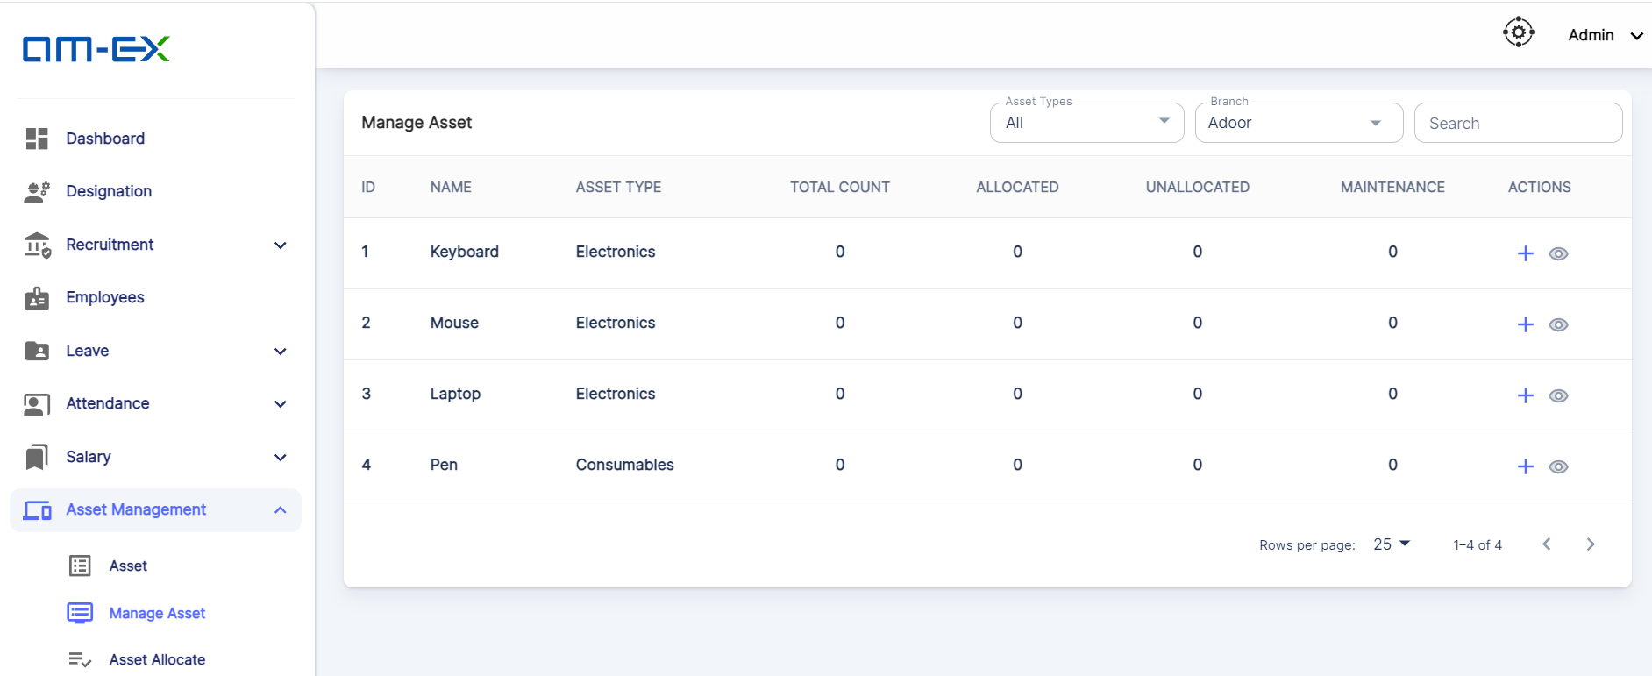

When **Add Details** (+) is selected against an Asset, the below screen appears to enter the asset details for a specific branch.

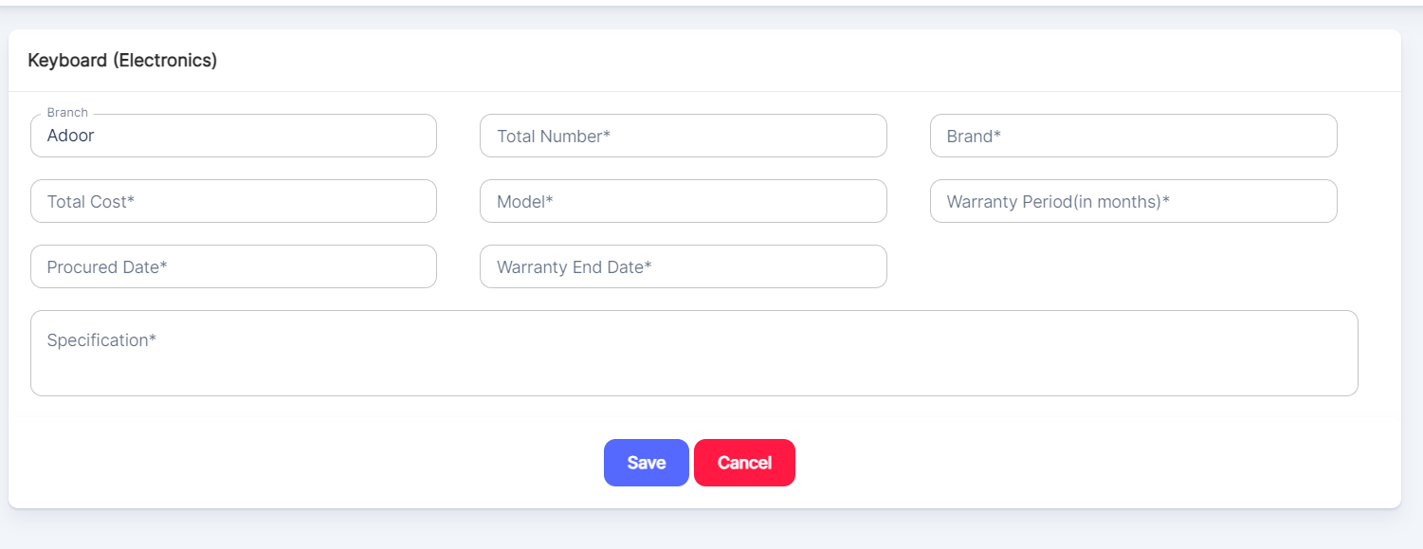

When **View Details** is selected against an Asset, it will show the details associated with it. In the Actions, there is an option to Remove the Asset as well.

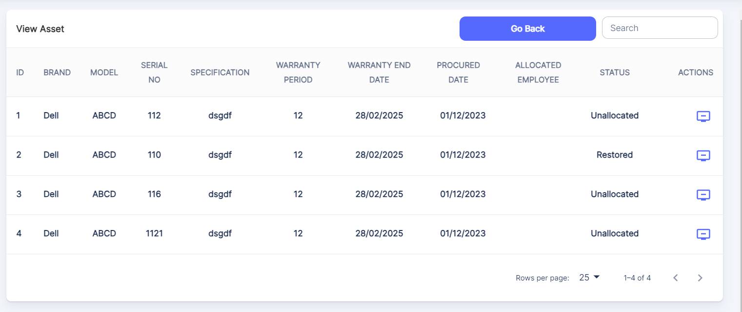

**3.8.3 Asset Allocate**

HR can handle Asset Allocation for every employee from here. Asset History will be maintained in this Asset Allocate module.

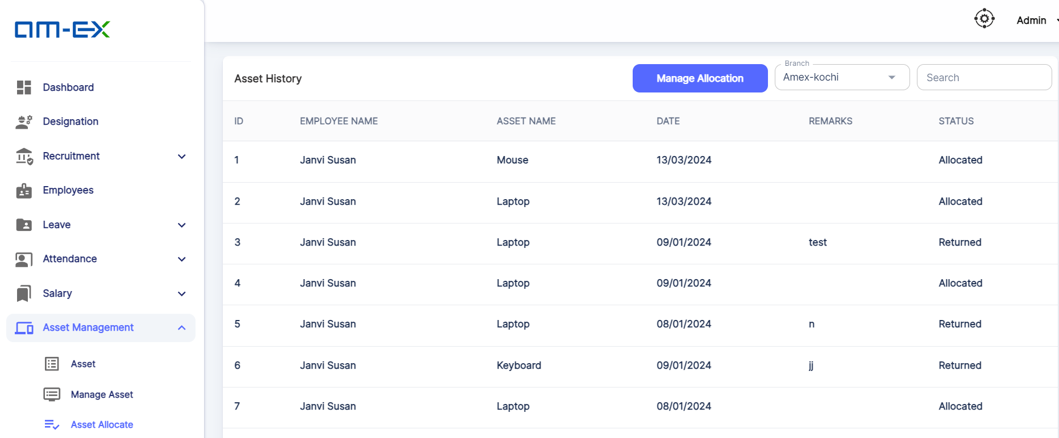

When **Manage Allocation** is selected, the below screen appears:

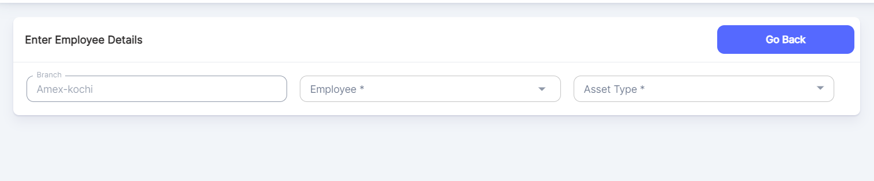

Based on Asset Type & Branch, assets can be allocated to each employee in the organization.

* 1. **Employee Finance**

Under Employee Finance, there are different sub categories like:

* Advance Payment
* Reimbursement
* Loans
* Insurance
  + 1. **Advance Payment**

Under Advance Payment, there are 2 types:

My Advance Payment

Advance Payment Requests

**🡪My Advance Payments**

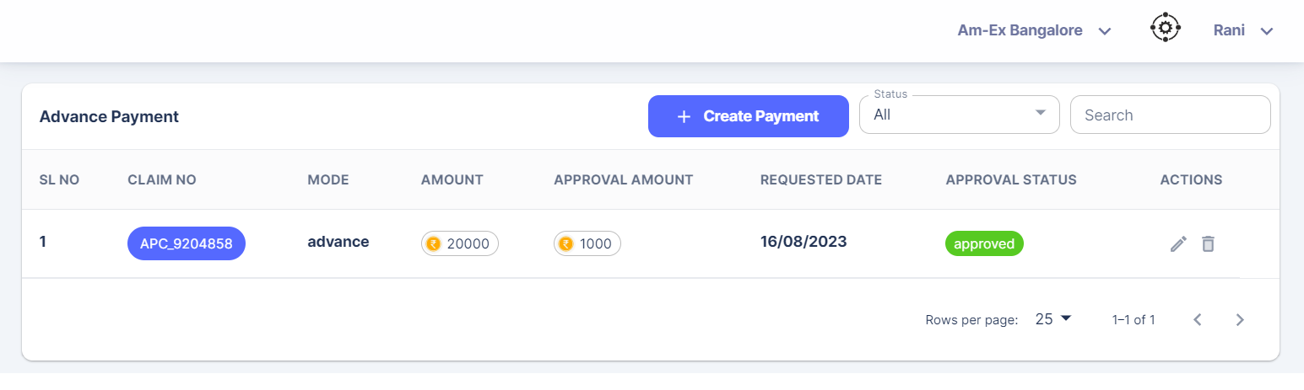

Click on Create Payment

Transaction Type selection will not be there in future. This is a new change.

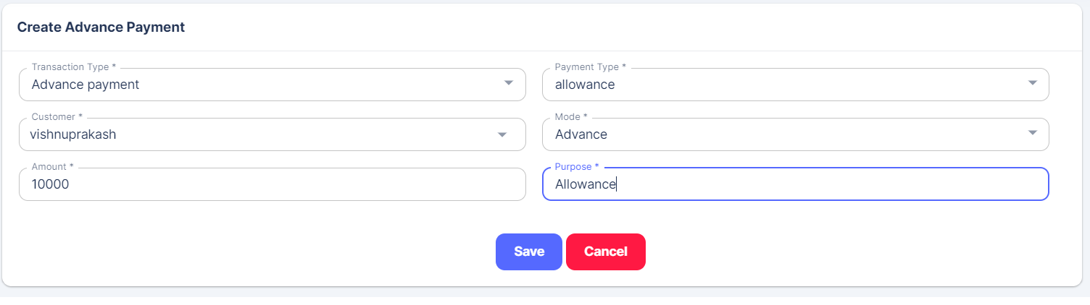

Mode can be Advance, Refund & Payable.

Based on the Mode, form fields will change. In case of Refund & Payable, an additional form field called Select Claim & an attachment will also be there.

Once saved, mail will be sent to the logged in employee’s Reporting Manager.

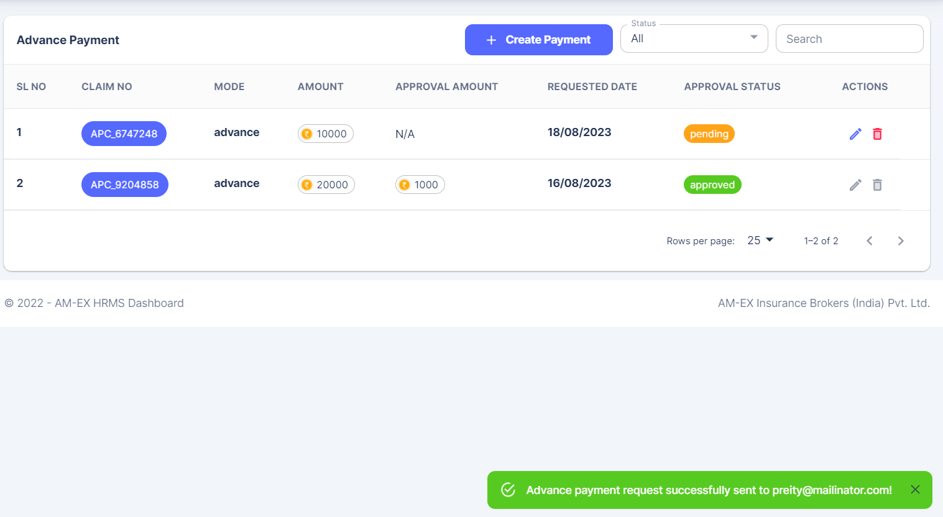

Mail will be in the Inbox of Reporting Manager & Branch Manager will be in cc. So, he also can do the verification.

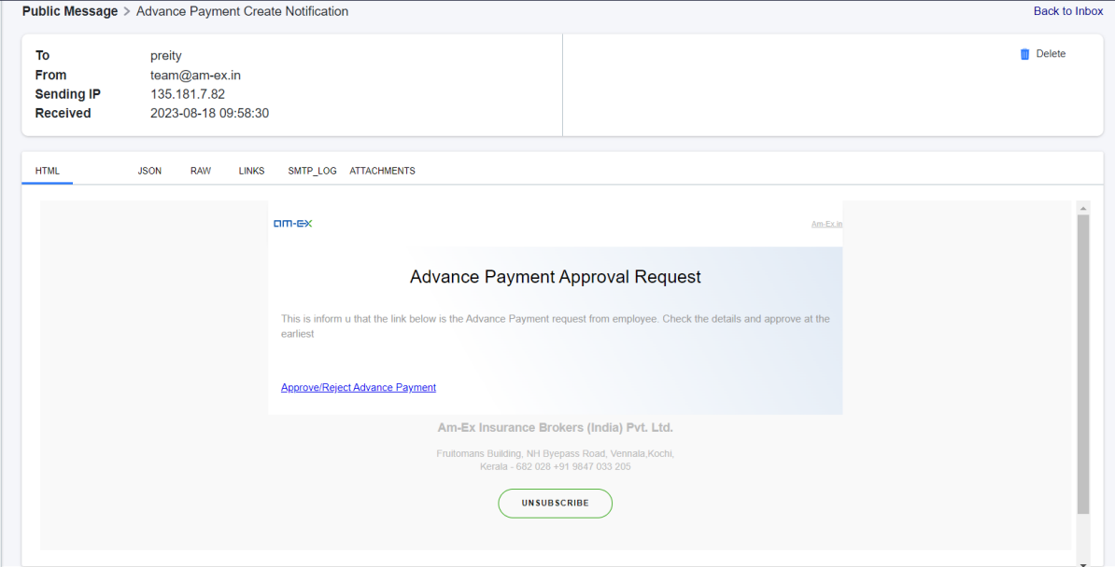

Click on the link from email. The request will be visible when we login as Reporting Manager. Select HR & change status to Verified.

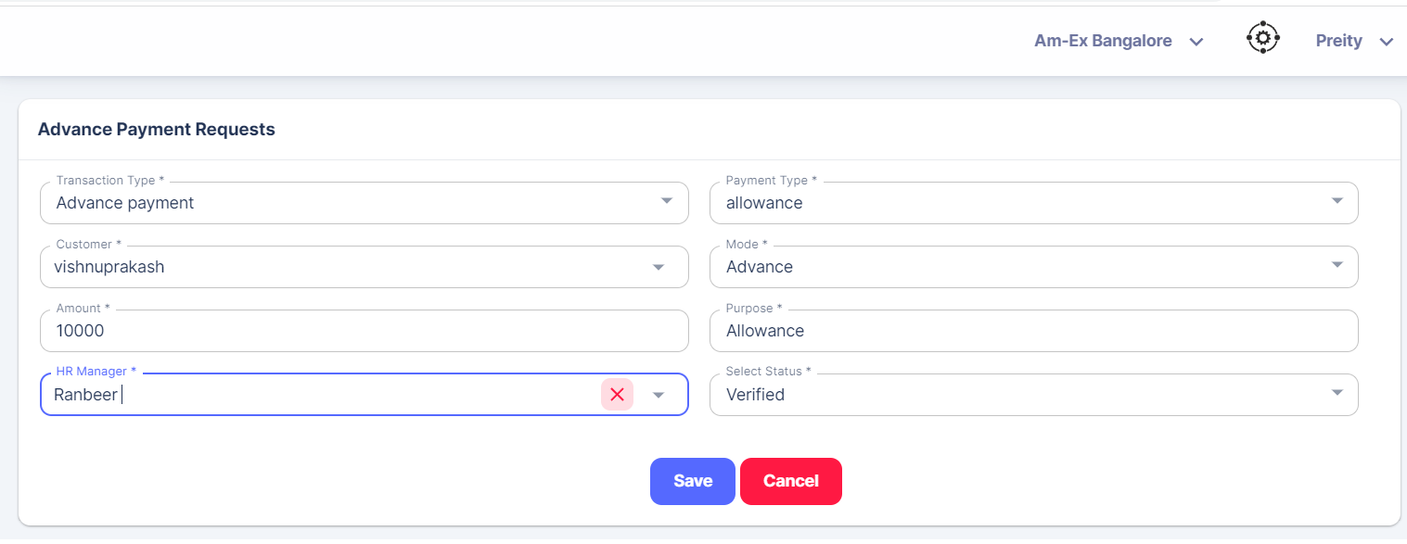

Once saved, mail notification will be sent to HR Manager. Now, HR needs to login & then approve it. If any of the HR Managers are present in the Branch, then they can view this in the list.

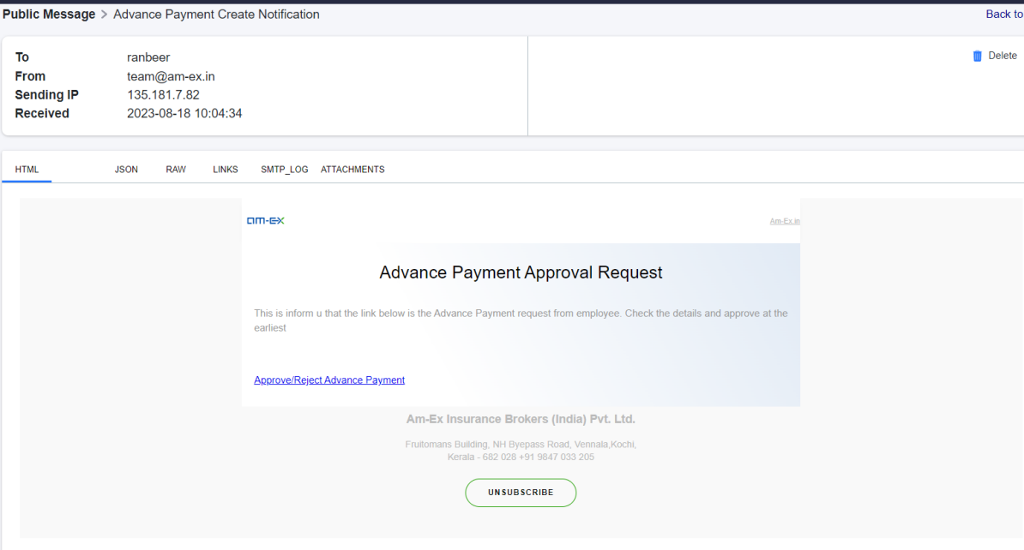

Click on the link & login as HR. Select the Payment Mode, Amount Approved & Change Status (Approved or Rejected)

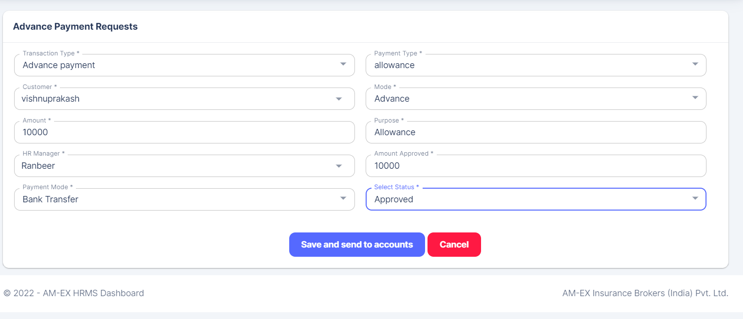

If it is Approved, then only Save & Send to Accounts button is visible.

If it is Rejected, then Save & Send to Accounts button will not be visible.

Once Approved, click on Save & Send to Accounts. The fields which will be sent to Accounts Module are:

transactionTypeId, transactionDate, incomeFlag, expenseFlag, accountHeads, journalEntryFlag, amount

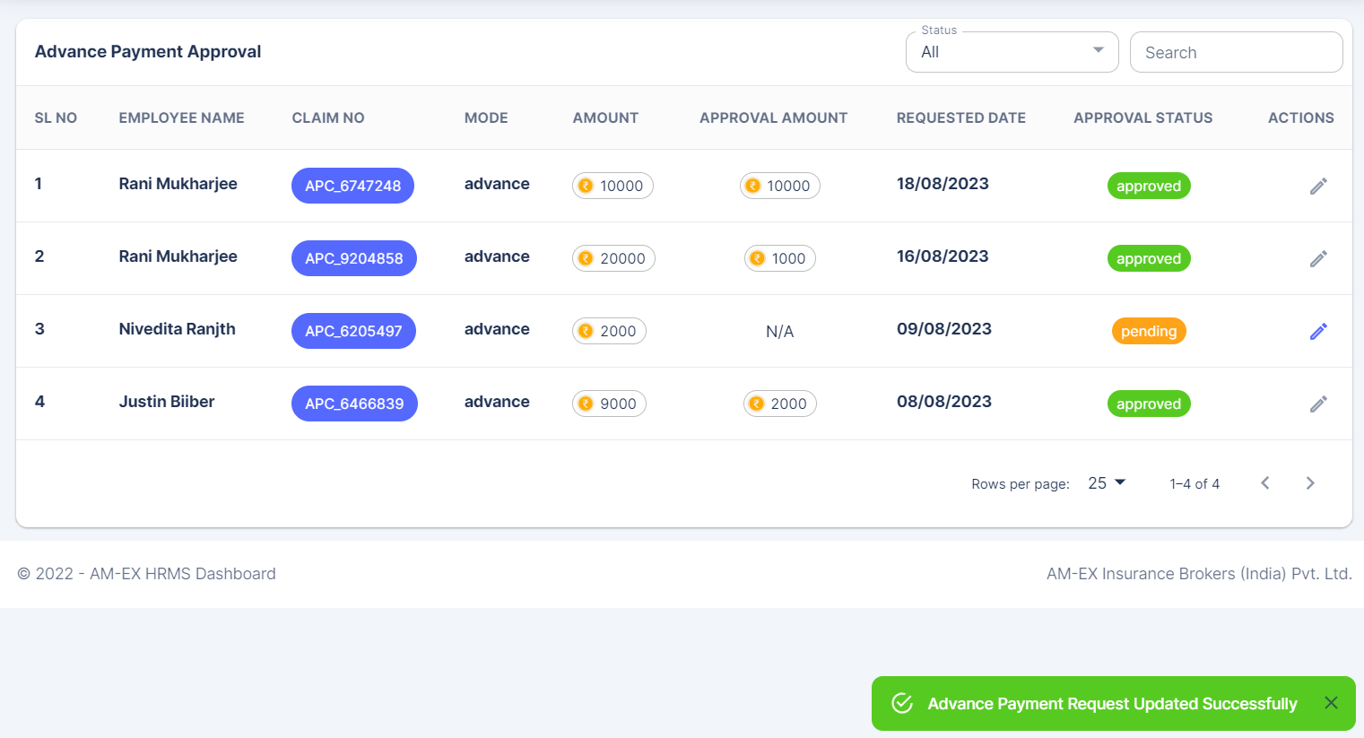

The requests which are in Approved Status cannot be edited. Only those which are in Pending status can be edited.

There is a filter for status. We can filter the list based on the status like Approved, Pending, etc.

The below illustration shows the list which is in Pending Status.

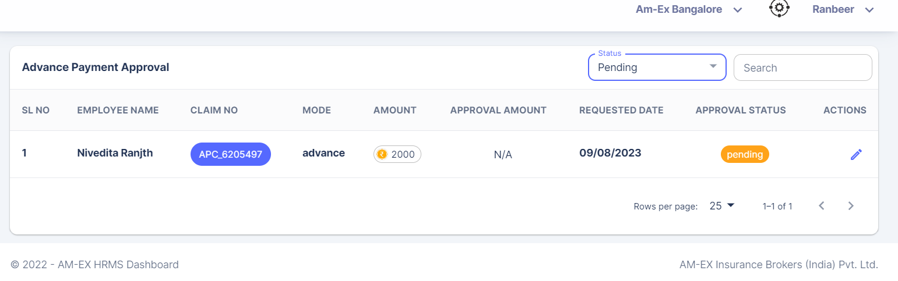

🡪**Advance Payment Requests**

In this, if the Branch Manager, HR Manager or Reporting Manager belongs to the Branch where the Advance Payment request is raised, then he or she can see the list.

Admin will also have the permission to see the Advance Payment Requests.

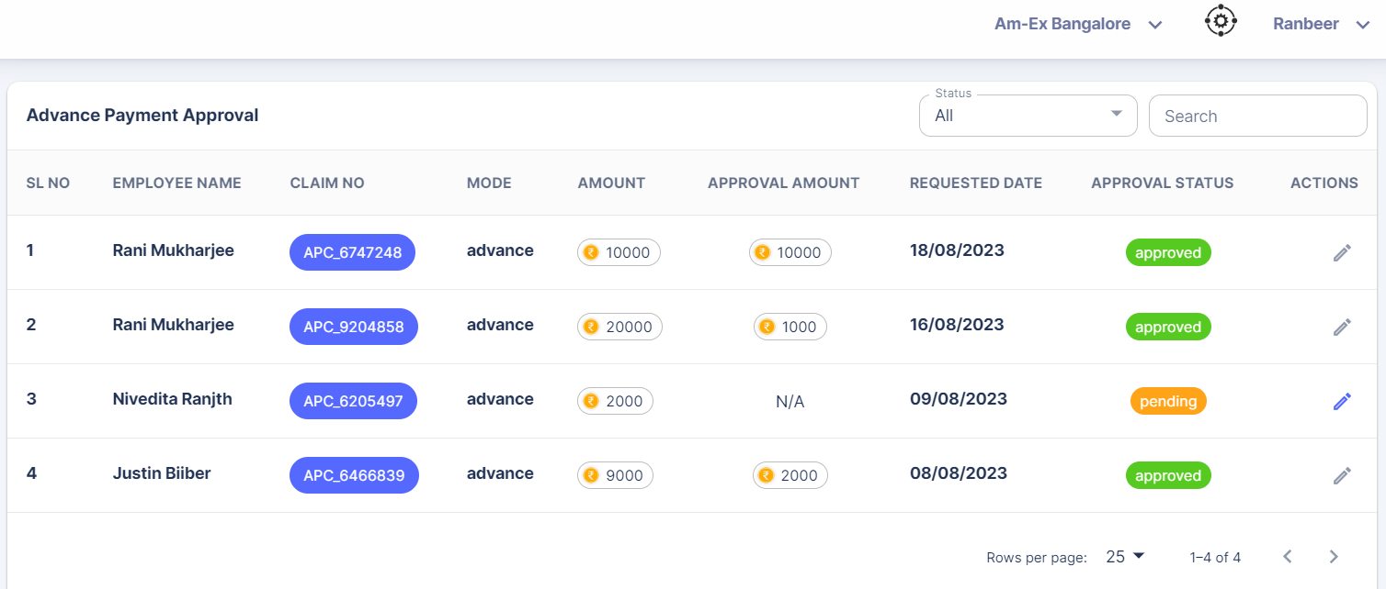

* + 1. **Reimbursement**

**🡪My Reimbursement**

If employee uses any money for company expenses, then he or she can reimburse the amount.

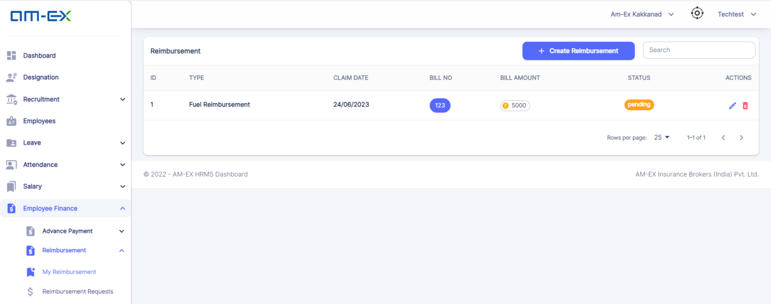

Similar like Advance Payment, here also, Transaction Type field will not be there. This is a new change.

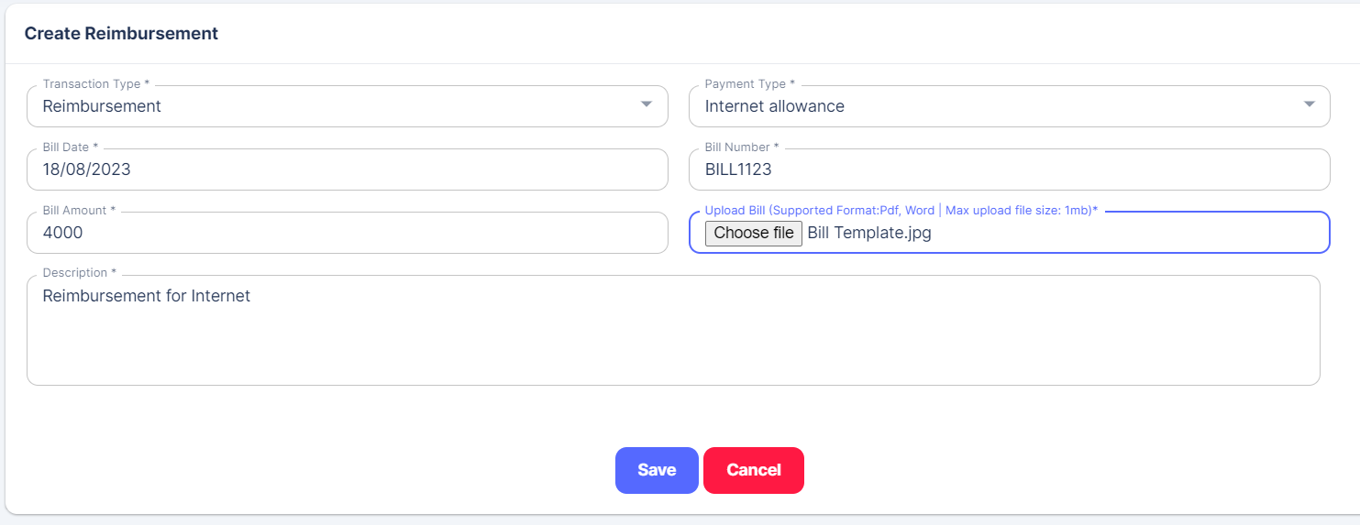

Click on Save.

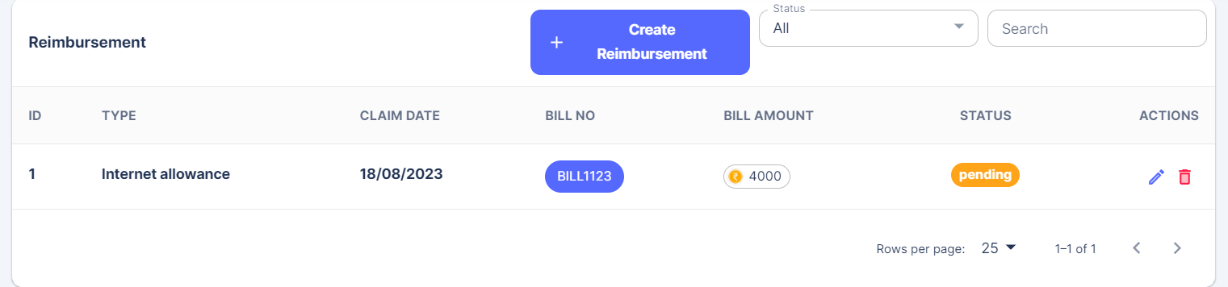

Mail will be sent to the Reporting Manager.

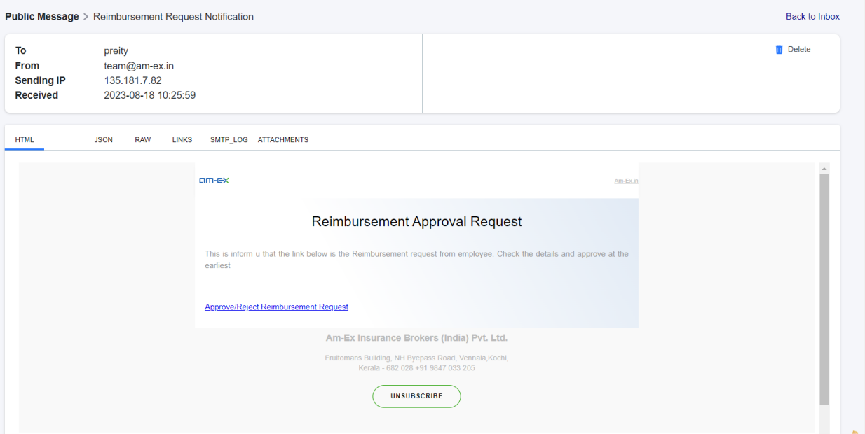

Click on the link in the email. Then login as the Reporting Manager.

Once Reporting Manager logs in, select the HR Manager & change the status to Verified.

Click on Save.

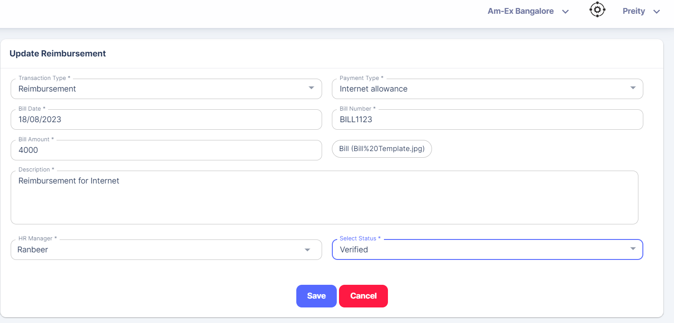

Then, mail will be sent to the selected HR Manager.

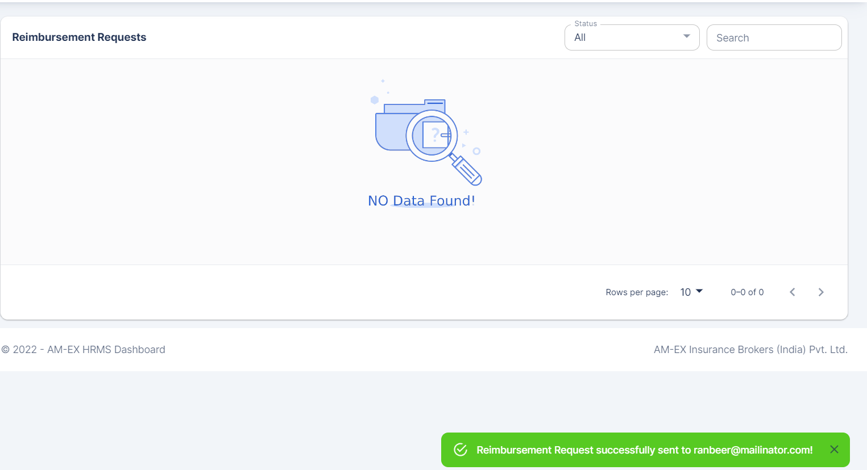

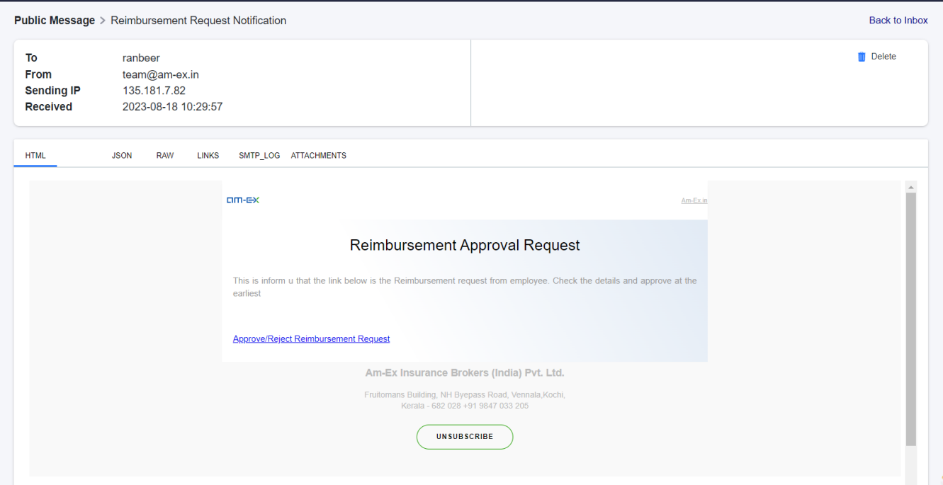

Click on the link in the email. Then, login as HR.

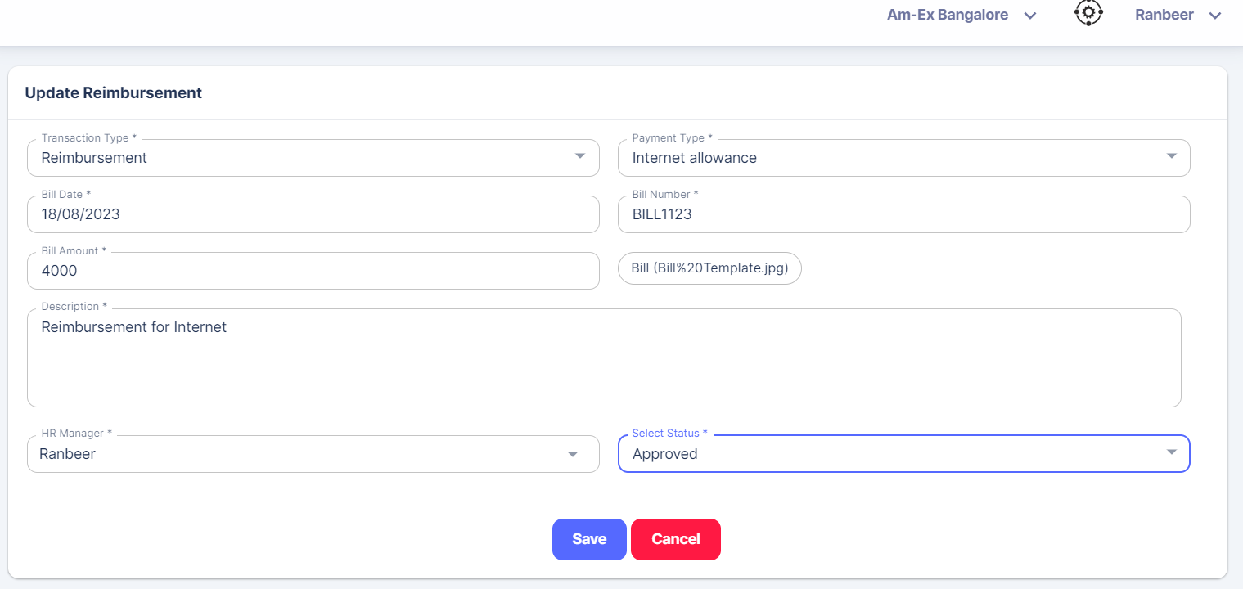

Change the status to Approved. Click on Save.

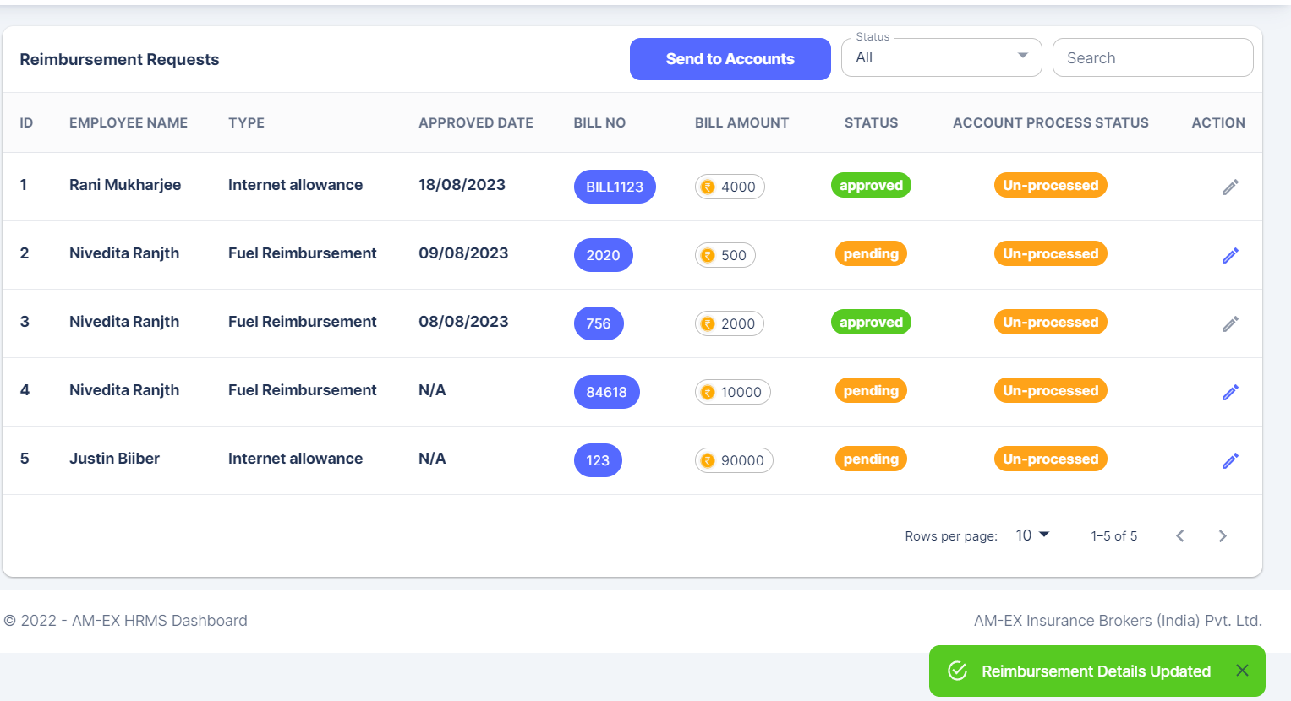

In the case of Reimbursement, these requests will be sent monthly to Accounts together. Click on Send to Accounts.

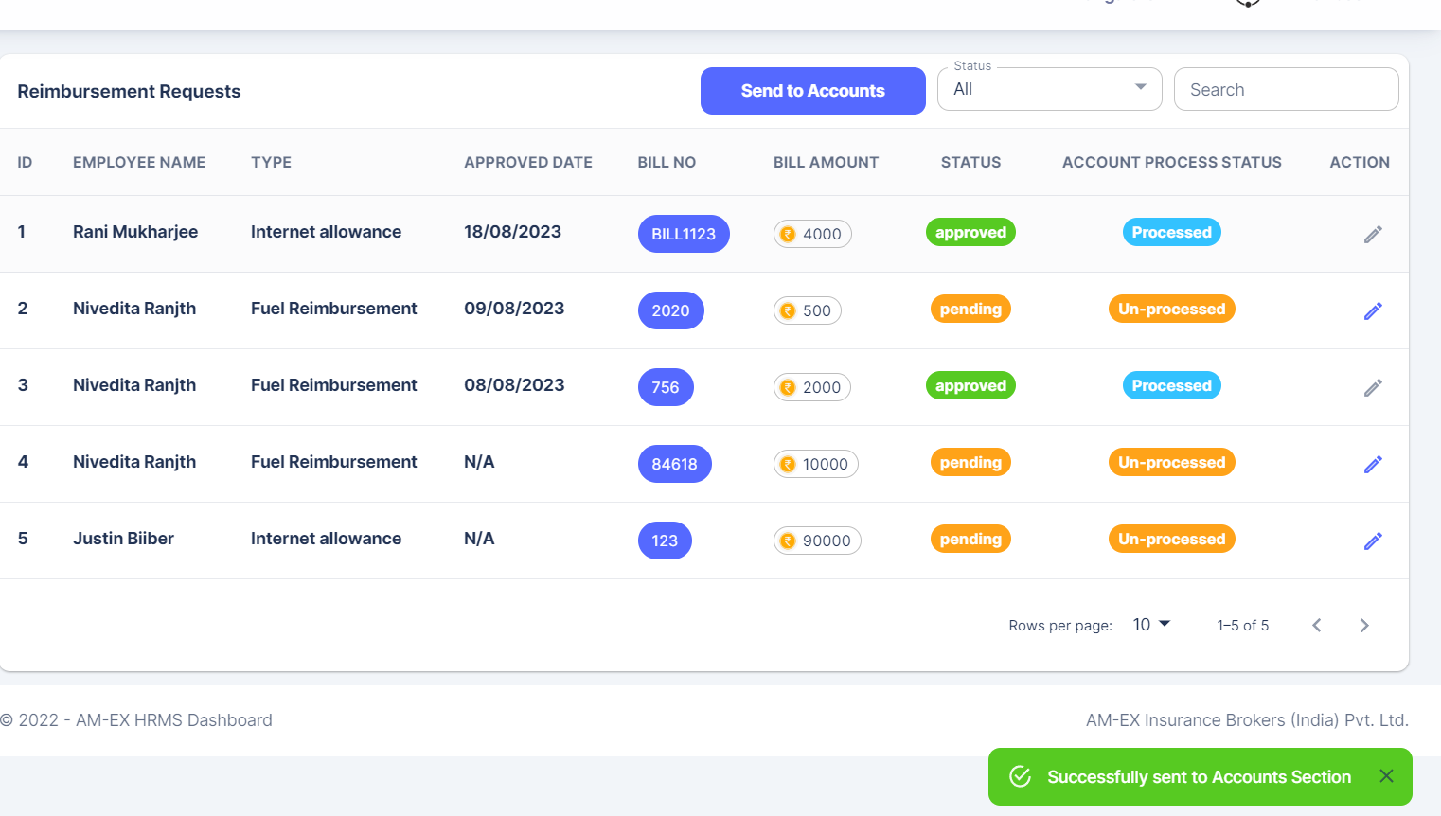

Processed ones cannot be edited. Also, there is a filter for Status.

**🡪Reimbursement Requests:**

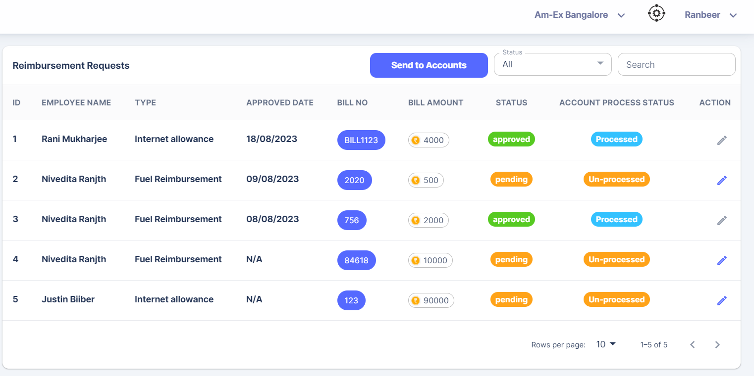

* + 1. **Loans**

**🡪My Loan**

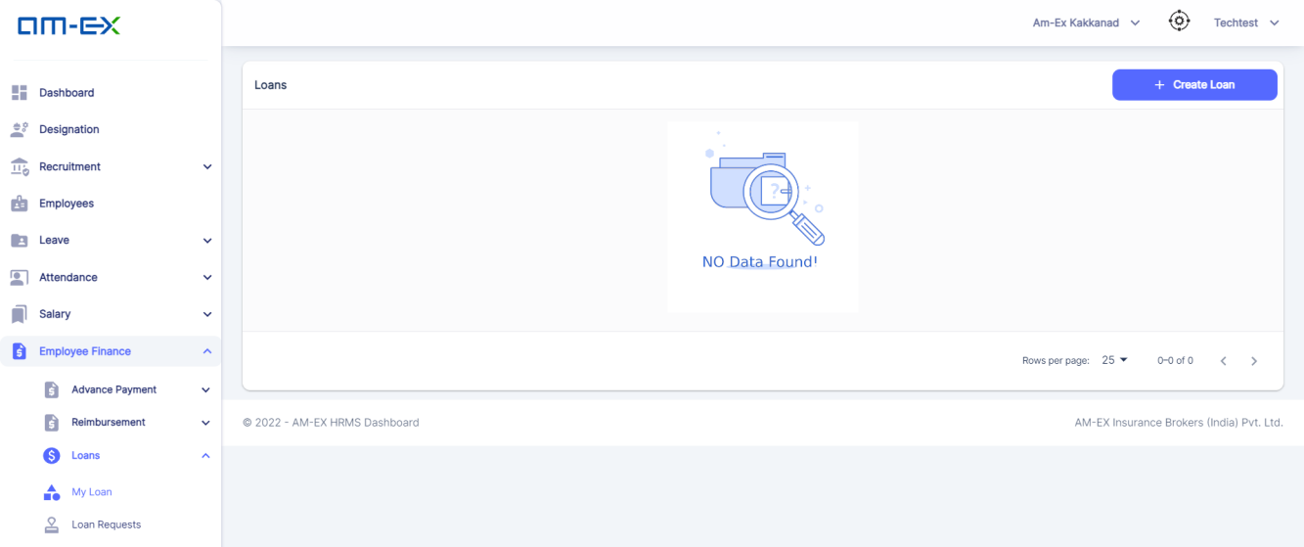

Click on Create Loan.

Transaction Type will not be there for Loans as well. In the LoanType, Personal Loan will be there. This is a new change.

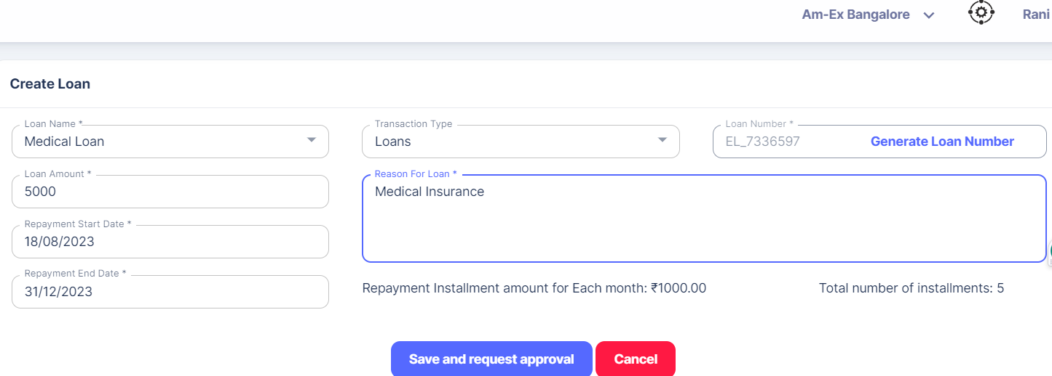

Mail will be sent to Reporting Manager once Save & Request Approval is selected.

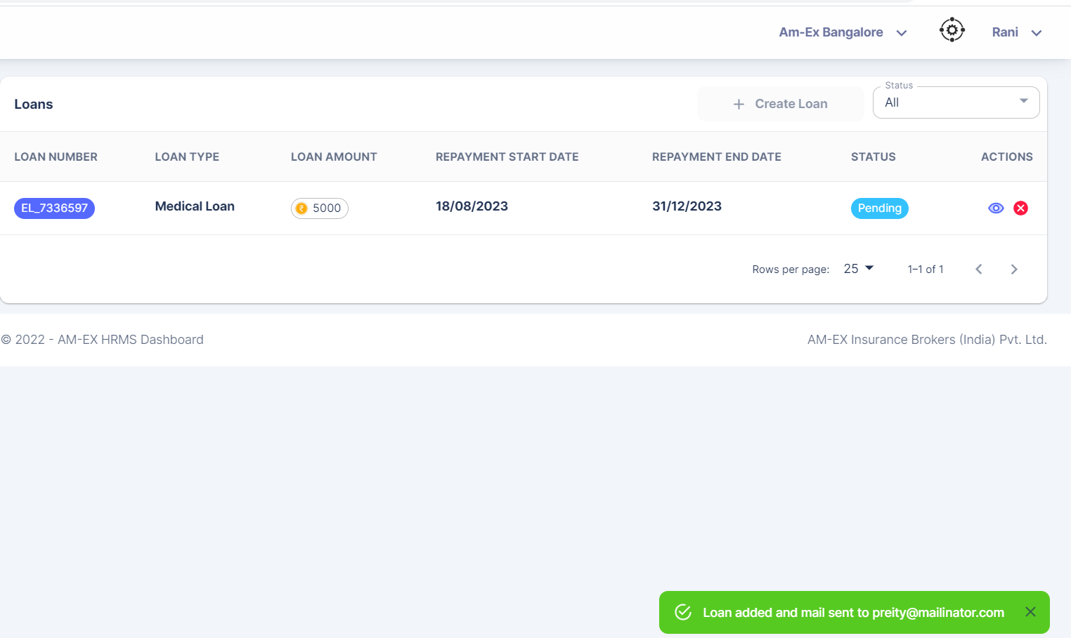

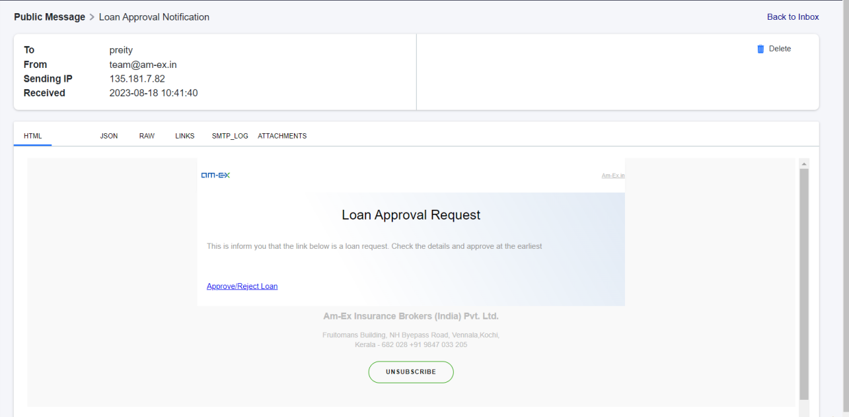

Click on the link in the email & then login as Reporting Manager.

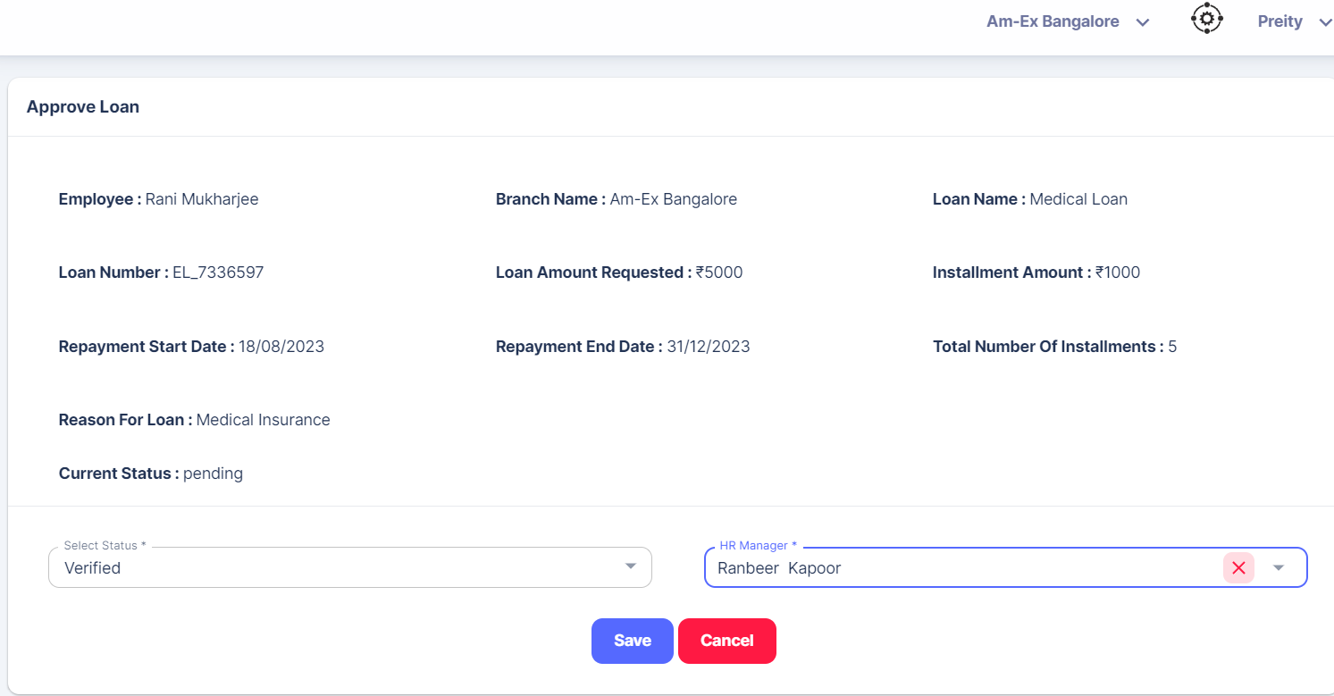

Change the status to Verified & select the HR Manager.

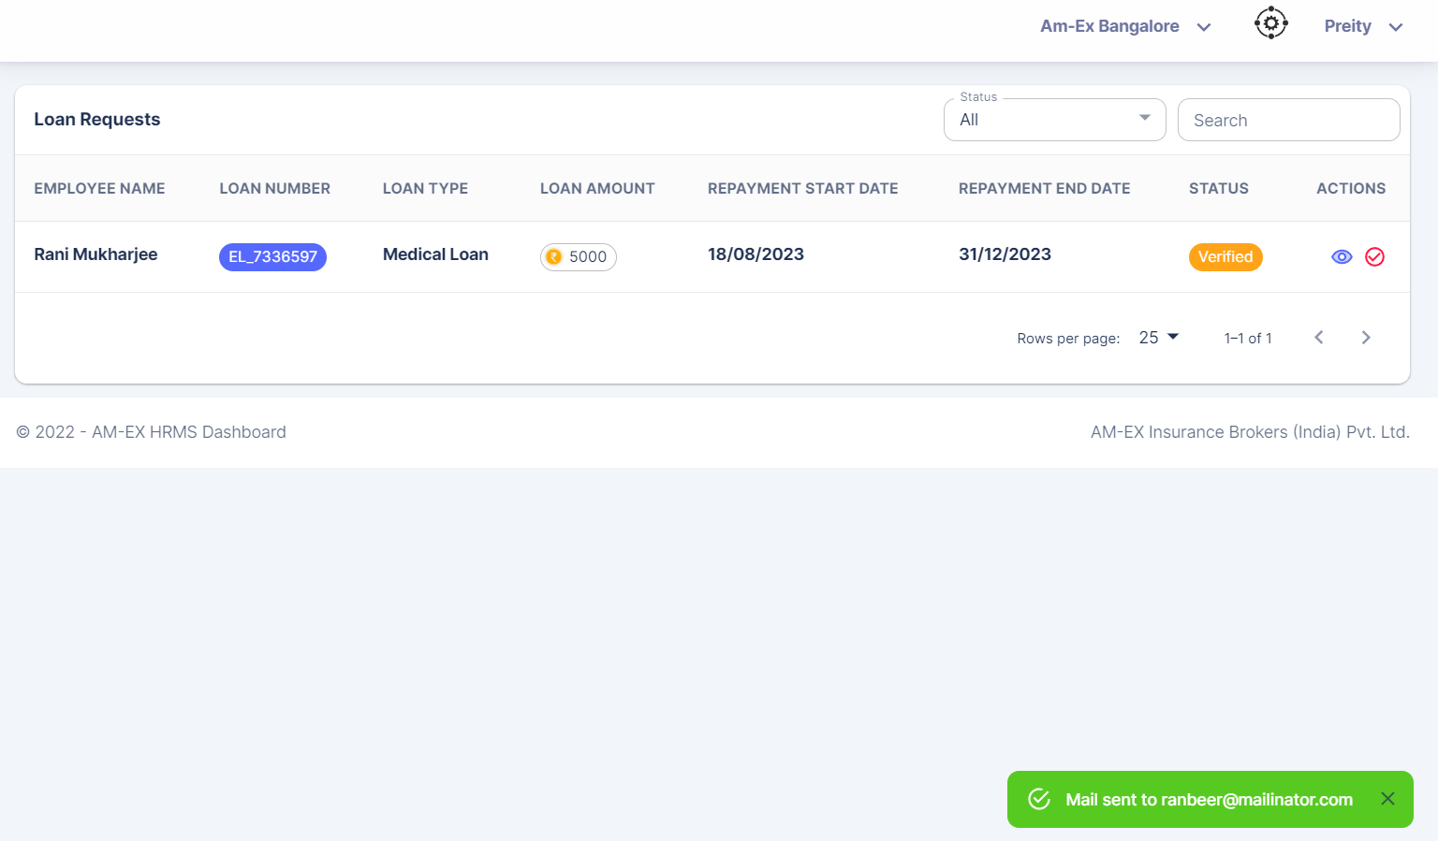

Now, login as HR Manager & Approve it.

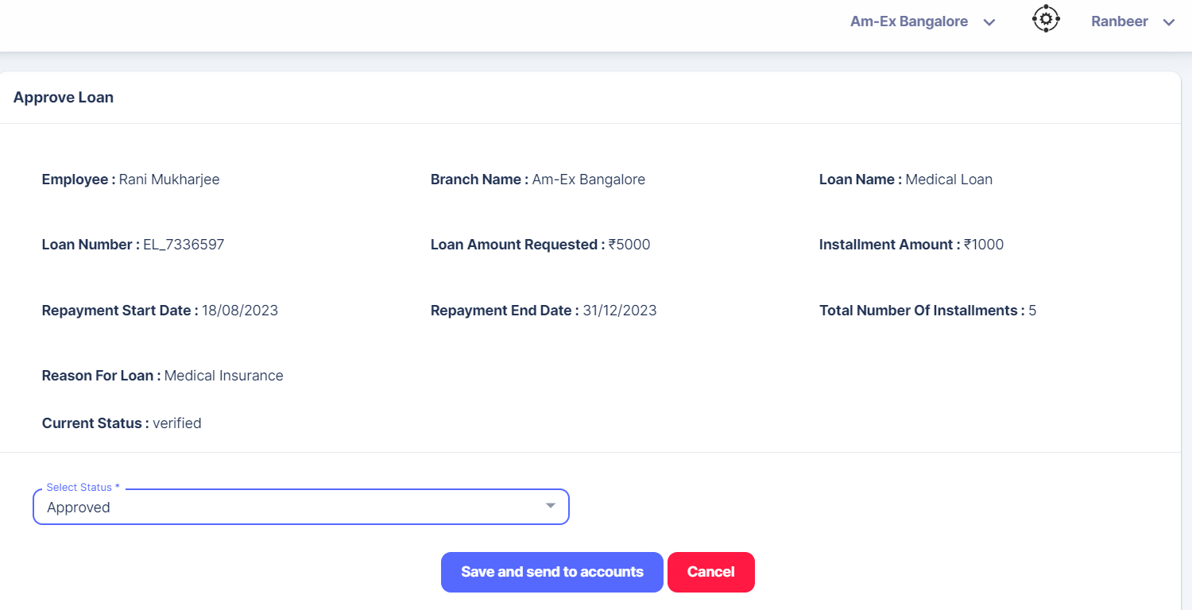

Once Status is changed to Approved, Save & Send to Accounts button is enabled.

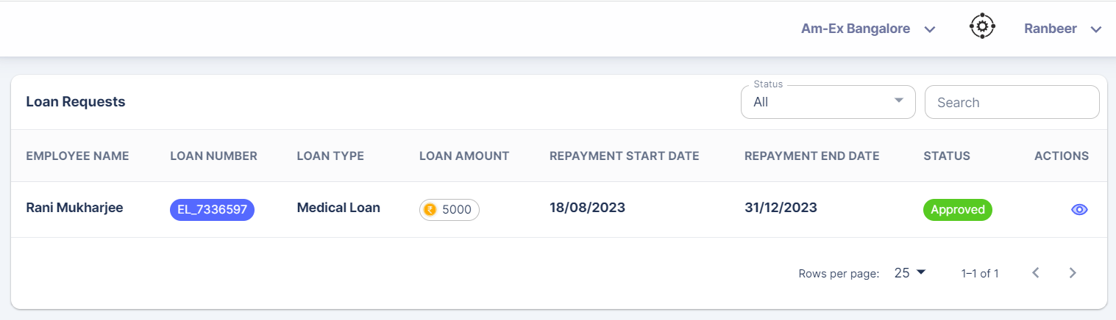

Click on Preview.

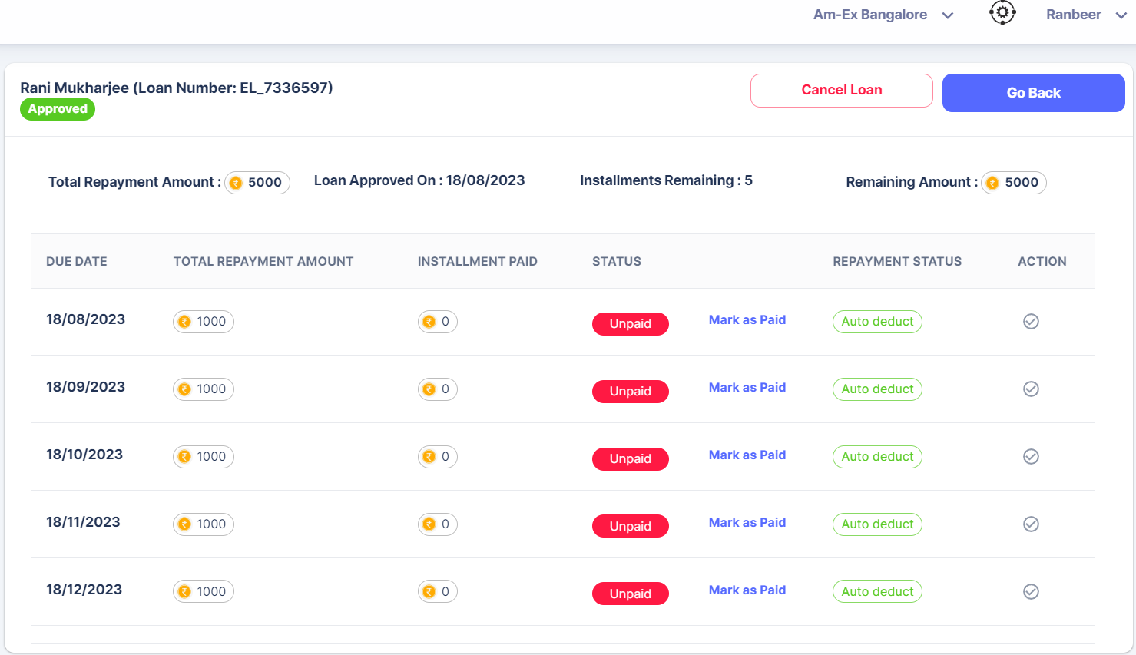

There is an option to Cancel Loan as well.

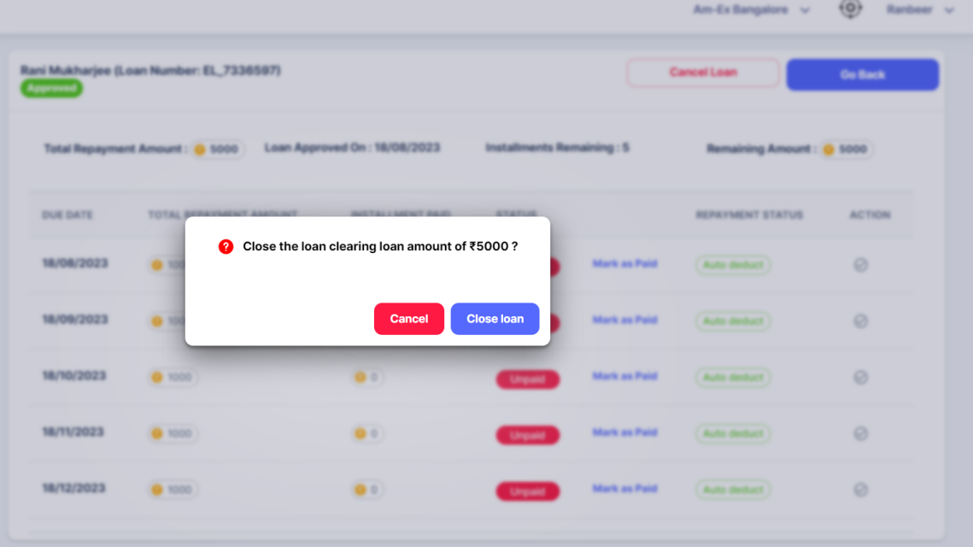

If we need to close the loan in between:

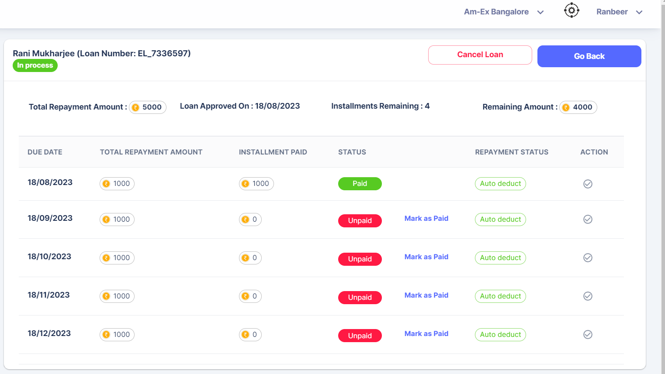

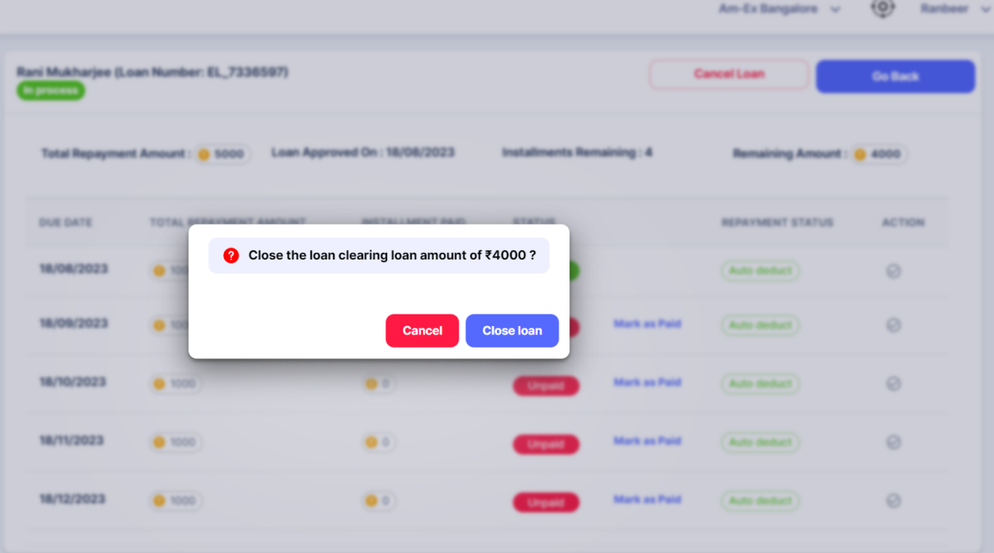

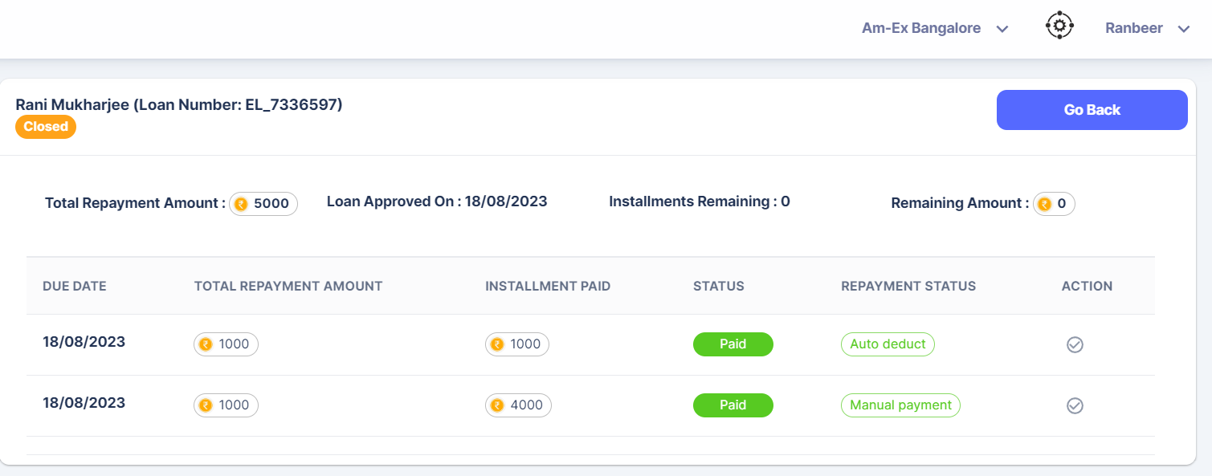

Here, the pending Instalments were 4. Already 1 installment was done. The rest of the amount here, which is 4000 will be shown as a new record for reference.

Employee can request for skipping an Installment which is auto deducted. Also, he or she can request for a Manual Payment instead of Auto Deduct in between.

Login as Employee & click on Create Loan.

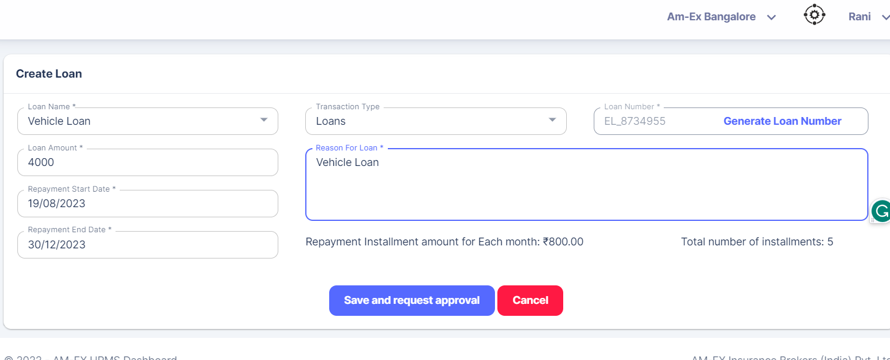

Click on Save & Request Approval. Now, Reporting Manager should verify it & select HR Manager. HR Manager should Approve or Reject it. Once HR Manager Approve, then Save & Send to Account is enabled.

Employee has the provision to request for One -Time Payment which is Manual.

Login as the employee who has requested for the Loan.

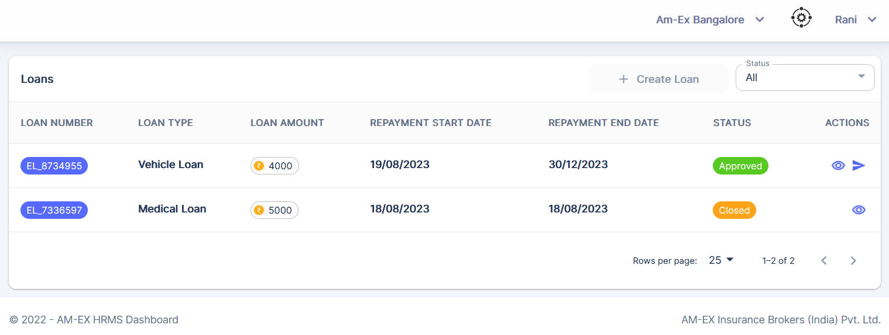

Click on Request for One-Time Payment. Below pop-up appears.

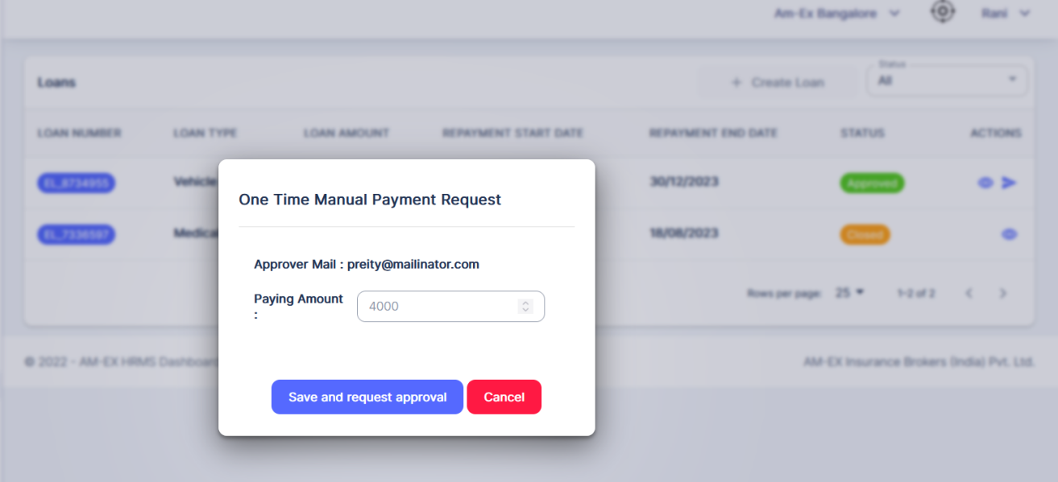

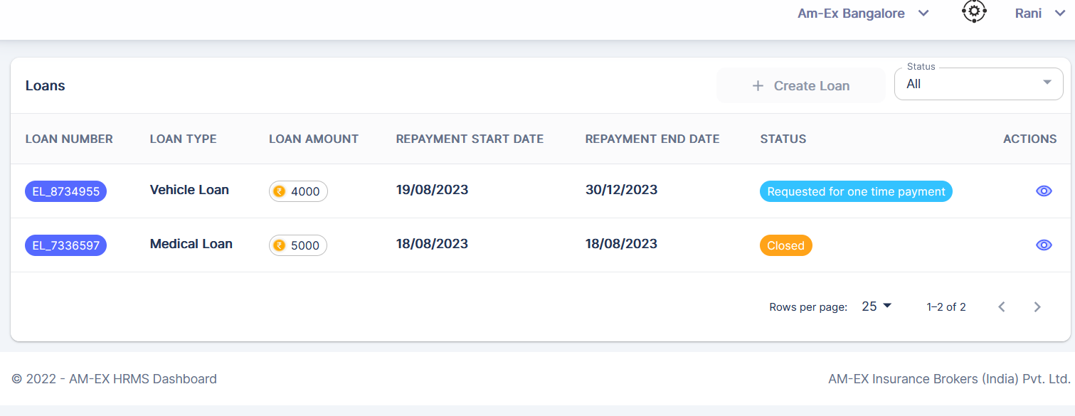

Click on Preview to see the details.

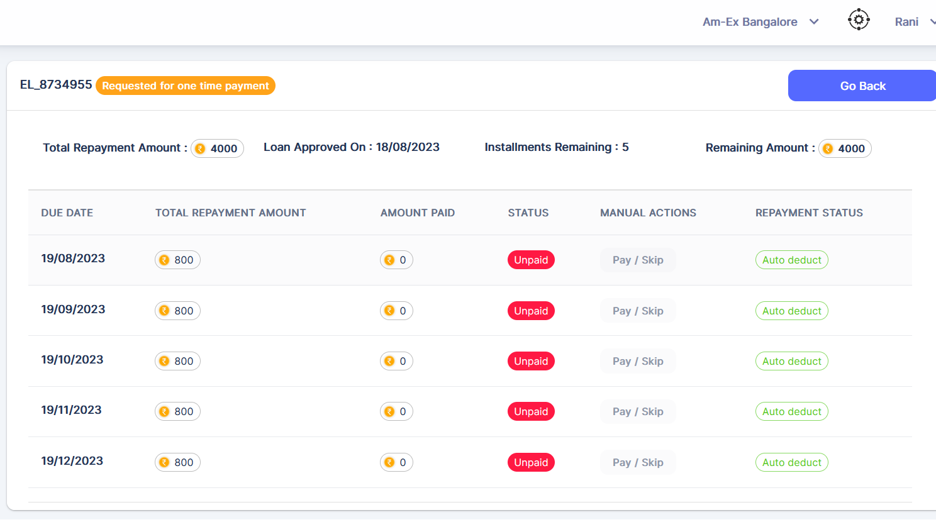

Once Request is raised, HR needs to approve or reject.

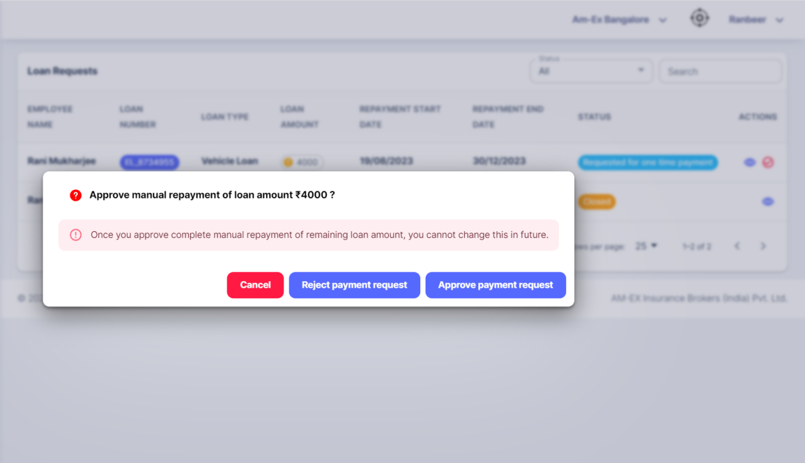

If rejected, then below pop up appears:

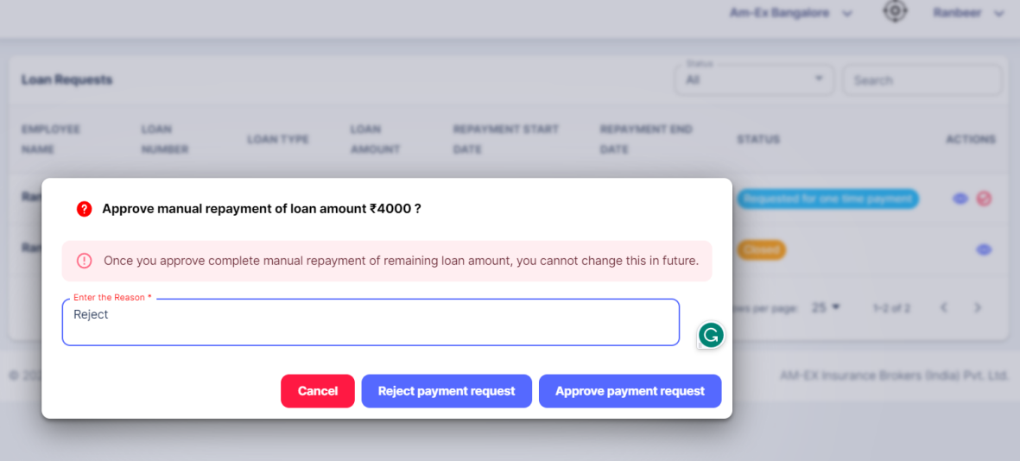

Mail will be sent to employee if its Rejected.

If approved, the loan will be completed & it will be closed.

If we click on View, then we will be able to see Pay/Skip option

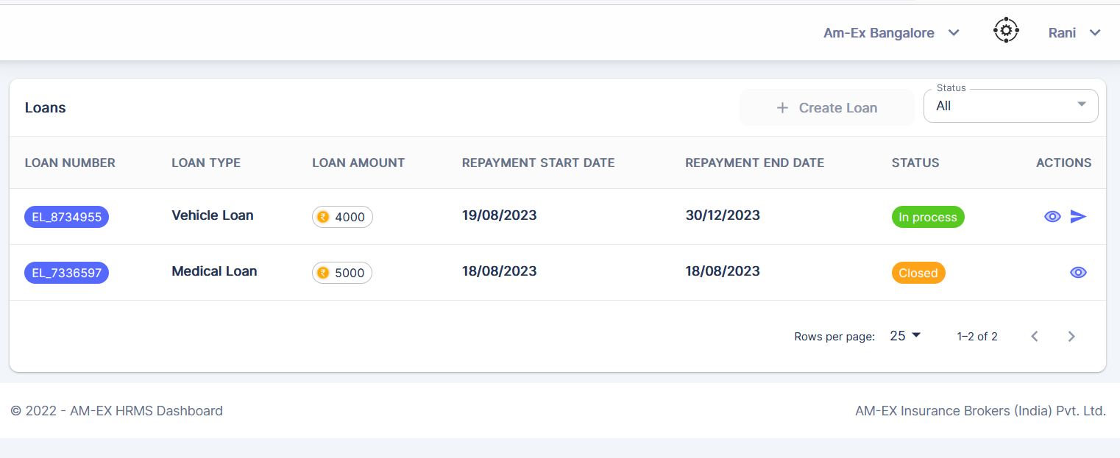

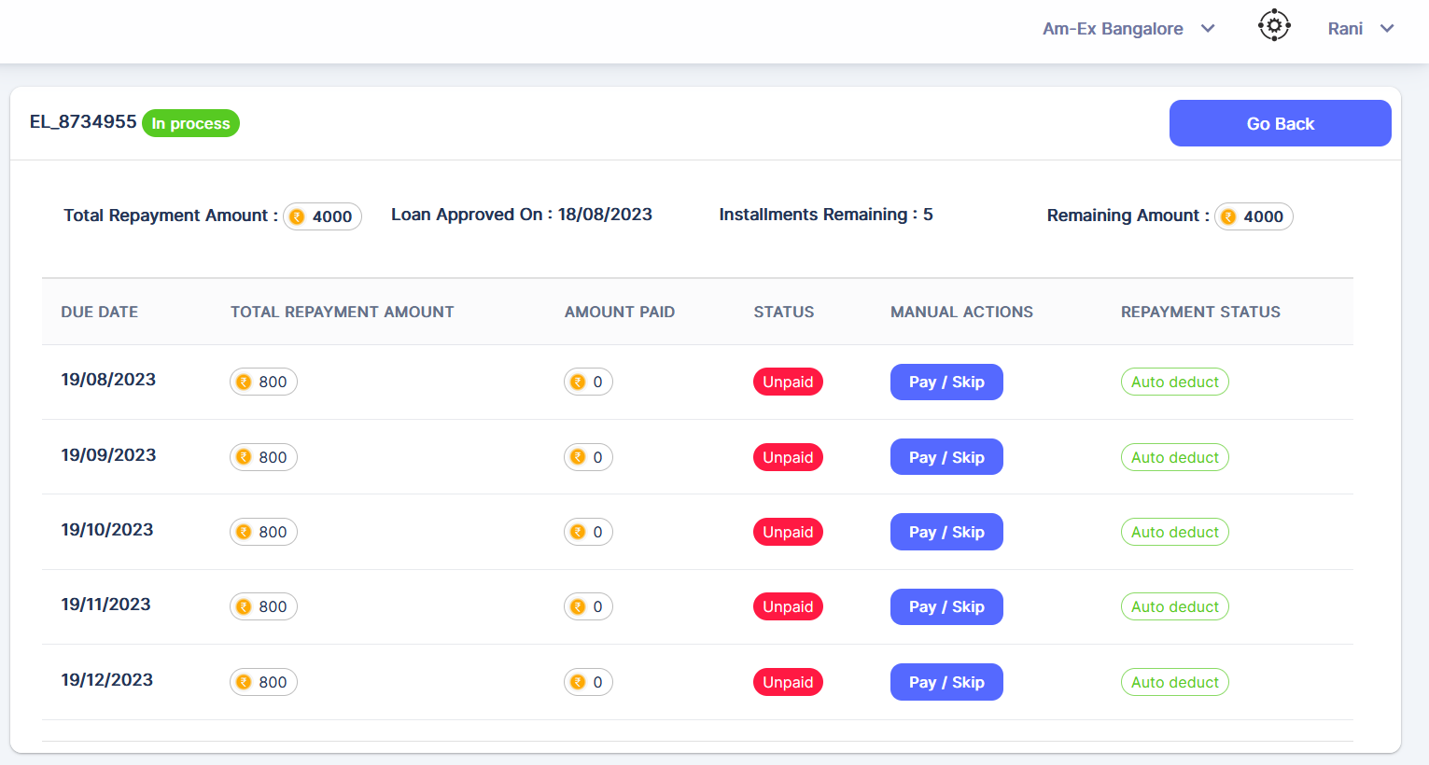

Click on Pay/Skip.

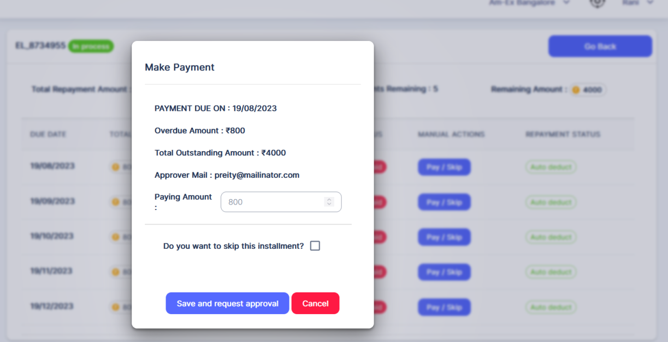

Click on Save & Request Approval.

The above screen is for Manual Payment Request per month. If you need to skip it, then click on the checkbox for skipping this installment.

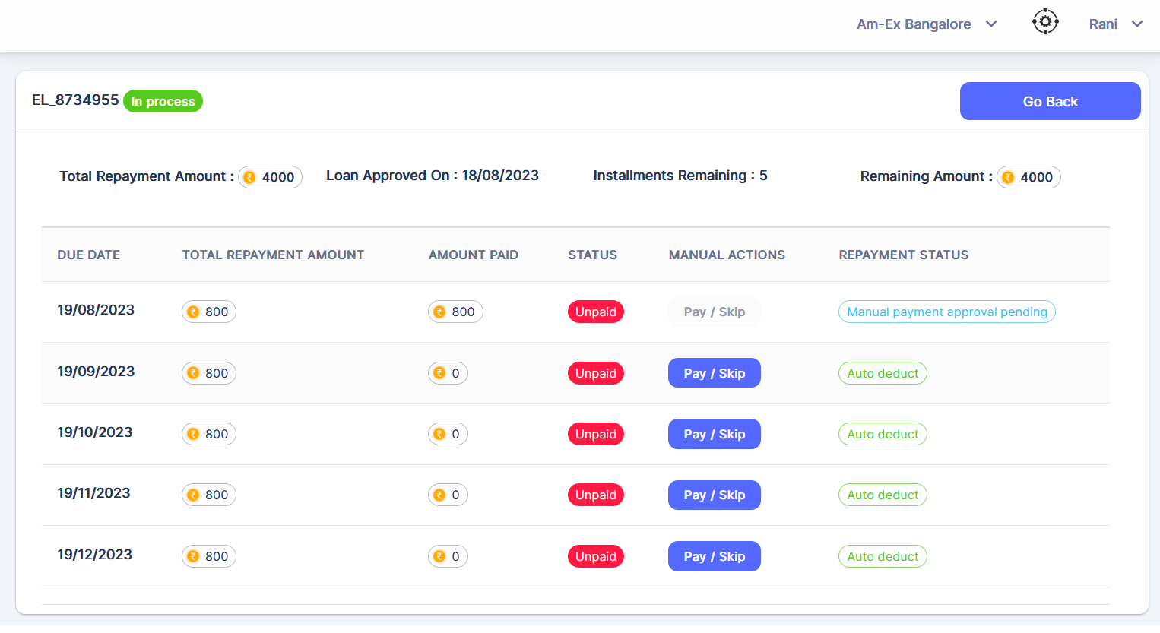

If it Skip, then refer the below screenshot.

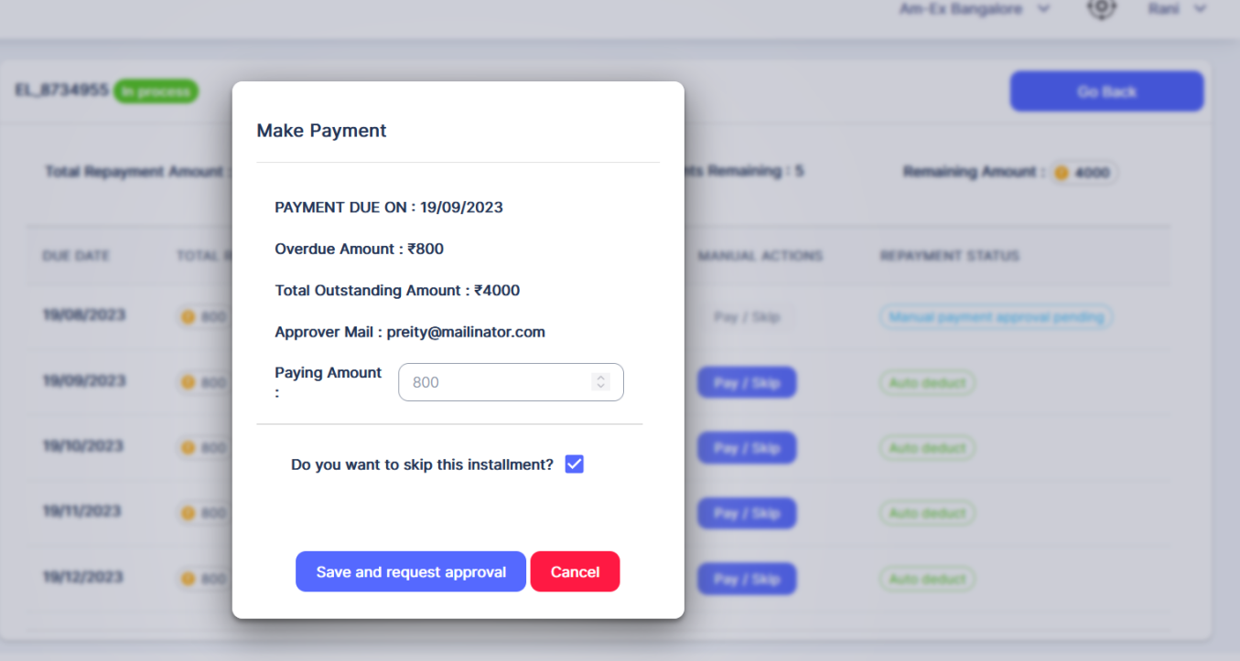

Click on Save & Request Approval.

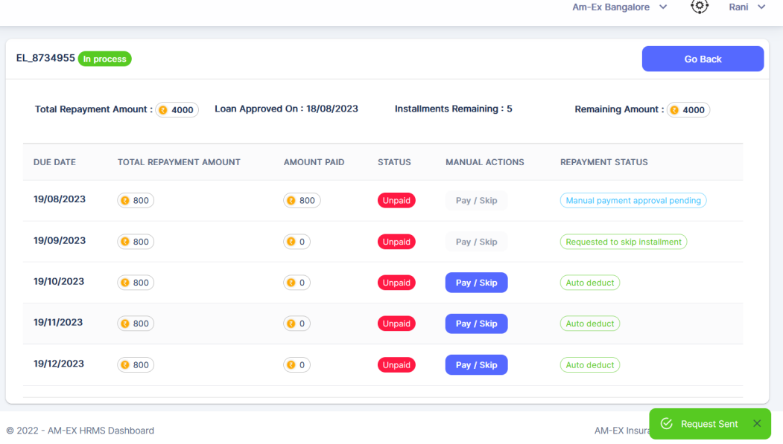

Once Employee has completed the Loan Procedures, then HR can Approve or Reject it.

Mail notification will be sent to the selected HR Manager. If any other HR Manager is present in the same branch then, he will also have access to these requests. But mail notification will not be there for him.

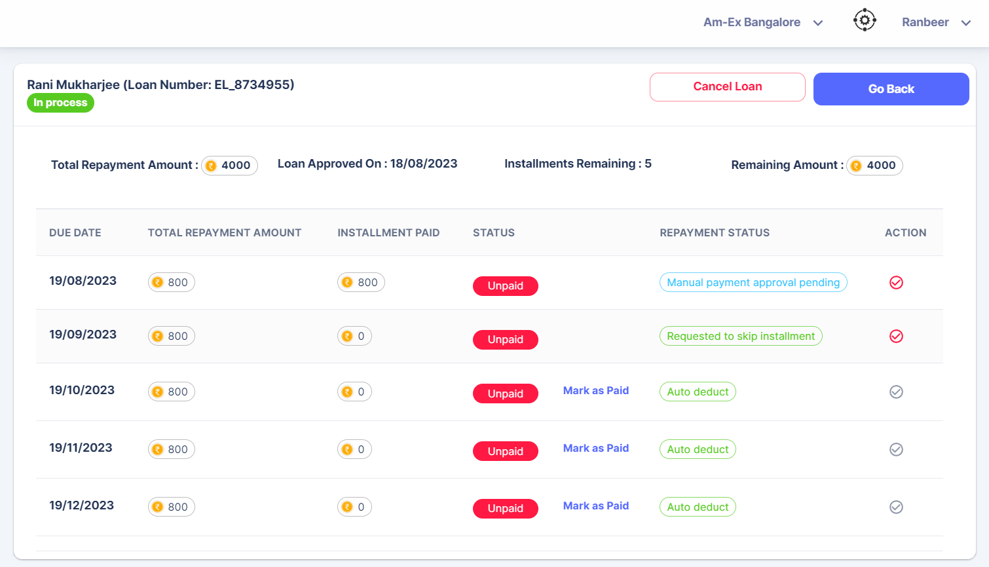

Click on the Approve/Reject Manual Payment.

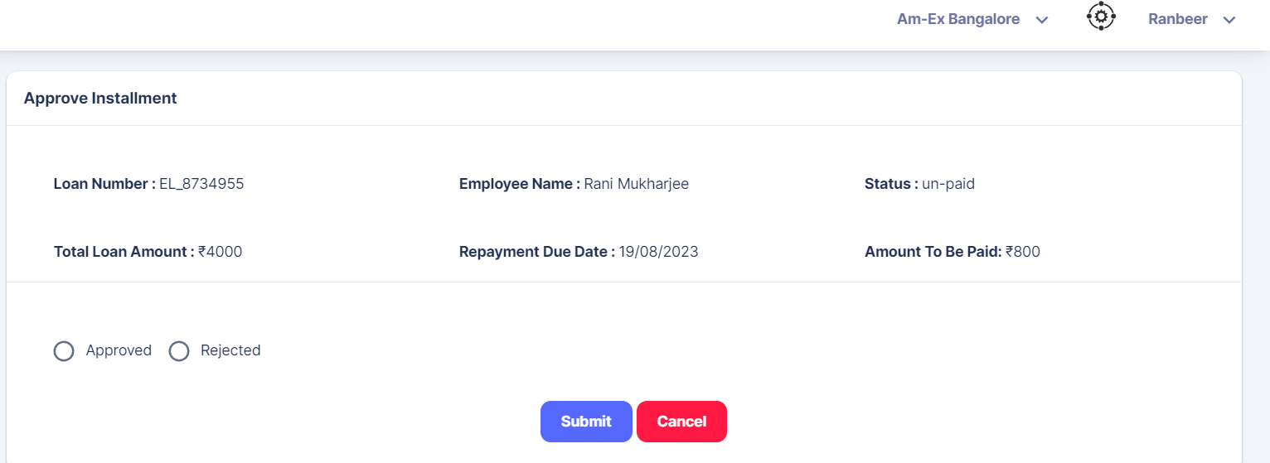

HR can either select Approve/Reject & then submit.

In the Actions, the count in the bell icon indicates, how many requests are there to be approved.

🡪**Loan Requests:**

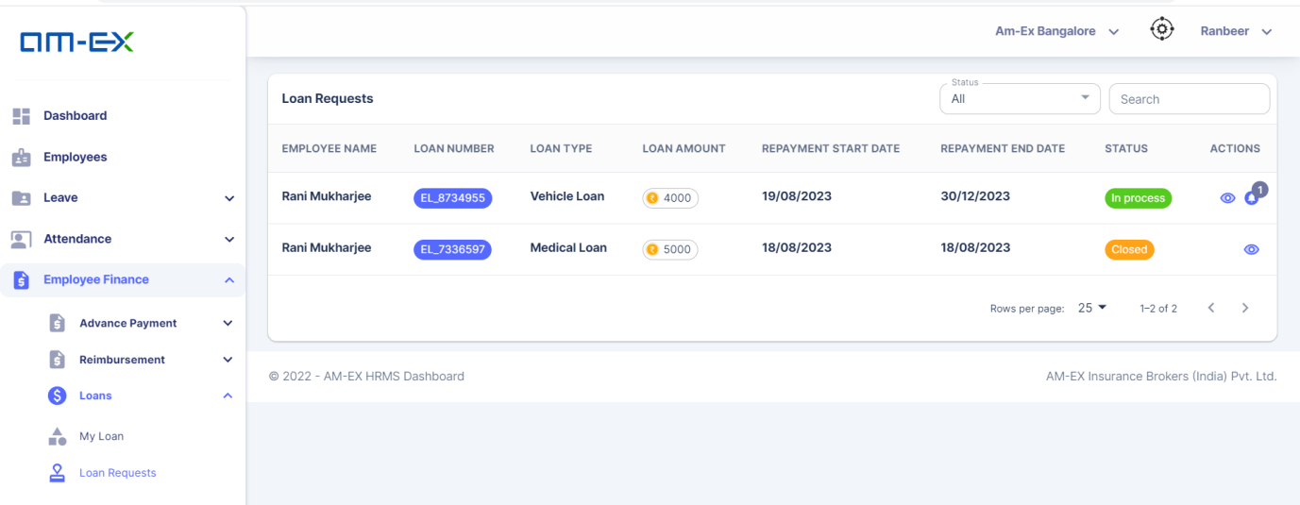

* + 1. **Employee Insurance**
* Here, new changes are covered in the Insurance Module.
* Employee Insurance is categorized into 2 : **GMC & GPA**

**GMC (Group Medical Coverage)**

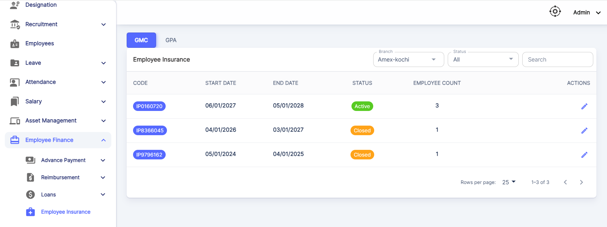

Note: If an insurance remains in Active status, then we cannot create another new Insurance for that particular branch. Once closed, the Insurance Renewal button will be enabled.

**GPA (Group Personal Accident)**

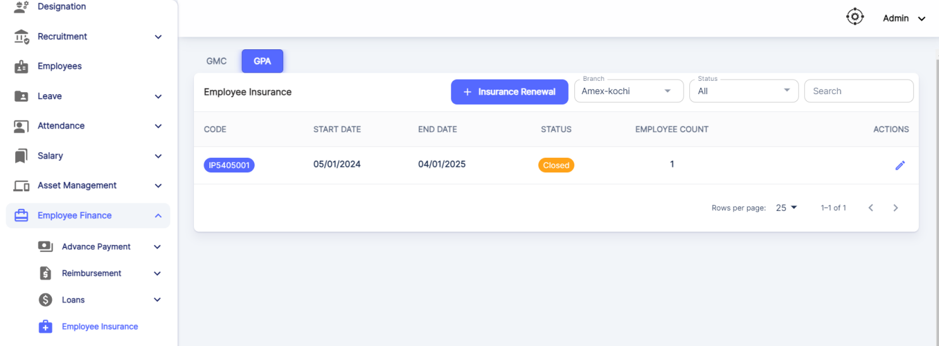

If we Create an Active Insurance, below screen appears for GPA:

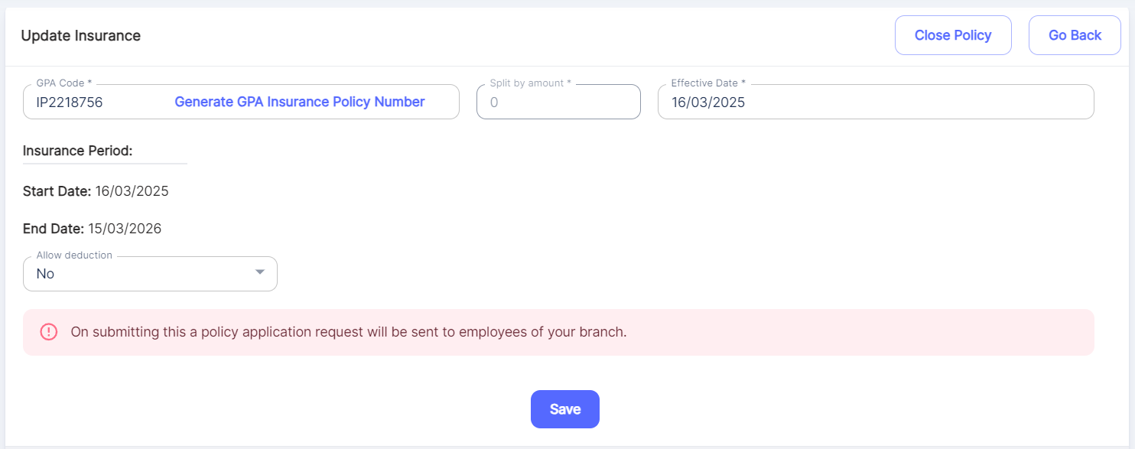

Deduction applicable only for GPA

Insurance can be created against a respective branch. Click on Create button:

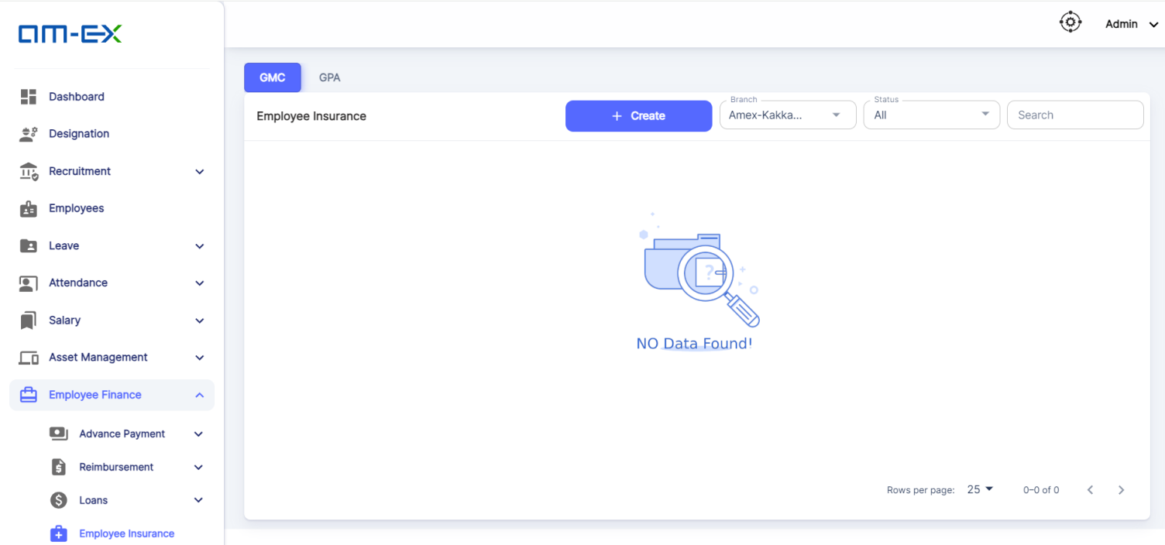

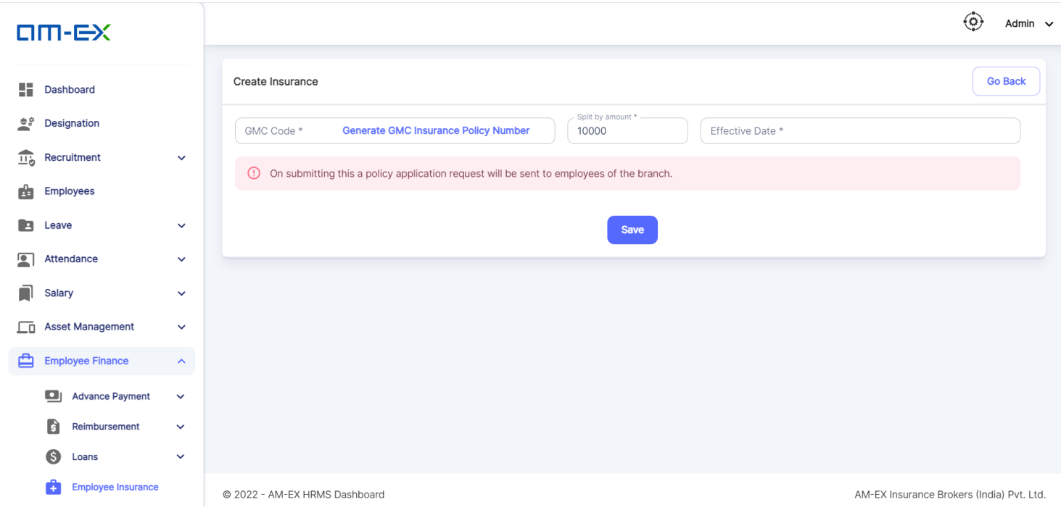

When details are filled in the above Create Insurance screen, the UI looks as shown below:

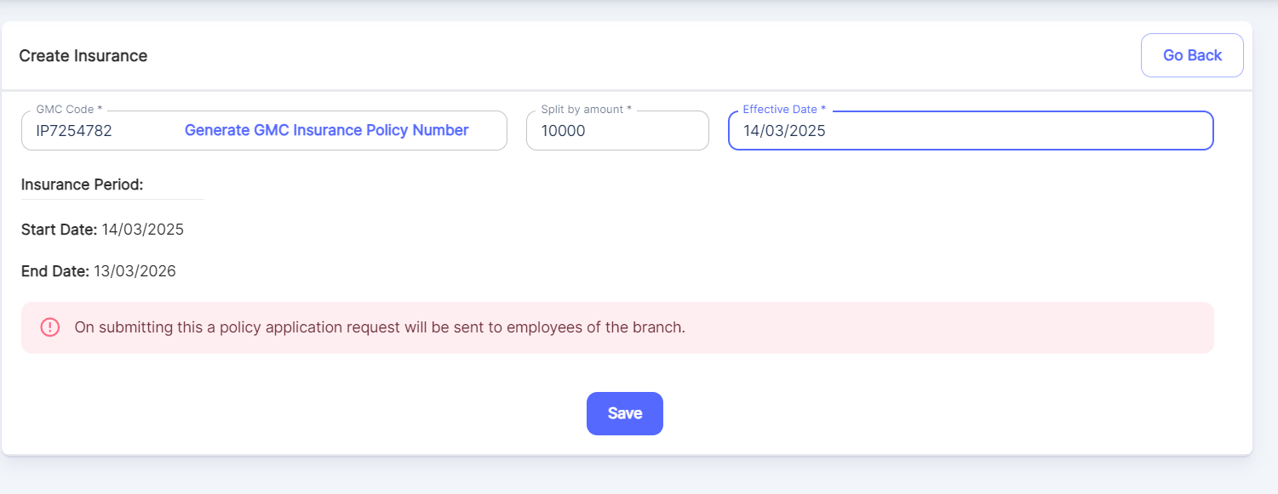

Once Saved, Insurance Policy will get added and details will be sent to the respective employees chosen.

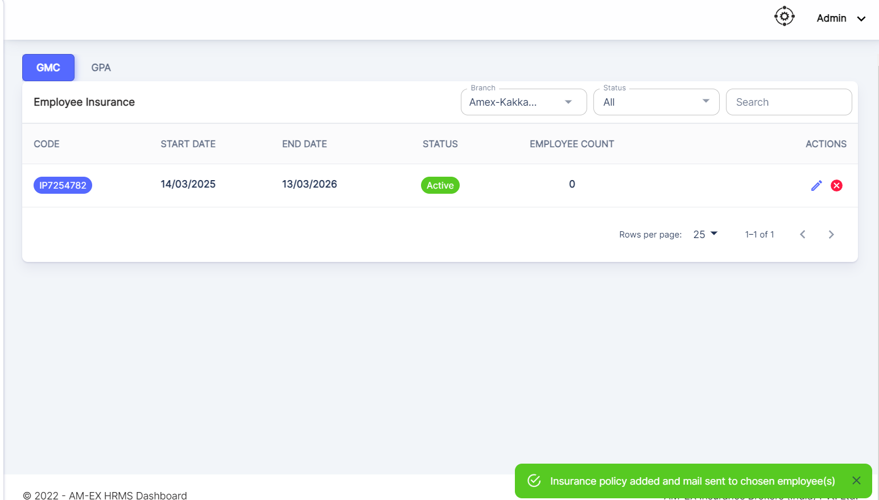

When Update Insurance is selected, there is an option to select the employees which needs to be added to this Insurance Policy

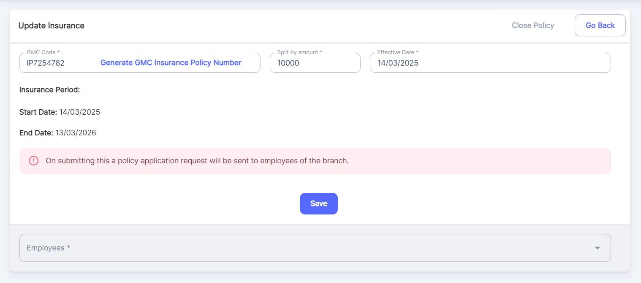

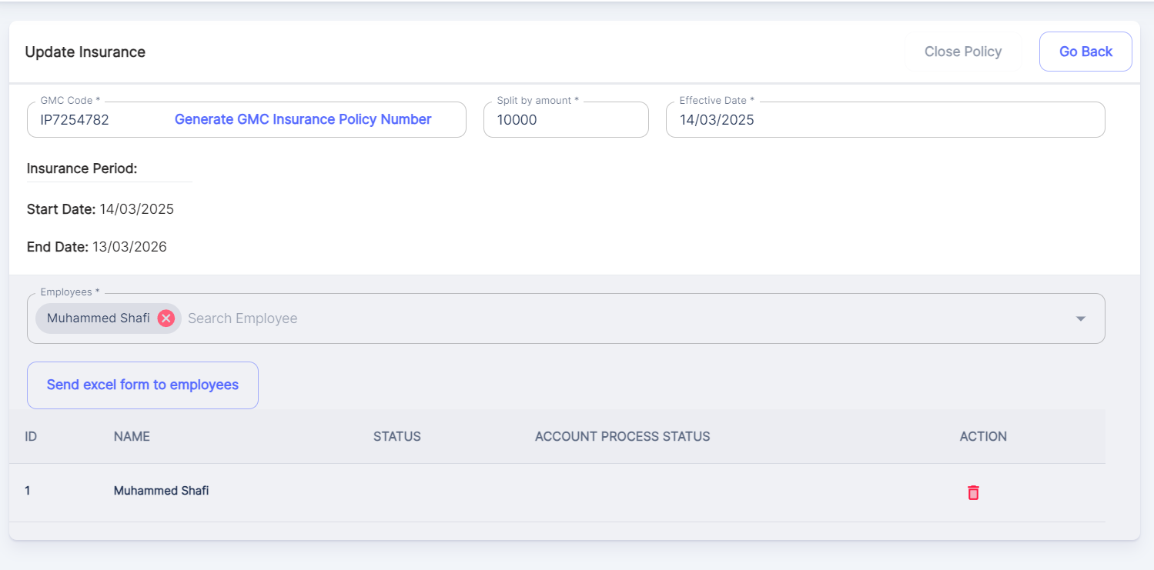

Also, there is a provision to send Excel form to employees regarding the Policy Application Request

Once Send Excel Form to Employees is selected, Mail will be sent to the Employee & in the Insurance list, employee count gets updated.

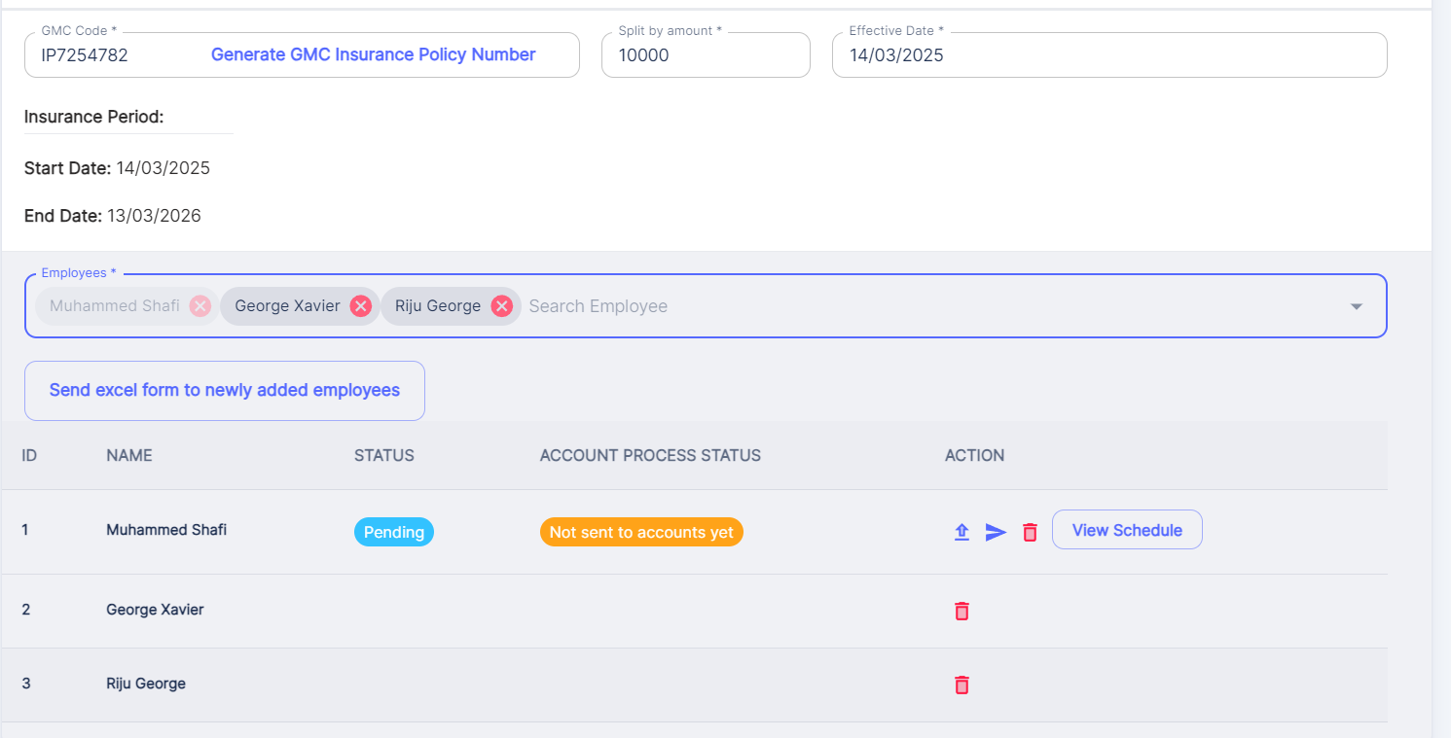

There is a provision to share Excel form to newly added employees as well as shown above.

Also, there are options to upload Insurance Form & Resend Insurance Form (in the Actions).

There is a format to Upload Insurance Form (Only Excel)

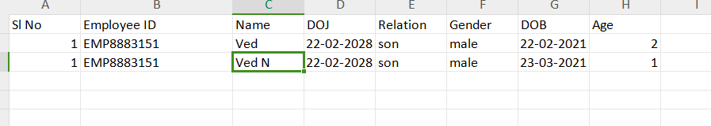

Once Insurance Form is uploaded for all employees as an excel, this will be the Preview of the uploaded details (only basic details will be shown in the preview).

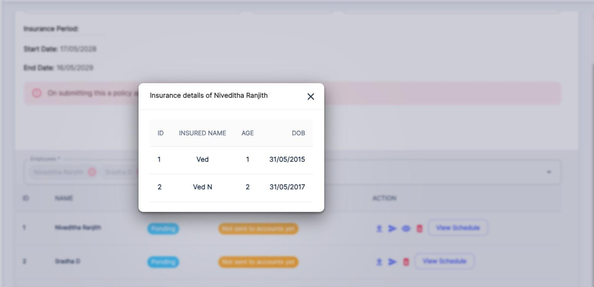

Post this action, HR can send Excel Data to Insurance Company

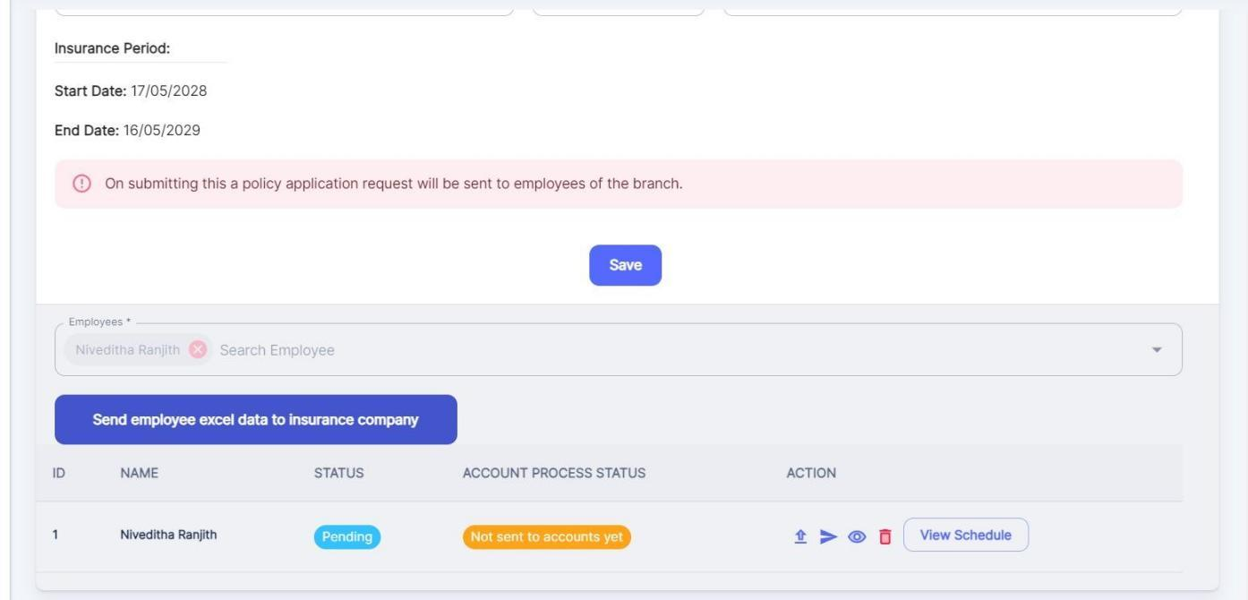

Also, there is a provision to Resend Excel Data to Insurance Company

The below screenshot shows how the email will be sent to Insurance Company:

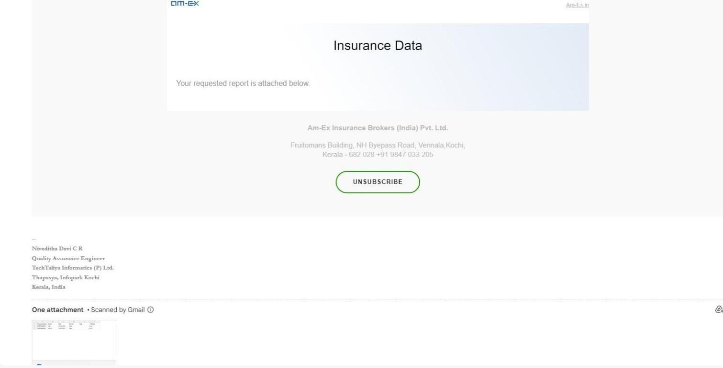

Once the details are shared to Insurance Company, and when HR clicks on Edit icon in the Employee Section of Insurance, the below screen appears for GMC:

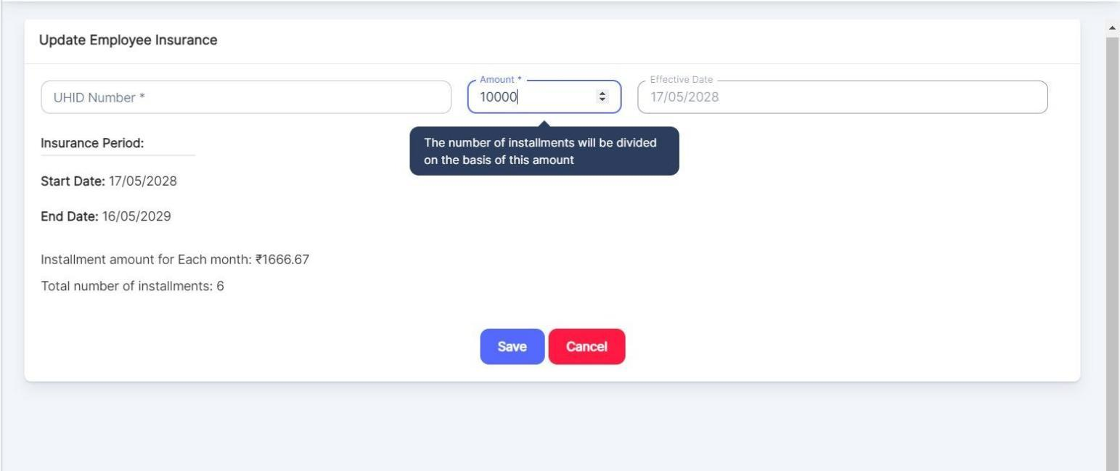

When View Schedule is selected, the below screen appears:

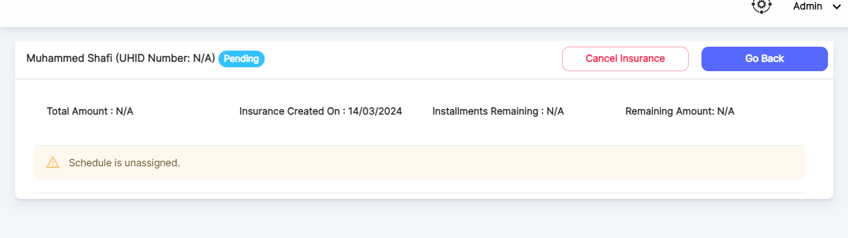

Also, there is a provision to Cancel Insurance.

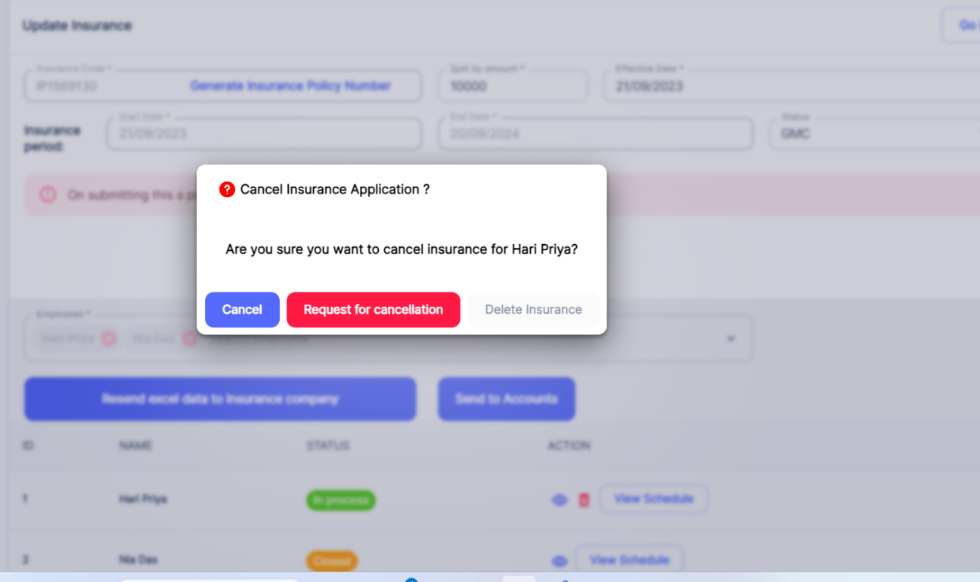

If an insurance is not started for the employee, then we can directly Delete an insurance if needed.

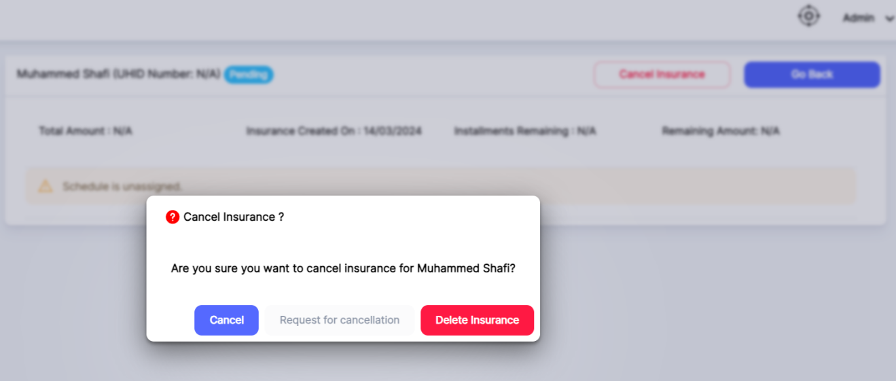

There is an option to **Close Policy** for a created Insurance Policy.

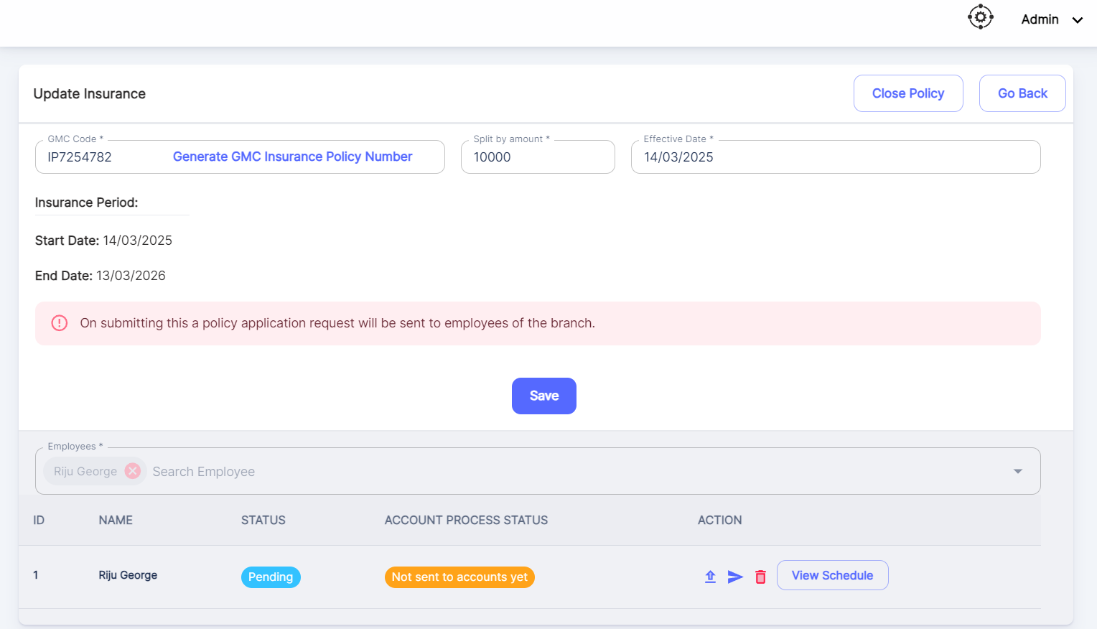

When Close Policy is selected, below message appears.

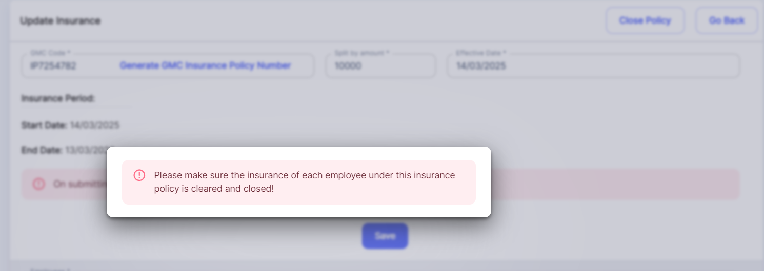

This pop up indicates that insurance installment is not completed for the selected employees against this policy. So, need to clear it first to close the policy. Once the Insurance form details are filled by the employee & is uploaded, then an Edit button is enabled.

At that time, HR can update the Policy Start Date & End Date with the Amount. Once these details are filled, then it will get updated to the View Schedule. Once the View Schedule is done, HR can Close Policy if needed.

In GPA Module, there is a checking of Salary deduction based on the Insurance Amount. By default, deduction is not applicable for GMC.

Salary deduction is not applicable for GMC.

If there is no Employee against an Insurance, then Close Policy is not possible. Cancel Insurance button will be enabled against this Insurance, if the employee count is ‘0’.

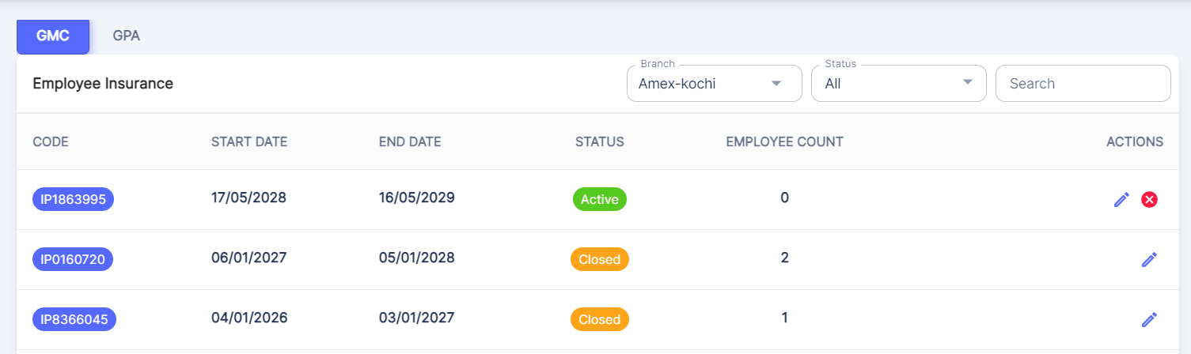

There is an option to Edit the Insurance details. Click on Edit & Then Resend Excel data to Insurance Company button will be enabled;

Once the button is selected, then mail will be sent to the Insurance Company!

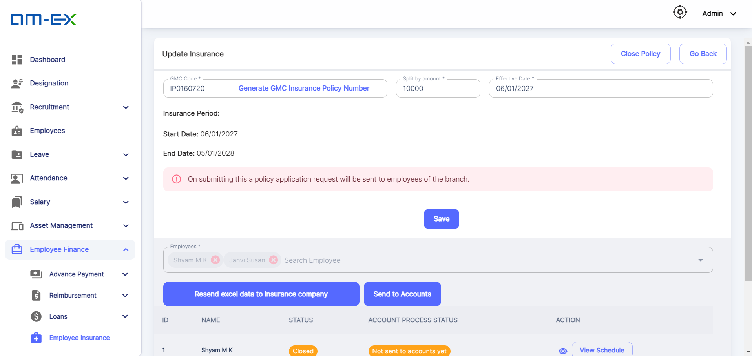

When View Schedule is selected:

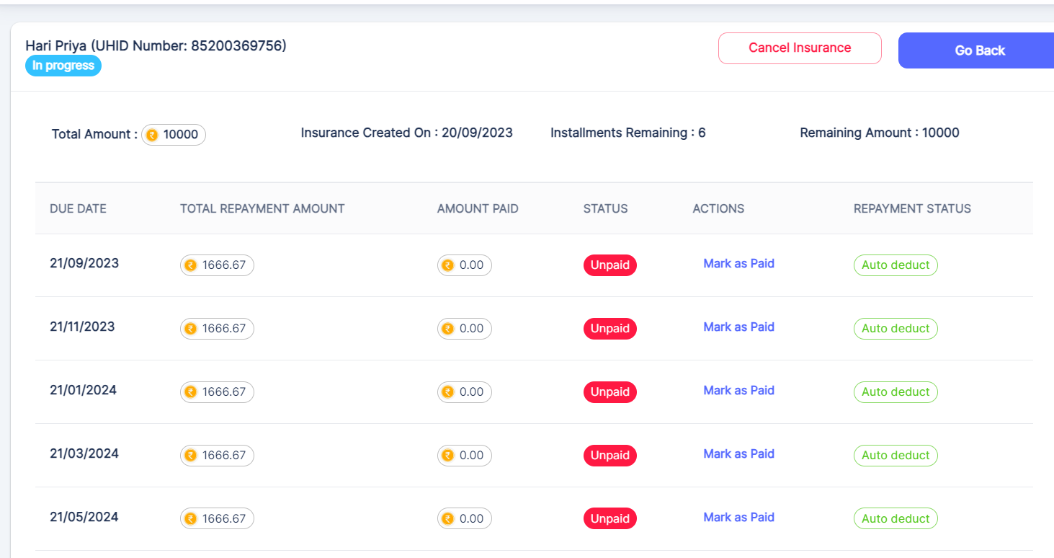

The Actions can be changed. Click on Mark as Paid ---> then below pop-up appears!

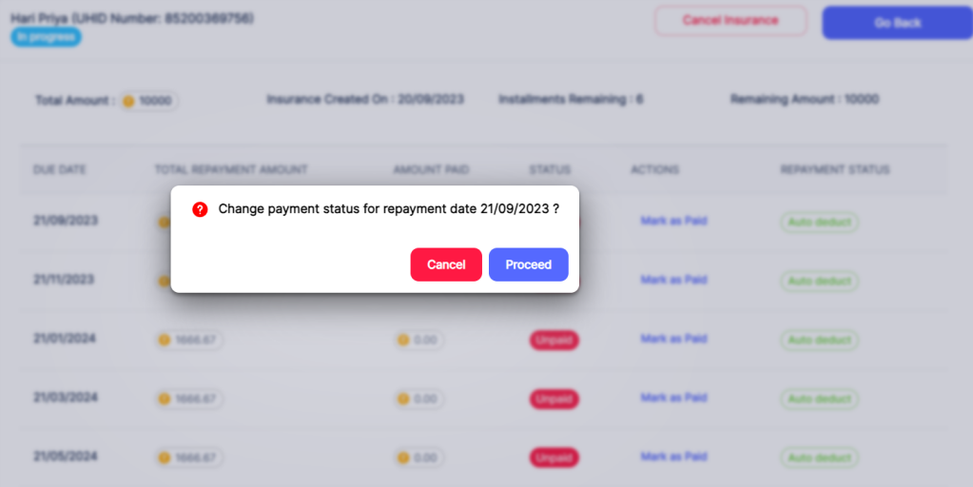

The status gets updated from Unpaid to Paid.

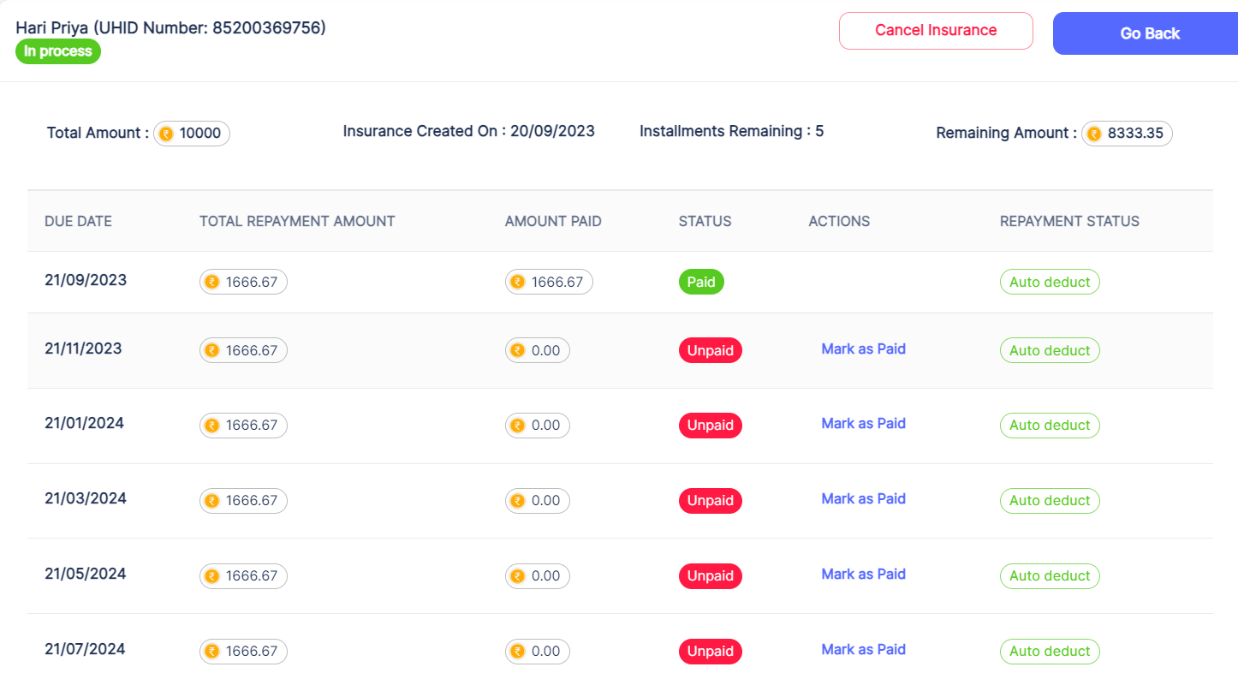

* 1. **Reports**

Reports are used in an organization as it is essential in providing relevant information, facilitating communication, support decision-making, monitoring progress & ensuring accountability & transparency within an organization.

In HRMS, two main reports are used:

* Candidate
* Employee

**3.10.1 Candidate**

Under Candidate, there are two types of reports:

* Candidate Report
* Education Report

**3.10.1.1 Candidate Report**

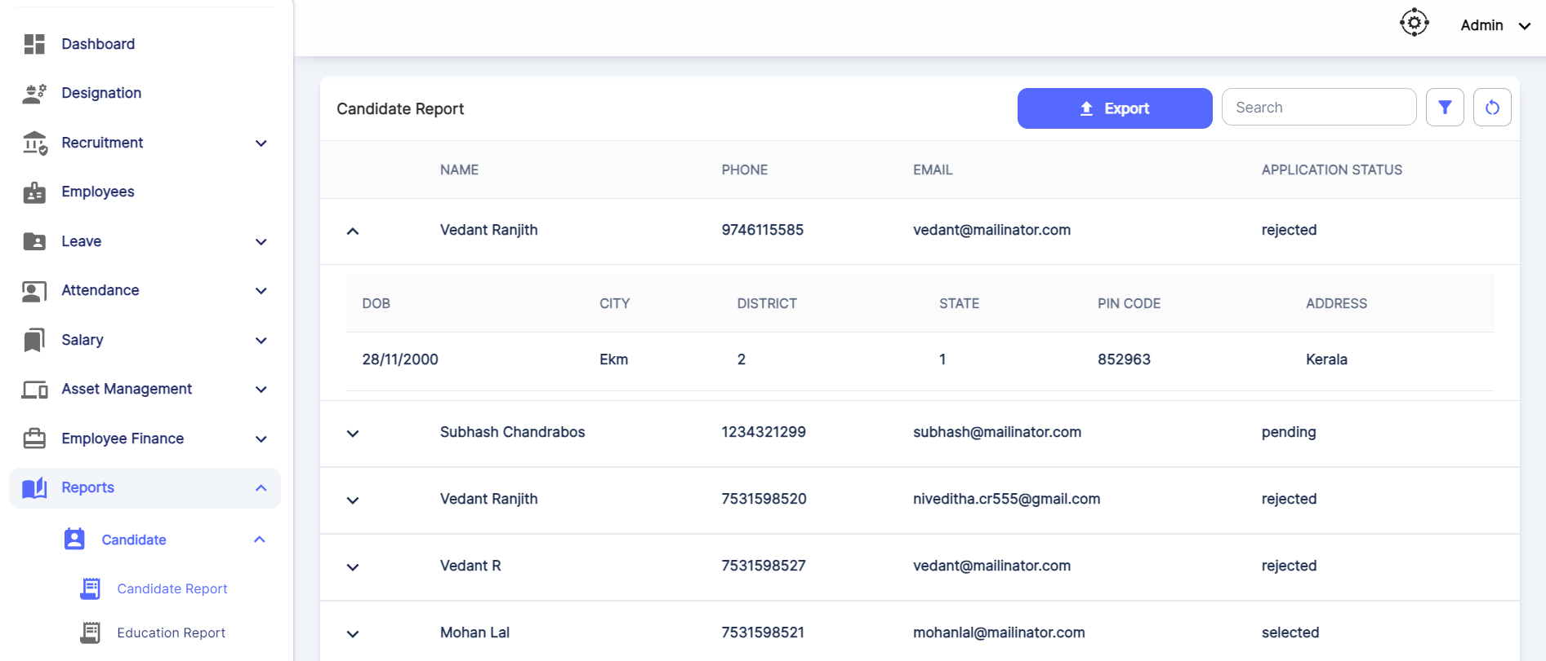

There is an option to Export Candidate Report either in CSV or PDF format.

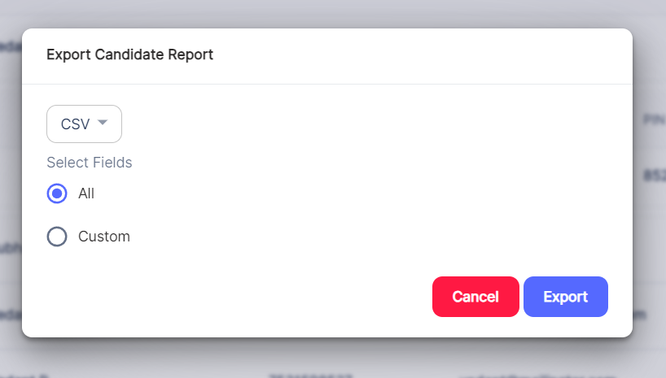

**3.10.1.2** **Education Report:**

In the Education Report, it gives the details of Course, Institute, Approving Organizations, Attended From & To, Score.

Also, we can filter the Reports based on:

Branch

Created By

Start Date

End Date

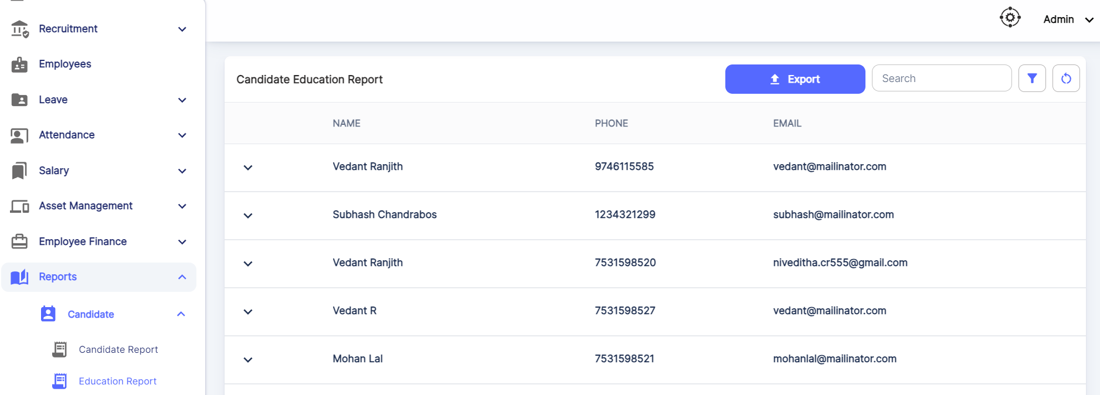

When details are expanded:

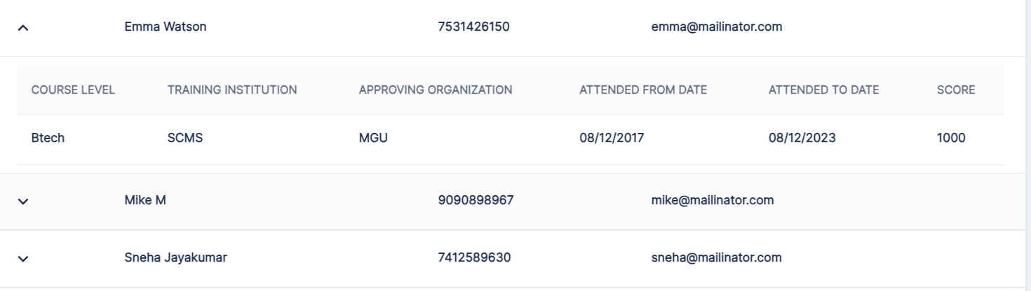

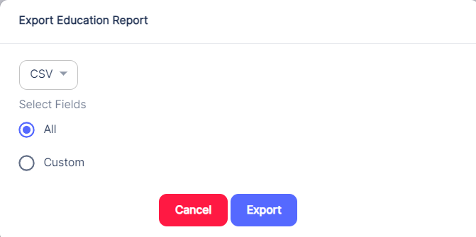

**3.10.2 Employee**

Under Employee, there are two types of reports:

* Employee Report
* Education Report

**3.10.2.1 Employee Report**

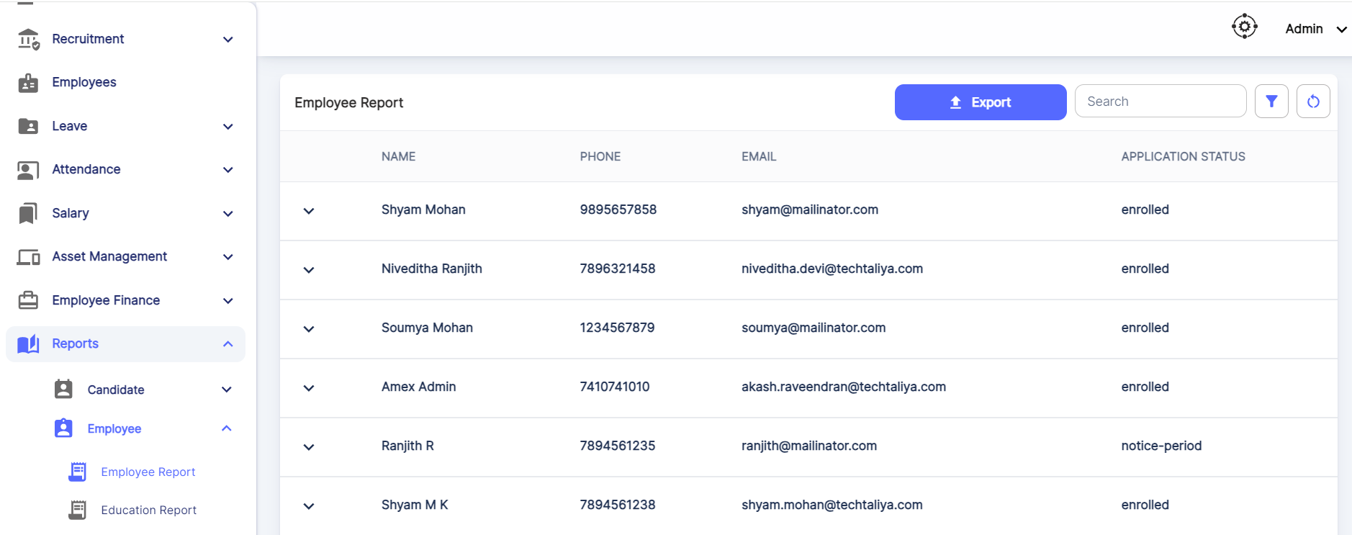

Upon expansion of the employee report, basic details of the employee will be visible.

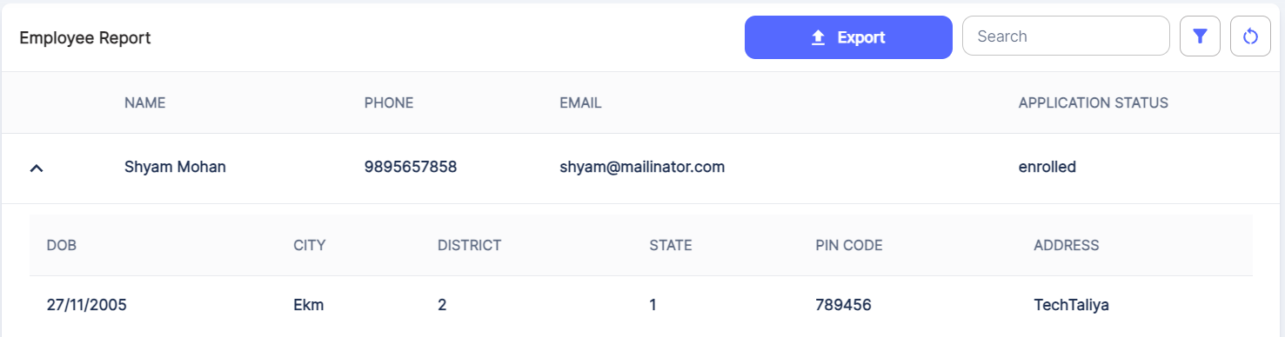

Also, there is a provision to Export the Employee Report as well.

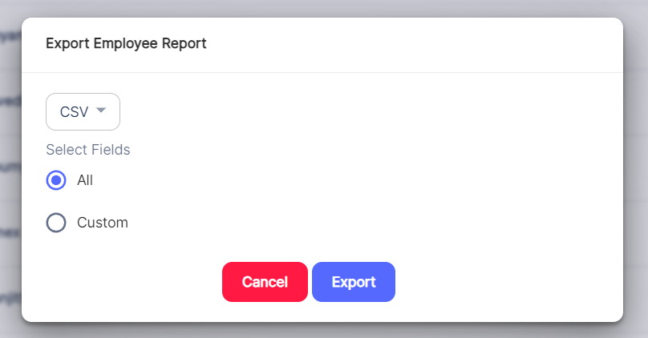

**3.10.2.2 Education Report**

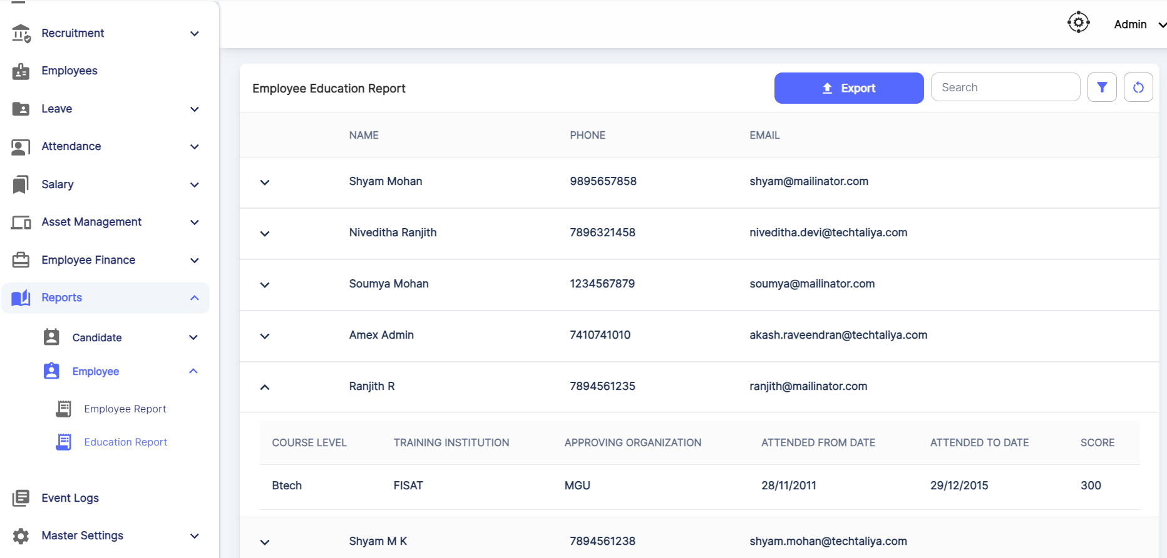

* 1. **Event Logs**

Event Logs help to know what all actions are done in each module.

Also, if any new fields are added, then a detailed view will be shown in expansion.

It will be visible to the person who has permission to view it.

Using Select Action, one can filter the event logs with the following options:

Add, Edit, List, View & Delete

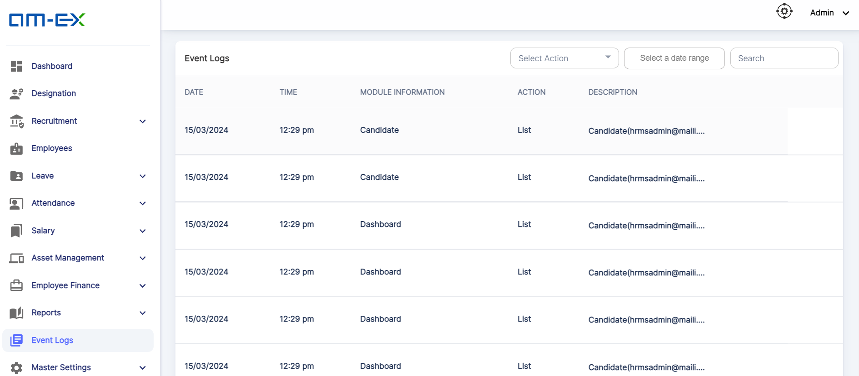

* 1. **Settings:**

Under Settings, there are 5 sub categories:

* Agency
* Extra Working Days
* Week Offs
* Payment Type
* Pay Schedule

For an Employee, only Extra Working Days will be visible.

**🡪Agency:**

Under agency, HR or the user with permission can add the respective agency details from which employees are provided.

Also, there is a provision to refer an employee as well using the Referral Link

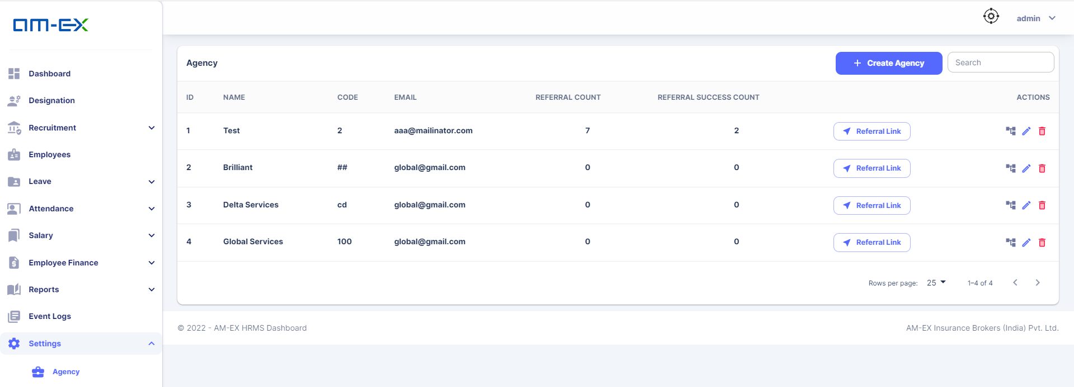

Click on Create Agency.

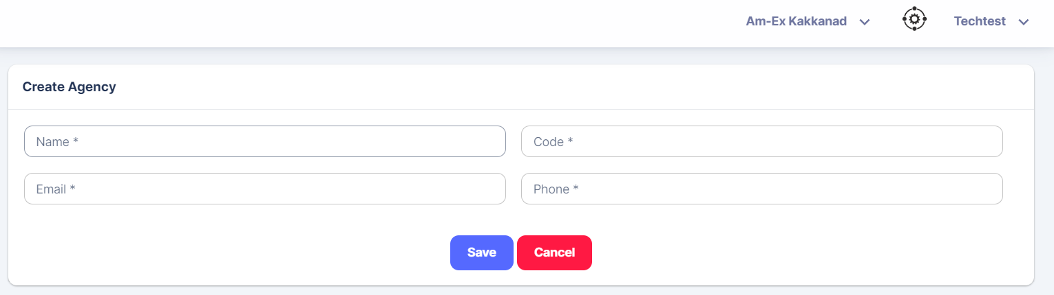



When Referral Link is selected, the below pop up appears. The user can copy the link & paste it in a browser.

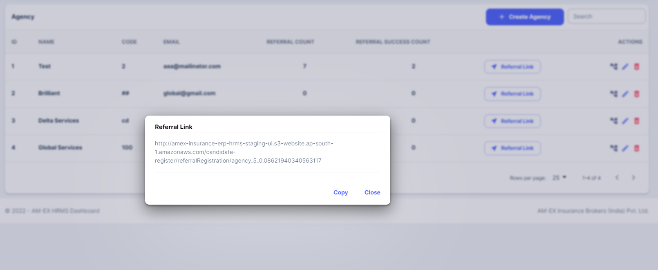

Once the link is opened in the browser, candidate registration can be done.

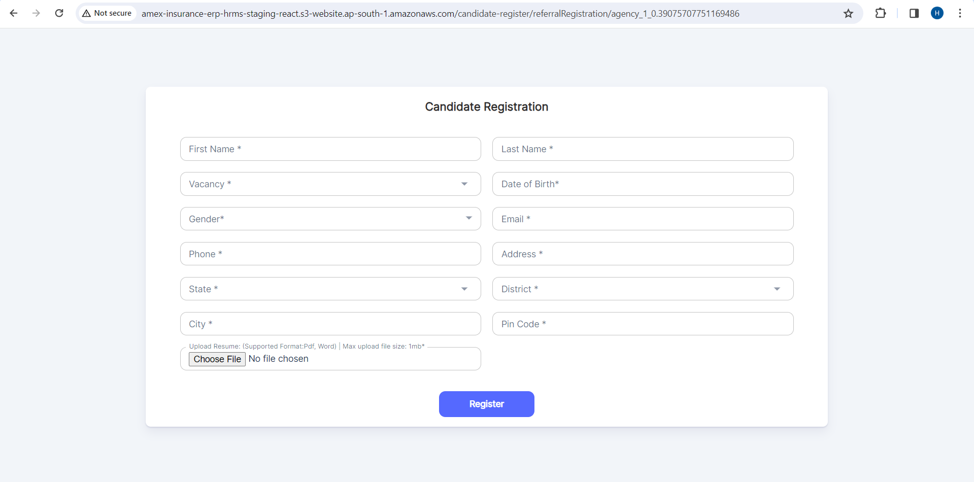

**🡪Extra Working Days:**

If any extra working days are needed to be added for an employee, then Click on Add a working day. It can be done for an employee against a Branch.

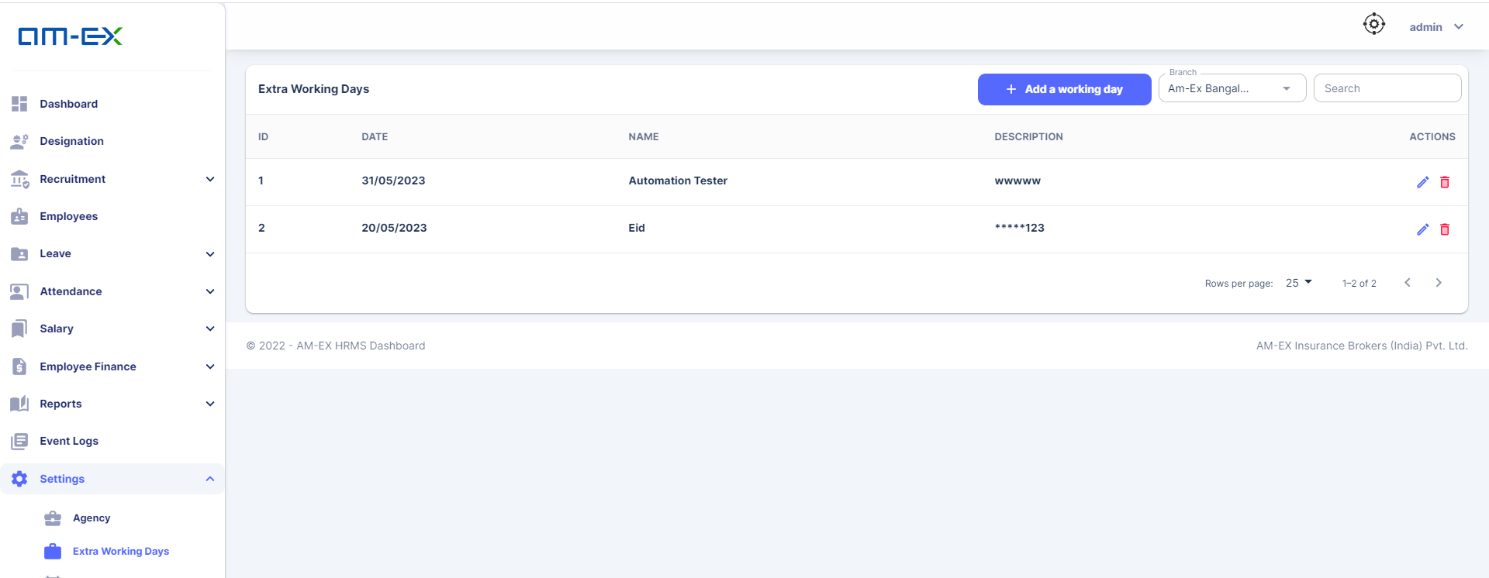

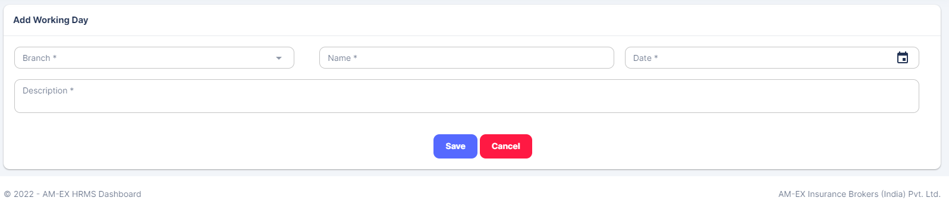

**🡪Week Offs:**

Using this feature, off days can be planned. HR or User with permission can select the off days from the list & can save it for each Branch.

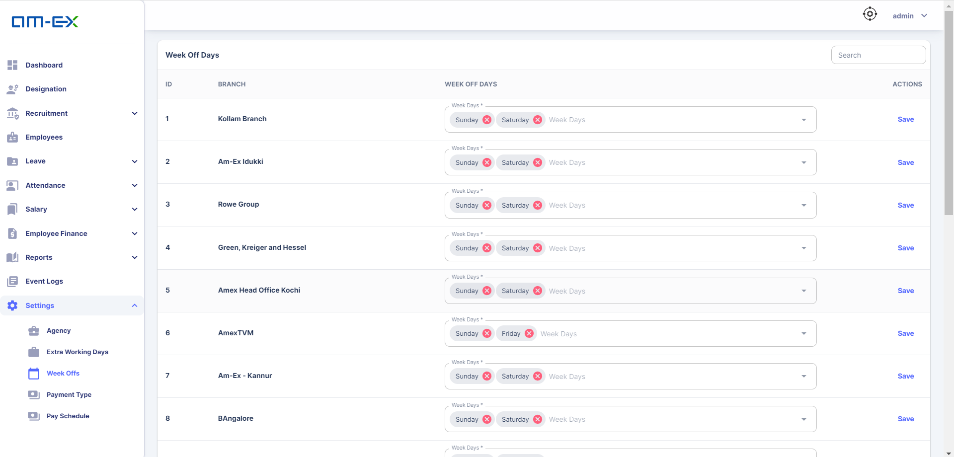

**🡪Payment Type:**

Payment type for employees in an organization can be of 2 types:

Advance Payment & Reimbursement

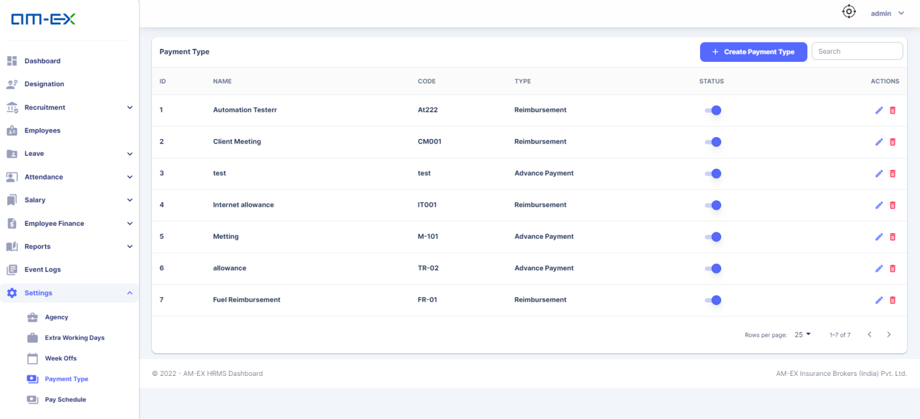

Click on Create Payment Type.

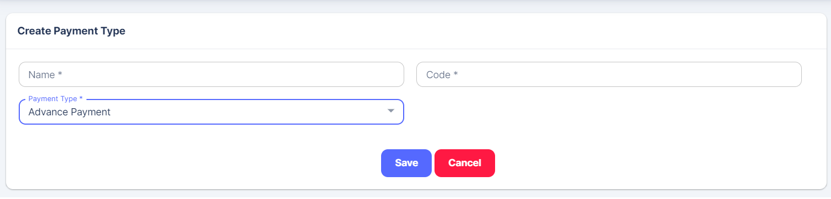

**🡪Pay Schedule:**

In Pay Schedule, HR can plan for the payroll activities. There is a provision to select the payroll date, at what time should the salary be credited & how monthly salary should be calculated.

Pay Schedule is created on the basis of branch.

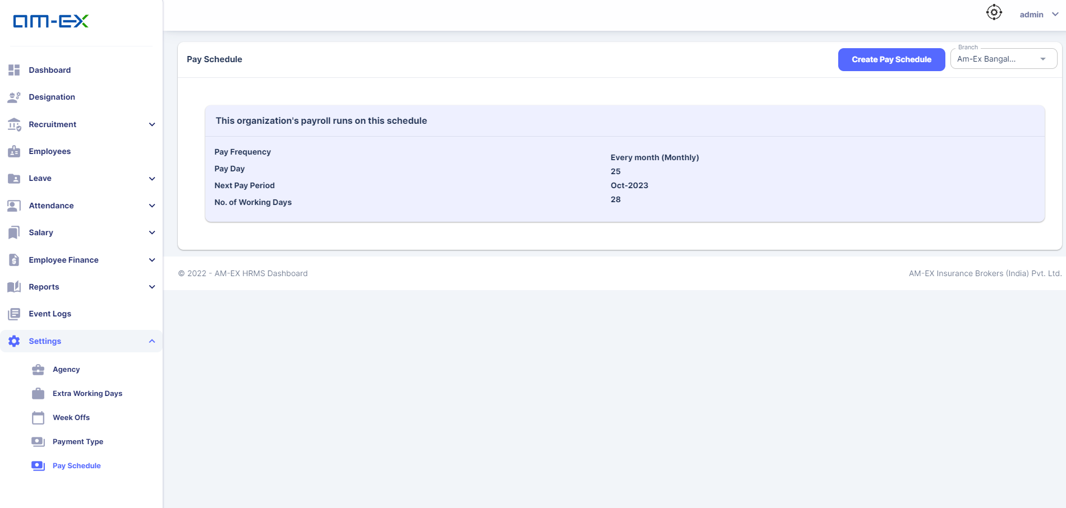

Click on Create Pay Schedule

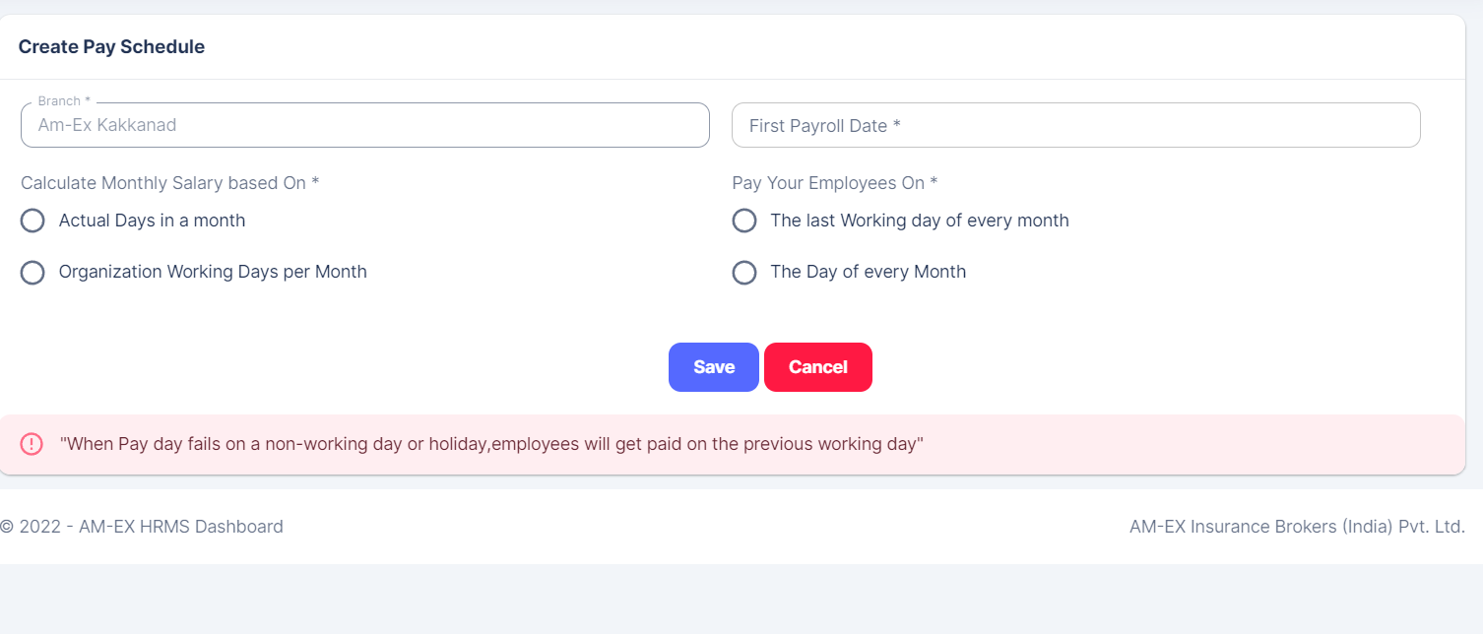

Click on Save. Details will get updated.

With the modules explained above, HRMS Module is completed.

* 1. **Accounts**

# **4.1.0 Project Overview**

This project is intended to create a cloud-based application to manage the accounting module of a company.

# **4.2.0 Project Scope**

AMS focuses on implementing Accounts management processes such as Account Heads, Transactions, Pay Outs, Assets, Expenses etc. Here we follow a double-entry system for accounting. AMS also provides basic financial statements like P&L, Trial Balance, Balance Sheet etc. Users can generate an invoice and make pay-outs against the created invoice; users will be able to list the invoice based on the status like fully paid and partially paid.

# **4.3.0 Project Architecture**

The serverless architecture will be followed in this project. Entire application will be designed as a monolith where each module can be split as a Microservice, each having its own assets and storage when there is a need with minimum coding effort. The application will run as AWS Lambda functions. Databases will be implemented either in RDS. All other assets will be stored in S3.

A headless approach is followed for UI development and ReactJS will be used for Web applications and React Native for Mobile applications.

AWS CI/CD pipeline will be used for deployment and AWS Code Commit will be used for source code versioning.

# **4.4.0 Project Audience**

This project is an application for accounts management. Expected audiences are

Accounts and Finance Department

Sales Department

Operations Department

# **4.5.0 Project Features**

One of the major functions in AMS projects is managing Account Heads and Posting Transactions.

The different processes involved in AMS are

1. Creating Account Heads
2. Posting Entries (Recording transactions)
3. Tax settings
4. Tax period settings
5. Generate Invoice
6. Insurance company issued incentives entry (Rewards)
7. Credit note
8. Cost centre management
9. Generating Reports – Ledger, TB, P&L, BS
10. Year-end process

## **4.6.0 Accounts Management**

This module is used for managing all accounts processes in an efficient manner. Accounts Management feature provides all the functionalities required to handle various processes related to accounts. Users can create accounts under the AMS provided primary accounts.



### **4.6.1 Account Heads (Accounts)**

As we are implementing the double entry system for accounting, a transaction must have two accounts in a single entry. These accounts can be managed in this module, to create an account user must need to select a primary account provided in the AMS to generate the same under that primary account. AMS will allow the users to edit or delete the accounts generated early, please note if an account is already applied as part of a transaction; it can’t be removed directly without deleting the transaction entry it is affected.

***AMC Primary account list is given below***

| **Sl No** | **Group Name** |
| --- | --- |
| 1 | Bank Account |
| 2 | Capital A/c |
| 3 | Cash in Hand |
| 4 | Current Assets |
| 5 | Current Liabilities |
| 6 | Deposit Account Asset |
| 7 | Direct Expenses |
| 8 | Direct Incomes |
| 9 | Duties and Taxes |
| 10 | Fixed Assets |
| 11 | Indirect Expenses |
| 12 | Indirect Income |
| 13 | Investments |
| 14 | Loans and Advances (Assets) |
| 15 | Loans Liabilities |
| 16 | Misc. Expense (Asset) |
| 17 | Provisions |
| 18 | Purchase Accounts |
| 19 | Reserve & Surplus |
| 20 | Retained Earring |
| 21 | Sales Account |
| 22 | Secured Loan |
| 23 | Stock-in-hand |
| 24 | Sundry Creditor |
| 25 | Sundry Debtors |
| 26 | Suspense A/c |
| 27 | Unsecured Loan |

## **4.7.0 Posting Transactions**

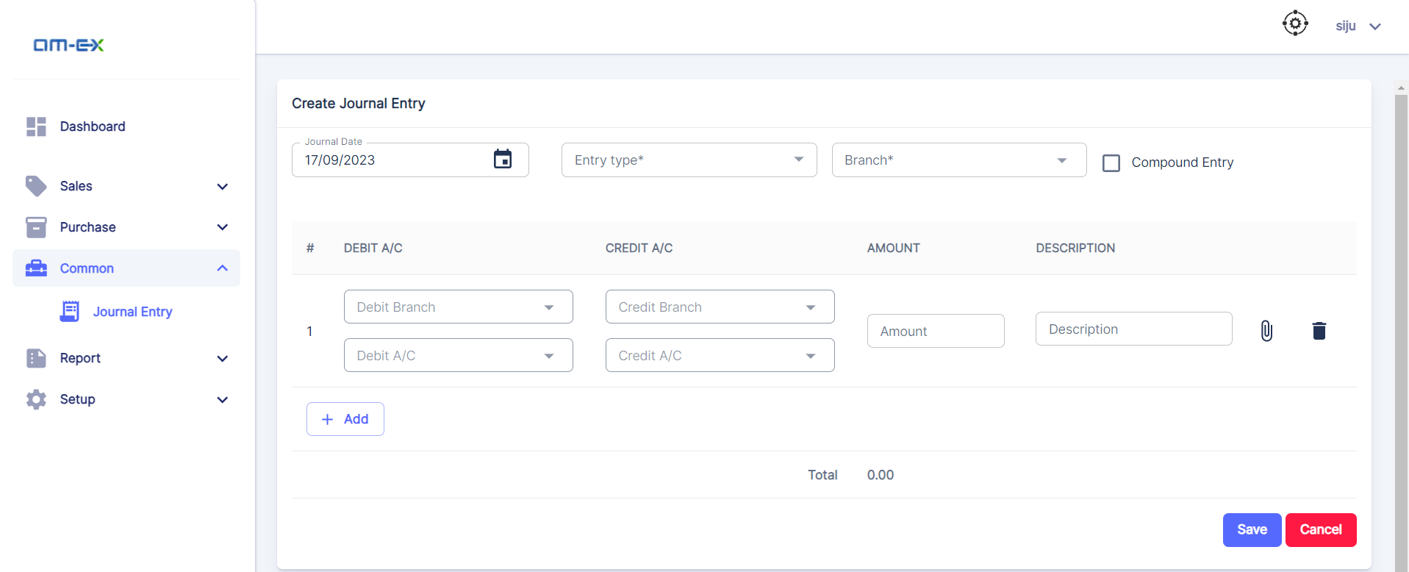

### **4.7.1 Entry Type**

Entry type is the type of transaction the user is trying to post. This list will be provided by the AMS as a drop-down list, from which the user can select the type before proceeding with the transactions. Supported entry types are as follows

1. ~~Sales~~
2. Purchase
3. Payment
4. Receipt
5. Contra (Bank / Cash)
6. Journal (Payable / receivable) (Adjustment)
7. ~~Credit Note~~
8. Debit Note

### **4.7.2 Date**

User need to select the date of transaction to record an entry in AMC

### **4.7.3 Transaction Number**

Transaction number is an automated number generated by AMC. User can use this number for the future reference. Multiple entries of similar type can be posted from a single screen.

### **4.7.4 Compound Entry**

Compound entry helps to enter a transaction with single debit and multiple credits or with single credit and multiple debits entries. This can be selected with the given checkbox.

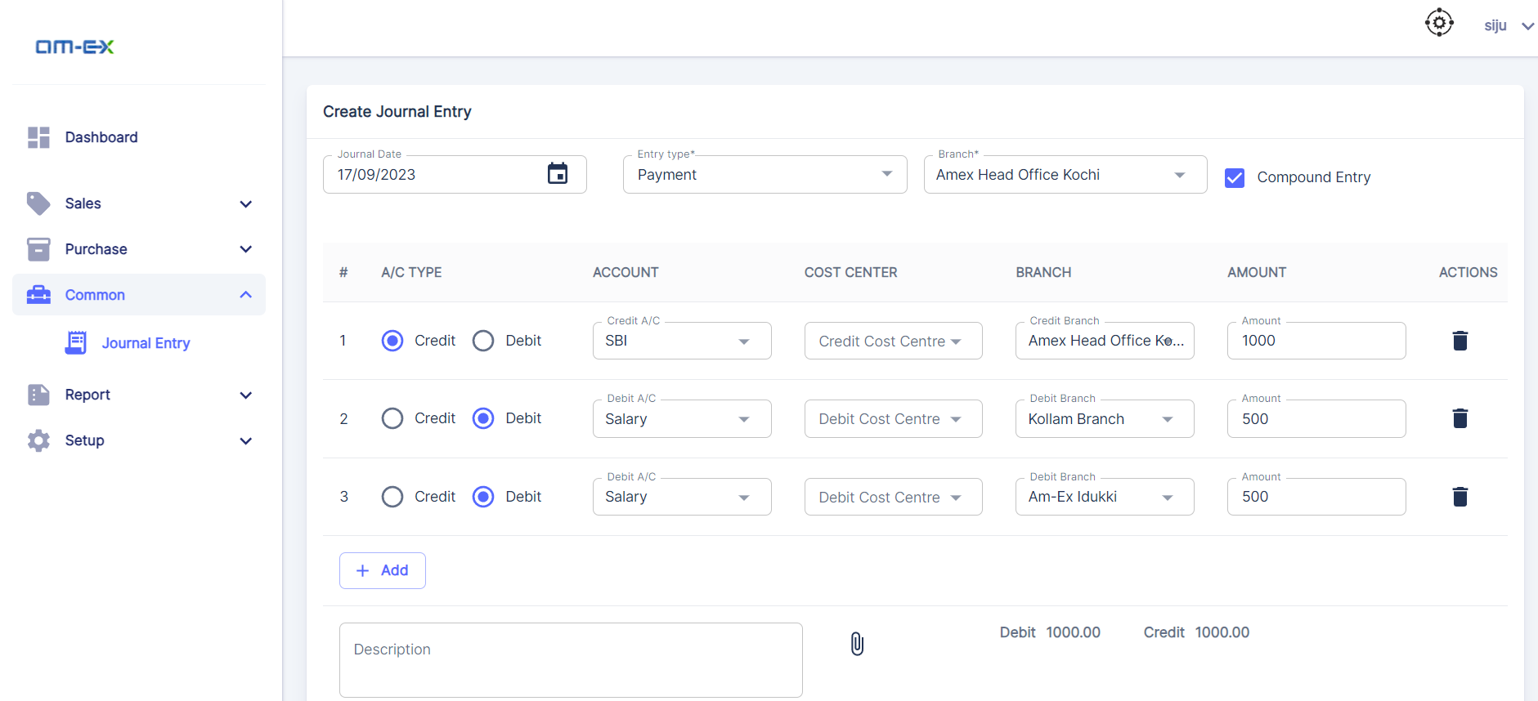

## As per our last discussion we are requested to include the branch dropdown for each Dr and Cr accounts, in this way we can resolve the inter branch transactions entries.

## **4.8.0 Tax Settings**

Users are free to create any number of tax slabs as they require. A tax slab may consist of one or more tax account heads with a percentage value.

### **4.8.1 Tax Slab**

A tax slab consists of one or more tax heads with a percentage value for each. Tax slab name can be any meaningful word to understand the purpose of the tax slab.

**Ex-** *GST 18%*

### **4.8.2 Tax Accounts**

A tax account can be created from the AMS with a name and percentage value. Once you create a tax head which can be reused as part of another tax slab.

**Ex-** S*GST 9%*



## **4.9.0 Tax Period Settings**

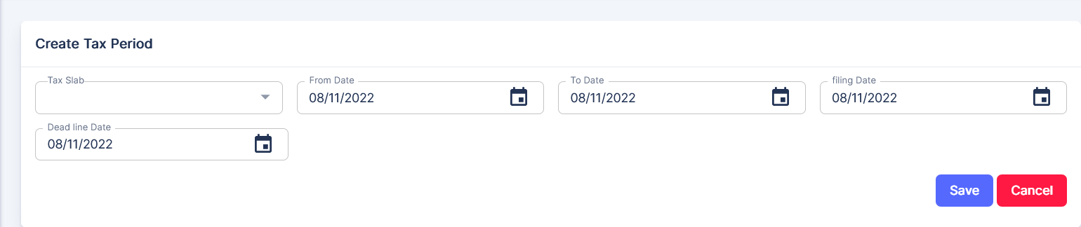

Tax period settings helps the users to set up a specific tax slab for the given period of dates. The relevant tax is calculated and will be applied automatically when the user applies tax against an invoice (Please refer section 5.0 for more details).

## **5.0.0 Generate Commission (Invoice)**

The user can create GST bills against the customer (insurance companies) for commission receivable and record the payment receipt against them in whole or in part. Policy related information is fetched from the admin side, so here we will receive the calculated brokerage value as well. E-invoice API integration will also be implemented on this module to embed the QR code in the invoice report.

Steps to create a commission -

1. Click on the Create Commission Button under the Invoice menu of accounts module
2. After selecting the commission date from the calendar, mention the period by selecting the date fields like From Date, To Date and Due Date to display the policies. Here the default due date will be displayed by adding 15 days to the commission date, if needed users can change the due date.
3. Select the name, business and billing branch of the Insurance company and Amex from the drop-down list. Here multi selection with all option is available for the business branch.
4. All unbilled policies will be listed down from which the user is able to make multi selections by clicking on the checkbox.
5. Selected policies will be added as invoice items and based on the tax period settings and by comparing the billing branches of both parties; a tax amount will be applied to the total invoice amount
6. Click on the Save button to finally create the invoice.

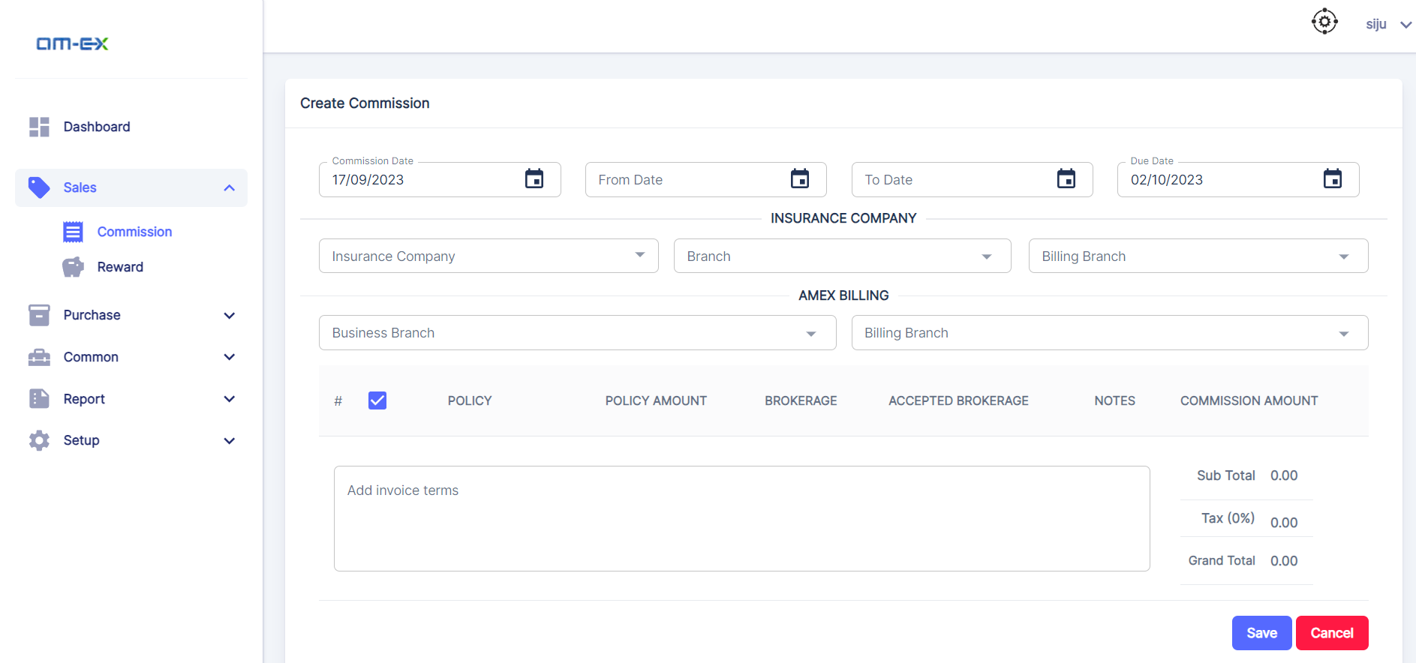

As per the last discussion we agreed to include the business and billing branch in the invoicing screen. Based on the GSTN we can decide the tax slab. Business branch dropdown allows you to select the multiple branches while the billing branch dropdown only allows the single selection.

**Invoice Listing screen:**

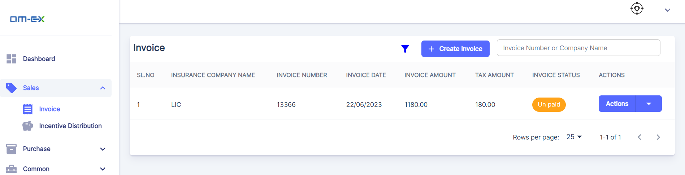

Once the user generates a tax invoice, they can post the payments from the invoice listing page. The amount will be posted against the invoice and the same will be posted internally against invoice items. Payment posting will be done as per the order of occurrence in the policy list. Invoice / Policy item has multiple status like Unpaid, Fully-paid, Partially-paid, and cancelled. Filters are also available to extract the type of list as per the status. An invoice can be cancelled until any payment is posted against it and the cancellation is done by selecting the Cancel option from the Actions dropdown.

Note: AMS will post a commission receivable JE as part of this process

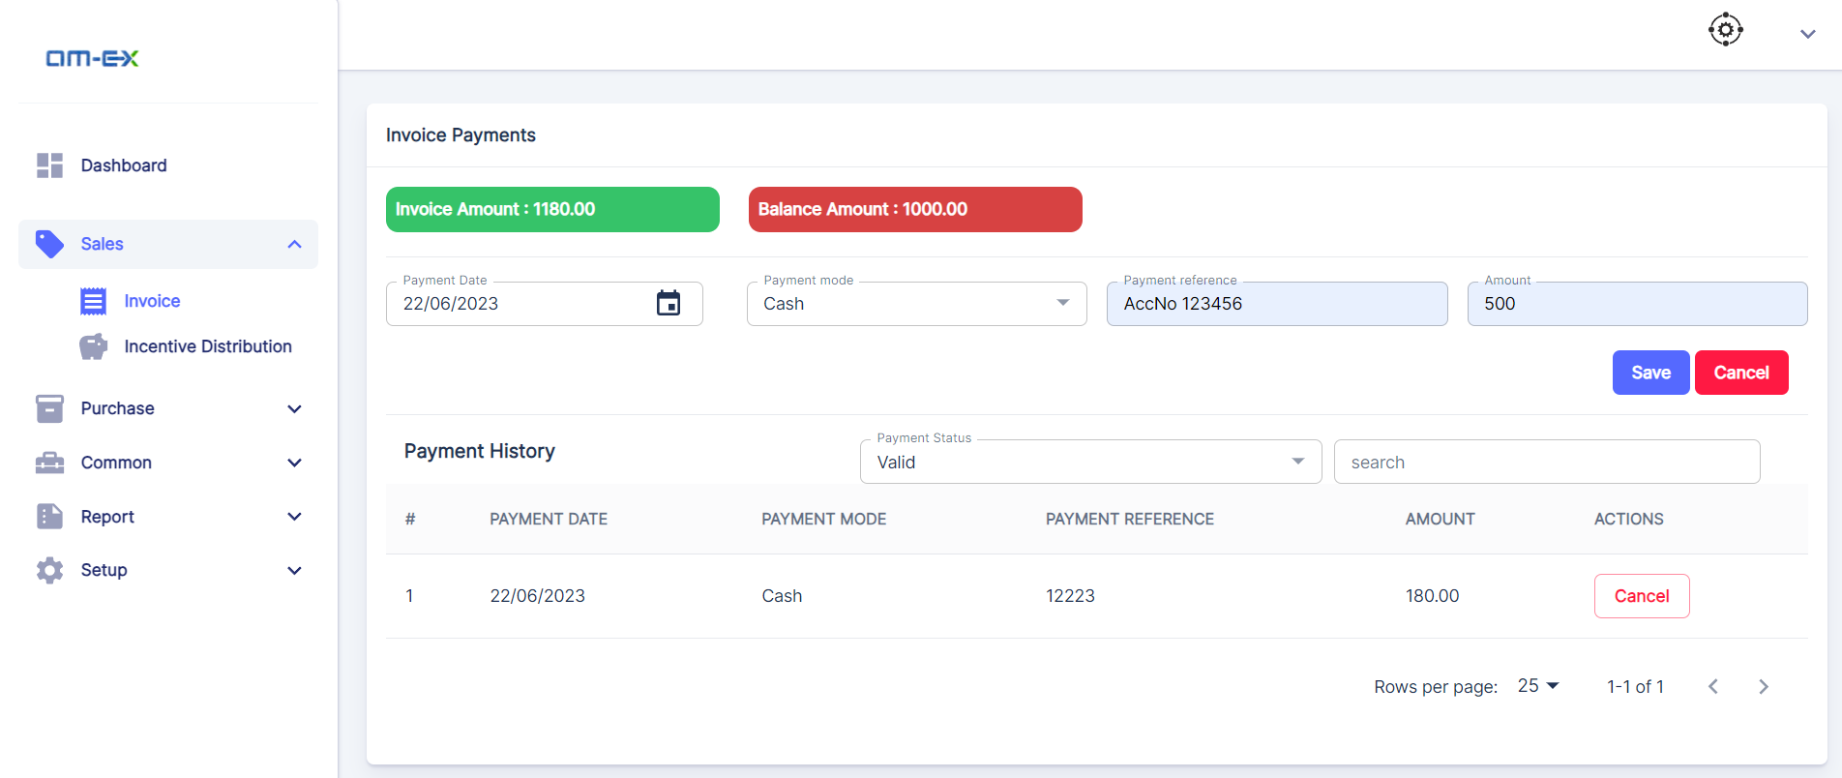

Steps to receive payment against the invoice:

1. From the commission listing screen, Click on the Actions dropdown list against the unpaid or partially paid invoice.
2. Select the “Record Payment” option.
3. Enter the Receipt date and account accordingly, here the account will be created as part of a new invoice generating procedure. A separate account head will be created for each insurance company in the system. This account is the temporary COA to park all the payments received from the respective insurance company.
4. Enter the Receipt reference (Cheque number/Voucher number/Bank account number or any other description to identify the payment details)
5. Enter the Amount (The full Invoice amount and the balance amount are displayed on the top in green and red bars respectively)
6. Click on Save button.
7. The payment will be listed and can be viewed under Receipt History

In case the user wants to cancel the payment, he can do so by clicking on the Cancel button under Actions, this is only possible until any receipt is posted against the invoice. All valid or cancelled payments can be filtered using the Payment status search box. The invoice payment screen also lists the previous payments if any.

Note: AMS will post a compound entry to write-off the related receivable entry and to post the received payment for the given amount.

## **5.1.0 Create Reward**

Insurance companies will issue additional incentive/reward for the total policies taken from them for a particular period and the user can create a reward distribution request by entering the type of policy. The work-flow for the incentive/reward is the same as invoice/commission mentioned above, only difference is in the reward/commission amount for each policy selected in the list.

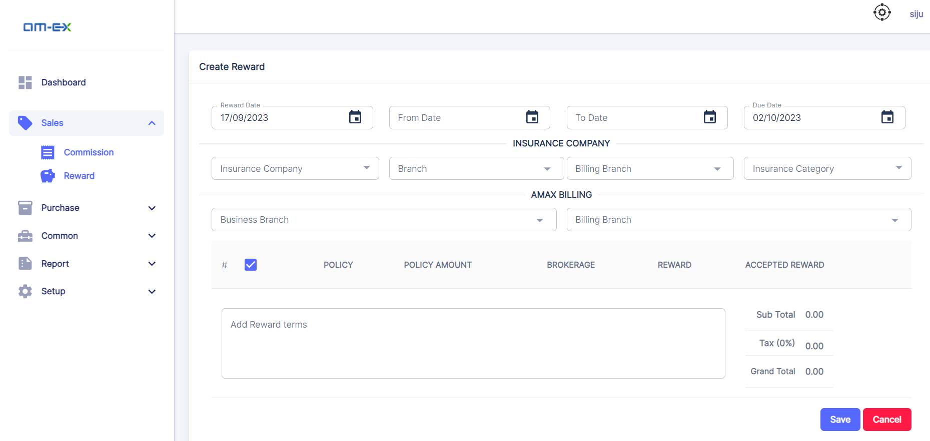

## **5.2.0 Credit note**

Credit note is created against a customer with several policies. Once a credit note is created, we can adjust the same to the upcoming invoice(s).

1. **Steps to create a credit note –** 
   1. Select the Customer (Insurance company) from the drop-down list
   2. To display the policies, mention the period by selecting the dates such as - From Date, To Date
   3. Enter the credit note amount
   4. All policies will be listed down in the screen, from which the user can select any number of policies using the checkbox
   5. Click on the Save button to finally create the credit note.

(Note: This will internally mark the invoice that are part of the selected policies)

1. **Adjust Credit note with upcoming invoice(s) –**
   1. Select the Customer (Insurance company) from the drop-down list
   2. To display the invoices, mention the period by selecting the dates such as - From Date, To Date
   3. All invoices which are not fully paid will be listed down in the screen, from which the user can enter the amount allotted to each invoice
   4. Click on the Save button to finally allocate the credit note.

We can post the credit note amount against the selected invoices and change the status accordingly.

## **5.3.0 Cost centre**

Cost centre management feature allow the user to create the cost centre groups and its related items. These cost centre items are available in the journal entry screen to post the related accounts

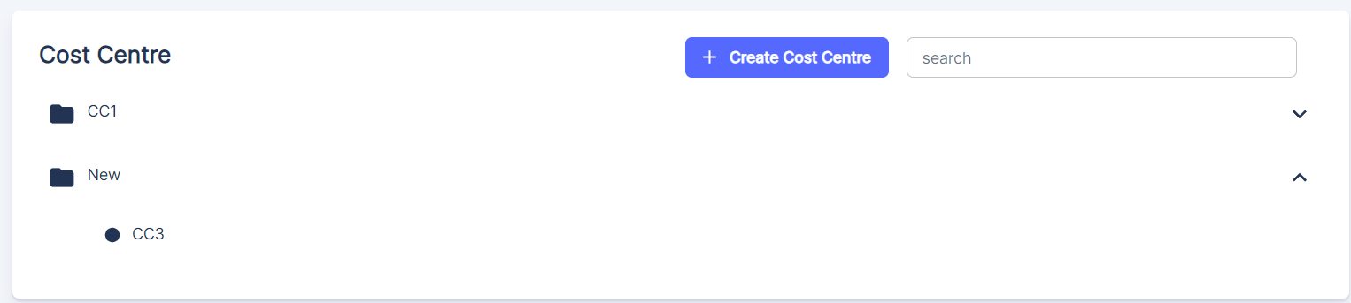

## **5.4.0 Reports**

Reports tab provides the access to generate the financial statements like Trail balance, Profit & Loss, Balance sheet, Cash flow and Ledger. In order to generate these reports users need to set up the general format of financial statements from the settings tab, a general format is provided as default but this can be customized as per the requirement. Any number of head nodes and sub nodes can be created as per your requirement, to display the amounts in nodes we need to map the associated chart of account head to the nodes by clicking the settings icon provided.

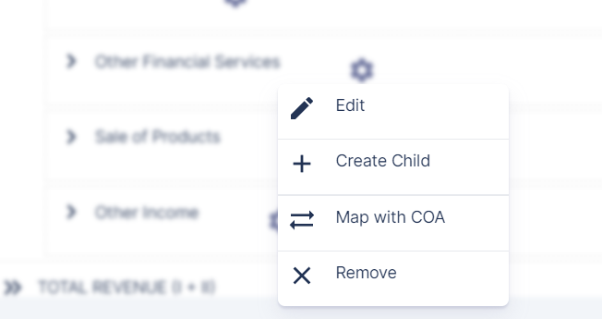

**Sample TB:**

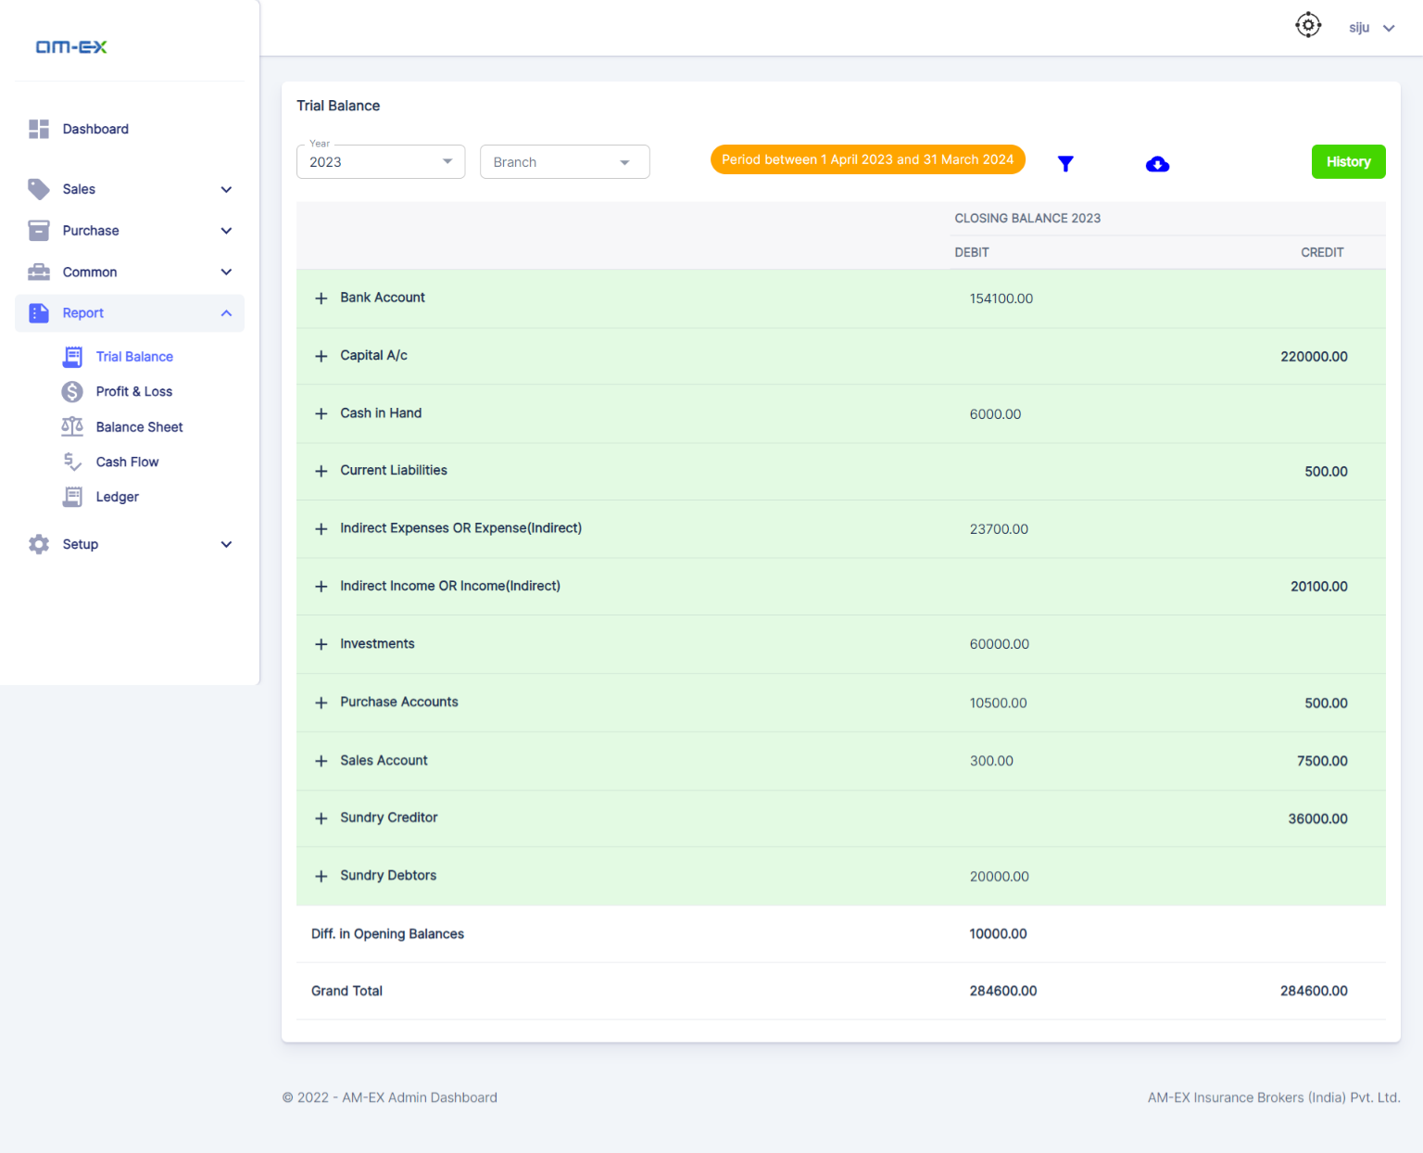

**Settings screen:**

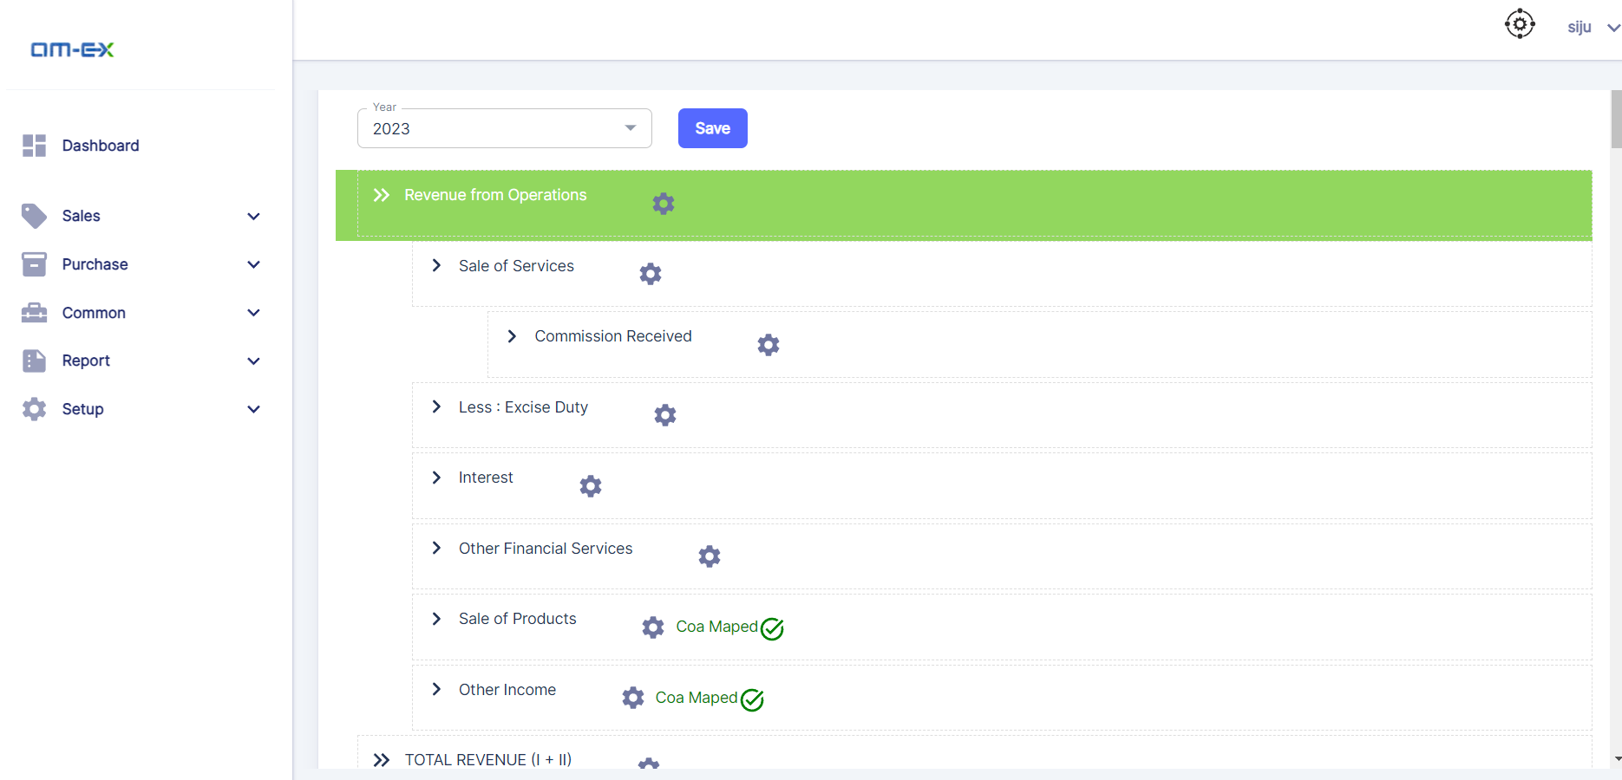

As per the last discussion P&L and balance sheet report will also be provided in the general format (above reports are based on Schedule VI).

## **5.5.0 Year end process**

Year-end process is to prepare the final financial statements for an accounting period. This must be done by the end of a financial period, once the process is done it cannot be reverted. This can be done by clicking the generate button provided for each FS reports. Once any one of the FS is generated no addition / modifications are allowed in the specific accounting period. So please make sure to verify the financials are correct before proceeding with this process. After generating only, the view option will be available for the associated FS.

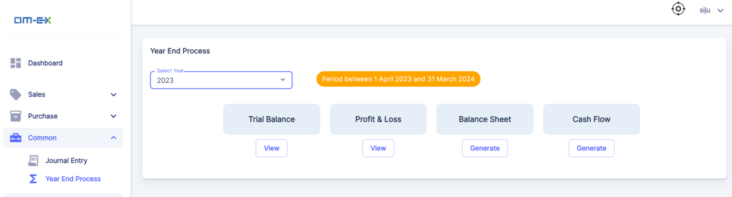

**5.6.0 Conclusion**

The proposed Insurance ERP System with integrated Insurance, HRMS, and Accounts modules aims to streamline and enhance the overall operations of the organization.

By combining these critical functions, the system is poised to provide a seamless experience that improves efficiency and reduces redundancy.

The Insurance module is designed to optimize policy management, claims processing, and underwriting activities.

This integration ensures that insurance operations are tightly connected with HR and Accounts functions, enabling better risk assessment, customer service, and financial transparency.

The HRMS module offers a centralized platform for managing employee information, recruitment, training, performance evaluations, and more.

The integration with other modules facilitates informed decision-making by incorporating HR insights into insurance and financial processes.

The Accounts module provides robust financial management capabilities, including invoicing, billing, etc. This integration with the Insurance and HRMS modules ensures accurate financial data and reporting across the organization.

In conclusion, the proposed Insurance ERP System represents a significant step toward achieving operational excellence by seamlessly integrating Insurance, HRMS, and Accounts module.